2D case: Intersection between **Two Segments**

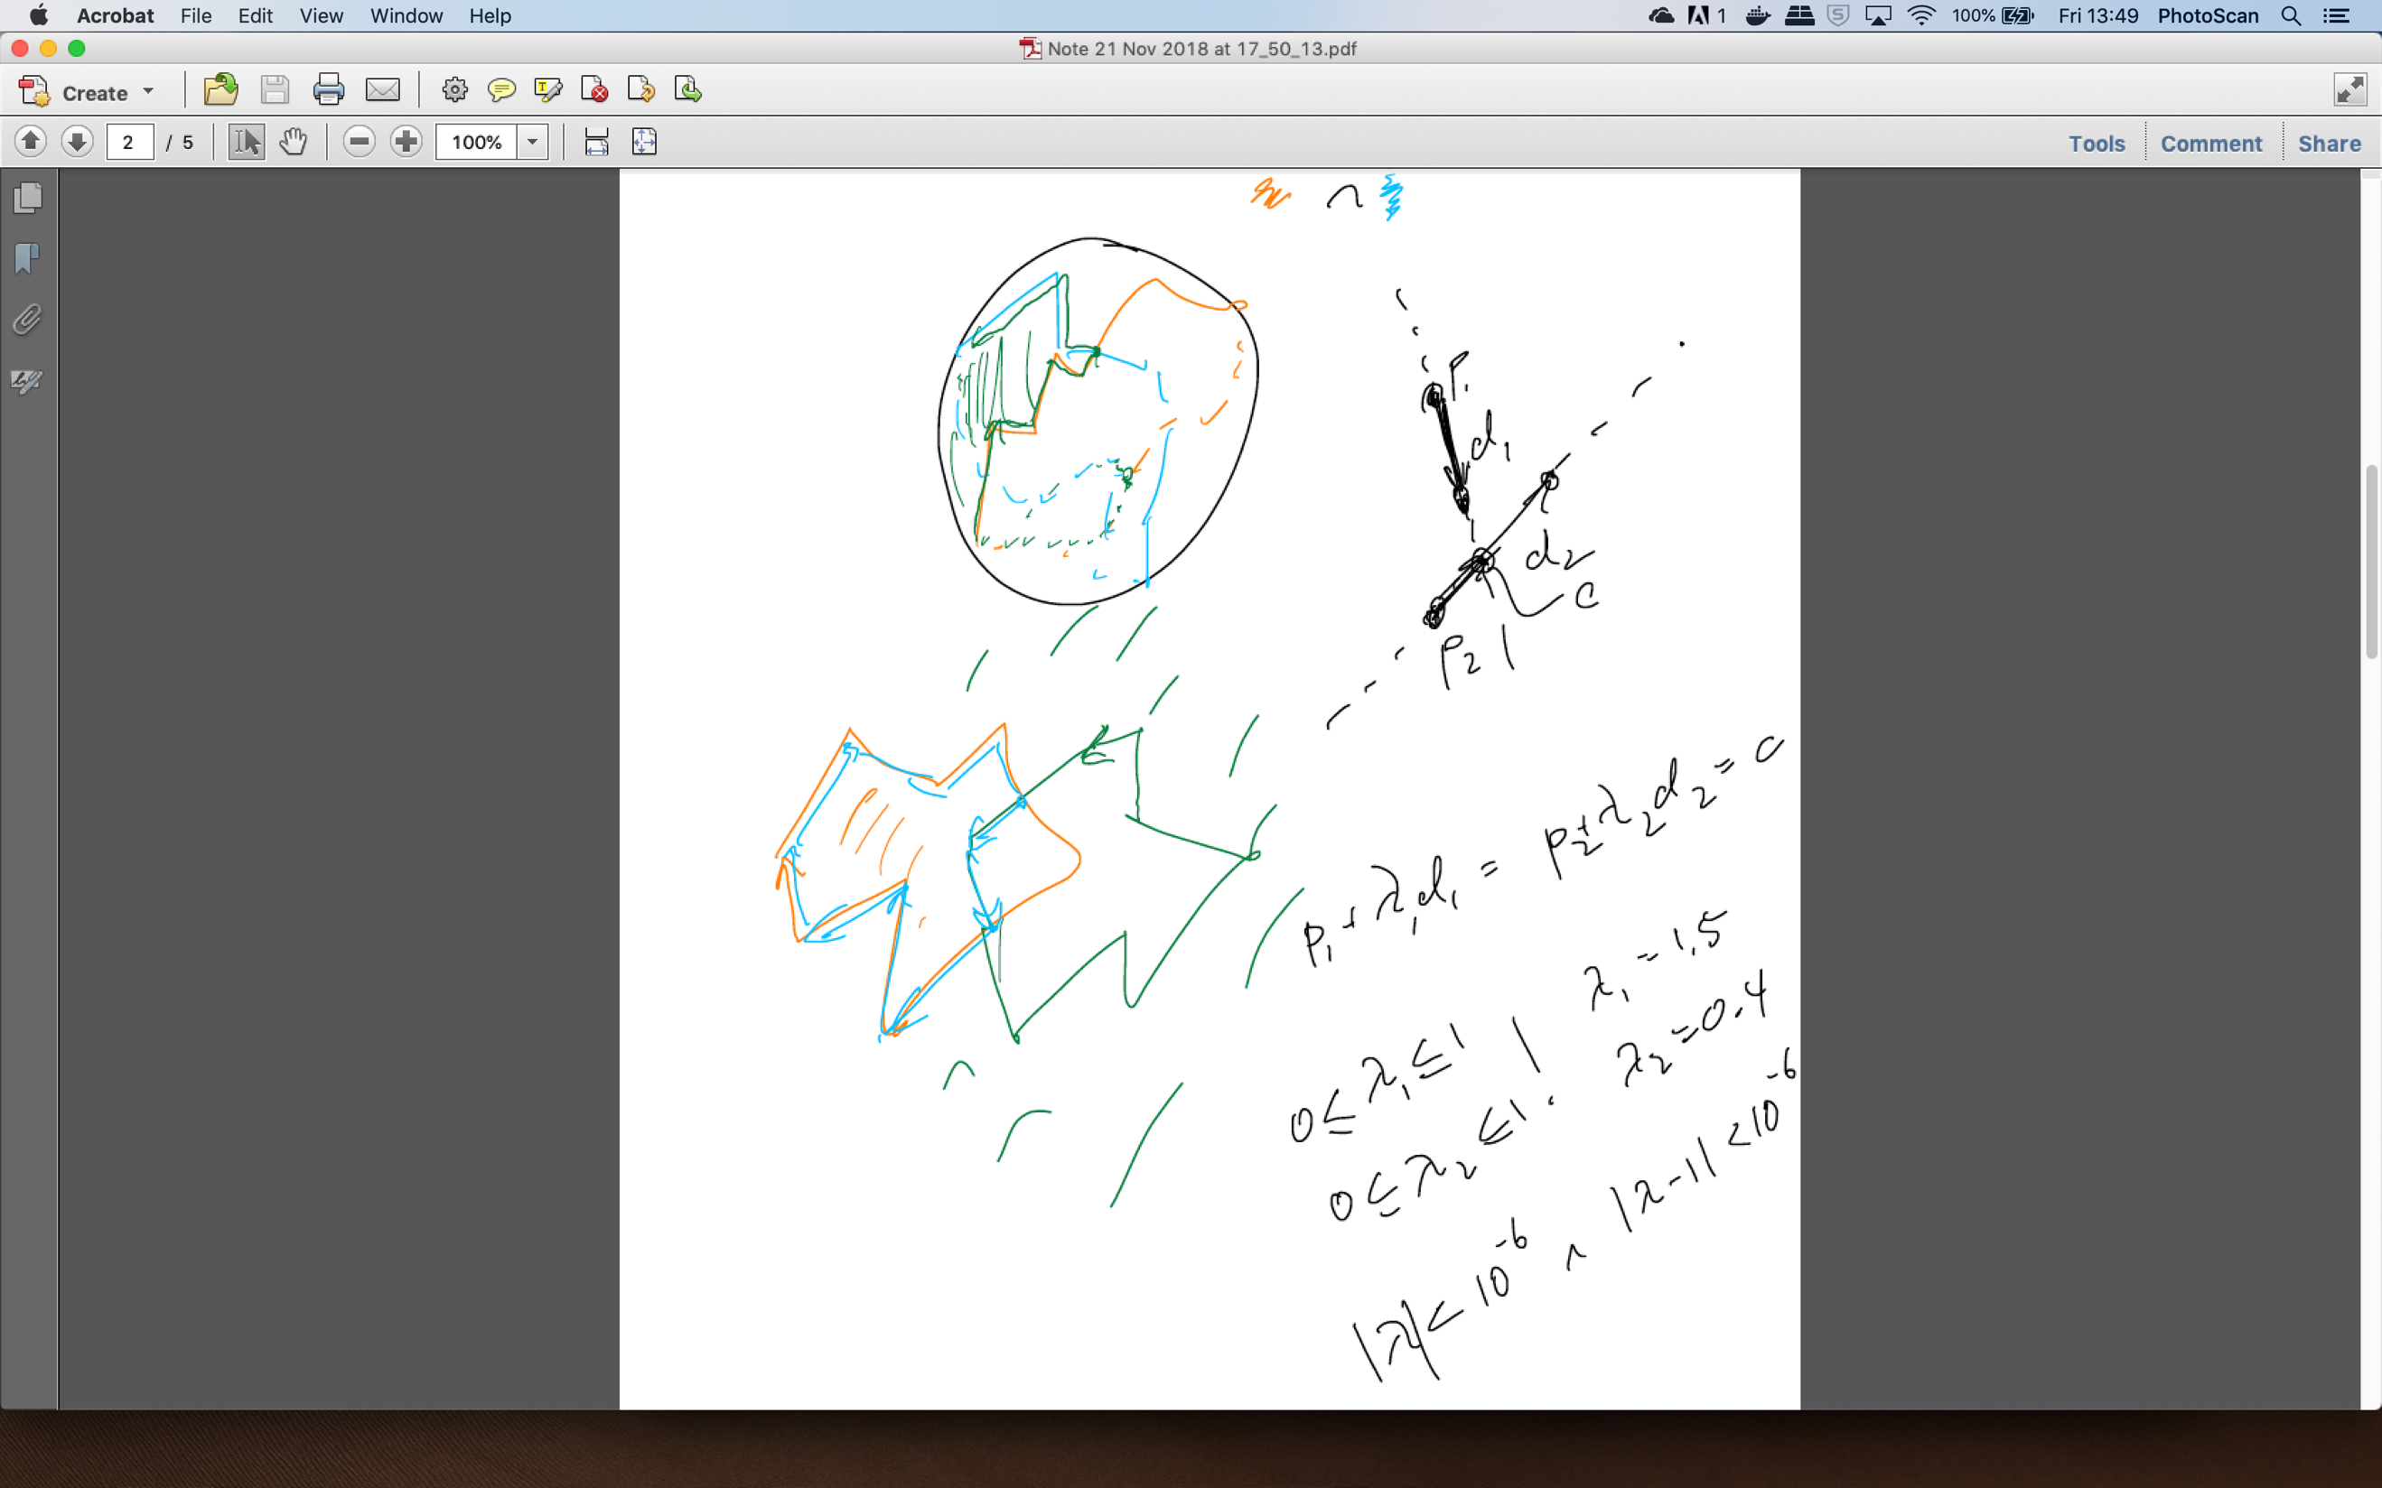

From: https://stackoverflow.com/questions/9043805/test-if-two-lines-intersect-javascript-function

Lines can be described by some initial vector, P, and a direction vector, d:

r = P1 + lambda*d

We use one point (a,b) as the initial vector and the difference between them (c-a,d-b) as the direction vector. Likewise for our second line.

If our two lines intersect, then there must be a point, X, that is reachable by travelling some distance, lambda, along our first line and also reachable by travelling gamma units along our second line. This gives us two simultaneous equations for the coordinates of X:

c = P1 + lambda*d1

c = P2 + gamma *d2

These equations can be represented in matrix form. We check that the determinant is non-zero to see if the intersection c even exists.

If there is an intersection, then we must check that the intersection actually lies between both sets of points. If lambda is greater than 1, the intersection is beyond the second point. If lambda is less than 0, the intersection is before the first point.

Hence, 0<lambda<1 && 0<gamma<1 indicates that the two lines intersect!

**They do not intersect if 1.000001 < absolute (lambda) < 0.000001 and 1.000001 < absolute (lambda) < 0.000001**

3D case: Intersection between **a Plane and a segment**

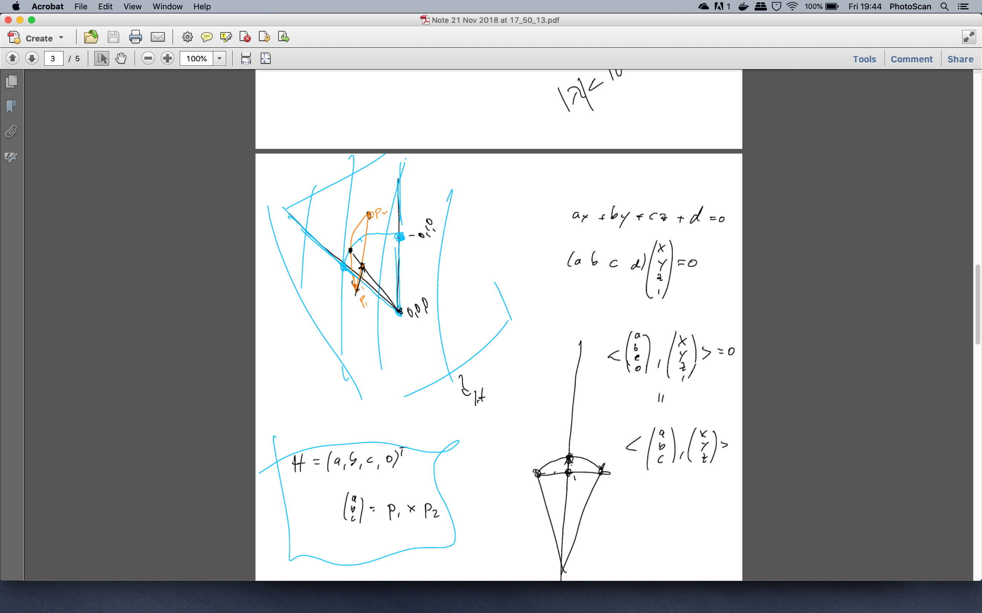

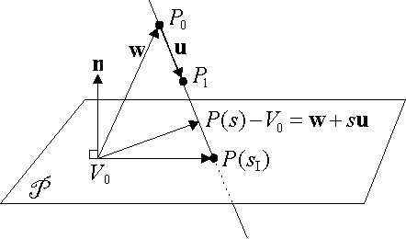

In 3D a line **L** is either parallel to a plane **P**  or intersects it in a single point.

Our plane is defined by point(0,0,0) and normal vector n: P1 cross P2

We can check if **L** is parallel to **P**  by testing if

n dot u = 0

where n is the normal and P is the plane

P1 x P2 dot (LineP1 – Line P0)

This means that the line direction vector **u** is perpendicular to the plane normal **n**. Hence the line should be parallel to our plane.

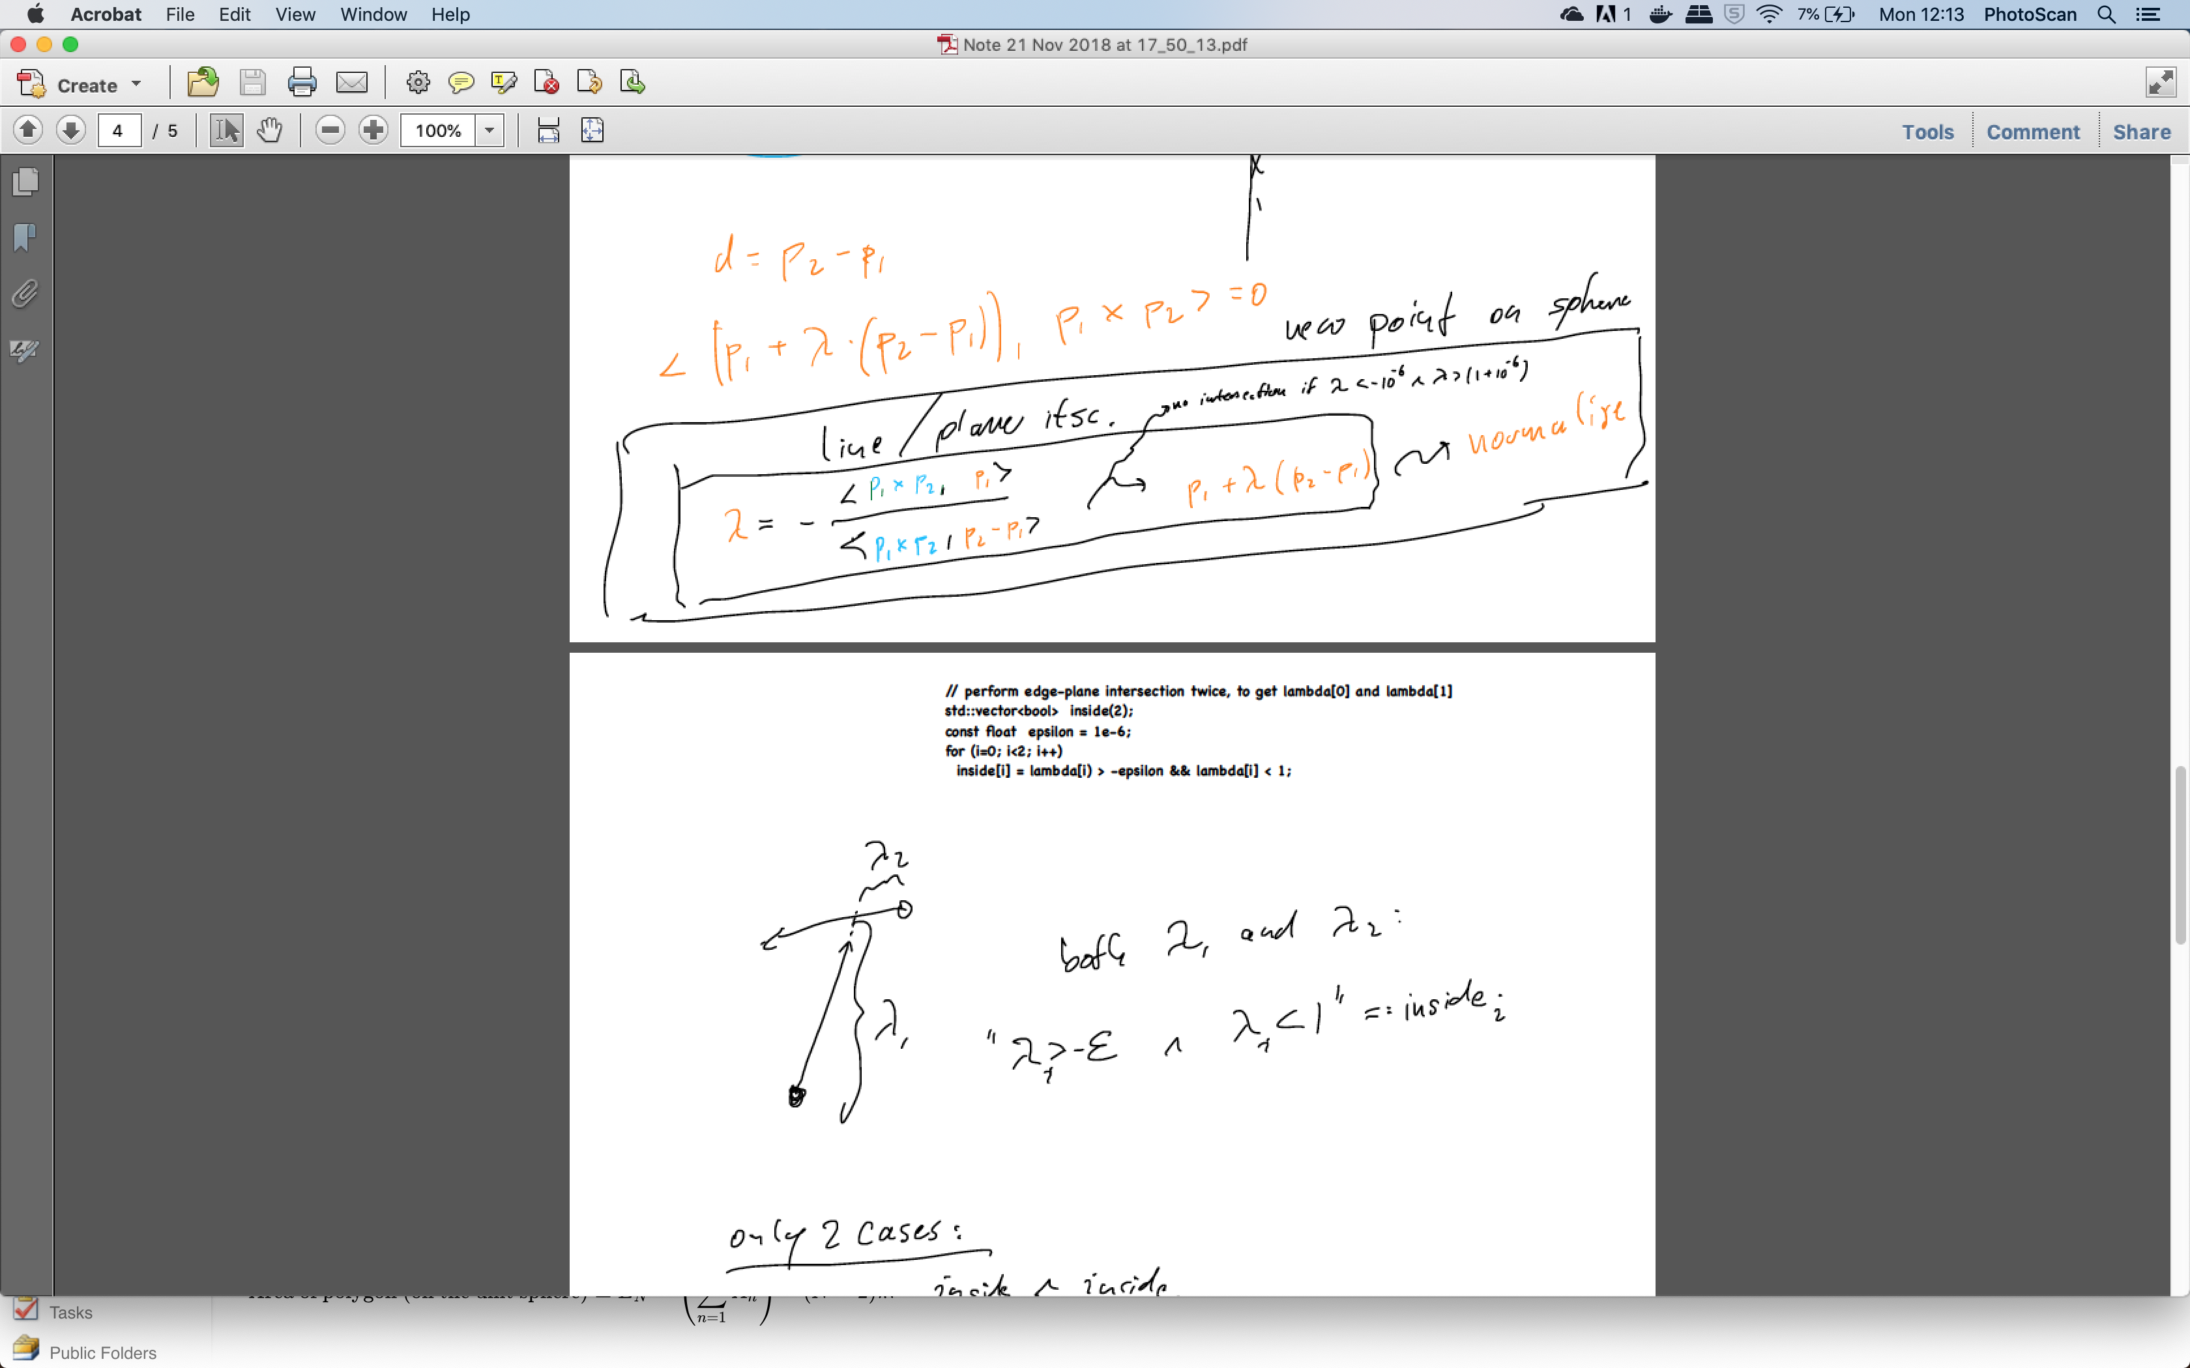

To get the new point on the sphere, add the