Entity Relationship Diagram for **Async Inn**  Karina Chen

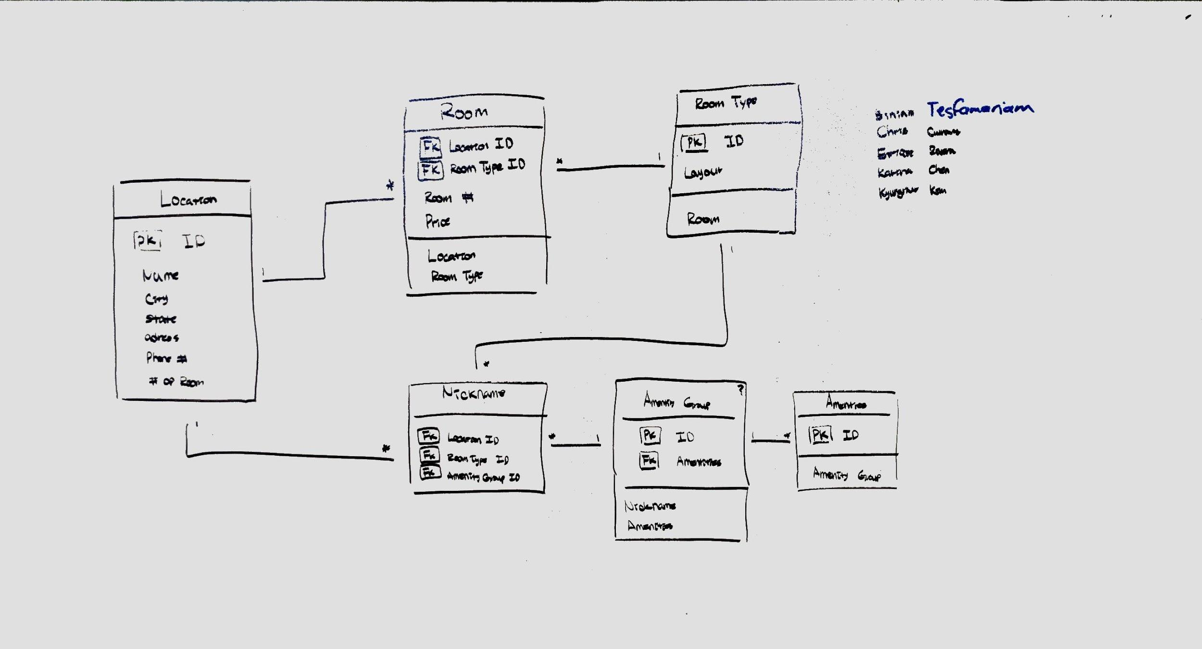

**Tables:**

**Location** Joint Entity Table with Payload

This table contains information including name, city, state, address, phone number, and number of rooms. This table is linked to room table and nickname table. Each location has many number of rooms and the nicknames are different depending on the locations.

**Room** Joint Entity Table with Payload

Room table has data of price and room number. Each room has a different number and different price. Room table is linked to location table and room type table. Each room has one room type and each room has one location.

**Room Type** Joint Entity Table with Payload

Room type table has data of room layout. Each room type can be in many rooms, and each room type can have many nicknames depending on the amenities the room has.

**Nickname** Pure Joint Table

A nickname table has relationships with location table, room type, and amenity group. A nickname is associated with one location, a nickname can have one room type, and a nickname can have one amenity group.

**Amenity Group** Pure Joint Table

Amenity group can have many different amenities and each amenity group can associated with many nicknames.

**Amenities** Enum

Amenities only has relationship with amenity group. Each amenity can be placed in many amenity group.