7524 - Teoría de la programaciónTP Individual

short line

Karina Alaya  
Padron 75840

# 

Ejercicio 1) - Procesamiento de listas

Length

Take

Drop

Append

Member

Position

Ejercicio 2) - Referencias externas

Ejercicio 3) - Ejemplo de ejecución

Programa 1

Programa 2

Programa 3

Programa 4

Programa 5

Programa 6

Ejercicio 4) - Case

Ejercicio 5) - Recursividad

1. Traducción al lenguaje Kernel

2. “Tail Recursive”

3. Ejecución en la máquina abstracta

Implementación básica

Implementación Tail Recursive

Ejercicio 6) - Alto orden con listas

FoldL

FoldR

Map

Filter

Ejercicio 7) - Hilos

WaitSome

Maquina abstracta

Ejercicio 8) - Evaluación perezosa

8.1 Maquina Abstracta

8.2 Reverse

Ejercicio 9) - Mensajes

Ejercicio 10) - Servidor de filtros

Ejercicio 11) - Celdas de memoria

# 

# 

# Ejercicio 1) - Procesamiento de listas

## Length

* 1. Código Oz

|  |
| --- |
| % Length function  declare fun {Length Xs}  case Xs of nil then 0  [] H|T then 1 + {Length T}  end  end |

* 1. Ejemplos de ejecución

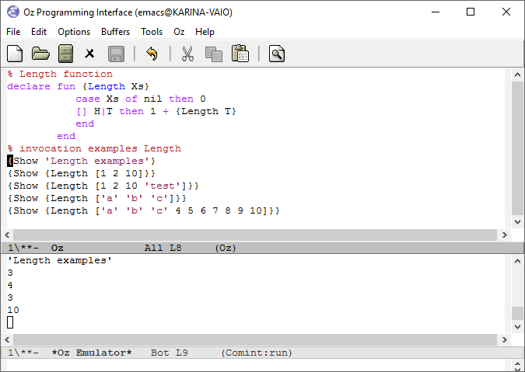

## Take

* 1. Código Oz

|  |
| --- |
| % Take function  declare fun {Take Xs N}  if N == 0 then nil  else  case Xs of nil then nil  [] H|T then H|{Take T N-1}  end  end  end |

* 1. Ejemplos de ejecución

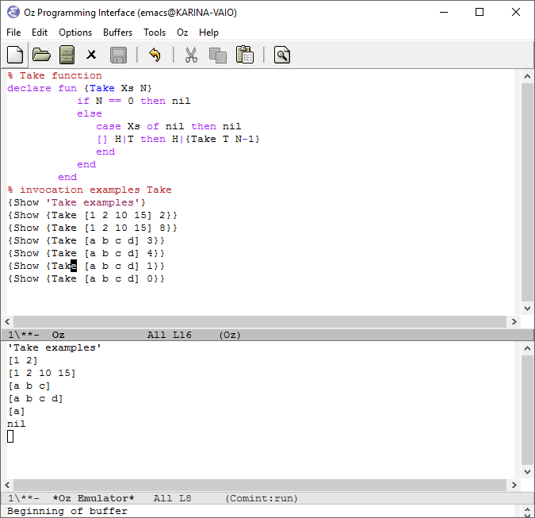

## Drop

* 1. Código Oz

|  |
| --- |
| % Drop function  declare fun {Drop Xs N}  if N == 0 then Xs  else  case Xs of nil then nil  [] H|T then {Drop T N-1}  end  end  end |

* 1. Ejemplos de ejecución

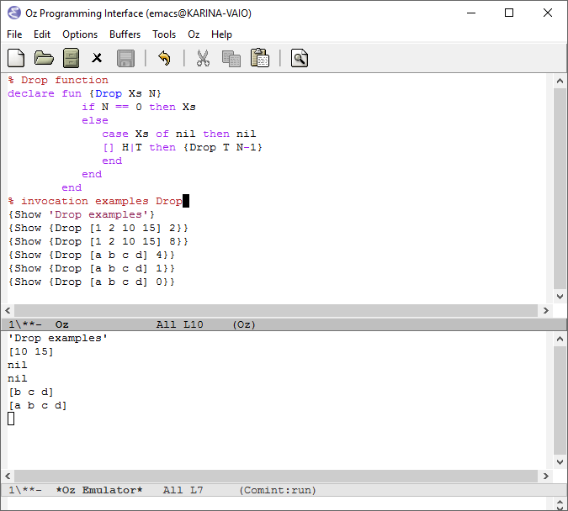

## Append

* 1. Código Oz

|  |
| --- |
| % Append function  declare fun {Append Xs Ys}  if Ys == nil then Xs  else  case Xs of nil then Ys  [] H|T then H|{Append T Ys}  end  end  end |

* 1. Ejemplos de ejecución

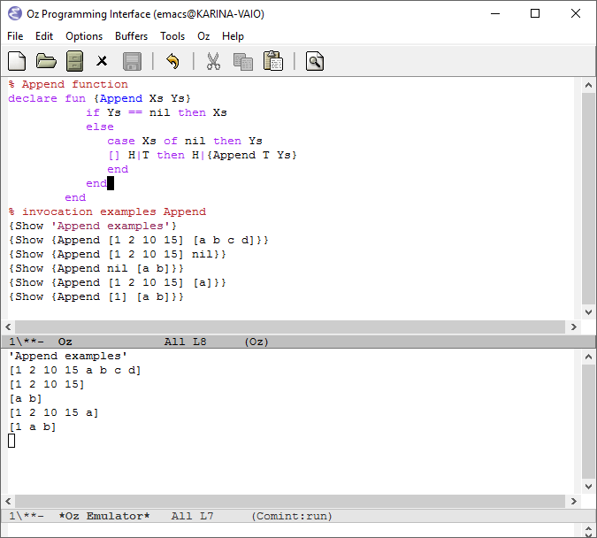

## Member

* 1. Código Oz

|  |
| --- |
| % Member function  declare fun {Member Xs Y}  case Xs of nil then false  [] H|T then  if H == Y then true  else  {Member T Y}  end  end  end |

* 1. Ejemplos de ejecución

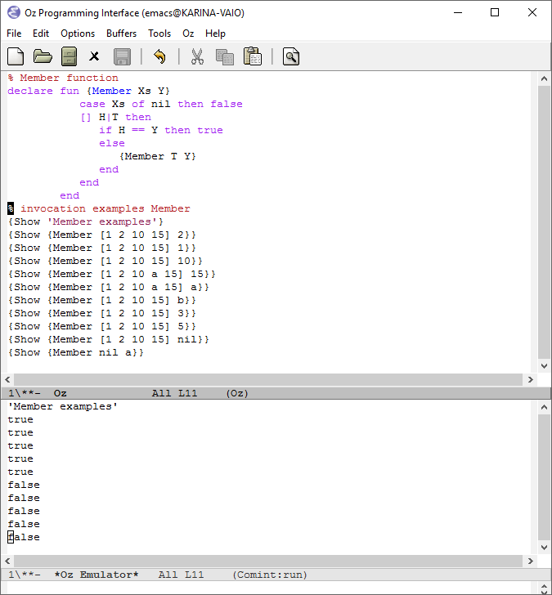

## Position

* 1. Código Oz

|  |
| --- |
| % Position function  declare fun {Position Xs Y}  case Xs of nil then 0  [] H|T then  if H == Y then 0  else 1 + {Position T Y}  end  end  end |

* 1. Ejemplos de ejecución

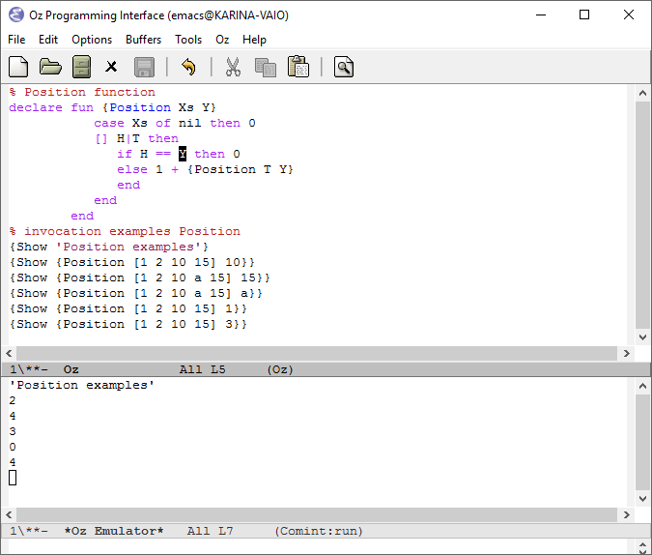

# Ejercicio 2) - Referencias externas

1. proc {P X Y} local Z in {Q Z U} end end

Referencias externas: Q, U

1. proc {P X Y} local Z in {Q Z Y} end end

Referencias externas: Q

1. proc {P X Y} local Z in {P Z Y} end end

Referencias externas: ninguna

# Ejercicio 3) - Ejemplo de ejecución

## Programa 1

**Estado inicial**

|  |  |  |
| --- | --- | --- |
| **Stack** | **Store** | **E** |
| local B in  if B then  Skip  else  skip  end  end | - | **-** |

**=> Ejecución de declaración de variable**

|  |  |  |
| --- | --- | --- |
| **Stack** | **Store** | **E** |
| if B then  skip  else  skip  end | **b1** | **B-> b1** |

**=> Ejecución de condicional. Como E(B) no está determinado, el programa se suspende, a la espera que b1 tome algun valor.**

## Programa 2

**Estado inicial**

|  |  |  |
| --- | --- | --- |
| **Stack** | **Store** | **E** |
| local B in  B = false  if B then  skip  else  skip  end  end | - | **-** |

**=> Ejecución de declaración de variable y composición**

|  |  |  |
| --- | --- | --- |
| **Stack** | **Store** | **E** |
| B = false  if B then  skip  else  skip  end | **b1** | **B-> b1** |

**=> Ejecución de binding de variables**

|  |  |  |
| --- | --- | --- |
| **Stack** | **Store** | **E** |
| if B then  skip  else  skip  end | b1 = **false** | B-> b1 |

**=> Ejecución de condicional, como B = false entonces se agrega en el stack la sentencia dentro del else**

|  |  |  |
| --- | --- | --- |
| **Stack** | **Store** | **E** |
| skip | b1 = false | B-> b1 |

**=> Ejecución del skip (St6), no hay cambios en el store y se quita la sentencia.**

|  |  |  |
| --- | --- | --- |
| **Stack** | **Store** | **E** |
| - | b1 = false | B-> b1 |

**No hay nada mas en el stack, entonces el programa finaliza.**

## Programa 3

**Estado inicial**

|  |  |  |
| --- | --- | --- |
| **Stack** | **Store** | **E** |
| local X Z A B P in  proc {P X Y}  Y = X+Z  end  Z=7  X=4  {P X A}  {P A B}  end | - | **-** |

**=> Ejecución de declaración de variables**

|  |  |  |
| --- | --- | --- |
| **Stack** | **Store** | **E** |
| proc {P X Y}  Y = X+Z  end  Z=7  X=4  {P X A}  {P A B} | **x1**  **z1**  **a1**  **b1**  **p1** | **X -> x1**  **Z-> z1**  **A -> a1**  **B -> b1**  **P-> p1** |

**=> Ejecución de procedure value**

|  |  |  |
| --- | --- | --- |
| **Stack** | **Store** | **E** |
| Z=7  X=4  {P X A}  {P A B} | x1  z1  a1  b1  p1 **= proc {P X Y}**  **Y = X+Z**  **end, CE = {Z -> z1}** | X -> x1  Z-> z1  A -> a1  B -> b1  P-> p1 |

**=> Ejecución de binding de variable**

|  |  |  |
| --- | --- | --- |
| **Stack** | **Store** | **E** |
| X=4  {P X A}  {P A B} | x1  z1 = **7**  a1  b1  p1 =proc {P X Y}  Y = X+Z  end, CE = {Z -> z1} | X -> x1  Z-> z1  A -> a1  B -> b1  P-> p1 |

**=> Ejecución de binding de variable**

|  |  |  |
| --- | --- | --- |
| **Stack** | **Store** | **E** |
| {P X A}  {P A B} | x1 = **4**  z1 = 7  a1  b1  p1 = proc {P X Y}  Y = X+Z  end, CE = {Z -> z1} | X -> x1  Z-> z1  A -> a1  B -> b1  P-> p1 |

**=> Ejecución de procedure value**

|  |  |  |
| --- | --- | --- |
| **Stack** | **Store** | **E** |
| **A = X + Z**  {P A B} | x1 = 4  z1 = 7  a1  b1  p1 = proc {$ X Y}  Y = X+Z  end, CE = {Z -> z1} | X -> x1  Z-> z1  A -> a1  B -> b1  P-> p1 |

**=> Asignacion de variable mas suma en base al store**

|  |  |  |
| --- | --- | --- |
| **Stack** | **Store** | **E** |
| {P A B} | x1 = 4  z1 = 7  a1 = **11**  b1  p1 = proc {$ X Y}  Y = X+Z  end, CE = {Z -> z1} | X -> x1  Z-> z1  A -> a1  B -> b1  P-> p1 |

**=> Ejecución de procedure value**

|  |  |  |
| --- | --- | --- |
| **Stack** | **Store** | **E** |
| **B = A + Z** | x1 = 4  z1 = 7  a1 = 11  b1  p1 **=** proc {$ X Y}  Y = X+Z  end, CE = {Z -> z1} | X -> x1  Z-> z1  A -> a1  B -> b1  P-> p1 |

**=> Asignacion de variable mas suma en base al store**

|  |  |  |
| --- | --- | --- |
| **Stack** | **Store** | **E** |
| - | x1 = 4  z1 = 7  a1 = 11  b1 **= 18**  p1 **=** proc {$ X Y}  Y = X+Z  end, CE = {Z -> z1} | X -> x1  Z-> z1  A -> a1  B -> b1  P-> p1 |

## Programa 4

**Estado inicial**

|  |  |  |
| --- | --- | --- |
| **Stack** | **Store** | **E** |
| local X Z A B P in  proc {P X Y}  Y = X+Z  end  Z=10  local Z in  Z = 2  X=4  {P X A}  {P A B}  end  end | - | **-** |

**=> Ejecución de declaración de variables**

|  |  |  |
| --- | --- | --- |
| **Stack** | **Store** | **E** |
| proc {P X Y}  Y = X+Z  end  Z=10  local Z in  Z = 2  X=4  {P X A}  {P A B}  end | **x1**  **z1**  **a1**  **b1**  **p1** | **X - > x1**  **Z -> z1**  **A -> a1**  **B -> b1**  **P -> p1** |

**=> Ejecución de declaración de procedure value**

|  |  |  |
| --- | --- | --- |
| **Stack** | **Store** | **E** |
| Z=10  local Z in  Z = 2  X=4  {P X A}  {P A B}  end | x1  z1  a1  b1  p1 **= proc {$ X Y}**  **Y = X+Z**  **end, CE = {Z -> z1}** | X - > x1  Z -> z1  A -> a1  B -> b1  P -> p1 |

**=> Ejecución de asignación de variable**

|  |  |  |
| --- | --- | --- |
| **Stack** | **Store** | **E** |
| local Z in  Z = 2  X=4  {P X A}  {P A B}  end | x1  z1 **= 10**  a1  b1  p1 = proc {$ X Y}  Y = X+Z  end, CE = {Z -> z1} | X - > x1  Z -> z1  A -> a1  B -> b1  P -> p1 |

**=> Ejecución de declaración de variable Z**

|  |  |  |
| --- | --- | --- |
| **Stack** | **Store** | **E** |
| Z = 2  X=4  {P X A}  {P A B} | x1  z1 = 10  **z2**  a1  b1  p1 = proc {$ X Y}  Y = X+Z  end, CE = {Z -> z1} | X - > x1  Z -> **z2**  A -> a1  B -> b1  P -> p1 |

**=> Ejecución de asignación de variable Z (en el nuevo entorno)**

|  |  |  |
| --- | --- | --- |
| **Stack** | **Store** | **E** |
| X=4  {P X A}  {P A B} | x1  z1 = 10  z2 = **2**  a1  b1  p1 = proc {$ X Y}  Y = X+Z  end, CE = {Z -> z1} | X - > x1  Z -> z2  A -> a1  B -> b1  P -> p1 |

**=> Ejecución de asignación de variable X (en el nuevo entorno)**

|  |  |  |
| --- | --- | --- |
| **Stack** | **Store** | **E** |
| {P X A}  {P A B} | x1 = **4**  z1 = 10  z2 = 2  a1  b1  p1 = proc {$ X Y}  Y = X+Z  end, CE = {Z -> z1} | X - > x1  Z -> z2  A -> a1  B -> b1  P -> p1 |

**=> Ejecución de procedure value (en el nuevo entorno usando su entorno contextual)**

|  |  |  |
| --- | --- | --- |
| **Stack** | **Store** | **E** |
| A = X + Z  {P A B} | x1 = 4  z1 = 10  z2 = 2  a1  b1  p1 = proc {$ X Y}  Y = X+Z  end, CE = {Z -> z1} | X - > x1  Z -> z2  A -> a1  B -> b1  P -> p1 |

**=> Ejecución de la única sentencia del procedure (en el nuevo entorno usando su entorno contextual)**

|  |  |  |
| --- | --- | --- |
| **Stack** | **Store** | **E** |
| {P A B} | x1 = 4  z1 = 10  z2 = 2  a1 = **14 (Z -> z1 = 10)**  b1  p1 = proc {$ X Y}  Y = X+Z  end, CE = {Z -> z1} | X - > x1  Z -> z2  A -> a1  B -> b1  P -> p1 |

**=> Ejecución del procedure value(en el nuevo entorno usando su entorno contextual)**

|  |  |  |
| --- | --- | --- |
| **Stack** | **Store** | **E** |
| B = A + Z | x1 = 4  z1 = 10  z2 = 2  a1 = 14  b1  p1 = proc {$ X Y}  Y = X+Z  end, CE = {Z -> z1} | X - > x1  Z -> z2  A -> a1  B -> b1  P -> p1 |

**=> Ejecución de la única sentencia del procedure (en el nuevo entorno usando su entorno contextual)**

|  |  |  |
| --- | --- | --- |
| **Stack** | **Store** | **E** |
| - | x1 = 4  z1 = 10  z2 = 2  a1 = 14  b1 = **24 (a1:14 +z1:10)**  p1 = proc {$ X Y}  Y = X+Z  end, CE = {Z -> z1} | X - > x1  Z -> z2  A -> a1  B -> b1  P -> p1 |

**Fin del programa**

## 

## 

## Programa 5

**Estado inicial**

|  |  |  |
| --- | --- | --- |
| **Stack** | **Store** | **E** |
| local X Y Z P Q in  X=6  Y=4  proc {P A B}  proc {B U V}  local F in  F=A+1  V=U+F  end  end  end  {P X Q}  {Q Y Z}  end | - | **-** |

**=> Declaracion de variables**

|  |  |  |
| --- | --- | --- |
| **Stack** | **Store** | **E** |
| X=6  Y=4  proc {P A B}  proc {B U V}  local F in  F=A+1  V=U+F  end  end  end  {P X Q}  {Q Y Z} | **x1**  **y1**  **z1**  **p1**  **q1** | **X -> x1**  **Y -> y1**  **Z -> z1**  **P -> p1**  **Q -> q1** |

**=> Asignación de variable**

|  |  |  |
| --- | --- | --- |
| Stack | Store | E |
| Y=4  proc {P A B}  proc {B U V}  local F in  F=A+1  V=U+F  end  end  end  {P X Q}  {Q Y Z} | x1 = **6**  y1  z1  p1  q1 | X -> x1  Y -> y1  Z -> z1  P -> p1  Q -> q1 |

**=> Asignación de variable**

|  |  |  |
| --- | --- | --- |
| Stack | Store | E |
| proc {P A B}  proc {B U V}  local F in  F=A+1  V=U+F  end  end  end  {P X Q}  {Q Y Z} | x1 =6  y1 = **4**  z1  p1  q1 | X -> x1  Y -> y1  Z -> z1  P -> p1  Q -> q1 |

**=> Declaración procedure value**

|  |  |  |
| --- | --- | --- |
| Stack | Store | E |
| {P X Q}  {Q Y Z} | x1 =6  y1 = 4  z1  p1 = **proc {$ A B}**  **proc {B U V}**  **local F in**  **F=A+1**  **V=U+F**  **end**  **end**  **end, CE = {}**  q1 | X -> x1  Y -> y1  Z -> z1  P -> p1  Q -> q1 |

**=> Ejecución procedure value**

|  |  |  |
| --- | --- | --- |
| Stack | Store | E |
| **proc {Q U V}**  **local F in**  **F = X + 1**  **V = U + F**  **end**  **end**  {Q Y Z} | x1 =6  y1 = 4  z1  p1 = proc {$ A B}  proc {B U V}  local F in  F=A+1  V=U+F  end  end  end, CE = {}  q1 | X -> x1  Y -> y1  Z -> z1  P -> p1  Q -> q1 |

**=> Declaración procedure value**

|  |  |  |
| --- | --- | --- |
| Stack | Store | E |
| {Q Y Z} | x1 =6  y1 = 4  z1  p1 = proc {$ A B}  proc {B U V}  local F in  F=A+1  V=U+F  end  end  end, CE = {}  q1 = **proc {$ U V}**  **local F in**  **F = X + 1**  **V = U + F**  **end**  **End, CE = {X-> x1}** | X -> x1  Y -> y1  Z -> z1  P -> p1  Q -> q1 |

**=> Ejecución procedure value**

|  |  |  |
| --- | --- | --- |
| Stack | Store | E |
| **local F in**  **F = X + 1**  **Z = Y + F**  **end** | x1 =6  y1 = 4  z1  p1 = proc {$ A B}  proc {B U V}  local F in  F=A+1  V=U+F  end  end  end, CE = {}  q1 = proc {$ U V}  local F in  F = X + 1  V = U + F  end  End, CE = {X-> x1} | X -> x1  Y -> y1  Z -> z1  P -> p1  Q -> q1 |

**=> declaración de variable**

|  |  |  |
| --- | --- | --- |
| Stack | Store | E |
| F = X + 1  Z = Y + F | x1 =6  y1 = 4  z1  **f1**  p1 = proc {$ A B}  proc {B U V}  local F in  F=A+1  V=U+F  end  end  end, CE = {}  q1 = proc {$ U V}  local F in  F = X + 1  V = U + F  end  End, CE = {X-> x1, **F -> f1**} | X -> x1  Y -> y1  Z -> z1  P -> p1  Q -> q1 |

**=> Asignación y suma de variables**

|  |  |  |
| --- | --- | --- |
| Stack | Store | E |
| Z = Y + F | x1 =6  y1 = 4  z1  f1 = **7**  p1 = proc {$ A B}  proc {B U V}  local F in  F=A+1  V=U+F  end  end  end, CE = {}  q1 = proc {$ U V}  local F in  F = X + 1  V = U + F  end  End, CE = {X-> x1, F -> f1} | X -> x1  Y -> y1  Z -> z1  P -> p1  Q -> q1 |

**=> Asignación y suma de variables**

|  |  |  |
| --- | --- | --- |
| Stack | Store | E |
| - | x1 =6  y1 = 4  z1 = **7(f1) + 4(y1) = 11**  f1 = 7  p1 = proc {$ A B}  proc {B U V}  local F in  F=A+1  V=U+F  end  end  end, CE = {}  q1 = proc {$ U V}  local F in  F = X + 1  V = U + F  end  End, CE = {X-> x1, F -> f1} | X -> x1  Y -> y1  Z -> z1  P -> p1  Q -> q1 |

## Programa 6

**Estado inicial**

|  |  |  |
| --- | --- | --- |
| **Stack** | **Store** | **E** |
| local X Y Z in  X = Y  try  X = 1 Y = 2 Z = 3  catch Exception then  skip  end  {Browse X#Y#Z}  end | - | **-** |

**=> Declaración de variables**

|  |  |  |
| --- | --- | --- |
| **Stack** | **Store** | **E** |
| X = Y  try  X = 1 Y = 2 Z = 3  catch Exception then  skip  end  {Browse X#Y#Z} | **x1**  **y1**  **z1** | **X -> x1**  **Y -> y1**  **Z -> z1** |

**=> Asignación de variables**

|  |  |  |
| --- | --- | --- |
| **Stack** | **Store** | **E** |
| try  X = 1  Y = 2  Z = 3  catch Exception then  skip  end  {Browse X#Y#Z} | x1  y1  z1 | **X -> y1**  Y -> y1  Z -> z1 |

**=> Ejecución de try**

|  |  |  |
| --- | --- | --- |
| **Stack** | **Store** | **E** |
| X = 1  Y = 2  Z = 3  catch Exception then  skip  end  {Browse X#Y#Z} | x1  y1  z1 | X -> y1  Y -> y1  Z -> z1 |

**=> Ejecución de asignación de variable (dentro del catch)**

|  |  |  |
| --- | --- | --- |
| **Stack** | **Store** | **E** |
| Y = 2  Z = 3  catch Exception then  skip  end  {Browse X#Y#Z} | x1  y1 **= 1**  z1 | X -> y1  Y -> y1  Z -> z1 |

**=> Ejecución de asignación de variable (dentro del catch)**

|  |  |  |
| --- | --- | --- |
| **Stack** | **Store** | **E** |
| Y = 2  Z = 3  catch Exception then  skip  end  {Browse X#Y#Z} | x1  y1 **=** 1  z1 | X -> y1  Y -> y1  Z -> z1 |

Acá se intenta asignar a y1 el valor 2, pero esta variable ya tiene valor porque X = Y, entonces dispara la Exception y se quitan todas las operaciones hasta la del catch

**=> Ejecución Exception**

|  |  |  |
| --- | --- | --- |
| **Stack** | **Store** | **E** |
| skip  {Browse X#Y#Z} | x1  y1 **=** 1  z1 | X -> y1  Y -> y1  Z -> z1 |

**=> Ejecución Skip**

|  |  |  |
| --- | --- | --- |
| **Stack** | **Store** | **E** |
| {Browse X#Y#Z} | x1  y1 **=** 1  z1 | X -> y1  Y -> y1  Z -> z1 |

**=> Ejecución Browse**

|  |  |  |
| --- | --- | --- |
| **Stack** | **Store** | **E** |
|  | x1  y1 **=** 1  z1 | X -> y1  Y -> y1  Z -> z1 |

Como el valor de Z no esta determinado el browse mostrará un ‘_’ indicando que aun no se definió, en otras operaciones podría suspenderse la ejecución, pero no ocurre con Browse. La ejecución mostrará:

**1#1#_**

# Ejercicio 4) - Case

**{Test [b c a]}**

Predicción: 'case'(4)

Ejecución: 'case'(4)

La lista no empieza con a como primer elemento, ni es un record, es una lista pero el primer y elemento no son iguales, luego es una lista, entonces case 4.

**{Test f(b(3))}**

Predicción: 'case'(5)

Ejecución: 'case'(5)

No es lista que empiece con a, si bien es un tupla llamada f, su valor no es a sino b(3), tampoco es una lista, con lo cual saltamos al caso 5 que cumple, dado que es un tupla llamada f y Y tomará el valor b(3)

**{Test f(a)}**

Predicción: 'case'(2)

Ejecución: 'case'(2)

No es lista, entonces analiza el case 2 donde coincide el nombre de la tupla y el elemento que contiene.

**{Test f(a(3))}**

Predicción: 'case'(5)

Ejecución: 'case'(5)

No es lista, luego es una tupla llamada f pero el elemento no es a, luego caso 3 y 4 no cumple por no ser una lista, en el caso 5 satisface la condición porque se llama f y el valor de la variable Y será a(3)

**{Test f(d)}**

Predicción: 'case'(5)

Ejecución: 'case'(5)

No es lista, luego es una tupla llamada f pero el elemento no es a, luego caso 3 y 4 no cumple por no ser una lista, en el caso 5 satisface la condición porque se llama f y el valor de la variable Y será d

**{Test [a b c]}**

Predición: 'case'(1)

Ejecución: 'case'(1)

Es una lista que empieza con el valor a, cumple la primer condición.

**{Test [c a b]}**

Prediccion: 'case'(4)

Ejecución:'case'(4)

No es una lista que comience con el valor a, luego no es una tupla, luego no es una lista con los primeros dos elementos iguales. Finalmente es una lista por lo que entra en el caso 4.

**{Test a|a}**

Predicción: 'case'(1)

Ejecución: 'case'(1)

Es una lista que comienza con el valor a.

**{Test '|'(v b)}**

Predicción: 'case'(6)

Ejecución: 'case'(4)

No es una lista que comience con a, tampoco es tupla, no es una lista con dos elementos iguales al inicio, pero si es una lista donde el valor de Zes b. El motivo por el cual mi predicción fue incorrecta es que pensé que el formato aceptado era una cabeza con una cola, o sea que debía ser ‘|’(v [b]), pero es incorrecto.

**{Test '|'(a a)}**

Predicción: 'case'(6)

Ejecución: 'case'(1)

Es una lista que comienza con a, por el mismo motivo que el punto anterior me equivoqué en la predicción.

**{Test '|'(b b)}**

Predicción 'case'(6)

Ejecución: 'case'(3)

No es una lista que comienza con a, luego tampoco es tupla, luego si es una lista con ambos elementos primero y segundo iguales.

**{Test '|'(a b c)}**

Predicción 'case'(6)

Ejecución: 'case'(6)

Al tener 3 elementos no coincide con una lista iniciando con a, luego no es tupla ni lista con ambos elementos iguales, tampoco es lista en la 4ta opcion, tampoco tupla llamada f, y queda como única opción el caso 6.

**{Test '|'(a [b c]}**

Predicción: 'case'(1)

Ejecución: 'case'(1)

En este caso si crea con la cabeza y la cola la lista con 3 elementos que empiezan con a, por lo tanto coincide la primer condición.

# Ejercicio 5) - Recursividad

## 1. Traducción al lenguaje Kernel

|  |
| --- |
| local Length in  Length = proc {$ Xs N}  case Xs of nil then  N = 0  else  case Xs of _|T then  local U in  {Length T U}  N = U + 1  end  else  skip  end  end  end  end  local K in  {Length [1 2 3 4] K}  {Show K}  end |

## 2. “Tail Recursive”

|  |
| --- |
| local Length in  Length = proc {$ Xs A N}  case Xs of nil then  N = A  else  case Xs of _|T then  local X in  X = A + 1  {Length T X N}    end  else  skip  end  end    end  end  local K in  {Length [1 2 3 4] 0 K}  {Show K}  end |

En el primer caso no es la llamada recursiva lo último que se ejecuta, entonces voy a tener las operaciones que siguen acumuladas en el stack y hasta que no se termine la invocación de la última llamada recursiva no voy a poder liberar el stack. Al hacerlo tail recursive no tengo en el stack operaciones pendientes, el cual me queda claramente más pequeño. Este es el motivo por el cual siempre debemos tratar de hacer la invocación a la recursividad al final. Esto se verá claramente en el punto 3.

## 3. Ejecución en la máquina abstracta

### Implementación básica

**Estado inicial**

|  |  |  |
| --- | --- | --- |
| **Stack** | **Store** | **E** |
| local Length in  Length = proc {$ Xs N}  case Xs of nil then  N = 0  else  case Xs of _|T then  local U in  {Length T U}  N = U + 1  end  else  skip  end  end  end  end  local K in  {Length [1 2 3 4] K}  {Show K}  end | - | **-** |

**=> Declaración de variable**

|  |  |  |
| --- | --- | --- |
| **Stack** | **Store** | **E** |
| Length = proc {$ Xs N}  case Xs of nil then  N = 0  else  case Xs of _|T then  local U in  {Length T U}  N = U + 1  end  else  skip  end  end  end  local K in  {Length [1 2 3 4] K}  {Show K}  end | length | **length -> Length** |

**=> Asignación de procedure value**

|  |  |  |
| --- | --- | --- |
| **Stack** | **Store** | **E** |
| local K in  {Length [1 2 3 4] K}  {Show K}  end | length = (**proc {$ Xs N}**  **case Xs of nil then**  **N = 0**  **else**  **case Xs of _|T then**  **local U in**  **{Length T U}**  **N = U + 1**  **end**  **else**  **skip**  **end**  **end**  **end, CE = {})** | length -> Length |

**=> Declaración variable K**

|  |  |  |
| --- | --- | --- |
| **Stack** | **Store** | **E** |
| {Length [1 2 3 4] K}  {Show K} | length = (proc {$ Xs N}  case Xs of nil then  N = 0  else  case Xs of _|T then  local U in  {Length T U}  N = U + 1  end  else  skip  end  end  end, CE = {})  **k** | **k-> K** |

**=> Ejecución de procedure**

|  |  |  |
| --- | --- | --- |
| **Stack** | **Store** | **E** |
| **case Xs of nil then**  **N = 0**  **else**  **case Xs of _|T then**  **local U in**  **{Length T U}**  **N = U + 1**  **end**  **else**  **skip**  **end**  **end**  {Show K} | length = (proc {$ Xs N}  case Xs of nil then  N = 0  else  case Xs of _|T then  local U in  {Length T U}  N = U + 1  end  else  skip  end  end  end, *)  k   |  |  | | --- | --- | | Store* | CE* | | xs = [1 2 3 4]  n = | xs -> Xs  n -> K | | k-> K |

**=> Ejecución de case**

|  |  |  |
| --- | --- | --- |
| **Stack** | **Store** | **E** |
| **case Xs of _|T then**  **local U in**  **{Length T U}**  **N = U + 1**  **end**  **else**  **skip**  **end**  {Show K} | length = (proc {$ Xs N}  case Xs of nil then  N = 0  else  case Xs of _|T then  local U in  {Length T U}  N = U + 1  end  else  skip  end  end  end, *)  k   |  |  | | --- | --- | | Store* | CE* | | xs = [1 2 3 4]  n = | xs -> Xs  n -> K | | k-> K |

**=> Ejecución de case**

|  |  |  |
| --- | --- | --- |
| **Stack** | **Store** | **E** |
| **local U in**  **{Length T U}**  **N = U + 1**  **end**  {Show K} | length = (proc {$ Xs N}  case Xs of nil then  N = 0  else  case Xs of _|T then  local U in  {Length T U}  N = U + 1  end  else  skip  end  end  end, *)  k   |  |  | | --- | --- | | Store* | CE* | | xs = [1 2 3 4]  n =  **t = [2 3 4]** | xs -> Xs  n -> K  t -> T | | k-> K |

**=> Declaración de U**

|  |  |  |
| --- | --- | --- |
| **Stack** | **Store** | **E** |
| **{Length T U}**  **N = U + 1**  {Show K} | length = (proc {$ Xs N}  case Xs of nil then  N = 0  else  case Xs of _|T then  local U in  {Length T U}  N = U + 1  end  else  skip  end  end  end, *)  k   |  |  | | --- | --- | | Store* | CE* | | xs = [1 2 3 4]  n =  t = [2 3 4]  **u =** | n -> K  t -> T  **u->U** | | k-> K |

**=> Ejecución de Length**

|  |  |  |
| --- | --- | --- |
| **Stack** | **Store** | **E** |
| **case Xs of nil then**  **N = 0**  **else**  **case Xs of _|T then**  **local U in**  **{Length T U}**  **N = U + 1**  **end**  **else**  **skip**  **end**  **end**  N = U + 1  {Show K} | length = (proc {$ Xs N}  case Xs of nil then  N = 0  else  case Xs of _|T then  local U in  {Length T U}  N = U + 1  end  else  skip  end  end  end, *)  k   |  |  | | --- | --- | | Store* | CE** | | xs = [1 2 3 4]  n =  t = [2 3 4]  u =  **xs’=[2 3 4]**  **n’=** | **xs’ -> Xs**  **n’ -> N**  t -> T  u->U | | k-> K |

**=> Ejecución de case**

|  |  |  |
| --- | --- | --- |
| **Stack** | **Store** | **E** |
| **case Xs of _|T then**  **local U in**  **{Length T U}**  **N = U + 1**  **end**  **else**  **skip**  **end**  N = U + 1  {Show K} | length = (proc {$ Xs N}  case Xs of nil then  N = 0  else  case Xs of _|T then  local U in  {Length T U}  N = U + 1  end  else  skip  end  end  end, *)  k   |  |  | | --- | --- | | Store* | CE** | | xs = [1 2 3 4]  n =  t = [2 3 4]  u =  **xs’=[2 3 4]**  **n’=** | **xs’ -> Xs**  **n’ -> N**  t -> T  u->U | | k-> K |

**=> Ejecución de case**

|  |  |  |
| --- | --- | --- |
| **Stack** | **Store** | **E** |
| **local U in**  **{Length T U}**  **N = U + 1**  **end**  N = U + 1  {Show K} | length = (proc {$ Xs N}  case Xs of nil then  N = 0  else  case Xs of _|T then  local U in  {Length T U}  N = U + 1  end  else  skip  end  end  end, *)  k   |  |  | | --- | --- | | Store* | CE** | | xs = [1 2 3 4]  n =  t = [2 3 4]  u =  xs’=[2 3 4]  n’=  **t’=[3 4]** | xs’ -> Xs  n’ -> N  **t’ -> T**  u->U | | k-> K |

**=> Declaración de U**

|  |  |  |
| --- | --- | --- |
| **Stack** | **Store** | **E** |
| **{Length T U}**  **N = U + 1**  N = U + 1  {Show K} | length = (proc {$ Xs N}  case Xs of nil then  N = 0  else  case Xs of _|T then  local U in  {Length T U}  N = U + 1  end  else  skip  end  end  end, *)  k   |  |  | | --- | --- | | Store* | CE** | | xs = [1 2 3 4]  n =  t = [2 3 4]  u =  xs’=[2 3 4]  n’=  t’=[3 4]  **u’=** | xs’ -> Xs  n’ -> N  t’ -> T  **u’->U** | | k-> K |

**=> Ejecución de Length**

|  |  |  |
| --- | --- | --- |
| **Stack** | **Store** | **E** |
| **case Xs of nil then**  **N = 0**  **else**  **case Xs of _|T then**  **local U in**  **{Length T U}**  **N = U + 1**  **end**  **else**  **skip**  **end**  **end**  N = U + 1  N = U + 1  {Show K} | length = (proc {$ Xs N}  case Xs of nil then  N = 0  else  case Xs of _|T then  local U in  {Length T U}  N = U + 1  end  else  skip  end  end  end, *)  k   |  |  | | --- | --- | | Store* | CE*** | | xs = [1 2 3 4]  n =  t = [2 3 4]  u =  xs’=[2 3 4]  n’=  t’=[3 4]  u’=  **xs’’ = [3 4]**  **n’’ =** | **xs’’ -> Xs**  **n’’ -> N**  t’ -> T  u’->U | | k-> K |

**=> Ejecución de case**

|  |  |  |
| --- | --- | --- |
| **Stack** | **Store** | **E** |
| **case Xs of _|T then**  **local U in**  **{Length T U}**  **N = U + 1**  **end**  **else**  **skip**  **end**  N = U + 1  N = U + 1  {Show K} | length = (proc {$ Xs N}  case Xs of nil then  N = 0  else  case Xs of _|T then  local U in  {Length T U}  N = U + 1  end  else  skip  end  end  end, *)  k   |  |  | | --- | --- | | Store* | CE*** | | xs = [1 2 3 4]  n =  t = [2 3 4]  u =  xs’=[2 3 4]  n’=  t’=[3 4]  u’=  **xs’’ = [3 4]**  **n’’ =** | **xs’’ -> Xs**  **n’’ -> N**  t’ -> T  u’->U | | k-> K |

**=> Ejecución de case**

|  |  |  |
| --- | --- | --- |
| **Stack** | **Store** | **E** |
| **local U in**  **{Length T U}**  **N = U + 1**  **end**  N = U + 1  N = U + 1  {Show K} | length = (proc {$ Xs N}  case Xs of nil then  N = 0  else  case Xs of _|T then  local U in  {Length T U}  N = U + 1  end  else  skip  end  end  end, *)  k   |  |  | | --- | --- | | Store* | CE*** | | xs = [1 2 3 4]  n =  t = [2 3 4]  u =  xs’=[2 3 4]  n’=  t’=[3 4]  u’=  xs’’ = [3 4]  n’’ =  **t’’ = [4]** | xs’’ -> Xs  n’’ -> N  **t’’ -> T**  u’->U | | k-> K |

**=> Declaración de variable U**

|  |  |  |
| --- | --- | --- |
| **Stack** | **Store** | **E** |
| **{Length T U}**  **N = U + 1**  N = U + 1  N = U + 1  {Show K} | length = (proc {$ Xs N}  case Xs of nil then  N = 0  else  case Xs of _|T then  local U in  {Length T U}  N = U + 1  end  else  skip  end  end  end, *)  k   |  |  | | --- | --- | | Store* | CE*** | | xs = [1 2 3 4]  n =  t = [2 3 4]  u =  xs’=[2 3 4]  n’=  t’=[3 4]  u’=  xs’’ = [3 4]  n’’ =  t’’ = [4]  **u’’ =** | xs’’ -> Xs  n’’ -> N  t’’ -> T  **u’’->U** | | k-> K |

**=> Ejecución de Length**

|  |  |  |
| --- | --- | --- |
| **Stack** | **Store** | **E** |
| **case Xs of nil then**  **N = 0**  **else**  **case Xs of _|T then**  **local U in**  **{Length T U}**  **N = U + 1**  **end**  **else**  **skip**  **end**  **end**  N = U + 1  N = U + 1  N = U + 1  {Show K} | length = (proc {$ Xs N}  case Xs of nil then  N = 0  else  case Xs of _|T then  local U in  {Length T U}  N = U + 1  end  else  skip  end  end  end, *)  k   |  |  | | --- | --- | | Store* | CE**** | | xs = [1 2 3 4]  n =  t = [2 3 4]  u =  xs’=[2 3 4]  n’=  t’=[3 4]  u’=  xs’’ = [3 4]  n’’ =  t’’ = [4]  u’’ =  **xs’’’= [4]**  **n’’’=** | **xs’’’-> Xs**  **n’’’ -> N**  t’’ -> T  u’’->U | | k-> K |

**=> Ejecución de case**

|  |  |  |
| --- | --- | --- |
| **Stack** | **Store** | **E** |
| **case Xs of _|T then**  **local U in**  **{Length T U}**  **N = U + 1**  **end**  **else**  **skip**  **end**  N = U + 1  N = U + 1  N = U + 1  {Show K} | length = (proc {$ Xs N}  case Xs of nil then  N = 0  else  case Xs of _|T then  local U in  {Length T U}  N = U + 1  end  else  skip  end  end  end, *)  k   |  |  | | --- | --- | | Store* | CE**** | | xs = [1 2 3 4]  n =  t = [2 3 4]  u =  xs’=[2 3 4]  n’=  t’=[3 4]  u’=  xs’’ = [3 4]  n’’ =  t’’ = [4]  u’’ =  xs’’’= [4]  n’’’= | xs’’’-> Xs  n’’’ -> N  t’’ -> T  u’’->U | | k-> K |

**=> Ejecución de case**

|  |  |  |
| --- | --- | --- |
| **Stack** | **Store** | **E** |
| **local U in**  **{Length T U}**  **N = U + 1**  **end**  N = U + 1  N = U + 1  N = U + 1  {Show K} | length = (proc {$ Xs N}  case Xs of nil then  N = 0  else  case Xs of _|T then  local U in  {Length T U}  N = U + 1  end  else  skip  end  end  end, *)  k   |  |  | | --- | --- | | Store* | CE**** | | xs = [1 2 3 4]  n =  t = [2 3 4]  u =  xs’=[2 3 4]  n’=  t’=[3 4]  u’=  xs’’ = [3 4]  n’’ =  t’’ = [4]  u’’ =  xs’’’= [4]  n’’’=  t’’’ = nil | xs’’’-> Xs  n’’’ -> N  **t’’’ -> T**  u’’->U | | k-> K |

**=> Declaración variable U**

|  |  |  |
| --- | --- | --- |
| **Stack** | **Store** | **E** |
| **{Length T U}**  **N = U + 1**  N = U + 1  N = U + 1  N = U + 1  {Show K} | length = (proc {$ Xs N}  case Xs of nil then  N = 0  else  case Xs of _|T then  local U in  {Length T U}  N = U + 1  end  else  skip  end  end  end, *)  k   |  |  | | --- | --- | | Store* | CE**** | | xs = [1 2 3 4]  n =  t = [2 3 4]  u =  xs’=[2 3 4]  n’=  t’=[3 4]  u’=  xs’’ = [3 4]  n’’ =  t’’ = [4]  u’’ =  xs’’’= [4]  n’’’=  t’’’ = nil  u’’’ = | xs’’’-> Xs  n’’’ -> N  **t’’’ -> T**  **u’’’->U** | | k-> K |

**=> Ejecución Length**

|  |  |  |
| --- | --- | --- |
| **Stack** | **Store** | **E** |
| **case Xs of nil then**  **N = 0**  **else**  **case Xs of _|T then**  **local U in**  **{Length T U}**  **N = U + 1**  **end**  **else**  **skip**  **end**  **end**  N = U + 1  N = U + 1  N = U + 1  N = U + 1  {Show K} | length = (proc {$ Xs N}  case Xs of nil then  N = 0  else  case Xs of _|T then  local U in  {Length T U}  N = U + 1  end  else  skip  end  end  end, *)  k   |  |  | | --- | --- | | Store* | CE**** | | xs = [1 2 3 4]  n =  t = [2 3 4]  u =  xs’=[2 3 4]  n’=  t’=[3 4 ]  u’=  xs’’ = [3 4]  n’’ =  t’’ = [4]  u’’ =  xs’’’= [4]  n’’’=  t’’’ = nil  u’’’ =  **xs’’’’= nil**  **n’’’’=** | **xs’’’’-> Xs**  **n’’’’ -> N**  t’’’ -> T  u’’’->U | | k-> K |

**=> Ejecución case**

|  |  |  |
| --- | --- | --- |
| **Stack** | **Store** | **E** |
| **N = 0**  N = U + 1  N = U + 1  N = U + 1  N = U + 1  {Show K} | length = (proc {$ Xs N}  case Xs of nil then  N = 0  else  case Xs of _|T then  local U in  {Length T U}  N = U + 1  end  else  skip  end  end  end, *)  k   |  |  | | --- | --- | | Store* | CE**** | | xs = [1 2 3 4]  n =  t = [2 3 4]  u =  xs’=[2 3 4]  n’=  t’=[3 4 ]  u’=  xs’’ = [3 4]  n’’ =  t’’ = [4]  u’’ =  xs’’’= [4]  n’’’=  t’’’ = nil  u’’’ =  xs’’’’= nil  n’’’’= | xs’’’’-> Xs  n’’’’ -> N  t’’’ -> T  u’’’->U | | k-> K |

**=> Ejecución asignación valor**

|  |  |  |
| --- | --- | --- |
| **Stack** | **Store** | **E** |
| N = U + 1  N = U + 1  N = U + 1  N = U + 1  {Show K} | length = (proc {$ Xs N}  case Xs of nil then  N = 0  else  case Xs of _|T then  local U in  {Length T U}  N = U + 1  end  else  skip  end  end  end, *)  k   |  |  | | --- | --- | | Store* | CE**** | | xs = [1 2 3 4]  n =  t = [2 3 4]  u =  xs’=[2 3 4]  n’=  t’=[3 4]  u’=  xs’’ = [3 4]  n’’ =  t’’ = [4]  u’’ =  xs’’’= [4]  n’’’=  t’’’ = nil  u’’’ =  xs’’’’= nil  **n’’’’= 0** | xs’’’’-> Xs  n’’’’ -> N  t’’’ -> T  u’’’->U | | k-> K |

**=> Ejecución asignación valor**

|  |  |  |
| --- | --- | --- |
| **Stack** | **Store** | **E** |
| N = U + 1  N = U + 1  N = U + 1  {Show K} | length = (proc {$ Xs N}  case Xs of nil then  N = 0  else  case Xs of _|T then  local U in  {Length T U}  N = U + 1  end  else  skip  end  end  end, *)  k   |  |  | | --- | --- | | Store* | CE*** | | xs = [1 2 3 4]  n =  t = [2 3 4]  u =  xs’=[2 3 4]  n’=  t’=[3 4]  u’=  xs’’ = [3 4]  n’’ =  t’’ = [4]  u’’ =  xs’’’= [4]  n’’’= 1  t’’’ = nil  u’’’ = 0 | n’’’ -> N  u’’’->U | | k-> K |

**=> Ejecución asignación valor**

|  |  |  |
| --- | --- | --- |
| **Stack** | **Store** | **E** |
| N = U + 1  N = U + 1  {Show K} | length = (proc {$ Xs N}  case Xs of nil then  N = 0  else  case Xs of _|T then  local U in  {Length T U}  N = U + 1  end  else  skip  end  end  end, *)  k   |  |  | | --- | --- | | Store* | CE** | | xs = [1 2 3 4]  n =  t = [2 3 4]  u =  xs’=[2 3 4]  n’=  t’=[3 4]  u’=  xs’’ = [3 4]  n’’ = 2  t’’ = [4]  u’’ = 1 | n’’ -> N  u’’->U | | k-> K |

**=> Ejecución asignación valor**

|  |  |  |
| --- | --- | --- |
| **Stack** | **Store** | **E** |
| N = U + 1  {Show K} | length = (proc {$ Xs N}  case Xs of nil then  N = 0  else  case Xs of _|T then  local U in  {Length T U}  N = U + 1  end  else  skip  end  end  end, *)  k   |  |  | | --- | --- | | Store* | CE* | | xs = [1 2 3 4]  n =  t = [2 3 4]  u =  xs’=[2 3 4]  n’= 3  t’=[3 4]  u’= 2 | n’ -> N  u’->U | | k-> K |

**=> Ejecución asignación valor**

|  |  |  |
| --- | --- | --- |
| **Stack** | **Store** | **E** |
| {Show K} | length = (proc {$ Xs N}  case Xs of nil then  N = 0  else  case Xs of _|T then  local U in  {Length T U}  N = U + 1  end  else  skip  end  end  end, *)  **k = 4**   |  |  | | --- | --- | | Store* | CE | | xs = [1 2 3 4]  n = 4  t = [2 3 4]  u = 3 | n -> N  u->U | | k-> K |

**=> Ejecución de show, muestra un 4**

|  |  |  |
| --- | --- | --- |
| **Stack** | **Store** | **E** |
|  | length = (proc {$ Xs N}  case Xs of nil then  N = 0  else  case Xs of _|T then  local U in  {Length T U}  N = U + 1  end  else  skip  end  end  end, *)  k = 4 | k-> K |

### Implementación Tail Recursive

**Estado inicial**

|  |  |  |
| --- | --- | --- |
| **Stack** | **Store** | **E** |
| local Length in  Length = proc {$ Xs A N}  case Xs of nil then  N = A  else  case Xs of _|T then  local X in  X = A + 1  {Length T X N}    end  else  skip  end  end    end  end  local K in  {Length [1 2 3 4] 0 K}  {Show K}  end | - | **-** |

**=> Declaración de variable**

|  |  |  |
| --- | --- | --- |
| **Stack** | **Store** | **E** |
| Length = proc {$ Xs A N}  case Xs of nil then  N = A  else  case Xs of _|T then  local X in  X = A + 1  {Length T X N}  end  else  skip  end  end  end  local K in  {Length [1 2 3 4] 0 K}  {Show K}  end | **length =** | **Length ->length** |

**=> Asignación procedure value**

|  |  |  |
| --- | --- | --- |
| **Stack** | **Store** | **E** |
| local K in  {Length [1 2 3 4] 0 K}  {Show K}  end | length **={proc {$ Xs A N}**  **case Xs of nil then**  **N = A**  **else**  **case Xs of _|T then**  **local X in**  **X = A + 1**  **{Length T X N}**  **end**  **else**  **skip**  **end**  **end, CE={}}** | Length ->length |

**=> Declaración variable K**

|  |  |  |
| --- | --- | --- |
| **Stack** | **Store** | **E** |
| {Length [1 2 3 4] 0 K}  {Show K} | length =**{**proc {$ Xs A N}  case Xs of nil then  N = A  else  case Xs of _|T then  local X in  X = A + 1  {Length T X N}  end  else  skip  end  end, CE={}**}**  **K=** | Length ->length  **K -> k** |

**=> Ejecución de Length**

|  |  |  |
| --- | --- | --- |
| **Stack** | **Store** | **E** |
| case Xs of nil then  N = A  else  case Xs of _|T then  local X in  X = A + 1  {Length T X N}  end  else  skip  end  end  {Show K} | length =**{**proc {$ Xs A N}  case Xs of nil then  N = A  else  case Xs of _|T then  local X in  X = A + 1  {Length T X N}  end  else  skip  end  end, \***}**  K=   |  |  | | --- | --- | | Store* | CE | | xs=[1 2 3 4]  a =0  n=  k = | Xs -> xs  A -> a  N->n  K->k | | Length ->length  K -> k |

**=> Ejecución de case**

|  |  |  |
| --- | --- | --- |
| **Stack** | **Store** | **E** |
| case Xs of _|T then  local X in  X = A + 1  {Length T X N}  end  else  skip  end  {Show K} | length =**{**proc {$ Xs A N}  case Xs of nil then  N = A  else  case Xs of _|T then  local X in  X = A + 1  {Length T X N}  end  else  skip  end  end, \***}**  K=   |  |  | | --- | --- | | Store* | CE | | xs=[1 2 3 4]  a =0  n=  k = | Xs -> xs  A -> a  N->n  K->k | | Length ->length  K -> k |

**=> Ejecución de case**

|  |  |  |
| --- | --- | --- |
| **Stack** | **Store** | **E** |
| local X in  X = A + 1  {Length T X N}  end  {Show K} | length =**{**proc {$ Xs A N}  case Xs of nil then  N = A  else  case Xs of _|T then  local X in  X = A + 1  {Length T X N}  end  else  skip  end  end, \***}**  K=   |  |  | | --- | --- | | Store* | CE | | xs=[1 2 3 4]  a =0  n=  k =  **t=[2 3 4]** | Xs -> xs  A -> a  N->n  K->k  **T->t** | | Length ->length  K -> k |

**=> Declaración de variable local X**

|  |  |  |
| --- | --- | --- |
| **Stack** | **Store** | **E** |
| X = A + 1  {Length T X N}  {Show K} | length =**{**proc {$ Xs A N}  case Xs of nil then  N = A  else  case Xs of _|T then  local X in  X = A + 1  {Length T X N}  end  else  skip  end  end, \***}**  K=   |  |  | | --- | --- | | Store* | CE | | xs=[1 2 3 4]  a =0  n=  k =  t=[2 3 4]  **x=** | Xs -> xs  A -> a  N->n  K->k  T->t  **X->x** | | Length ->length  K -> k |

**=> Asignación de valor**

|  |  |  |
| --- | --- | --- |
| **Stack** | **Store** | **E** |
| {Length T X N}  {Show K} | length =**{**proc {$ Xs A N}  case Xs of nil then  N = A  else  case Xs of _|T then  local X in  X = A + 1  {Length T X N}  end  else  skip  end  end, \***}**  K=   |  |  | | --- | --- | | Store* | CE | | xs=[1 2 3 4]  a =0  n=  k =  t=[2 3 4]  **x=1** | Xs -> xs  A -> a  N->n  K->k  T->t  X->x | | Length ->length  K -> k |

**=> Ejecución de Length**

|  |  |  |
| --- | --- | --- |
| **Stack** | **Store** | **E** |
| case Xs of nil then  N = A  else  case Xs of _|T then  local X in  X = A + 1  {Length T X N}  end  else  skip  end  end  {Show K} | length =**{**proc {$ Xs A N}  case Xs of nil then  N = A  else  case Xs of _|T then  local X in  X = A + 1  {Length T X N}  end  else  skip  end  end, \***}**  K=   |  |  | | --- | --- | | Store* | CE* | | xs=[1 2 3 4]  a =0  n=  k =  t=[2 3 4]  x=1  **xs’=[2 3 4]**  **a’=1**  **n’=** | **Xs -> xs’**  **A -> a’**  **N->n’**  K->k  T->t  X->x | | Length ->length  K -> k |

**=> Ejecución de case**

|  |  |  |
| --- | --- | --- |
| **Stack** | **Store** | **E** |
| case Xs of _|T then  local X in  X = A + 1  {Length T X N}  end  else  skip  end  Show K} | length =**{**proc {$ Xs A N}  case Xs of nil then  N = A  else  case Xs of _|T then  local X in  X = A + 1  {Length T X N}  end  else  skip  end  end, \***}**  K=   |  |  | | --- | --- | | Store* | CE* | | xs=[1 2 3 4]  a =0  n=  k =  t=[2 3 4]  x=1  **xs’=[2 3 4]**  **a’=1**  **n’=** | **Xs -> xs’**  **A -> a’**  **N->n’**  K->k  T->t  X->x | | Length ->length  K -> k |

**=> Ejecución de case**

|  |  |  |
| --- | --- | --- |
| **Stack** | **Store** | **E** |
| local X in  X = A + 1  {Length T X N}  end  {Show K} | length =**{**proc {$ Xs A N}  case Xs of nil then  N = A  else  case Xs of _|T then  local X in  X = A + 1  {Length T X N}  end  else  skip  end  end, \***}**  K=   |  |  | | --- | --- | | Store* | CE* | | xs=[1 2 3 4]  a =0  n=  k =  t=[2 3 4]  x=1  xs’=[2 3 4]  a’=1  n’=  **t’=[3 4]** | Xs -> xs’  A -> a’  N->n’  K->k  **T->t’**  X->x | | Length ->length  K -> k |

**=> Declaración de X**

|  |  |  |
| --- | --- | --- |
| **Stack** | **Store** | **E** |
| X = A + 1  {Length T X N}  {Show K} | length =**{**proc {$ Xs A N}  case Xs of nil then  N = A  else  case Xs of _|T then  local X in  X = A + 1  {Length T X N}  end  else  skip  end  end, \***}**  K=   |  |  | | --- | --- | | Store* | CE* | | xs=[1 2 3 4]  a =0  n=  k =  t=[2 3 4]  x=1  xs’=[2 3 4]  a’=1  n’=  t’=[3 4]  **x’=** | Xs -> xs’  A -> a’  N->n’  K->k  T->t’  **X->x’** | | Length ->length  K -> k |

**=> Asignación de valor**

|  |  |  |
| --- | --- | --- |
| **Stack** | **Store** | **E** |
| {Length T X N}  {Show K} | length =**{**proc {$ Xs A N}  case Xs of nil then  N = A  else  case Xs of _|T then  local X in  X = A + 1  {Length T X N}  end  else  skip  end  end, \***}**  K=   |  |  | | --- | --- | | Store* | CE* | | xs=[1 2 3 4]  a =0  n=  k =  t=[2 3 4]  x=1  xs’=[2 3 4]  a’=1  n’=  t’=[3 4]  **x’= 2** | Xs -> xs’  A -> a’  N->n’  K->k  T->t’  X->x’ | | Length ->length  K -> k |

**=> Ejecución de Length**

|  |  |  |
| --- | --- | --- |
| **Stack** | **Store** | **E** |
| case Xs of nil then  N = A  else  case Xs of _|T then  local X in  X = A + 1  {Length T X N}  end  else  skip  end  end  {Show K} | length =**{**proc {$ Xs A N}  case Xs of nil then  N = A  else  case Xs of _|T then  local X in  X = A + 1  {Length T X N}  end  else  skip  end  end, \***}**  K=   |  |  | | --- | --- | | Store* | CE** | | xs=[1 2 3 4]  a =0  n=  k =  t=[2 3 4]  x=1  xs’=[2 3 4]  a’=1  n’=  t’=[3 4]  x’= 2  **xs’’=[3 4]**  **a’’=2**  **n’’=** | **Xs -> xs’’**  **A -> a’’**  **N->n’’**  K->k  T->t’  X->x’ | | Length ->length  K -> k |

**=> Ejecución de case**

|  |  |  |
| --- | --- | --- |
| **Stack** | **Store** | **E** |
| case Xs of _|T then  local X in  X = A + 1  {Length T X N}  end  else  skip  end  {Show K} | length =**{**proc {$ Xs A N}  case Xs of nil then  N = A  else  case Xs of _|T then  local X in  X = A + 1  {Length T X N}  end  else  skip  end  end, \***}**  K=   |  |  | | --- | --- | | Store* | CE** | | xs=[1 2 3 4]  a =0  n=  k =  t=[2 3 4]  x=1  xs’=[2 3 4]  a’=1  n’=  t’=[3 4]  x’= 2  xs’’=[3 4]  a’’=2  n’’= | Xs -> xs’’  A -> a’’  N->n’’  K->k  T->t’  X->x’ | | Length ->length  K -> k |

**=> Ejecución de case**

|  |  |  |
| --- | --- | --- |
| **Stack** | **Store** | **E** |
| local X in  X = A + 1  {Length T X N}  end  {Show K} | length =**{**proc {$ Xs A N}  case Xs of nil then  N = A  else  case Xs of _|T then  local X in  X = A + 1  {Length T X N}  end  else  skip  end  end, \***}**  K=   |  |  | | --- | --- | | Store* | CE** | | xs=[1 2 3 4]  a =0  n=  k =  t=[2 3 4]  x=1  xs’=[2 3 4]  a’=1  n’=  t’=[3 4]  x’= 2  xs’’=[3 4]  a’’=2  n’’=  **t’’=[4**] | Xs -> xs’’  A -> a’’  N->n’’  K->k  **T->t’’**  X->x’ | | Length ->length  K -> k |

**=> Declaración de variable X**

|  |  |  |
| --- | --- | --- |
| **Stack** | **Store** | **E** |
| X = A + 1  {Length T X N}  {Show K} | length =**{**proc {$ Xs A N}  case Xs of nil then  N = A  else  case Xs of _|T then  local X in  X = A + 1  {Length T X N}  end  else  skip  end  end, \***}**  K=   |  |  | | --- | --- | | Store* | CE** | | xs=[1 2 3 4]  a =0  n=  k =  t=[2 3 4]  x=1  xs’=[2 3 4]  a’=1  n’=  t’=[3 4]  x’= 2  xs’’=[3 4]  a’’=2  n’’=  t’’=[4]  x’’= | Xs -> xs’’  A -> a’’  N->n’’  K->k  T->t’’  X->x’’ | | Length ->length  K -> k |

**=> Asignación de valor**

|  |  |  |
| --- | --- | --- |
| **Stack** | **Store** | **E** |
| {Length T X N}  {Show K} | length =**{**proc {$ Xs A N}  case Xs of nil then  N = A  else  case Xs of _|T then  local X in  X = A + 1  {Length T X N}  end  else  skip  end  end, \***}**  K=   |  |  | | --- | --- | | Store* | CE** | | xs=[1 2 3 4]  a =0  n=  k =  t=[2 3 4]  x=1  xs’=[2 3 4]  a’=1  n’=  t’=[3 4]  x’= 2  xs’’=[3 4]  a’’=2  n’’=  t’’=[4]  **x’’= 3** | Xs -> xs’’  A -> a’’  N->n’’  K->k  T->t’’  X->x’’ | | Length ->length  K -> k |

**=> Ejecución de Length**

|  |  |  |
| --- | --- | --- |
| **Stack** | **Store** | **E** |
| case Xs of nil then  N = A  else  case Xs of _|T then  local X in  X = A + 1  {Length T X N}  end  else  skip  end  end  {Show K} | length =**{**proc {$ Xs A N}  case Xs of nil then  N = A  else  case Xs of _|T then  local X in  X = A + 1  {Length T X N}  end  else  skip  end  end, \***}**  K=   |  |  | | --- | --- | | Store* | CE*** | | xs=[1 2 3 4]  a =0  n=  k =  t=[2 3 4]  x=1  xs’=[2 3 4]  a’=1  n’=  t’=[3 4]  x’= 2  xs’’=[3 4]  a’’=2  n’’=  t’’=[4]  x’’= 3  **xs’’’=[4]**  **a’’’=3**  **n’’’=** | **Xs -> xs’’’**  **A -> a’’’**  **N->n’’’**  K->k  T->t’’  X->x’’ | | Length ->length  K -> k |

**=> Ejecución de Case**

|  |  |  |
| --- | --- | --- |
| **Stack** | **Store** | **E** |
| case Xs of _|T then  local X in  X = A + 1  {Length T X N}  end  else  skip  end  {Show K} | length =**{**proc {$ Xs A N}  case Xs of nil then  N = A  else  case Xs of _|T then  local X in  X = A + 1  {Length T X N}  end  else  skip  end  end, \***}**  K=   |  |  | | --- | --- | | Store* | CE*** | | xs=[1 2 3 4]  a =0  n=  k =  t=[2 3 4]  x=1  xs’=[2 3 4]  a’=1  n’=  t’=[3 4]  x’= 2  xs’’=[3 4]  a’’=2  n’’=  t’’=[4]  x’’= 3  xs’’’=[4]  a’’’=3  n’’’= | Xs -> xs’’’  A -> a’’’  N->n’’’  K->k  T->t’’  X->x’’ | | Length ->length  K -> k |

**=> Ejecución de Case**

|  |  |  |
| --- | --- | --- |
| **Stack** | **Store** | **E** |
| local X in  X = A + 1  {Length T X N}  end  {Show K} | length =**{**proc {$ Xs A N}  case Xs of nil then  N = A  else  case Xs of _|T then  local X in  X = A + 1  {Length T X N}  end  else  skip  end  end, \***}**  K=   |  |  | | --- | --- | | Store* | CE*** | | xs=[1 2 3 4]  a =0  n=  k =  t=[2 3 4]  x=1  xs’=[2 3 4]  a’=1  n’=  t’=[3 4]  x’= 2  xs’’=[3 4]  a’’=2  n’’=  t’’=[4]  x’’= 3  xs’’’=[4]  a’’’=3  n’’’=  **t’’’=nil** | Xs -> xs’’’  A -> a’’’  N->n’’’  K->k  **T->t’’’**  X->x’’’ | | Length ->length  K -> k |

**=> Declaración de variable X**

|  |  |  |
| --- | --- | --- |
| **Stack** | **Store** | **E** |
| X = A + 1  {Length T X N}  {Show K} | length =**{**proc {$ Xs A N}  case Xs of nil then  N = A  else  case Xs of _|T then  local X in  X = A + 1  {Length T X N}  end  else  skip  end  end, \***}**  K=   |  |  | | --- | --- | | Store* | CE*** | | xs=[1 2 3 4]  a =0  n=  k =  t=[2 3 4]  x=1  xs’=[2 3 4]  a’=1  n’=  t’=[3 4]  x’= 2  xs’’=[3 4]  a’’=2  n’’=  t’’=[4]  x’’= 3  xs’’’=[4]  a’’’=3  n’’’=  t’’’=nil  x’’’= | Xs -> xs’’’  A -> a’’’  N->n’’’  K->k  T->t’’’  **X->x’’’** | | Length ->length  K -> k |

**=> Asignación de valor**

|  |  |  |
| --- | --- | --- |
| **Stack** | **Store** | **E** |
| {Length T X N}  {Show K} | length =**{**proc {$ Xs A N}  case Xs of nil then  N = A  else  case Xs of _|T then  local X in  X = A + 1  {Length T X N}  end  else  skip  end  end, \***}**  K=   |  |  | | --- | --- | | Store* | CE*** | | xs=[1 2 3 4]  a =0  n=  k =  t=[2 3 4]  x=1  xs’=[2 3 4]  a’=1  n’=  t’=[3 4]  x’= 2  xs’’=[3 4]  a’’=2  n’’=  t’’=[4]  x’’= 3  xs’’’=[4]  a’’’=3  n’’’=  t’’’=nil  **x’’’=4** | Xs -> xs’’’  A -> a’’’  N->n’’’  K->k  T->t’’’  X->x’’’ | | Length ->length  K -> k |

**=> Ejecución de Length**

|  |  |  |
| --- | --- | --- |
| **Stack** | **Store** | **E** |
| case Xs of nil then  N = A  else  case Xs of _|T then  local X in  X = A + 1  {Length T X N}  end  else  skip  end  end  {Show K} | length =**{**proc {$ Xs A N}  case Xs of nil then  N = A  else  case Xs of _|T then  local X in  X = A + 1  {Length T X N}  end  else  skip  end  end, \***}**  K=   |  |  | | --- | --- | | Store* | CE**** | | xs=[1 2 3 4]  a =0  n=  k =  t=[2 3 4]  x=1  xs’=[2 3 4]  a’=1  n’=  t’=[3 4]  x’= 2  xs’’=[3 4]  a’’=2  n’’=  t’’=[4]  x’’= 3  xs’’’=[4]  a’’’=3  n’’’=  t’’’=nil  x’’’=4  **xs’’’’=nil**  **a’’’’=4**  **n’’’’=** | **Xs -> xs’’’’**  **A -> a’’’’**  **N->n’’’’**  K->k  T->t’’’  X->x’’’ | | Length ->length  K -> k |

**=> Ejecución de case**

|  |  |  |
| --- | --- | --- |
| **Stack** | **Store** | **E** |
| N = A  {Show K} | length =**{**proc {$ Xs A N}  case Xs of nil then  N = A  else  case Xs of _|T then  local X in  X = A + 1  {Length T X N}  end  else  skip  end  end, \***}**  K=   |  |  | | --- | --- | | Store* | CE**** | | xs=[1 2 3 4]  a =0  n=  k =  t=[2 3 4]  x=1  xs’=[2 3 4]  a’=1  n’=  t’=[3 4]  x’= 2  xs’’=[3 4]  a’’=2  n’’=  t’’=[4]  x’’= 3  xs’’’=[4]  a’’’=3  n’’’=  t’’’=nil  x’’’=4  xs’’’’=nil  a’’’’=4  n’’’’= | Xs -> xs’’’’  A -> a’’’’  N->n’’’**’**  K->k  T->t’’’  X->x’’’ | | Length ->length  K -> k |

**=> Asignación de valor**

|  |  |  |
| --- | --- | --- |
| **Stack** | **Store** | **E** |
| {Show K} | length =**{**proc {$ Xs A N}  case Xs of nil then  N = A  else  case Xs of _|T then  local X in  X = A + 1  {Length T X N}  end  else  skip  end  end, \***}**  **K=4**   |  |  | | --- | --- | | Store* | CE**** | | xs=[1 2 3 4]  a =0  n=  **k =4**  t=[2 3 4]  x=1  xs’=[2 3 4]  a’=1  **n’=4**  t’=[3 4]  x’= 2  xs’’=[3 4]  a’’=2  **n’’=4**  t’’=[4]  x’’= 3  xs’’’=[4]  a’’’=3  **n’’’=4**  t’’’=nil  x’’’=4  xs’’’’=nil  a’’’’=4  **n’’’’=4** | Xs -> xs’’’’  A -> a’’’’  N->n’’’**’**  K->k  T->t’’’  X->x’’’ | | Length ->length  K -> k |

**=> Ejecución de show, muestra un K=4 y finaliza la ejecución**

|  |  |  |
| --- | --- | --- |
| **Stack** | **Store** | **E** |
| -- | length =**{**proc {$ Xs A N}  case Xs of nil then  N = A  else  case Xs of _|T then  local X in  X = A + 1  {Length T X N}  end  else  skip  end  end, \***}**  K=4 | Length ->length  K -> k |

# 

# Ejercicio 6) - Alto orden con listas

## FoldL

* 1. Código Oz

|  |
| --- |
| % FoldL function  declare fun {FoldL L F U}  case L of nil then U  [] H|T then {F {FoldL T F U} H}  end  end  declare fun {Multiplica X Y}  X * Y  end  {Show {FoldL [2 2 3] Multiplica 1}} |

* 1. Ejemplo de ejecución

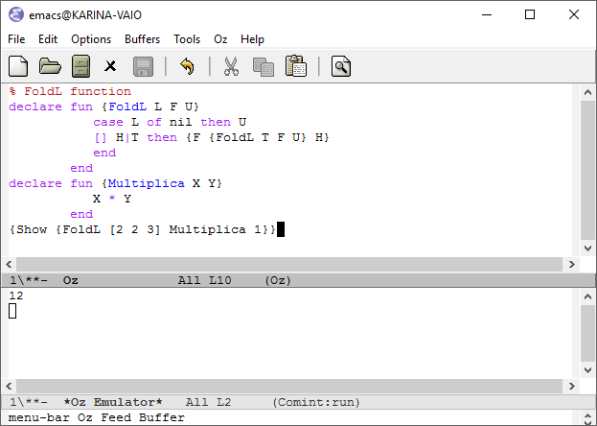

## FoldR

* 1. Código Oz

|  |
| --- |
| % FoldR function  declare fun {FoldR L F U}  case L of nil then U  [] H|T then {F H {FoldR T F U}}  end  end  declare fun {Suma X Y}  X + Y  end  {Show {FoldR [1 2 3] Suma 0}} |

* 1. Ejemplo de ejecución

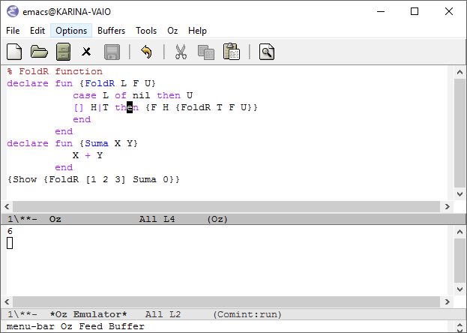

## 

## 

## Map

* 1. Código Oz

|  |
| --- |
| % Map function  declare fun {Map L F }  case L of nil then nil  [] H|T then {F H}|{Map T F}  end  end  declare fun {Potencia X}  X * X  end  {Show {Map [2 1 3 6] Potencia}} |

* 1. Ejemplo de ejecución

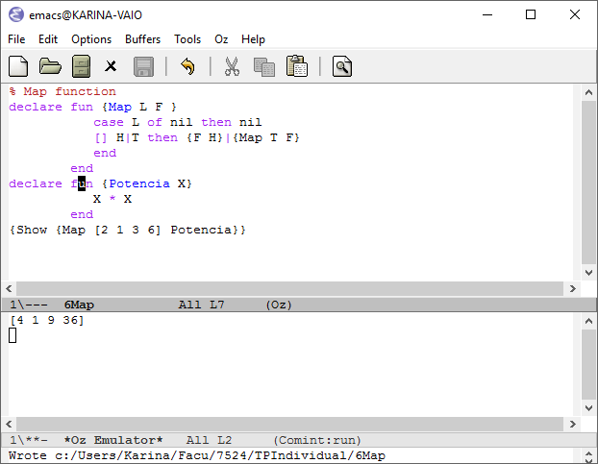

## Filter

* 1. Código Oz

|  |
| --- |
| % Filter function  declare fun {Filter L F}  case L of nil then nil  [] H|T then  if {F H} then  H|{Filter T F}  else  {Filter T F}  end  end  end  declare fun {Condicion X}  X > 2  end  {Show {Filter [2 1 3 6] Condicion}} |

* 1. Ejemplo de ejecución

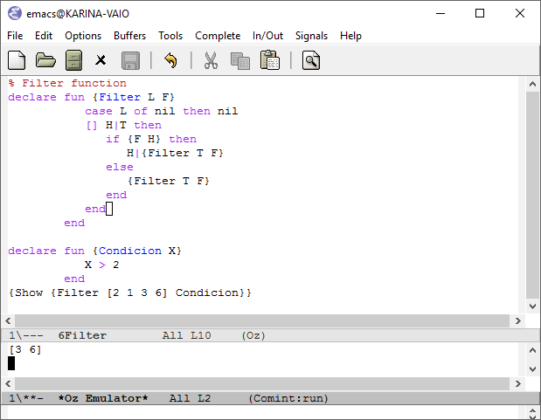

# Ejercicio 7) - Hilos

## WaitSome

* 1. Código Oz

|  |
| --- |
| local WaitSome in  WaitSome = proc {$ Xs}  local Y in  {ForAll Xs  proc {$ X}  thread {Wait X}  Y = true  {Show 'Valor Bindeado:'}  {Show X}  end  end  }  {Show 'Esperando por algun valor a bindear'}  {Wait Y}  {Show 'Al menos uno fue bindeado'}    end  end  {Show 'Primera lista los 3 valores bindeados'}  {WaitSome [1 2 3]}  {Show 'Segunda lista solo uno esta bindeado'}  {WaitSome [_ 2 _]}  {Show 'Tercera lista ninguno esta bindeado'}  {WaitSome [_ _ _]}  end |

* 1. Ejemplo de ejecución

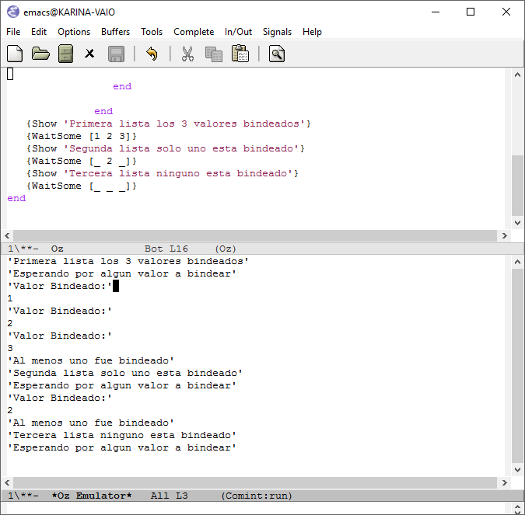

## Maquina abstracta

* 1. Código Oz

|  |
| --- |
| local A B C in  thread  if A then  B=true  {Show 'thread 1 A is true'}  else  B=false  {Show 'thread 1 A is false'}  end  end  thread  if B then  C=false  {Show 'thread 2 B is true'}  else  C=true  {Show 'thread 2 B is false'}  end  end  A=false  end |

* 1. Ejemplo de ejecución

Le agregué impresiones por pantalla para poder ver claramente el seguimiento del código. Vemos que se lanzan dos threads de ejecución, ambos comienzan con una sentencia if, la cual se suspende porque ni A ni B están definidos, entonces se suspende. En el momento de ejecutar A=false, el thread 1 se libera puesto que tiene asignado el valor de A y ejecuta la sentencia “B = false”. En consecuencia, B está definido por lo que la ejecución del thread 2 puede continuar y evaluar el if, para finalmente asignar el valor C=true.

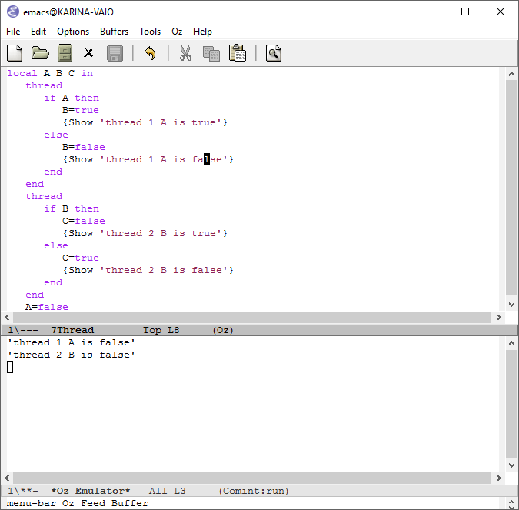

# Ejercicio 8) - Evaluación perezosa

## 8.1 Maquina Abstracta

* 1. Código Oz

|  |
| --- |
| local Ints in  local L in  local A in  local B in  local C in  fun lazy {Ints N}  {Show N}  N|{Ints N+1}  end  {Show 'Comienzo'}  L = {Ints 1}  {Show 'Asignacion de L'}  A = L.2.2.1  {Show 'Asignacion de A usando L'}  B = L.1  {Show 'Asignacion de B usando L'}  C = A+B  {Show 'Asignacion de C'}  {Show C}  end  end  end  end  end |

* 1. Ejemplo de ejecución

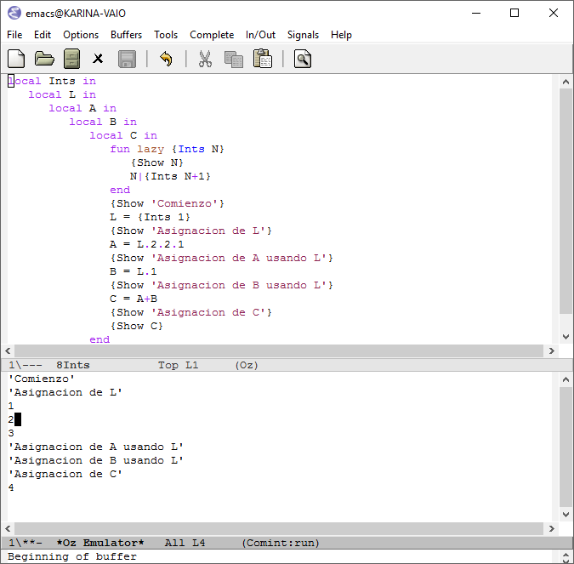

## 8.2 Reverse

* La diferencia en comportamiento es que la función Rev al ser lazy en la segunda implementación, solo va a ser ejecutada, cuando realmente sea necesario y no antes. Lo que ocurre es que como a su vez se encuentra dentro de otra funcion lazy, tambien va a ser ejecutada cuando necesitemos los valores de la lista y eso va a ocurrir al mismo tiempo, la necesidad de ejecución de una, en este caso fuerza a la ejecución de la otra.
* Ambas funciones retornan el mismo resultado, recién se ejecutan la función recursiva al hacer uso de los elementos de la lista. A continuación un ejemplo de ejecución:

Codigo oz

|  |
| --- |
| local Reverse1 Reverse2 A B C in  fun lazy {Reverse1 S}  fun {Rev S R}  case S of nil then  {Show R}  R    [] X|S2 then  {Show X}  {Rev S2 X|R}    end  end  in {Rev S nil} end    fun lazy {Reverse2 S}  fun lazy {Rev S R}  case S of nil then  {Show R}  R    [] X|S2 then  {Show X}  {Rev S2 X|R}    end  end  in {Rev S nil} end  {Show 'Comenzamos'}  A = [a b c]  {Show 'Antes de llamar reverse1'}  B = {Reverse1 A}  {Show 'Antes del Show B'}  % {Show {Reverse1 A}}  % {Show A}  {Show B}  {Show 'Antes del case'}  case B of K|_ then  {Show K}  end  {Show 'Antes de llamar reverse2'}  C = {Reverse2 A}  {Show 'Antes de Show C'}  %{Show {Reverse2 A}}  {Show C}  {Show 'Antes del case'}  case C of M|_ then  {Show M}  end  end |

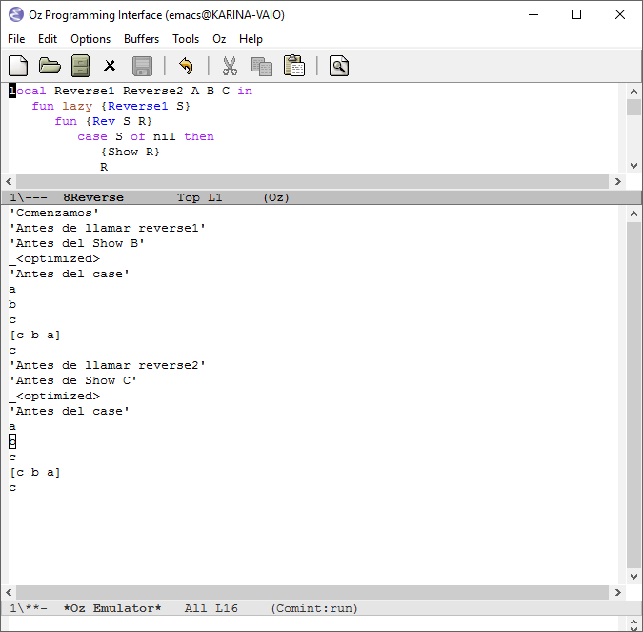

# Ejercicio 9) - Mensajes

* 1. Código Oz

|  |
| --- |
| declare P in  local S in  {NewPort S P}  thread {ForAll S proc {$ M} {Browse M} end} end  {Send P a}  {Send P b}  {Send P c}  {Send P 1}  end |

* 1. Ejemplo de ejecución

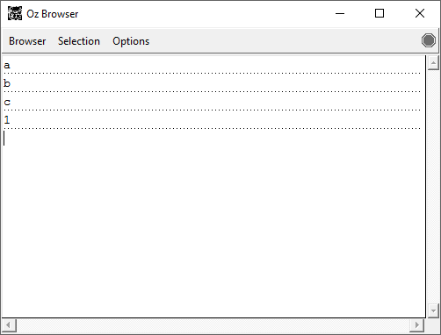

# 

# 

# Ejercicio 10) - Servidor de filtros

* 1. Código Oz

|  |
| --- |
| %funcion unaria  declare fun {EsPar A}  if (A mod 2 == 0) then  true  else  false  end  end  %P1 puerto donde envio todos los elementos  %P2 puerto donde envio solo los elementos que pasan el filtro  declare P1 P2 in  local S1 S2 in  {NewPort S1 P1}  {NewPort S2 P2}  thread {ForAll S1 proc {$ M}  if {EsPar M} then  {Send P2 M}  end  end} end  thread {ForAll S2 proc {$ M} {Browse M} end} end  {Send P1 1}  {Send P1 2}  {Send P1 3}  {Send P1 4}  end |

* 1. Ejemplo de ejecución

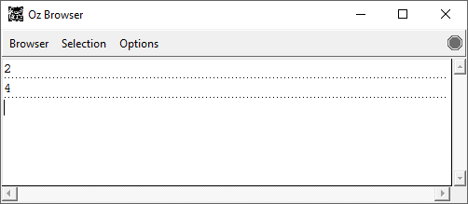

# Ejercicio 11) - Celdas de memoria

Explicación linea a linea

|  |  |
| --- | --- |
| declare  X={NewCell 0} | Declara la celda X y le asigna el valor inicial 0. |
| {Assign X 5} | A la celda X le asigna el nuevo valor 5 |
| Y=X | A la celda Y le asigna X, ambas variables son la misma y tienen el mismo valor. |
| {Assign Y 10} | A la celda Y e asigna el valor 10, también cambiará el valor de X porque es la misma celda que puedo acceder con dos identificadores. |
| {Browse {Access X}==10} | Pregunta si el valor de X es 10, lo cual es verdadero.  Imprime true |
| {Browse X==Y} | Pregunta si la celda X es igual a la celda Y, dado que son la misma celda, el valor es verdadero.  Imprime true |
| Z={NewCell 10} | Declara una nueva celda Z, le asigna el valor 10 |
| {Browse Z==Y} | Pregunta si la celda Z es igual a la celda Y, como son dos celdas diferentes la comparación es falsa.  Imprime false |
| {Browse @X==@Z} | Pregunta si el valor de la celda X, que es 10 es igua al valor de la celda Z que también es 10 son iguales, la condicion es verdadera.  Imprime true |