Due Wednesday, January 28, 2026 at 11:59 PM.
Homework 1 (total 100 points)
Please paste diagrams and SQL code scripts (SQL code needed only for question 3) into this Word document and upload this Word file with your answers to the HW1 assignment folder on Blackboard. Check the file after uploading it.
1. (40 points) Create a database diagram in MySQL Workbench based on the following rules (choose the appropriate data type for each attribute). Paste the diagram after this question.
AI Movie Rental Database
The AI Movie store asks you to create a database application system to assist with the administration of the store. The requirements collection and analysis phase has provided the following requirements for the database.
- The store stocks AI Movies that fall into the following categories - comedy, drama, education, artificial intelligence, nature and science fiction. Each category is identified by a unique identifier. A Movie can belong to one major category while each category has many Movies. For this HW, please consider each Movie as a unique physical Disk with a unique identifier. For example, the same Disk (for instance, with the same movie titled “AI education for all”), can be printed 99 times or more and each copy of the Disk is uniquely identified. Since customers will borrow each physical copy of the Disk, each copy should be tracked even though it could be the same movie with the same title.
- The data stored on the Movies for rent includes the Disk number, catalog number, title, year of creation, purchase price, daily rental rate. The Disk number of each physical Disk is created by the store manager and uniquely identifies each Disk. Think about how to show that each Disk can belong to only one category.
- The data stored on each customer renting AI Movies from the store includes customer number, date of joining the store, customer name (consists of first and last name as two separate attributes), address (consists of street, city, state, and zip code as 4 separate attributes), and one telephone number.
- Each customer may borrow an unlimited number of Disks, with the checkout date and the return date on each Disk. Each physical copy of the Disk can be borrowed by many customers over time. Each physical copy of the Disk may be borrowed only once by the same customer. Think about how to reflect this in the ER diagram.
- Data on sellers of Movies (from whom a store buys Disks) should also be stored, such as seller number, name, address (consists of street, city, state, and zip code as 4 separate attributes), and one telephone number. Date of Disk purchase by the store should also be tracked for each Disk (think about where to put date of purchase as an attribute). Each Disk has only one seller, but a seller can sell many Disks to the store.

- You may specify all the relationships as non-identifying (except for any many-to-many relationship)
- Save your MySQL diagram as image (File – Export - Export as png) and paste it here

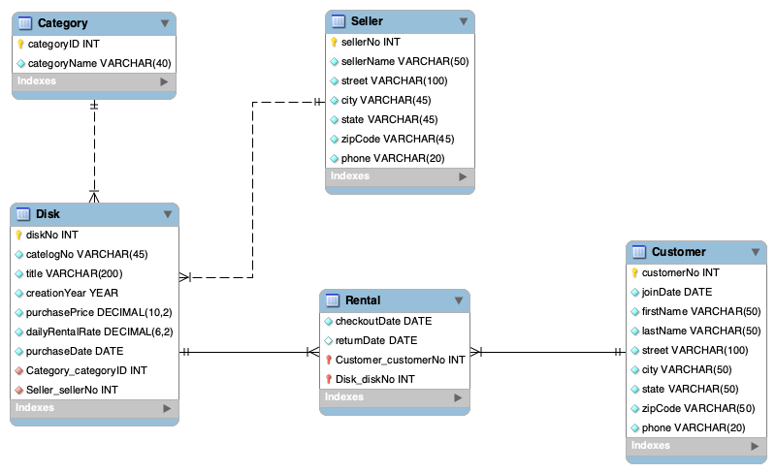

2. (30 points) Create a database diagram for student courses in MySQL workbench with the following rules (choose the appropriate data type for each attribute). Paste the diagram after this question.
Student Courses
- A student should register for at least one course (and can register for many courses) and a course should have one or more students
- A student table should have the following attributes: studentID as a primary key, and such attributes as firstName, lastName
- A course table should have the following attributes: courseID as a primary key, and such attributes as courseName, courseDescription
- Since the relationship between a student and a course is many-to-many, you need to add an intermediate table between them titled ‘Registration’ that would hold the appropriate foreign keys and an attribute Grade. For this ‘Registration’ table you need to correctly specify a composite primary key that consists of several foreign keys
- An instructor can teach one or many courses and a course is taught by at least one and at most one instructor
- An instructor table should have the following attributes: instructorID as a primary key, and such attributes as instructorFirstName, instructorLastName
- A classroom can be used by one or many courses, and each course is held in at least one and at most one classroom
- A classroom table should have the following attributes: classroomID as a primary key, and such attributes as classroomNumber, classroomCapacity
- Make sure all the foreign keys are in the correct tables
- You may specify all the relationships as non-identifying (except for any many-to-many relationship)
- Save your MySQL diagram as image (File – Export - Export as png) and paste it here
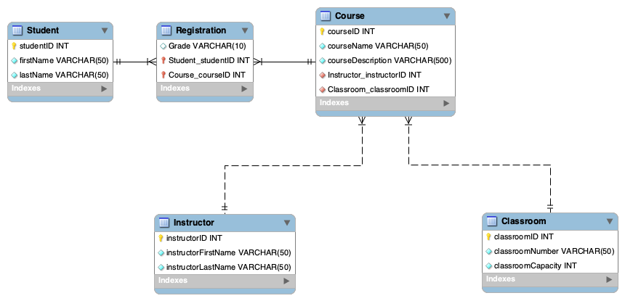
3. (30 points) Create a code to create tables based on your previous question design (code is needed only for Student Courses, question 2 database above) in MySQL Workbench, and run the code to create those tables (including the correct data types for each attribute). There is no need to insert any data into the tables but make sure all foreign keys and primary keys are correctly specified (similar to the lecture in week 1 and to self-paced Panopto video 2 – look at script create_university.sql)
Please copy the whole SQL script into this Word doc and upload your answers to all 3 HW1 questions as this Word document to the Blackboard Homework 1 folder

DROP DATABASE IF EXISTS university;
CREATE DATABASE university;

USE university;

CREATE TABLE Student
(
studentID INT PRIMARY KEY NOT NULL,
firstName VARCHAR(50) NOT NULL,
lastName VARCHAR(50) NOT NULL
);

CREATE TABLE Instructor
(
instructorID INT PRIMARY KEY NOT NULL,
instructorFirstName VARCHAR(50) NOT NULL,
instructorLastName VARCHAR(50) NOT NULL
);

CREATE TABLE Classroom
(
classroomID INT PRIMARY KEY NOT NULL,
classroomNumber VARCHAR(50) NOT NULL,
classroomCapacity INT NOT NULL
);

CREATE TABLE Course
(
courseID INT PRIMARY KEY NOT NULL,
courseName VARCHAR(50) NOT NULL,
courseDescription VARCHAR(500) NOT NULL,
instructorID INT NOT NULL,
classroomID INT NOT NULL
);

CREATE TABLE Registration
(
studentID INT NOT NULL,
courseID INT NOT NULL,
grade VARCHAR(10),
CONSTRAINT registration_pk PRIMARY KEY (studentID, courseID)
);

ALTER TABLE Course
ADD CONSTRAINT course_fk_instructor
FOREIGN KEY (instructorID) REFERENCES Instructor (instructorID);

ALTER TABLE Course
ADD CONSTRAINT course_fk_classroom
FOREIGN KEY (classroomID) REFERENCES Classroom (classroomID);

ALTER TABLE Registration
ADD CONSTRAINT registration_fk_student
FOREIGN KEY (studentID) REFERENCES Student (studentID);

ALTER TABLE Registration
ADD CONSTRAINT registration_fk_course
FOREIGN KEY (courseID) REFERENCES Course (courseID);

