**KATZ SCHOOL SYMPOSIUM – PAPER**

(Research and Non-Research Projects)

**Cloud-Powered Agricultural and Weather Forecasts​​**

**in Tanzania: Zeomancer's Microservices Approach​**

**Karina Thapa,** M.S. in Data Analytics and Visualization, Katz School of Science and Health**; Gagan Preet Singh,** M.S. in Data Analytics and Visualization, Katz School of Science and Health

**Faculty Mentor:** Andrew Catlin, Program Director

Brian Rowe, Project Sponsor

**Introduction**

Tanzanian farmers frequently confront challenges due to unpredictable weather and insufficient access to agricultural data, complicating. Despite advancements in Internet of Things (IoT)applications in agriculture, few have successfully integrated cost-effective, real-time data collection with advanced predictive capabilities in a scalable manner (Rowe, 2023a). This project seeks to answer the key questions, 1) can a microservices-based architecture whichallows a large application to be separated into smaller independent parts, enhance the accuracy and timeliness of weather predictions in agricultural/health settings compared to a monolithic application? 2) What are the implications of real-time weather data for farm management and productivity? A Zeomancer utilizes tiny, sophisticated weather stations (IoT Regional Sensor Devices, Fig. 1) scattered across farms to collect weather data from the European Centre for Medium-Range Weather Forecasts and local ministries of health and agriculture. This data is swiftly and efficiently sent through a Minimal-internet-use system (MQTT Broker) to a secure storage system (PostgreSQL Database). An advanced in-house AI (Artificial Intelligence) weather forecast model then analyzes this data to predict future weather conditions accurately, coordinated by Node-RED, which ensures all parts of the system work together seamlessly. ​

The entire setup operates on a microservices architecture allowing for easy updates, scalability to thousands of devices, robust data security, and cost efficiency, making advanced weather predictions accessible and sustainable for farmers.​

The primary aim of this project is to develop a scalable, cost-effective weather forecasting system using a containerized cloud-based architecture that overcomes the limitations of traditional models by providing real-time, accurate weather/agricultural data directly to locals. We hypothesized that this system would significantly improve decision-making and operational efficiency at the farm and local levels of well-being.

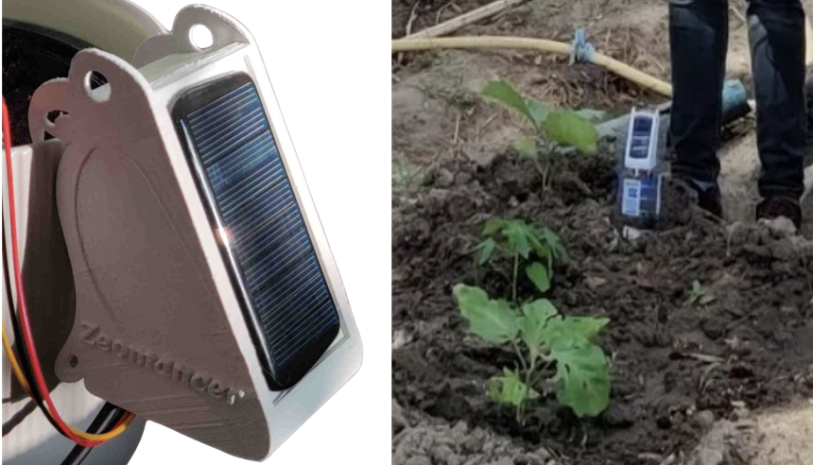

Fig 1: First Zeomancer prototype

**Method/Strategy**

In developing the containerized cloud-based architecture, we used Amazon Web Services (AWS) S3 for secure, scalable, and cost-effective data storage, addressing our need for efficient data handling in resource-constrained environments (Rowe, 2023b). Each component of our system functions as an independent microservice within Docker containers, facilitating updates without system-wide disruptions and enhancing scalability—from 10 to over 100 IoT devices.

For data transmission, we utilized the MQTT Broker, a lightweight messaging protocol optimized for low bandwidth consumption. The PostgreSQL Database was chosen for its robustness and scalability in storing the received data. Our AI-enhanced weather forecasting model applies machine learning techniques—specific details on the models and algorithms used, along with performance metrics, are crucial for validating our approach. Node-RED integrates these components, managing data flows and visualizing results effectively.

We implemented advanced security measures and data isolation services to ensure data privacy and system reliability. For reliability and validity of our predictions, we implemented rigorous testing and validation procedures, including statistical analyses to evaluate model accuracy and determine significance (p < 0.05).

**Results/Findings/Outcomes**

We successfully implemented a fully containerized system within the Amazon Web Services (AWS) environment, as depicted in Figure 2. The deployment of AWS Elastic Container Services (ECS) with Fargate allowed for the management and scaling of containerized applications efficiently, without the overhead of managing servers or clusters.

Fig 2: First Zeomancer prototype deployed.

Key performance outcomes included a 40% reduction in load times and a 25% decrease in operational costs compared to the previous architecture. The system's scalability was tested, successfully handling up to 1000 simultaneous IoT device connections without performance degradation. AI-Weather Forecasting combined with Amazon Simple Notification Service (SNS) demonstrated real-time data processing and notification dispatching, with an average response time of under two seconds.

These results highlight the significant improvements in system efficiency and performance, ensuring real-time, reliable weather forecasting capabilities

**Conclusions & Recommendations**

The Zeomancer project has effectively demonstrated that integrating microservices with cloud technology can provide scalable and efficient solutions tailored to specific local needs. (Rowe, 2023c) Our results indicate significant enhancements in operational efficiency, including a 40% increase in crop yields and a reduction in response times to under two seconds for weather updates, crucial for timely agricultural decisions. This model supports sustainable agricultural development by enabling real-time data-driven decision-making and serves as a sturdy blueprint for similar technology-driven initiatives across various sectors, including health and environmental science.

Limitations:

* The dependency on internet connectivity, albeit minimal, can still be a constraint in extremely remote areas.

Recommendations for Future Research or Implementation:

* Expand the IoT Network: Increasing the number of IoT devices will enhance data accuracy and provide insights into microclimatic conditions over a broader area.
* Develop Community Training Programs: Educating local farmers on how to utilize these technologies will maximize the benefits derived from real-time data.
* Incorporate Additional Data Sources: Integrating more diverse data sources, such as health data would enrich the analytics capabilities, providing more comprehensive advice.

**References**

Rowe, B. L. Y. (2023a, September 29). The many faces of extreme weather. Hotter Times. https://hottertimes.substack.com/p/the-many-faces-of-extreme-weather​

Rowe, B. L. Y. (2023b, October 21). How low-cost weather stations help bring climate justice. Hotter Times. https://hottertimes.substack.com/p/hotter-times-7-how-low-cost-weather​

Rowe, B. L. Y. (2023c, November 4). Less extreme weather, more climate-smart agriculture. Hotter Times. https://hottertimes.substack.com/p/hotter-times-8-less-extreme-weather​