1. **Airport and date schedule**

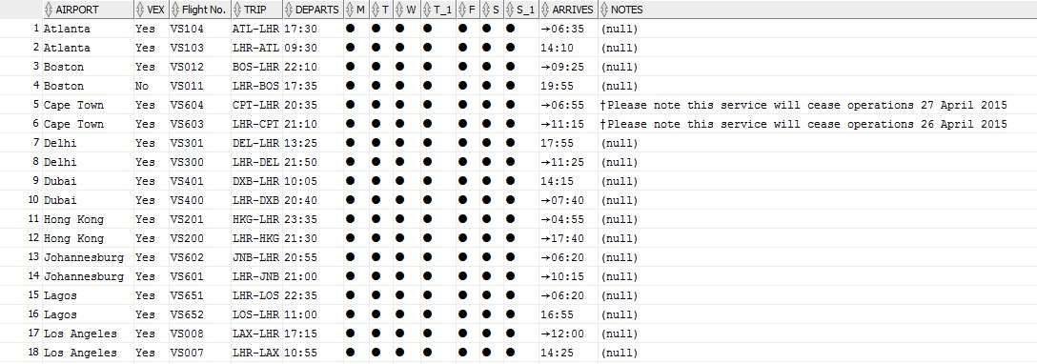

1. **Country and date schedule**

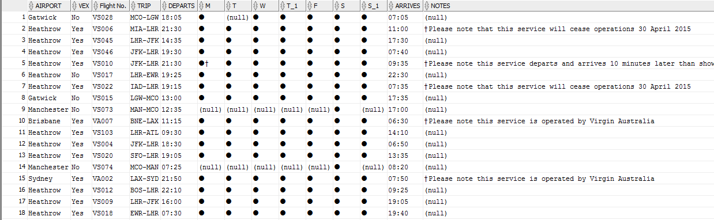

1. **Daily shipments report**

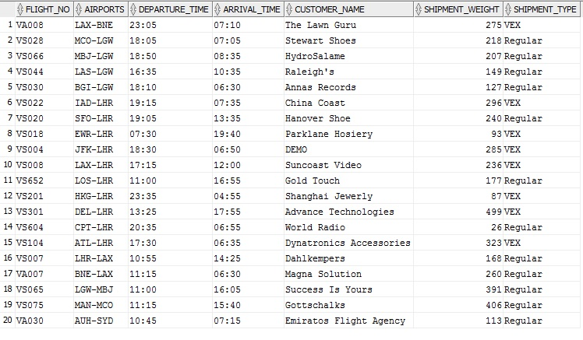

1. **Full flight departure schedule**

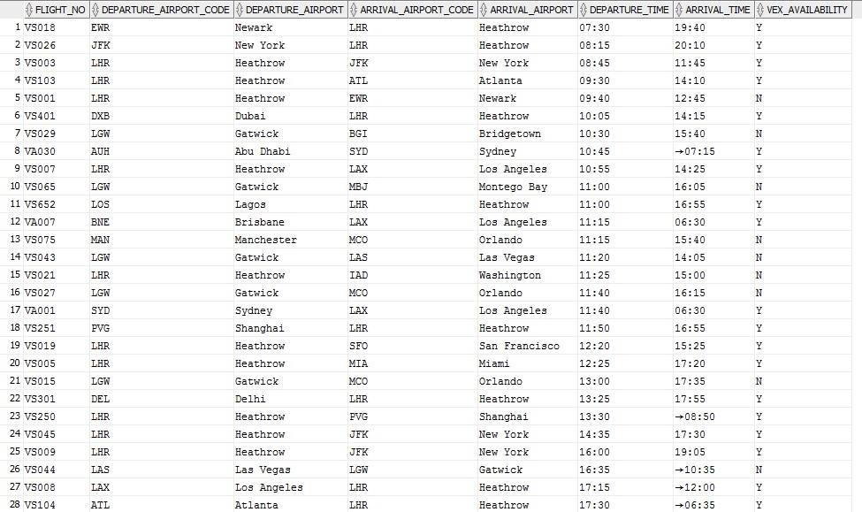

1. **Full flight arrival schedule**

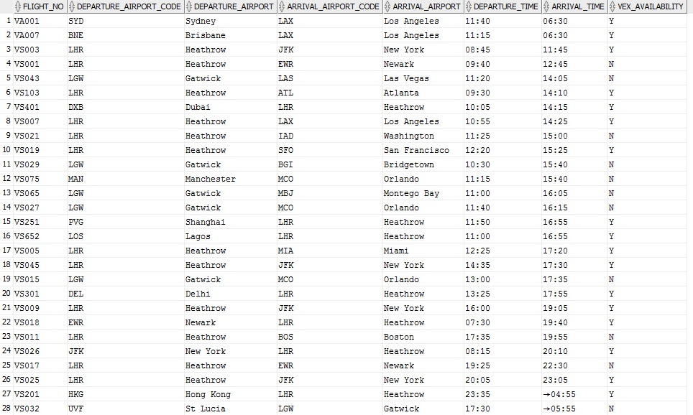

1. **Revenue report by flight**

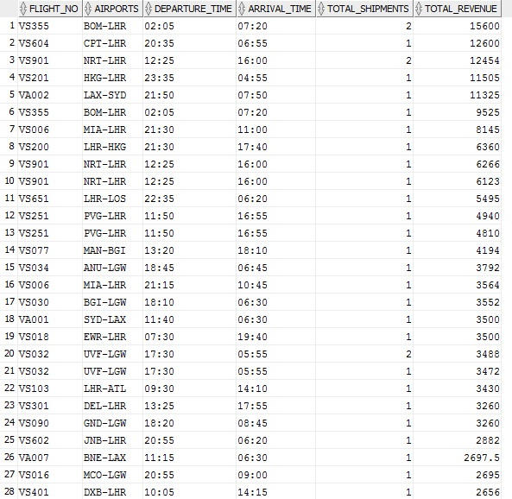

1. **Revenue report by day of week**

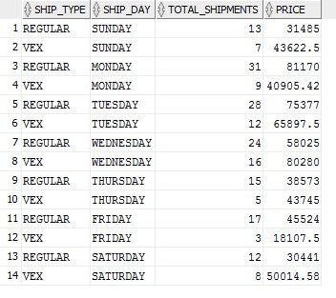

1. **Flag costumer for discount**

