Note: screenshot at 150% zoom

**Uncertainty of Neural Networks**

**and**

**Out-of-Distribution**

**Detection**

**Deep Generative Models**

**for Drug Design and Response**

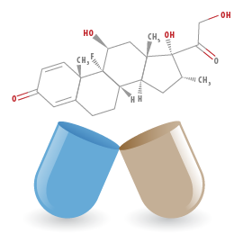

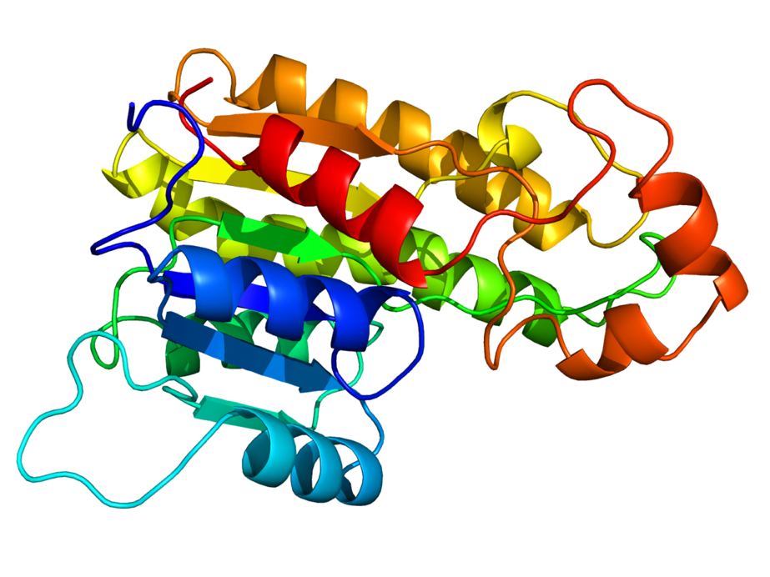

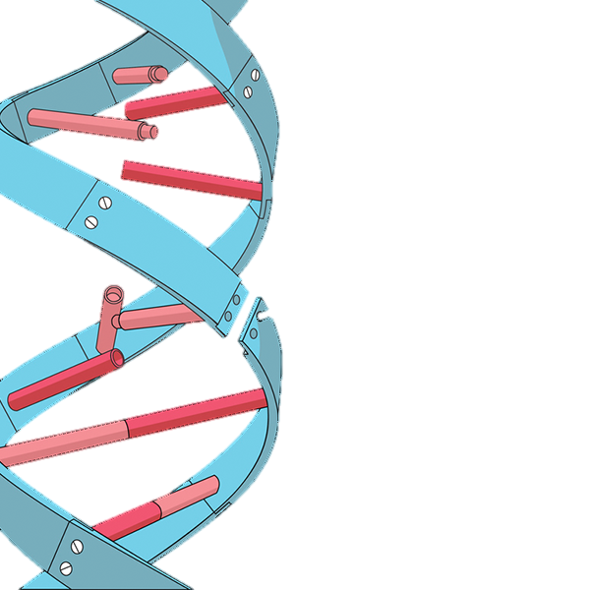

**Mechanisms of**

**DNA Repair and Genome Maintenance**

**Feedback Generative Adversarial Network**

**(FB-GAN) for**

**Protein Sequence**

**Generation­**