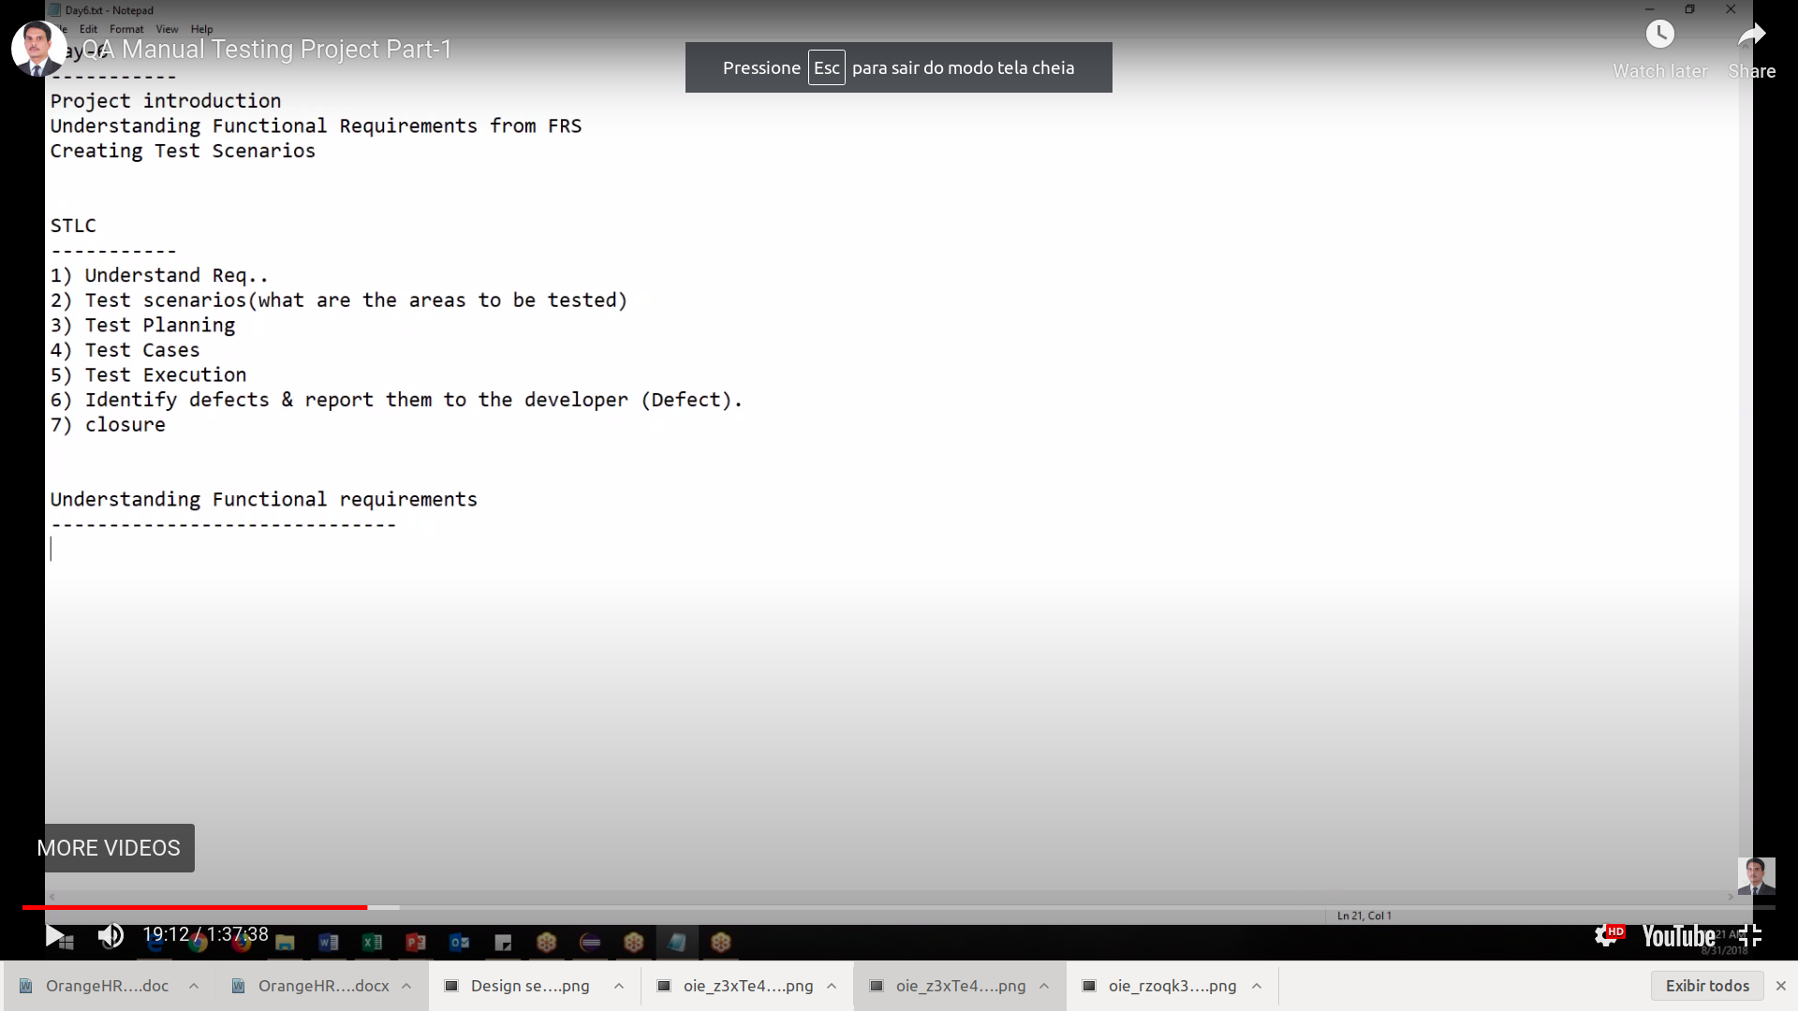
1) Documentacao usada:
https://web.kamihq.com/web/viewer.html?state=%7B%22ids%22%3A%5B%221LG7y95I-jxOYyjjSP-xCEVaXteoW08zF%22%5D%2C%22action%22%3A%22open%22%2C%22userId%22%3A%22113040722051958270199%22%7D&filename=null&kami_user_id=11763662
2)Test Planing
2)Usar tabelas de decisão
3)Usar BDD com cypress

1)Understading documentation:
3.0 My info module
criar user stories:
An ESS-User can only edit certain fields in the ESS Module, maintaining the security and confidentiality of employee information.

