**Project Scenario**

Mint Classics Company, a retailer of classic model cars and other vehicles, is looking at closing one of their storage facilities.

To support a data-based business decision, they are looking for suggestions and recommendations for reorganizing or reducing inventory, while still maintaining timely service to their customers. For example, they would like to be able to ship a product to a customer within 24 hours of the order being placed.

**ANALYSIS:**

1.Customer Count by Country:

* From the below output we can observe that total customer count of each country level. Here we can get USA and Germany having higher level count.

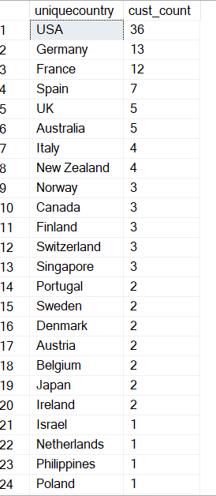

* An also we can observe that total order count from each country wise. Spain ang Germany having maximum order count.
* It shows the which customer did much payment of order;

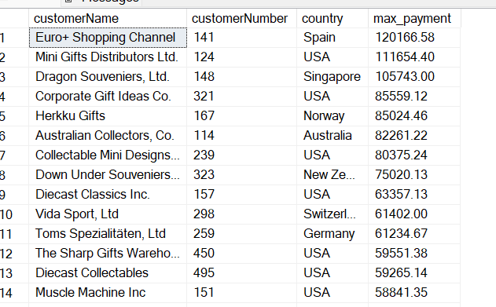

2.Order Count by Year:

* Here we are getting 2004 and 2003 are having higher order count from the data base.

* The below output is to extracted month wise orders, mostly order recorder on year end .

* The below output shows the total number of statuses count.

* Where are items stored and if they were rearranged, could a warehouse be eliminated?

* We can observe that **warehouse B** and **warehouse C** storing the same product, so we can move it into any of one warehouse to make any warehouse free. And **Classic cars and Vintage cars** having more selling profit so we can restore these products.

* How are inventory numbers related to sales figures. Do the inventory counts seem appropriate for each item?
* This part of the question is asking about the correlation or connection between the quantity of products in inventory and the number of products sold over a specific period (sales figures).

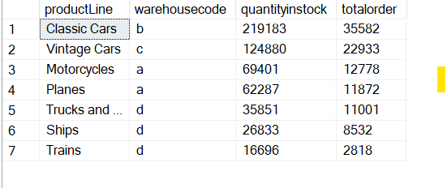

* Are we storing items that are not moving? Are any items candidates for being dropped from the product line?



* From the above screenshot ,its shows the not ordered item is Toyota supra
* 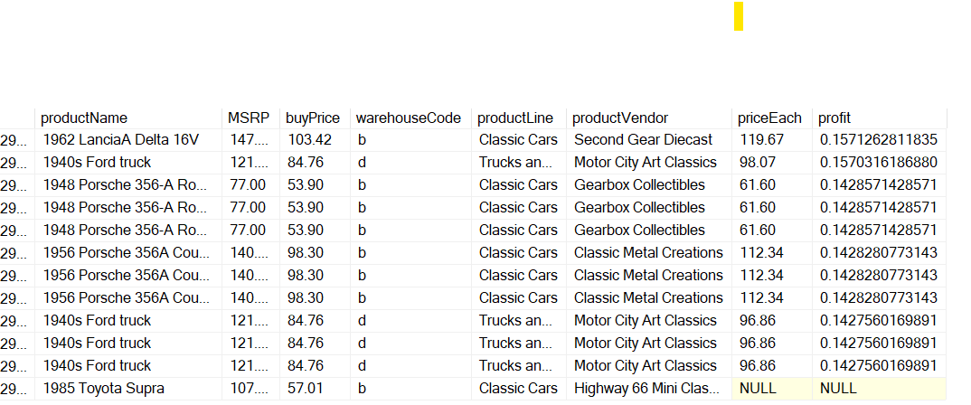We can observe that the Toyota Supra not in order list and its not making any payments , and also its not having any profit ,we can drop that item from warehouse;