Object-Oriented Programming in Java
MISM/MSIT 95-712
Homework 5

- We are now ready to extend the Algebra project by writing code that will produce randomly generated expression trees of various sizes and shapes. So that everyone is working from the same starting place, you can base your code for this problem on the “standard” Algebra project, which I’ll make available through Blackboard. You are totally free to use your own code; your code might be better!

The UML class diagram at this point looks like this:

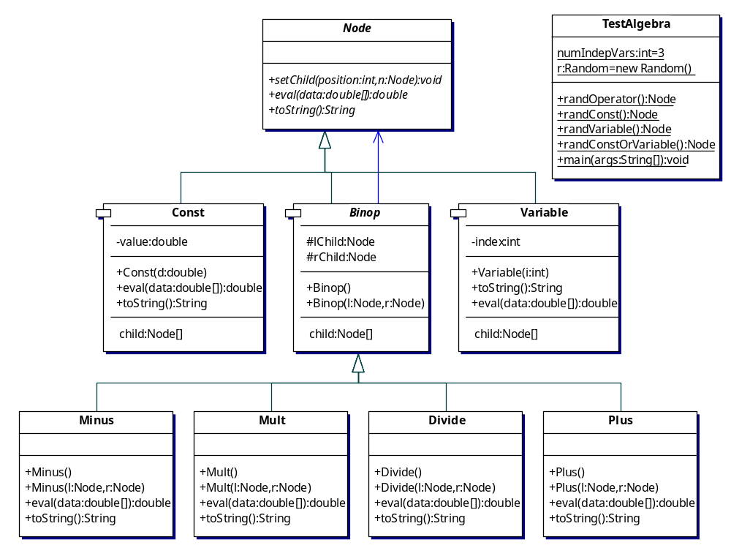

Note that should be an abstract class, for reasons that should become apparent later.

In this step, you will add the method addRandomKids(), first as an abstract method in Node, and then as a concrete method in Const, Binop, and Variable. AddRandomKids() will have the responsibility of adding new child nodes to a tree, until a specified maximum tree depth is reached. addRandomKids() is easy for Const and Variable. It does nothing at all! This is because objects of these two types are terminal nodes; they can only appear at the “bottom” of a tree.

addRandomKids() for Binop is a little bit trickier. To generalize the code as much as possible (for future extensibility), you will create two new factory classes, OperatorFactory and TerminalFactory. Think of these as factories that can supply a Node object when asked. OperatorFactory will have a method getOperator() that supplies one of Plus, Minus, Mult, or Divide, at random. TerminalFactory will have a method getTerminal() that provides either a Const or a Variable, again at random.

The OperatorFactory needs to know the set of binary operators to choose from. So, its constructor will take as an argument a Node[] array that contains one of each of the four types of Binop. It then stores the array as a member variable. When OperatorFactory is asked (through its getOperator() method) to supply an operator, it will randomly choose one of the Binop nodes from its array and return a clone of this node. This implies that the top-level Node class will have to implement the Cloneable interface, as will be described in the lecture. (The code for Node’s clone() method is exactly the same as that shown for SimpleClass in the lecture notes.) This is why Node goes back to being an abstract class. Since all of our other classes derive from Node, they will be Cloneable also, with no additional work on our part.

TerminalFactory only needs to know the number of independent variables, so its constructor takes this number (call it numIndepVars) as an int argument, and stores it as a member variable. The getTerminal() method chooses a random number between 0 and numIndepVars. If this random number is less than numIndepVars, a Variable node is created whose index is the random number. Thus the index held by a Variable object will lie between 0 and numIndepVars-1. If the random number equals numIndepVars, a Const node is returned (with its value a random double in [0, 1}.

Now for the Binop method addRandomKids(). This method needs to be supplied with (i.e., has as arguments) an OperatorFactory object, a TerminalFactory object, an int specifying the maximum tree depth, and a Random object (a single Random object will be created for the entire program, and passed around as necessary). To ensure that the trees created don’t get too large, each and every Node will now hold an int (call it depth) that records how far down in the tree it is. When a Node object is first created (i.e., by its constructor), it has depth zero. When a Node is added to a tree, its depth variable is set to be one larger than that of its parent.

When the addRandomKids() method is called for a Binop node n, it works like this:
- If n’s depth is equal to maxDepth, the tree shouldn’t be enlarged any further. Set both its left and right children to be terminals (i.e., call getTerminal() for both, and set the depth of these new terminals to n’s depth plus 1.
- Otherwise, the tree continues to grow. First add a left child, by choosing a random number between 0 and (numOperators + numIndepVars).
- If this number is less than numOperators, add a new operator as the left child (by calling getOperator()). Set the new child’s depth to one larger than n’s depth. Then call the new child’s addRandomKids() method. This is the recursive step that keeps the tree building process going. The recursion stops when a terminal is created, since the addRandomKids() for terminal types returns immediately, having done nothing at all.
- Otherwise, add a terminal as the left child (by calling getTerminal()) Again, set the new child’s depth appropriately..
- Repeat this process for the right child.

In summary, here are the classes and methods you need to produce:

public class OperatorFactory {
private Node[] currentOps;
OperatorFactory(Node[] n) {//add }
public Node getOperator(Random rand) {// add}
public int getNumOps() {// add }
}

public class TerminalFactory {
private int numIndepVars;
TerminalFactory(int n) {// add }
public Node getTerminal(Random rand) {// add}
public int getNumIndepVars() {// add}
}

In Node:
public Object clone() {// add}
public abstract void addRandomKids(OperatorFactory o,
TerminalFactory t, intmaxDepth, Random rand);

In Binop:
public void addRandomKids(OperatorFactory o,
TerminalFactory t, int maxDepth, Random rand) {// add}

In Const and Variable:
public void addRandomKids(OperatorFactory o,
TerminalFactory t, int maxDepth, Random rand) {}

Here is my class TestAlgebra:
import java.util.*;

public class TestAlgebra {
static int numIndepVars = 3;
static int maxDepth = 5;
static Random rand = new Random();
public static void main(String[] args) {
double[] data = new double[3];
data[0] = 3.14;
data[1] = 2.78;
data[2] = 1.0;
Node[] ops = {new Plus(), new Minus(), new Mult(), new Divide()};
OperatorFactory o = new OperatorFactory(ops);
TerminalFactory t = new TerminalFactory(numIndepVars);
Node root = o.getOperator(rand);
root.addRandomKids(o, t, maxDepth, rand);
String s = root.toString();
System.out.println(s + " = " + root.eval(data));

}
}
This produces, on two successive runs:
(X0 - ((X0 + X2) - ((((X2 - X1) / X2) + ((0.6643226248148392 - X2) * (X0 / X1))) * ((X0 / X1) / ((X1 * 0.35270021072871505) - (0.8091377155646736 / X1)))))) = -4.537237792628336

((((X0 + (0.3210808107861137 - X2)) * (0.36531662741100246 + X2)) * X2) + (0.4765980340813758 - ((X1 - (X2 * X2)) + 0.75953773359674))) * (((((0.8395647772434062 - 0.7621193511598635) + 0.3617947763651407) / 0.3067093770466125) + X2) + X2)) = 4.452178301700404

(You might consider making these doubles print out with fewer digits after the decimal point. I should too!)

One big tip: Make sure you’ve imported java.util.* everywhere, so that the Random class is known.

Submit to Bb in the usual way.

2. It’s time to plan ahead. If we try to process more trees in our main() method, it will get unwieldy and hard to maintain. A simplistic rule of thumb is that main() shouldn’t have more than about 20 lines of code in it. It should make a few objects, and then tell them to “go about their business.”

One way to add useful encapsulation is to create a GPTree class that consolidates some of the functionality of trees. Currently, the Node class and its subclasses know how to do things, but a tree class that encapsulates the root node of a tree will be useful.
You might be frustrated when you look at the GPTree class, since it really doesn’t do anything new (at least for now). It just passes off responsibilities to other objects. But I think it’s a necessary step in our progress, even if its usefulness may not become apparent until later. This is the object-oriented way. Here is a description of this class:

public class GPTree {
private Node root;
private int mySize;
GPTree() { root = null; }
GPTree(OperatorFactory o, TerminalFactory t, int maxDepth, Random rand) {
root = o.getOperator(rand);
root.addRandomKids(o, t, maxDepth, rand);
}
public String toString() { return root.toString(); }
public double eval(double[] data) { return root.eval(data); }
// The following requires that you add the mySize() method
// to Node and all its subclasses. The size of a node is 1 +
// sizeof left child + size of right child.
public int mySize() { return root.mySize(); }
}

If you’ve completed part 1 of this homework, this part is supposed to be insanely easy. Just add the class GPTree to your project, and modify your test class to this:

import java.util.*;

public class TestAlgebra {
static int numIndepVars = 3;
static int maxDepth = 5;
static Random rand = new Random();
public static void main(String[] args) {
double[] data = {3.14, 2.78, 1.0};
Node[] ops = {new Plus(), new Minus(), new Mult(), new Divide()};
OperatorFactory o = new OperatorFactory(ops);
TerminalFactory t = new TerminalFactory(numIndepVars);
GPTree gpt = new GPTree(o, t, maxDepth, rand);
System.out.println(gpt + " = " + gpt.eval(data));
}
}

The main() method of the test class is only a tiny bit shorter, but is ready to be extended to create multiple GPTrees in the next version.

Submit to Bb in the usual way. If you run your program many times, you might see that a GPtree that evaluates to Infinity, if a divisor in a Divide class object evaluates to zero. You’ll earn no extra points, but my sincere admiration, if you can suggest a way out of this problem. Put a comment near the beginning of your code that explains your solution and its rationale.

