

# TINYTOTS

**Supervisor:** *NGUYỄN HẠ VY*

**Semester:** *01*

**Batch No:** *T1.2208.M2*

**Group No:** *05*

|  |  |  |
| --- | --- | --- |
| **Order:** | **Full name** | **Roll No.** |
| *1.* | *VÕ MINH TIẾN* | Student1381867 |
| *2.* | *NGUYỄN MẠNH CHIẾN* | Student1414353 |
| *3.* | *HUỲNH HỮU KHA* | Student1414349 |
| *4.* | *ĐỔ HUỲNH NGUYÊN TÂM* | Student1414231 |

***Month****: 11* ***Year****: 2022*



This is to certify that

**Mr. VÕ MINH TIẾN Mr. NGUYỄN MẠNH CHIẾN Mr. HUỲNH HỮU KHA**

**Mr. ĐỔ HUỲNH NGUYÊN TÂM**

Have successfully Designed & Developed

# TINYTOTS

Submitted by:

**Ms. NGUYEN HA VY**

Date Of Issue:

Authorized Signature:

# Content

Content Acknowledge Synopsis

Review 1

Review 2

Review 3 ..

Tasksheet ..

# Acknowledge

As we understand that the eProject is a step-by-step learning environment that closely simulates the classroom and Lab-based learning environment into actual implementation. It is a project implementation at your fingertips!! An electronic, live juncture on the machine that allows you to.

* Practice step by step i.e. laddered approach.
* Build a larger more robust application.
* Usage of certain utilities in applications designed by user.
* Single program to unified code leading to a complete application.
* Learn implementation of concepts in a phased manner.
* Enhance skills and add value.
* Work on real-life projects.
* Give a real-life scenario and help to create applications that are more complicated and useful.
* Mentoring through email support.

First of all, I would like to thank India Aptech for allowing my team to work on this fantastic eProject. We have had a wonderful experience with this eProject.

Secondly, We would like to express our special thanks to our mentor, Ms. Ha Vy for the time and effort that she has provided throughout the project. Her helpful advice and suggestions were beneficial to us during completion of the project. In this respect, we are forever grateful to you.

Thirdly, although several mistakes were made during the project, it has given us the opportunity to develop and we hope to have more opportunities to widen our knowledge in the web-developing world.

We will continue to learn and improve ourselves even more in the future.

Yours Sincerely, Team Group 05.

# Synopsis

The Objective of this program we aim is to give a sample project to work on real- life projects. These applications help us build a larger more robust application.

The objective is not to teach us HTML/JavaScript but to provide us with a real-life scenario and help us create basic applications using the tools.

Hence, we can revise the chapters before we start with the project.

This project is meant for students like us who have completed the module of HTML5. These programs should be done in the Lab sessions with the assistance of the faculty if required.

The website (in this project) is a tool that brings everything in the world to you such as historic monuments information natural knowledge and skill in technology...

It is very essential for us that will have a clear understanding of the subject. We think we should go through the project and solve the assignments as per the requirements given.

And get back [***eprojects@aptech.ac.in***](mailto:eprojects@aptech.ac.in) as the assigned schedule.

## Problem Definition

Madam’s Boutiqueis the leading store of branded and designer clothes for women.

The boutique has tie up with various designers whose collection is on their display.

Also different apparel, accessories collection is also available with the store. The

website must be designed for this boutique showing the collection of clothing of

various brands, designer, unstitched garments. A website needs to be developing for

the boutique which must display all the collection.

The website is to be developed for the Windows Platform using HTML5, JavaScript

and Geolocation. The site should work well in all leading browsers including Chrome,

IE, Firefox etc.

The Web site is to be created based on the following requirements and pages

1. Pages:

a. Homes

b. About us

c. Products: Should be further categorized into

i. Baby care

ii. Fashion

iii. Toys

iv. Wellness & hygiene

d. Brands

e. Stores

f. News

g. Become franchise: If someone wish to be partner with them , related information needs to be included here.

h. Resources: Contact us & FAQs should be included here.

2. The Home Page should be created making use of Sections with a suitable logo, the header section can be added which will show images of various product images.

3. The site must contain the links to navigate through any category for the information.

4. The site should display a menu which will contain the options for brief introduction about the various products available, location of the shop and any other information if required.

5. The information should be categorized according to the brand names of the products like if a User wants to see only “funskool” products or any other company products then he/she can click on a Link/button/menu etc and can see only that Brand products.

6. When a user selects any particular brand, a list of products for that brand will be displayed

7. A brief summary of features of the products should be displayed on the Web Page along with the picture but detailed Features should be stored in Individual Word documents which can be downloaded or viewed by the User who wishes to see the same.

8. The user should also be able to compare the various products of different as well as similar brands.

9. “Contact Us” will have the Address of the Company which should be displayed using GeoLocation API (eg. GoogleMaps) and the email address which when clicked will invoke the local mail client from where they can send an email.

## Customer Requirements Specifications

### User:

#### input:

* Information on search.
* Data of registered members.
* Feedback to the webmaster.

#### Process:

* Find the searching
* Check the data of registered members.
* Check the feedback of users.

#### Output:

* Result of searching.
* Confirm the data of registered members.
* Confirm the feedback of the users.

### Hardware/ software requirement:

#### Software:

* + Notepad/HTML editor
  + Dreamweaver
  + IE 5.0/ Netscape 6.0

#### Hardware:

* + A minimum computer system that will help you access all the tools in the courses is a Pentium 166 or better
  + 64 Megabytes of RAM or better

|  |  |
| --- | --- |
| **Document Name**:  Architecture and design of the project | **SWD/Form** No.03/ARD/Ver1.0 |
| **Version** 1.0 | **Page 3** |

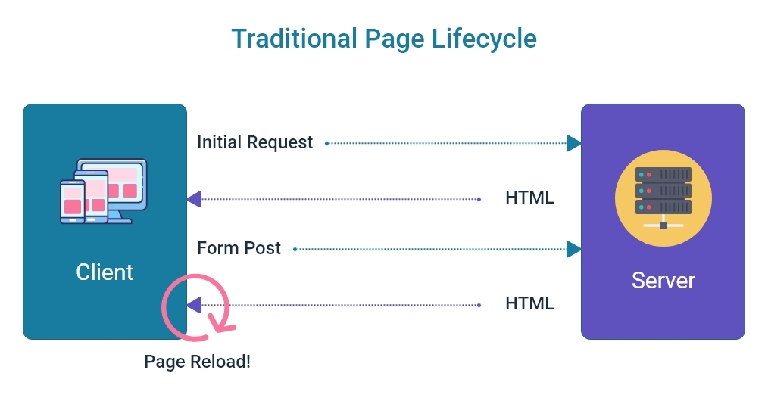

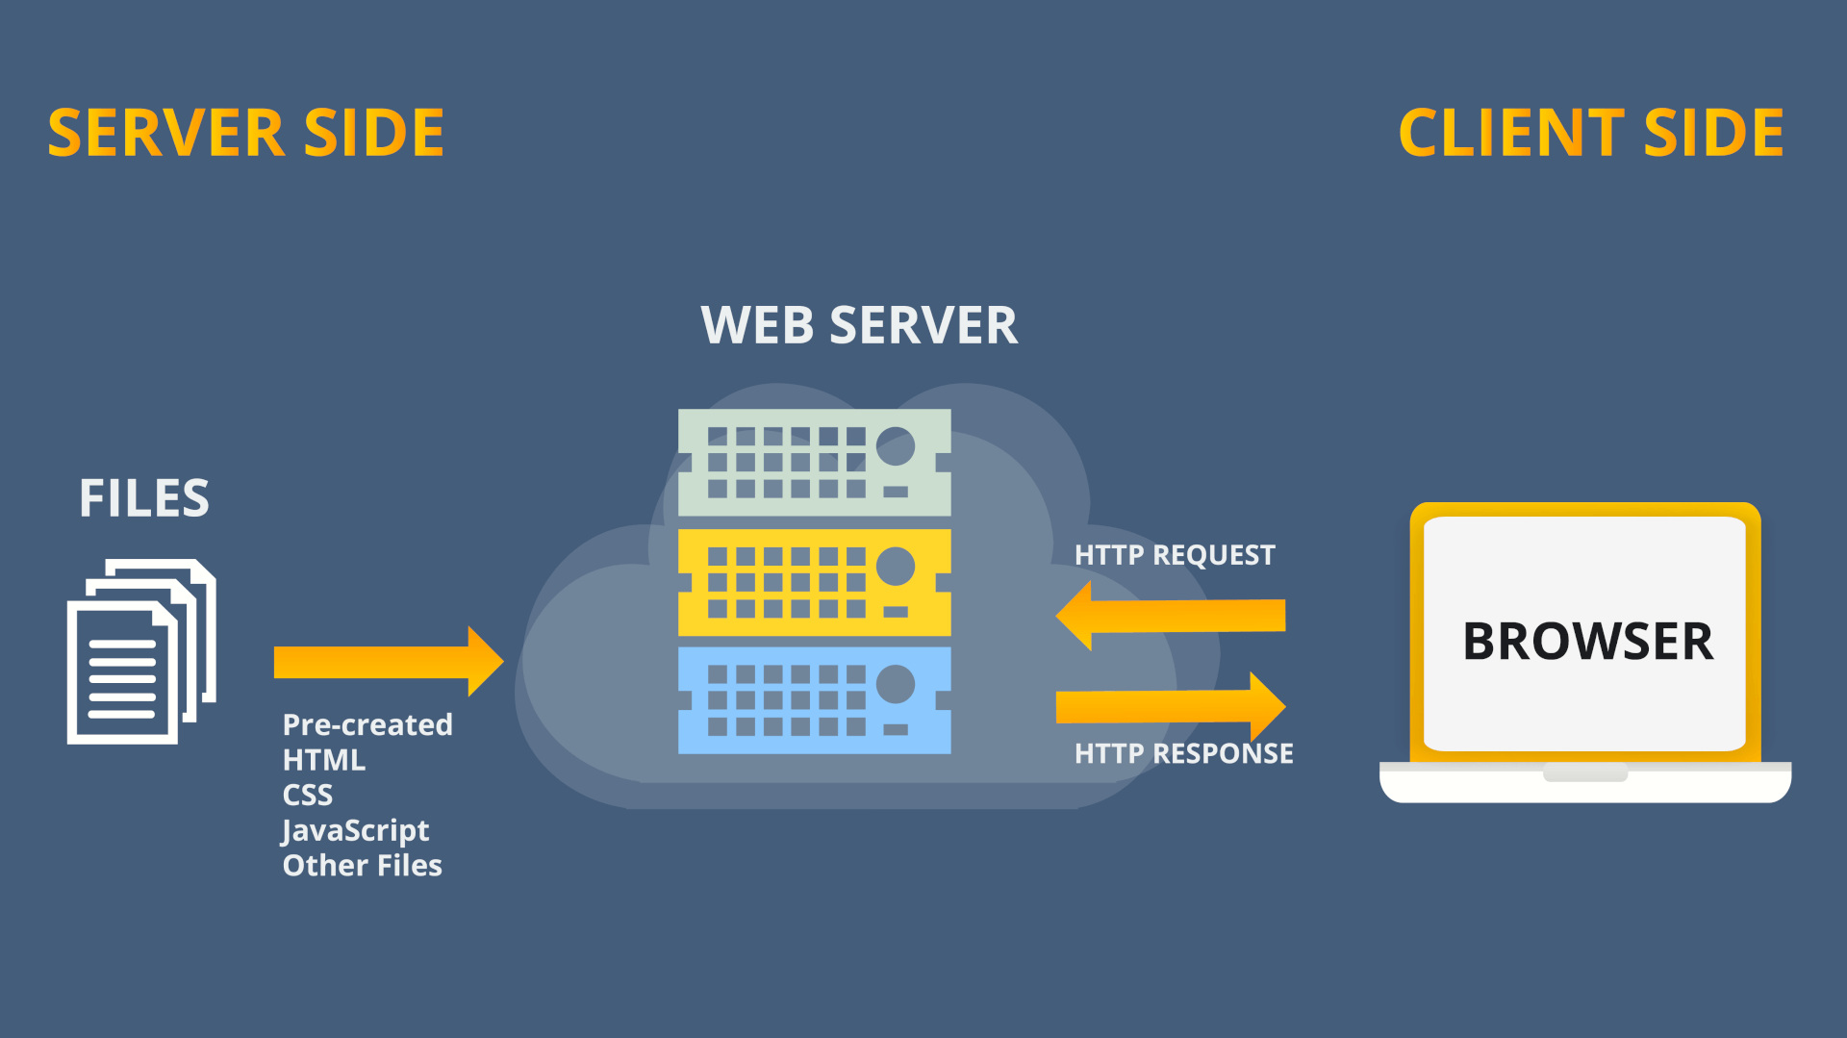

Home

Register/Login

Contact us

About us

Categories

Login

Register

Product Details

Compare products

Add to cart/View

Checkout

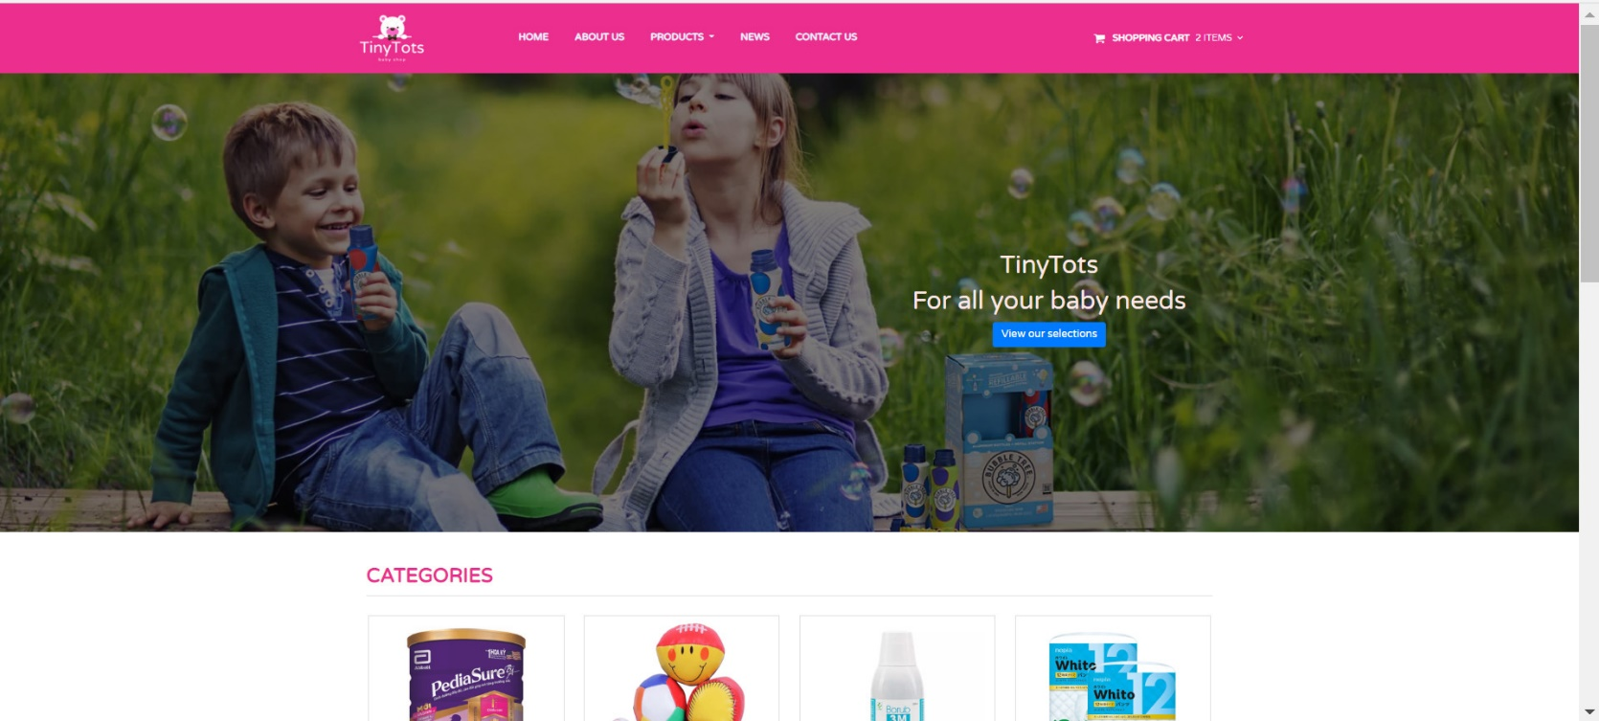

**Home Page**

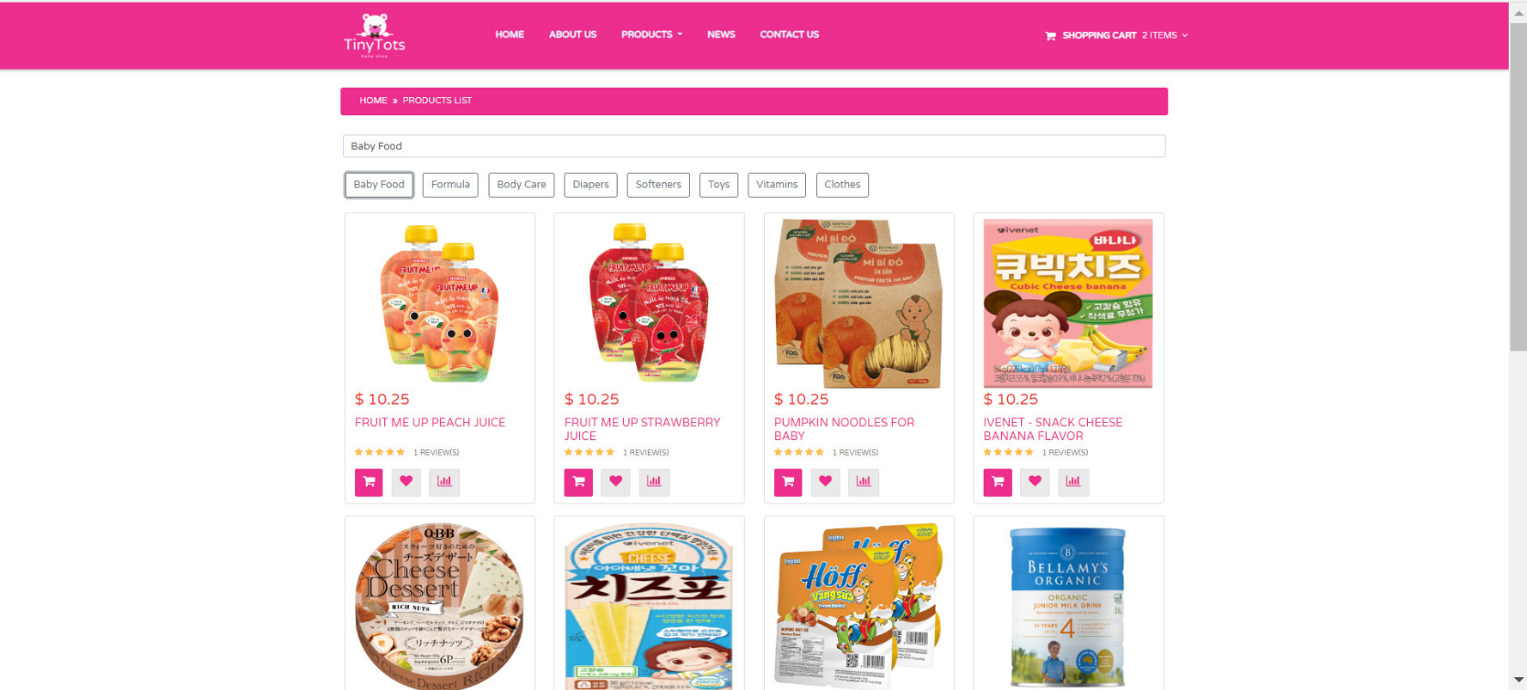

**Categories Page**

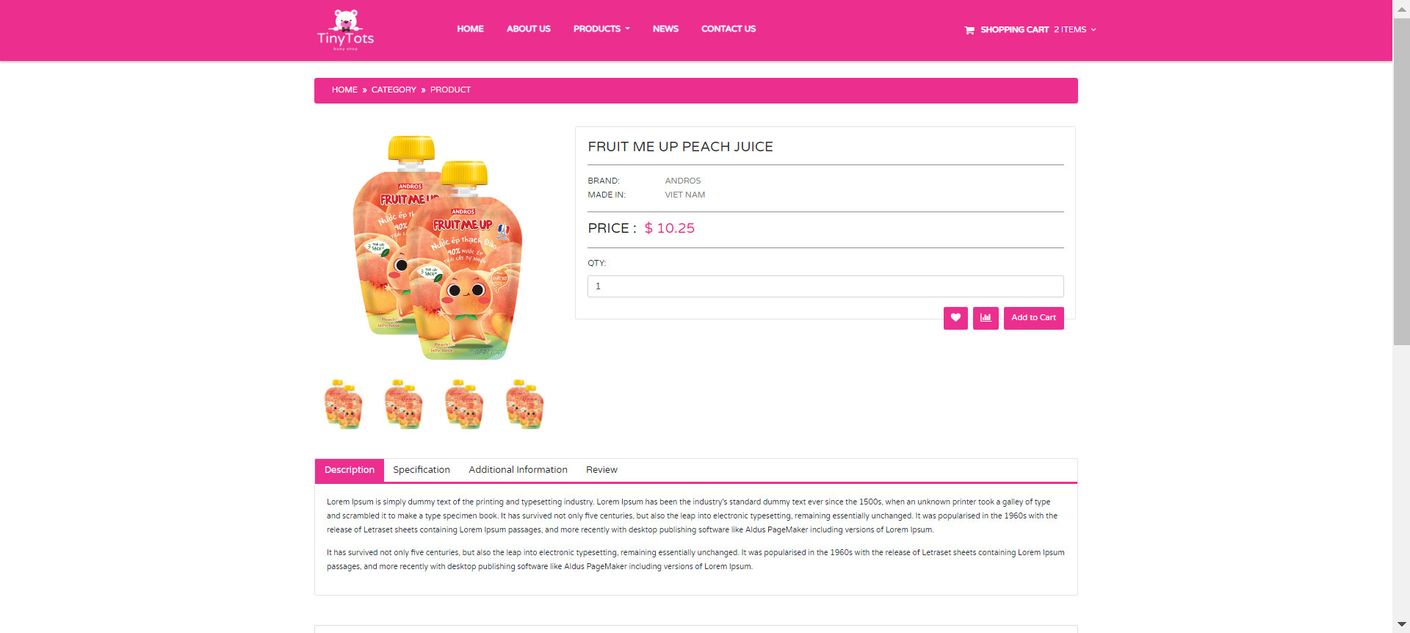

**Single Product Detail Page**

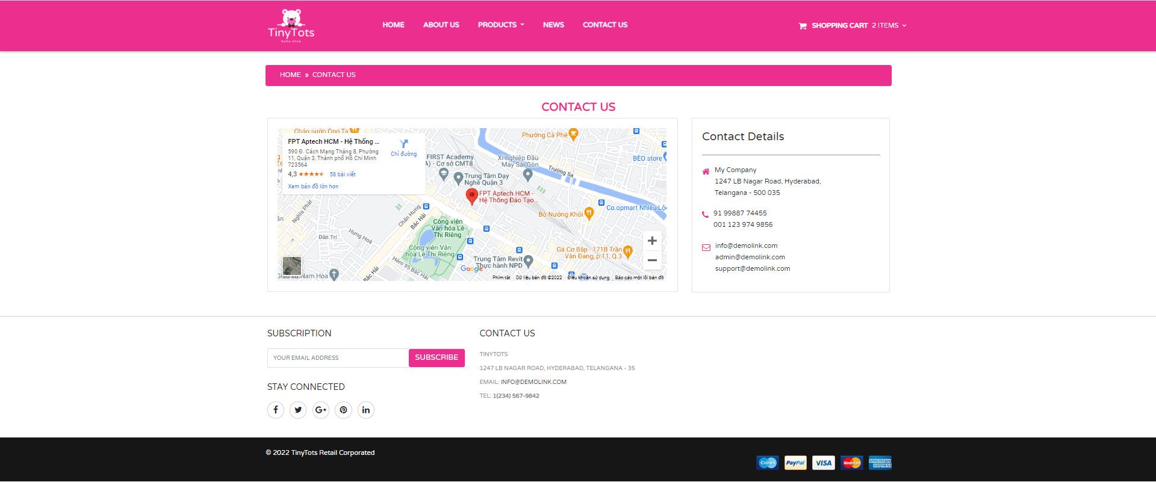

**Contact Us**

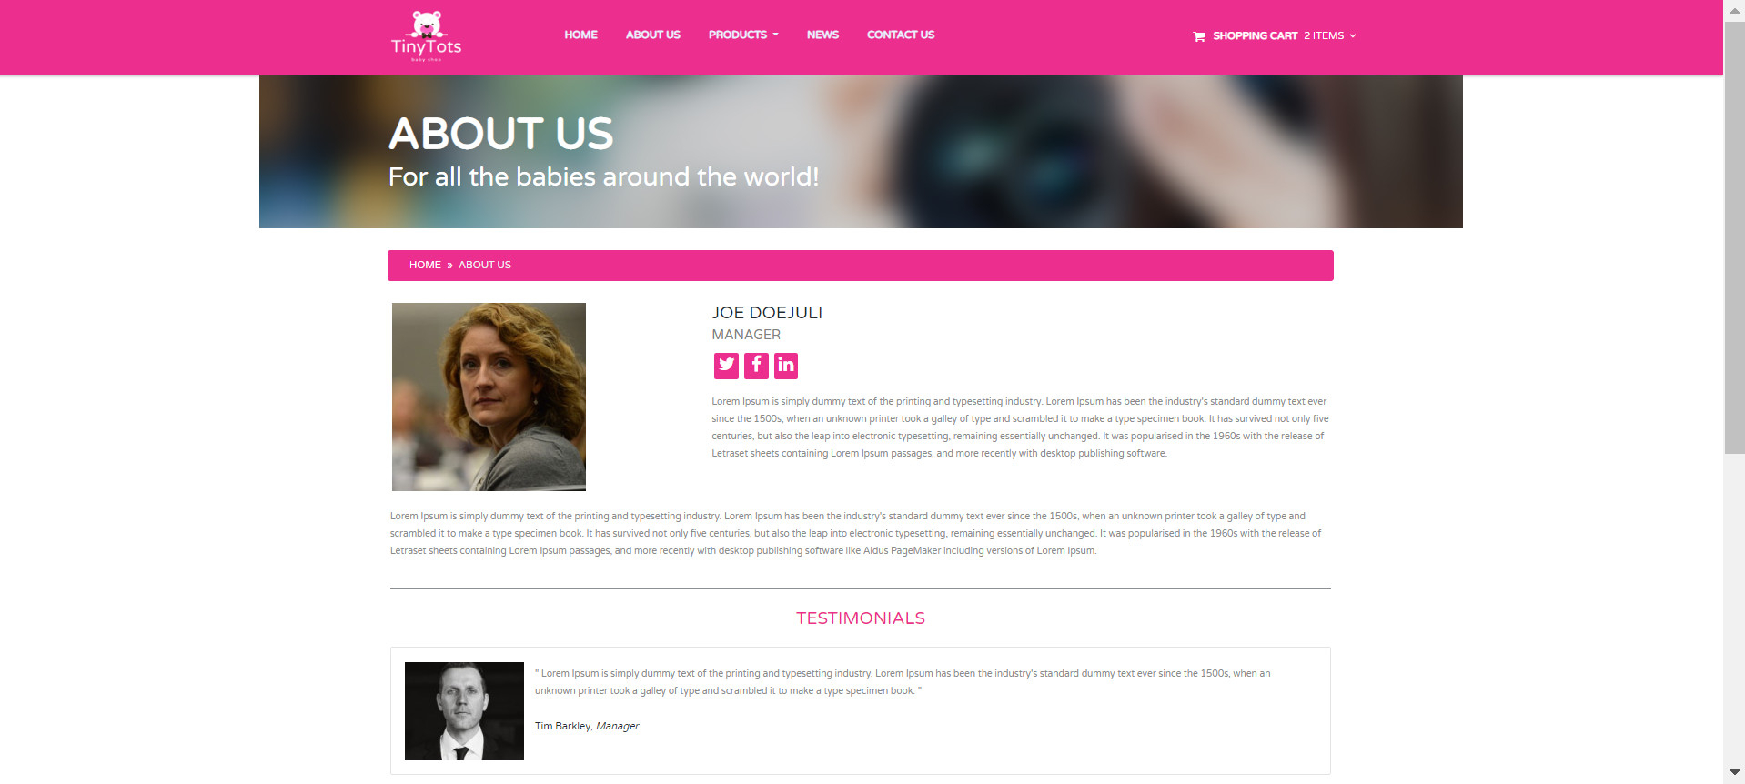

**About Us**