# VISVESVARAYA TECHNOLOGICAL UNIVERSITY



JNANA SANGAMA, BELAGAVI – 590 018

**An Internship Project Report on**

***Credit Card Approval***

Submitted in partial fulfillment of the requirements for the VIII Semester of the degree of **Bachelor of Engineering in Information Science and Engineering** of Visvesvaraya Technological University, Belagavi

**by**

#### Karishma Singh

#### 1RN18IS058

**Under the Guidance of**

#### Dr. Prakash S

**Professor Department of ISE**

**Department of Information Science and Engineering RNS Institute of Technology**

#### Dr. Vishnuvaradhan Road, Rajarajeshwari Nagar post, Channasandra, Bengaluru-560098

**2021-2022**

RNS INSTITUTE OF TECHNOLOGY

#### Dr. Vishnuvaradhan Road, Rajarajeshwari Nagar post, Channasandra, Bengaluru - 560098

**DEPARTMENT OF INFORMATION SCIENCE AND ENGINEERING**



**CERTIFICATE**

Certified that the Internship work entitled ***Twitter Sentiment Analysis*** has been successfully completed by **Karishma Singh (1RN18IS058)** a bonafide student of **RNS Institute of Technology, Bengaluru** in partial fulfillment of the requirements of 8th semester for the award of degree in **Bachelor of Engineering in Information Science and Engineering** of **Visvesvaraya Technological University, Belagavi** during the academic year **2021-2022**. The internship report has been approved as it satisfies the academic requirements in respect of internship work for the said degree.

|  |  |  |
| --- | --- | --- |
|  |  |  |
| **Dr. Mamatha G** | **Dr. Suresh L** | **Dr. M K Venkatesha** |
| Internship Guide | Professor and HoD | Principal |
| Associate Professor | Department of ISE | RNSIT |
| Department of ISE | RNSIT |  |
|  | **External Viva** |  |
| **Name of the Examiners** |  | **Signature with Date** |
| **1.** |  | **1. _** |
| **2.** |  | **2. _** |

# DECLARATION

I, **KARISHMA SINGH [USN: 1RN18IS058]** student of VII Semester BE, in

Information Science and Engineering, RNS Institute of Technology hereby declare that the Internship work entitled ***Credit Card Approval*** has been carried out by us and submitted in partial fulfillment of the requirements for the *VIII Semester degree of* ***Bachelor of Engineering in Information Science and Engineering*** *of Visvesvaraya Technological University, Belagavi* during the academic year 2021-2022.

Place: Bengaluru Date: 9th January2022

**KARISHMA SINGH**

#### (1RN18IS058)

**ABSTRACT**

In the banking system, there is a major task to determine if the person is eligible for the credit card. Profit to the credit card providers largely depend on if person is paying back.By predicting correct credit card customers ,the banks can maximize the profits. We here try to automate this process by applying machine learning techniques. Here we need to make sure to target the right customers.

With the advancement of web technology and its growth, there is a huge volume of data present on the web for internet users and a lot of data is generated too. Profit to the credit card providers largely depend on if person is paying back. By predicting correct credit card customers, the bankscan maximize the profits.

# ACKNOWLEDGMENT

At the very onset, I would like to place our gratefulness to all those people who helped me in making the Internship a successful one.

Coming up, this internship to be a success was not easy. Apart from the sheer effort, the enlightenment of the very experienced teachers also plays a paramount role because it is they who guided me in the right direction.

First, I would like to thank the **Management of RNS Institute of Technology** for providing such a healthy environment for the successful completion of internship work.

In this regard, I express sincere gratitude to our beloved Principal **Dr. M K Venkatesha,** for providing us with all the facilities.

We are extremely grateful to our own and beloved Professor and Head of the Department of Information science and Engineering, **Dr. Suresh L**, for having accepted to patronize me in the right direction with all her wisdom.

We place our heartfelt thanks to **Dr. Prakash S,** Professor, Department of Information Science and Engineering for having guided the internship and all the staff members of the Department of Information Science and Engineering for helping at all times.

I thank **Mr. Aman Upadhyay, NASTECH**, for providing the opportunity to be a part of the Internship program and has guided me to complete the same successfully.

I also thank our internship coordinator **Dr. R Rajkumar,** Associate Professor, Department of Information Science and Engineering. I would thank my friends for having supported me with all their strength and might. Last but not the least, I thank my parents for supporting and encouraging me throughout. I have made an honest effort in this assignment.

KARISHMA SINGH

##### v

**TABLE OF CONTENTS**

|  |  |
| --- | --- |
| **Abstract** | **iv** |
| **Acknowledgment** | **v** |
| **Contents** | **vi** |
| **List of figures** | **vii** |
| **List of Abbreviations** | **viii** |
| **1. Introduction** | **1** |
| 1.1 Background | 1 |
| 1.2 Existing System | 1 |
| 1.3 Proposed System | 1 |
| **2. Literature Review** | **2** |
| **3. Analysis** | **3** |
| 3.1 Introduction | 3 |
| 3.1.1 User Characteristics | 3 |
| 3.1.2 Software Requirements | 4 |
| 3.1.3 Hardware Requirements | 4 |
| **4. System Design** | **5** |
| 4.1 Introduction | 5 |
| 4.2 Low-level Design | 6 |

**vi**

|  |  |
| --- | --- |
| 4.3 Detailed Design | 7 |
| 4.4 Functional modules / Framework | 7 |

|  |  |
| --- | --- |
| **5. Implementation Details** | **8** |
| **6. Testing** | **17** |
| **7. Results** | **19** |
| **8. Conclusion and Future Enhancement** | **20** |
| 8.1 Conclusion | 20 |
| 8.2 Future Enhancement | 20 |
| **9. References** | **21** |

**vii**

**LIST OF FIGURES**

|  |  |  |
| --- | --- | --- |
| **Figure. No.** | **Descriptions** | **Page** |
| Figure. 4.1 | Use-Case of Project | 05 |
| Figure. 4.2.1 | Diagram for Credit Approval Process | 06 |
| Figure. 4.3 | Detailed Diagram for credit card approval | 07 |
| Figure. 5.1 | Importing libraries and dataset | 08 |
| Figure. 5.2 | Exploratory data analysis | 08 |
| Figure. 5.3 | Data description and distribution | 10 |
| Figure. 5.4 | Count plot using Seaborn Library | 13 |
| Figure. 5.5 | Correlational Matrix | 13 |
| Figure. 5.6 | Use of Scatter plot | 14 |
| Figure. 5.7 | Perform data cleaning | 15 |
| Figure. 5.8 | Attribute with most importance for selecting credit card | 15 |
| Figure. 6.1 | Testing User Interface | 18 |
| Figure. 7.1 | Result | 19 |

**ABBREVIATIONS**

|  |  |  |
| --- | --- | --- |
| NLP | - | Natural Language Processing |
| ML | - | Machine Learning |
| AI | - | Artificial Intelligence |
| NLTK | - | Natural Language Toolkit |
| NB | - | Naïve Bayes |
| KNN | - | K Nearest Neighbors |
| UI | - | User Interface |

**viii**

**Chapter 1**

**INTRODUCTION**

### Background

The correct assessment for credit card approval is very important for banks and organizations who lend credit card to the people. The recent years has seen huge growth in credit cards and loans. The exact judgment of person to be approved for credit cards allows the organizations to minimize losses and same time make suitable credit arrangements as per requirement. Due to huge growth in number of applicants there is need for more sophisticated method to automate the process and speed it up.

Credit card approval can very helpful for organizations that lend credit cards and due to increase in huge number of applicant there is need to automate the task and classify the applicants into if they are eligible for credit card or not. This helps to avoid organization losses by avoiding potential defaulters. Here we are not just looking into bank balance but into there personal attributes like gender, married, age, Occupation etc. We account for these personal attributes to evaluate if given is applicant is good customer. This can also help cut down week’s long process into few days. This gives benefit by cutting down costs on credit analysis and faster credit decisions.

### 1.2 Existing System

The correct assessment for credit card approval is very important for banks and organizations who lend credit card to the people. The recent years has seen huge growth in credit cards and loans. The exact judgment of person to be approved for credit cards allows the organizations to minimize losses and same time make suitable credit arrangements as per requirement. Due to huge growth in number of applicants there is need for more sophisticated method to automate the process and speed it up.

### Proposed System

### The existing application has been enhanced to make the application more interactive and make user friendly with add-on functionalities. It has functionalities like taking age, debt, no. of years of employment, credit score, and income. It verifies these inputs and then calculates if the customer is eligible for credit card. If he/she is eligible then credit card for that customer is approved.

## Chapter 2

**LITERATURE REVIEW**

In past various models have been proposed to determine the and evaluate the credit scoring criteria. Techniques can be further classified into parametric and non-parametric models. The most well liked parametric model was logistic regression and linear discriminant analysis.LDA has been criticized because of categorical nature of data. Logistic regression overcomes these problems later turn out to be common credit scoring tool for credit lending organizations. The prediction is taken into consideration after applying sigmoid function into it.

Commercial banks receive a lot of applications for credit cards. Many of them get rejected for many reasons, like high loan balances, low-income levels, or too many inquiries on an individual’s credit report. Techniques that were used previously parametric and non-parametric models, models like logistic regression and LDA. Logistic regression overcomes these problems later turn out to be common credit scoring.

Non-parametric techniques that can be used are K-nearest neighbor, decision tree and support vector machines. SVM can be combined with back propagation neural network to get better accuracy. The results displayed SVM’s accuracy comparable to that of back propagation neural network. Further there has been improvement in various other hybrid data mining techniques to get better results at these kinds of problems. Various ensemble methods have also been used to get improved accuracy by aggregating scores.

Credit card approval is also being done through genetic programming; this paper examines the usage of strong typed genetic programming for automated credit approval. Eight different genetic programming approaches were applied and compared.

In another paper implementation based on logistic regression has been compared with XGBoost algorithm. It is found that XGBoost algorithm has significantly higher model discrimination and model stability than that of logistic regression.

**Chapter 3**

**ANALYSIS**

### Introduction

A credit card is a small plastic card issued to users as a system of payment. It allows its holder to buy goods and services based on the holder's promise to pay for these goods and services. The issuer of the card creates a revolving account and grants a line of credit to the consumer (or the user) from which the user can borrow money for payment to a merchant or as a cash advance to the user.

When a purchase is made the merchant swipes the card. The information goes to a gateway processor, which either accepts or rejects the transaction. If it is accepted, the transaction is held until the end of the business day. The merchant then re-enters the transaction via the gateway processor, the data is logged, and the debt is transferred to the account. The use of an ATM for cash advance is a similar process. If you are selling to consumers, merchant services will allow you to expand your customer base and provide a more convenient method of payment than cash or checks. And if you are interested in selling over the Internet, accepting credit card processing is a must. Accepting credit cards allows funds to be transferred to your bank account in less than a week. This can be a welcome relief for businesses that experience a tight cash flow. The two purchase options for Credit Card Processing facility are:

• Validation only

• Credit card processing (which secures deposits at the time of booking)

With either option, credit card accounts entered during booking are validated to assure that the account is active and in good standing. The credit card processing option also allows properties to process credit card deposits.

## User Characteristics

1) User/Customer - They are the people who desires to purchase the goods using credit card.

2) Authorization Service

• Validate the credit card payments to ensure that the card number is valid and the card has not expired

• Deposit processing to apply the deposit payment to the card

• Prepare Credit card transaction reports that show authorization codes, amounts, and error/success messages

### Software Requirements

* Operating system: Windows 7/8/10/11 or Linux
* Credit Card Dataset
* Modern web browser with internet access
* Python 3

### Hardware Requirements

* Processor: Intel i5 or more
* RAM: 8 GB or more
* Cache: 512KB
* Hard disk: 16GB
* Monitor: 1024 x 720display
* Speed: 2.7GHZ or more

## Chapter 4

**SYSTEM DESIGN**

* 1. **Introduction**

*Fig 4.1:Use-case of project*

The above diagram shows the use-case of the project. The details of the customer like age, debt, income, etc are taken and sent for verification. If the inputs are correct and valid for the customer to get the credit card, then it is approved, and the customer gets their credit card.

## Low-level design

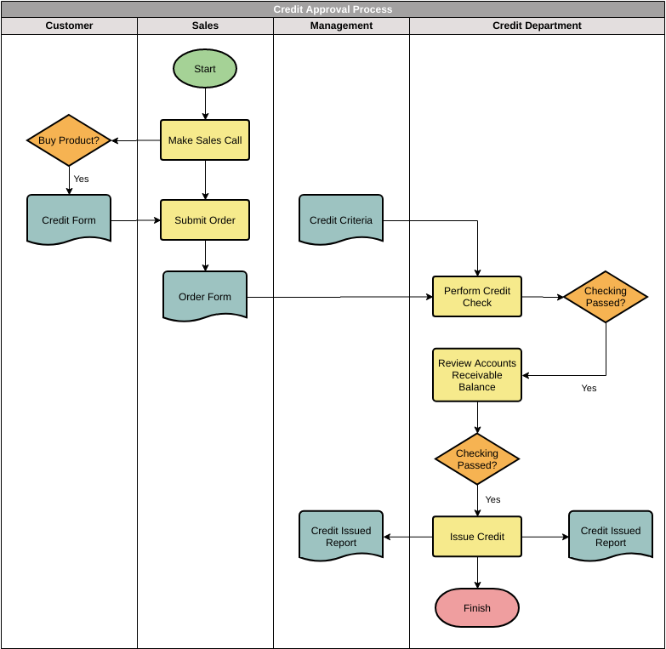

*Fig 4.2.1: Diagram for credit approval process*

## Detailed design

*Fig 4.3: Detailed Diagram for credit card approval*

## Functional Module /Framework

Following are functional modules and frameworks used in the project:

* + - NumPy - NumPy is a library for the Python programming language, adding support for large, multi-dimensional arrays and matrices, along with a large collection of high- level mathematical functions to operate on thesearrays.
    - Matplotlib - Matplotlib is a plotting library for the Python programming language and its numerical mathematics extension NumPy. It provides an object-oriented API for embedding plots into applications using general-purpose GUI toolkits like Tkinter, wxPython, Qt, orGTK.
    - Seaborn - Seaborn is a Python data visualization library based on [matplotlib](https://matplotlib.org/). It provides a high-level interface for drawing attractive and informative statistical graphics.
    - Pandas – It is a Python library for data analysis. Pandas is built on top of 2 core Python libraries – matplotlib for data visualization and NumPy for mathematical operations. Pandas acts as a wrapper over these libraries, allowing us to access many of matplotlib’s and NumPy’s methods with less code.

## Chapter 5

**IMPLEMENTATION DETAILS**

##### Text Description automatically generated with medium confidenceImporting Libraries and Datasets

*Figure 5.1: importing libraries and datasets*

1. **Exploratory data analysis**

*Figure 5.2: Exploratory data analysis*

1. **Data Description and Distribution**

*Figure 5.3: Data Description and Distribution*

1. **Count plot using Seaborn Library**

*Figure 5.4: Count plot using Seaborn Library*

1. **Correlational Matrix**

*Figure 5.5: Correlational Matrix*

1. **Use of ScatterplotText

   Description automatically generated**

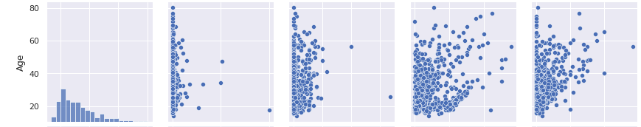

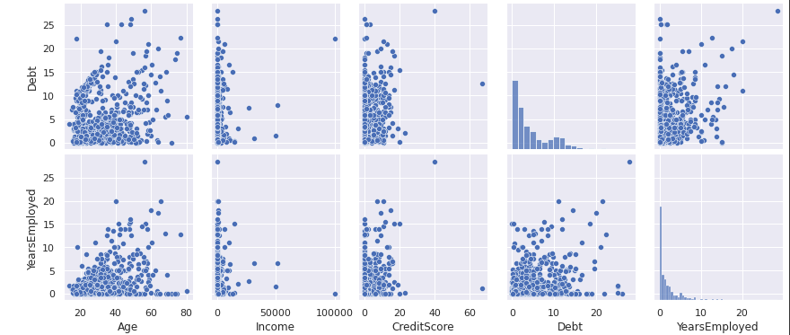

*Figure 5.6: Use of Scatter Plot*

##### Perform data cleaning

*Figure 5.7: Perform Data Cleaning*

1. **Attribute with most importance for selecting credit card**

*Figure 5.8: Attribute with most importance for selecting credit card*

## Chapter 6

**TESTING**

Testing is done by finding the maximum posterior probability of the test data and then finding its accuracy.

P (A|B) = P(B|A) * P(A)

_ P(B)

Where,

P(A|B) – Posterior Probability P(A) – Prior Probability P(B|A) – Maximum Likelihood P(B) – Marginal Probability

Accuracy = [Summation (True positive) + Summation (True Negative)] /

(Summation (Total Population)]

The purpose of testing is to discover errors. Testing is the process of trying to discover every conceivable fault or weakness in a work product. It provides a way to check functionality of components, sub-assemblies, and/or a finished product it is the process of exercising software with the intent of ensuring that the software system meets its requirements and user expectations and does not fail in an unacceptable manner.

## Types of Testing

* **Unit Testing**: A unit test is a way of testing a unit - the smallest piece of code that can be logically isolated in a system. In most programming languages, that is a function, a subroutine, a method, or property. The isolated part of the definition is important.
* **Integration Testing**: Integration testing is the phase in software testing in which individual software modules are combined and tested as a group. Integration testing is conducted to evaluate the compliance of a system or component with specified functional requirements.
* **Validation Testing**: The process of evaluating software during the development processor at the end of the development process to determine whether it satisfies specified business requirements. Validation Testing ensures that the product actually meets the client's needs.
* **System Testing**: System Testing is a type of software testing that is performed on a complete integrated system to evaluate the compliance of the system with the corresponding requirements. In system testing, integration testing passed components are taken as input.

## Testing User Interface

*Figure 6.1: Testing User Interface*

## Chapter 7

**RESULTS**

*Figure 7.1: Result*

Accuracy is 85%.

## Chapter 8

**CONCLUSION AND FUTURE ENHANCEMENT**

### Conclusion

* As our country developing so it will surely increase the credit card holders, issuing more credit cards will also boost the country’s economy.
* But issuing credit card requires a lot of human time, by developing Credit Card Approval System
* We are helping the bank sector and saving them from bankrupting by predicting whom to issue credit card whom to not.

### Future Enhancements

1. Finding Sarcasm in the text and predicting emotion accordingly.
2. Sentiment analysis can be done on live tweets on a large-scale using Twitter API
3. Future Enhancement can be done for Sentiment analysis for Dravidian Languages
4. Many analyzers don’t perform well when the number of classes is increased. Also, it’s still not tested that how accurate the model will be for topics other than the one in consideration. Hence sentiment analysis has a very bright scope of development in the future.
5. Machine Learning algorithm’s accuracy to be increased.
6. Database is limited for processing structured data and has a limitation when dealing with a large amount of data.

## Chapter 9

**REFERENCES**

1. [https://www.kaggle.com](https://www.kaggle.com/) for Credit Card dataset
2. <https://ieeexplore.ieee.org/document/7877424>
3. <https://ieeexplore.ieee.org/document/9537243>
4. <https://ieeexplore.ieee.org/document/8474783>
5. <https://ieeexplore.ieee.org/document/7912034>
6. <https://ieeexplore.ieee.org/document/8252118>
7. <https://ieeexplore.ieee.org/document/8515844>