SMARTKISAN
Mobile Application
Testing & QA Report
Functional Testing, Results & Evidence

Application | SmartKisan Mobile Application
Document Type | Functional Testing & QA Report
Test Area | Mobile Application
Coverage | 22 documented functional test cases
Report Date | 27 August 2026
Prepared for Management Review

1. Executive Summary
This report presents the functional testing results for the SmartKisan mobile application. The testing covers the primary user journey from registration and authentication through farm setup, dashboard usage, pump management, soil readings, weather, crop suitability, disease detection, fertilizer calculation, AI field monitoring, profile management, farm management, devices and logout.
The report records the observed application behaviour and highlights areas that are functioning correctly as well as areas requiring implementation, correction or further validation. Supporting application screens are included within the relevant test case sections for traceability.
Total Cases | Working Fine | Needs Checking | Needs Implementation
21 | 7 | 10 | 2

Overall QA observation: The core navigation and several major application screens are operational, while data persistence, authentication alternatives, location-specific data and image-based intelligence features require additional attention.

2. Test Scope
Registration & Authentication — New-user registration, duplicate username validation, email login, phone login, username login and Google sign-in.
Farm Setup — Farm configuration including farm type, soil information, farm dimensions/location and setup completion.
Dashboard — Farm overview and dashboard data displayed after login.
Pump Management — Pump listing, pump categories and adding pumps.
Agricultural Data — Soil readings, weather information and crop suitability.
Smart Agriculture Features — Disease detection, fertilizer calculation and AI Field Monitor.
Account & Farm Management — Profile updates, farm management, connected devices and logout.

3. Test Result Classification
Classification | Meaning | Count
PASS — Working Fine | Observed behaviour is functioning as expected for the tested scenario. | 7
OPEN — Needs Checking | Functionality exists but requires correction, validation or data verification. | 10
OPEN — Needs Implementation | Required functionality is currently unavailable or incomplete. | 2
NOT RECORDED | No test status was recorded. | 1

4. Test Case Summary
Test Case | Feature | Scenario | Result | Evidence
TC-001 | Register | Register as a new user | OPEN — Needs Checking | Available
TC-002 | Register | Registering as new user with same username | OPEN — Needs Implementation | Available
TC-003 | Setup of farm | Setting up the farm type of soil, length of farm | PASS — Working Fine | Available
TC-004 | Main dashboard | Seeing the details of the farm | PASS — Working Fine | Available
TC-005 | Login with email | entering the email and password | PASS — Working Fine | Available
TC-006 | Login with email | entering the email and password invalid | PASS — Working Fine | Available
TC-007 | Login with phone | Enter valid phone number | OPEN — Needs Implementation | Available
TC-008 | Login with username | Enter the valid username and password | OPEN — Needs Implementation | Not available
TC-009 | Sign in through google | signing in directly from google | PASS — Working Fine | Available
TC-010 | main dashboard | data in main dashboard | OPEN — Needs Checking | Available
TC-011 | my pumps | There are options in my pumps which pump is to be selected | PASS — Working Fine | Available
TC-012 | Add pump | Adding pump | OPEN — Needs Checking | Available
TC-013 | add soil reading | adding the soil readings | OPEN — Needs Checking | Available
TC-014 | The weather | Shows the weather according to the farm situated | OPEN — Needs Checking | Available
TC-015 | Settings | crop suitability | OPEN — Needs Checking | Available
TC-016 | Settings | Disease detection | OPEN — Needs Checking | Available
TC-017 | settings | fertilizer calculate | PASS — Working Fine | Available
TC-018 | settings | ai field monitor | OPEN — Needs Checking | Available
TC-019 | profile update | the user can update the details | OPEN — Needs Checking | Available
TC-020 | farm management | farm management | OPEN — Needs Checking | Available
TC-021 | devices | devcices | NOT RECORDED | Available

5. Detailed Test Case Results
The following sections provide the detailed test result for every documented case. Evidence is presented only where an application screen relevant to the test case is available.

TC-001 — Register
Test Scenario | Register as a new user
Expected Result | Adding the details and registering
Actual Result | It is not registering the user and giving the error of status 404
Status | OPEN — Needs Checking
Remarks | Resolved by the team

Application Evidence
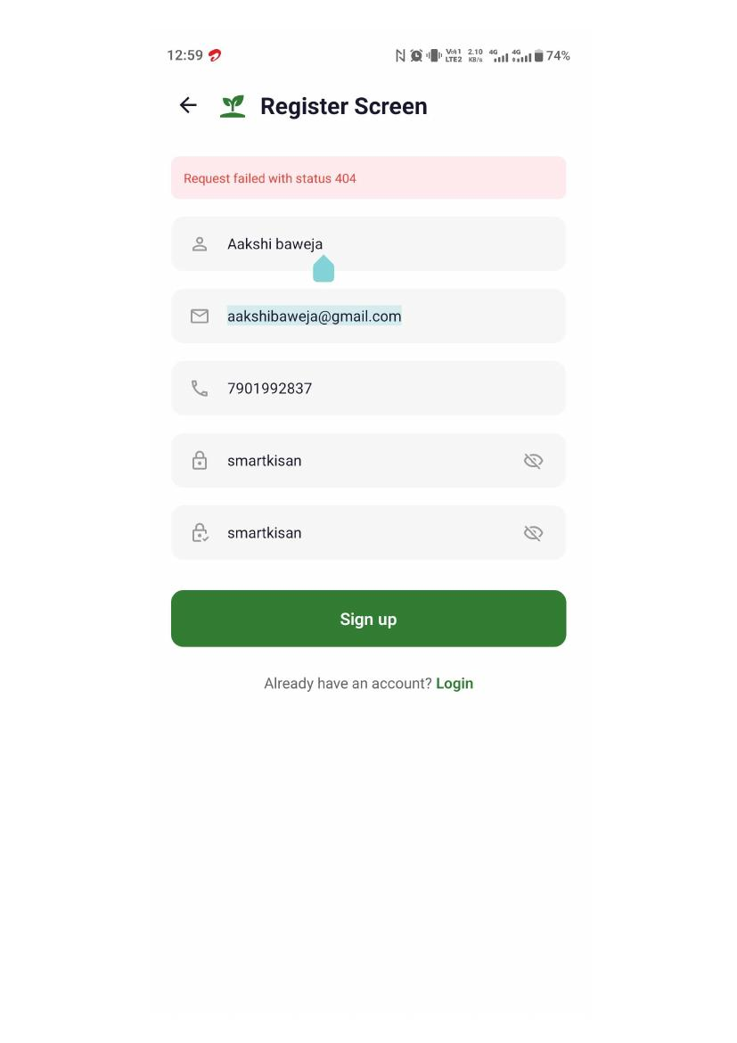
Application screen evidence

TC-002 — Register
Test Scenario | Registering as new user with same username
Expected Result | it should show the error for that and show that it already exist
Actual Result | It is not giving the error for the username and as well as for the validation format for the email and also for the phone number format
Status | OPEN — Needs Implementation
Remarks | Not recorded

Application Evidence
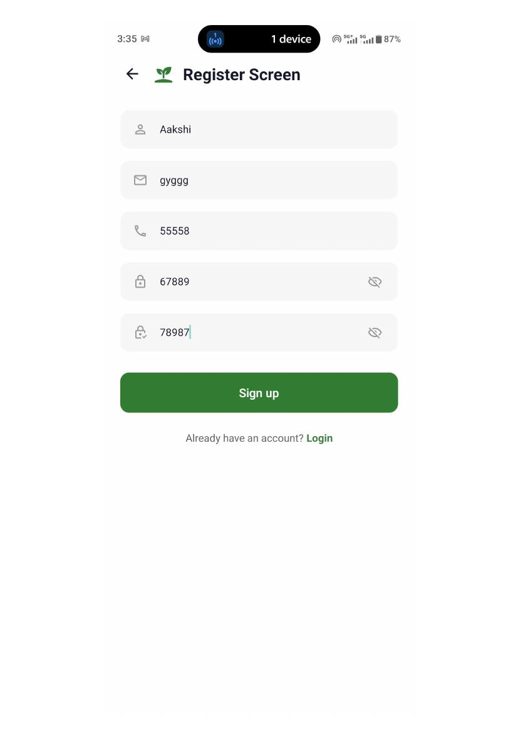
Application screen evidence
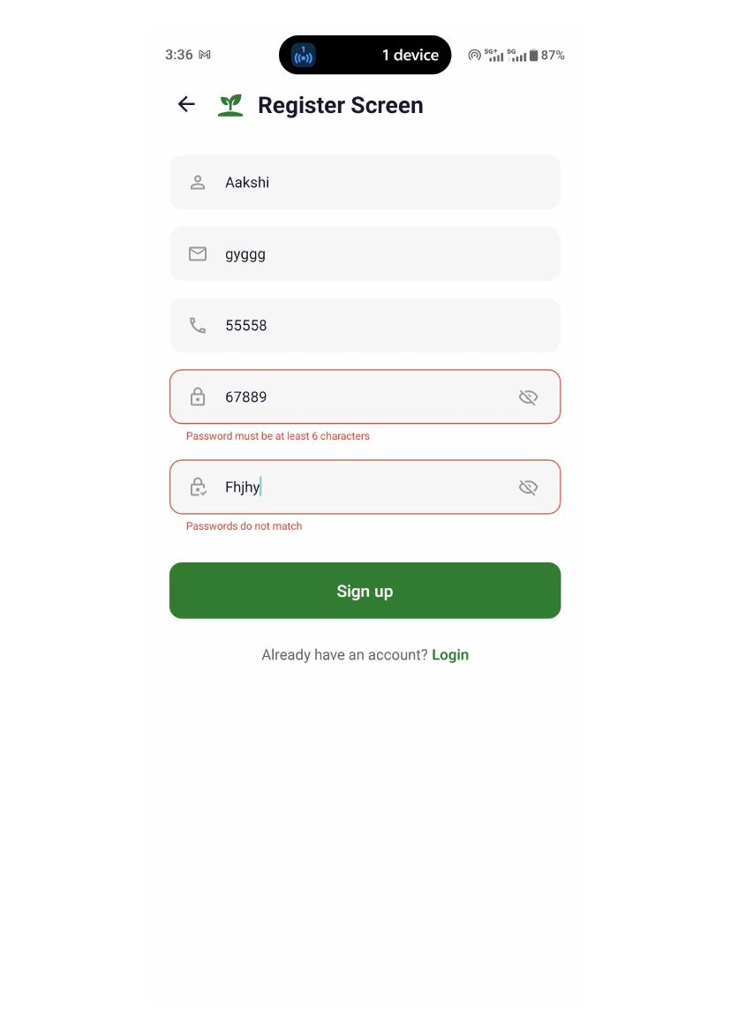
Application screen evidence

TC-003 — Setup of farm
Test Scenario | Setting up the farm type of soil, length of farm
Expected Result | After registering it should land on the farm setup screen where there are 4 screens in which all the features are there
Actual Result | It is landing on that page after login and all the features that are there for setting up the farm are working
Status | PASS — Working Fine
Remarks | Not recorded

Application Evidence
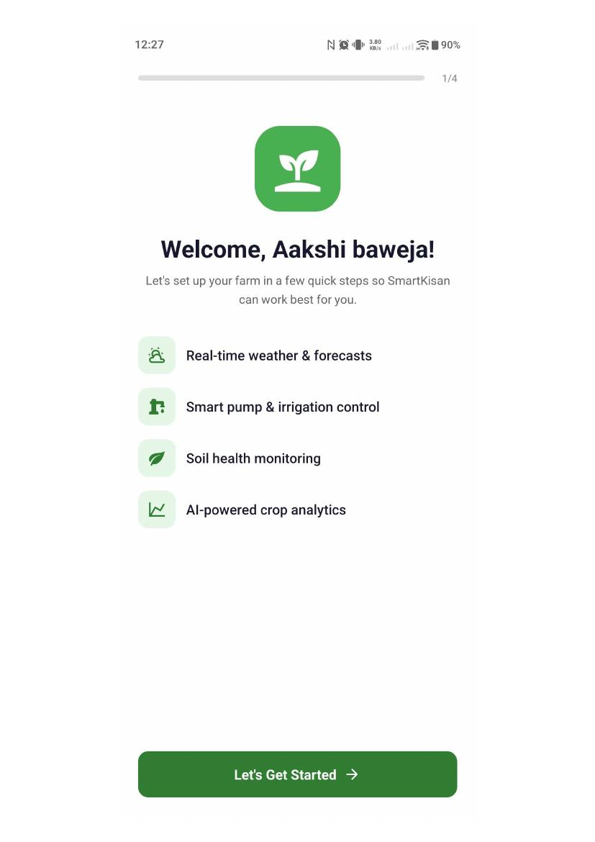
Application screen evidence
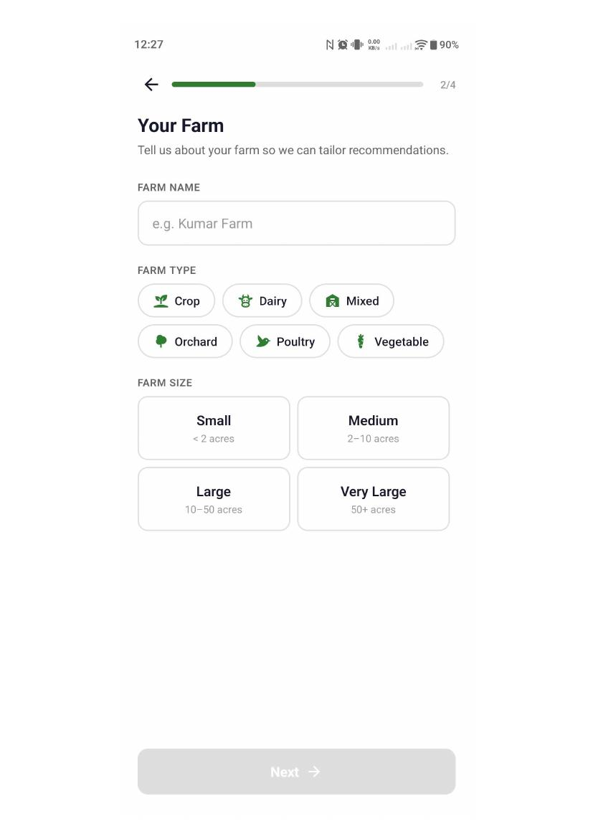
Application screen evidence
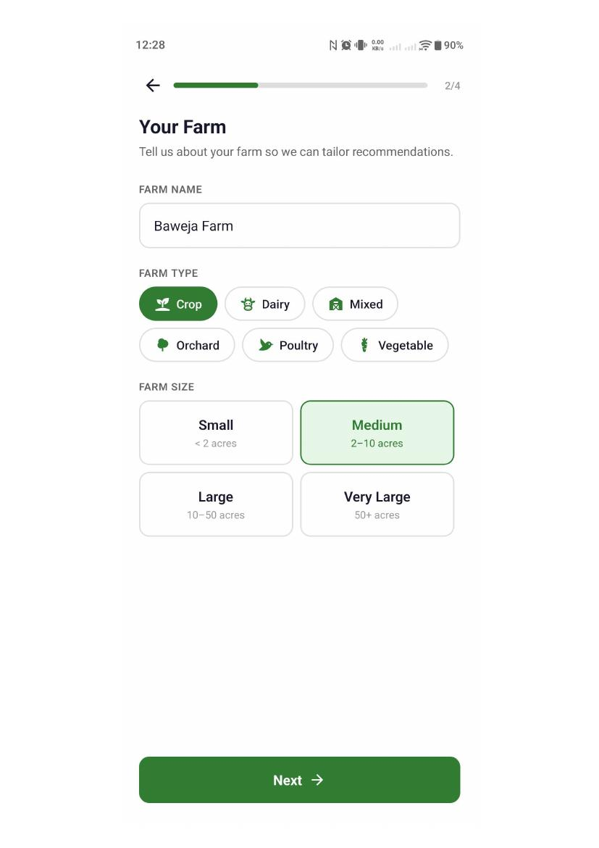
Application screen evidence
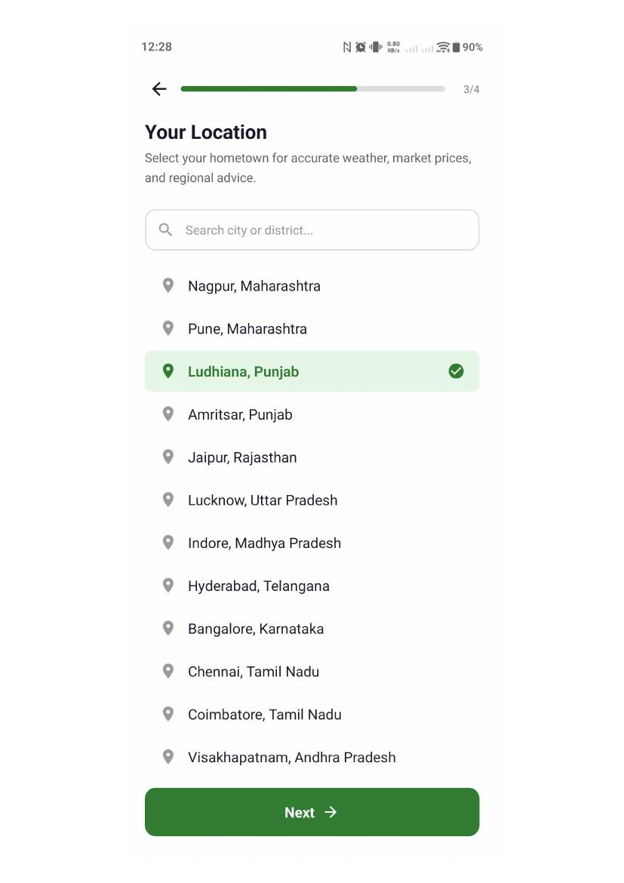
Application screen evidence
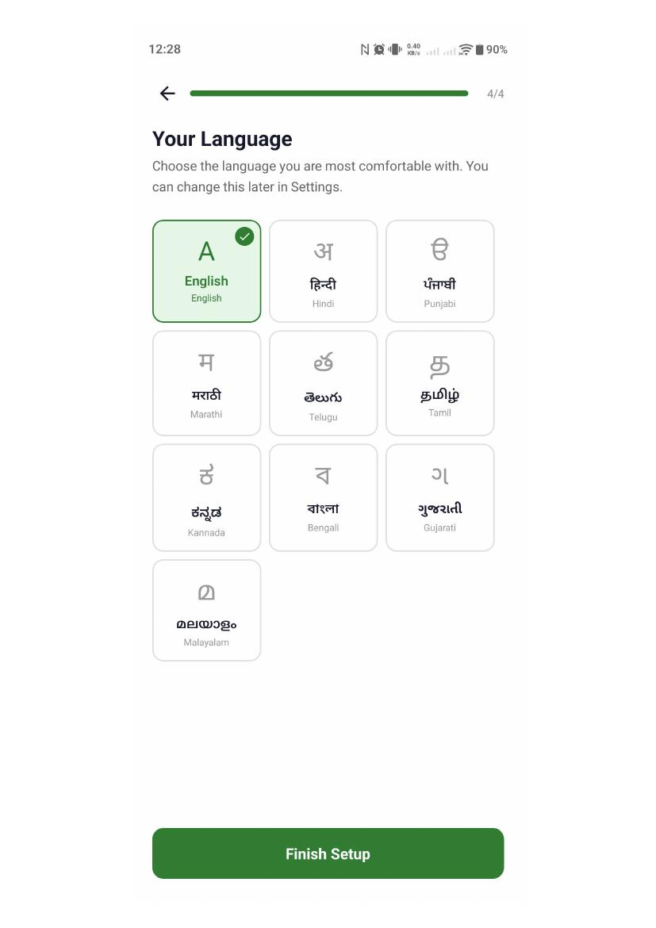
Application screen evidence

TC-004 — Main dashboard
Test Scenario | Seeing the details of the farm
Expected Result | after setting up the farm it should land on the main dashboard
Actual Result | It is landing on main dashboard page
Status | PASS — Working Fine
Remarks | Not recorded

Application Evidence
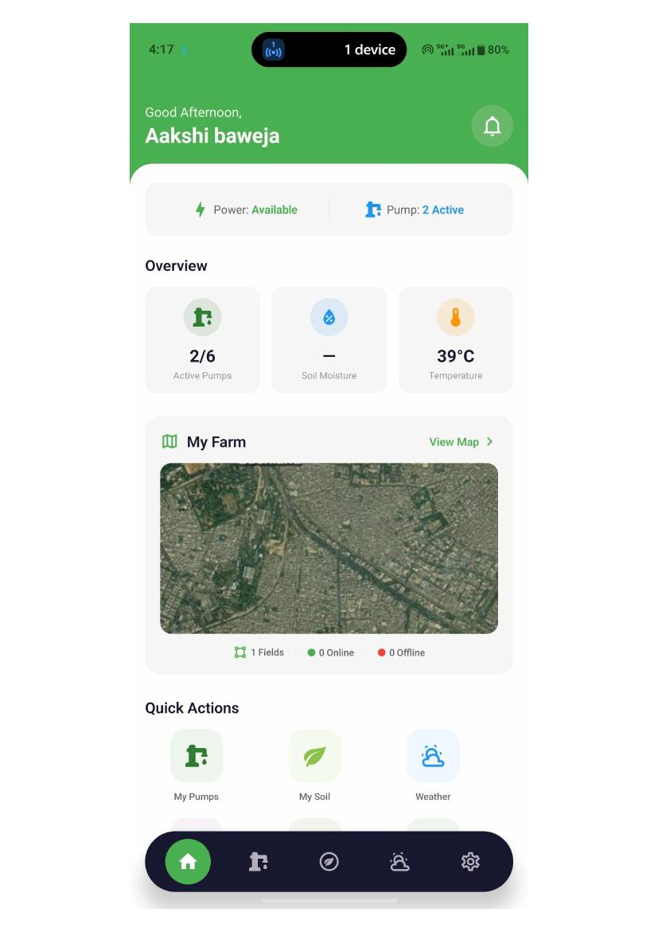
Application screen evidence
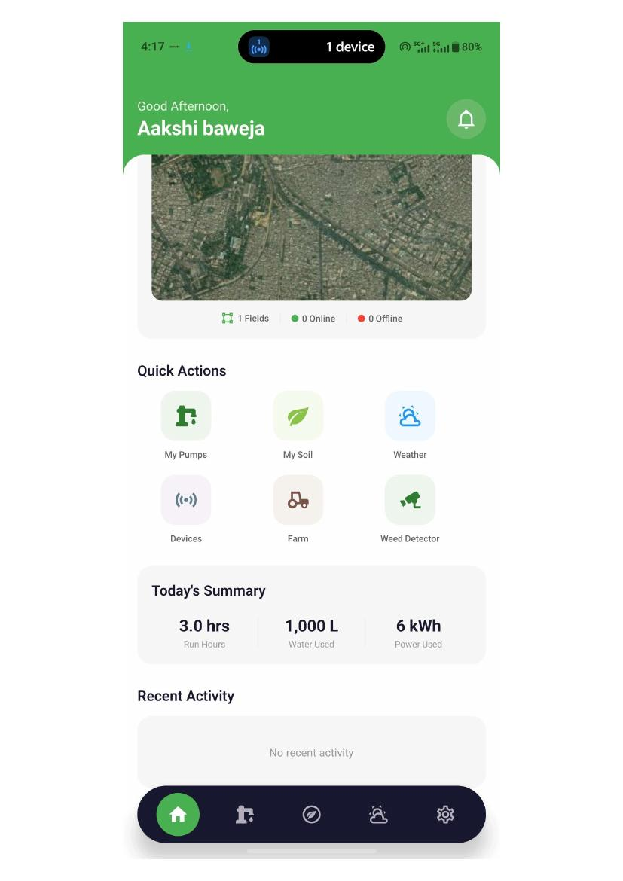
Application screen evidence

TC-005 — Login with email
Test Scenario | entering the email and password
Expected Result | entering the valid email and password login and landing on the main dashboard
Actual Result | It is landing on main dashboard page
Status | PASS — Working Fine
Remarks | Not recorded

Application Evidence
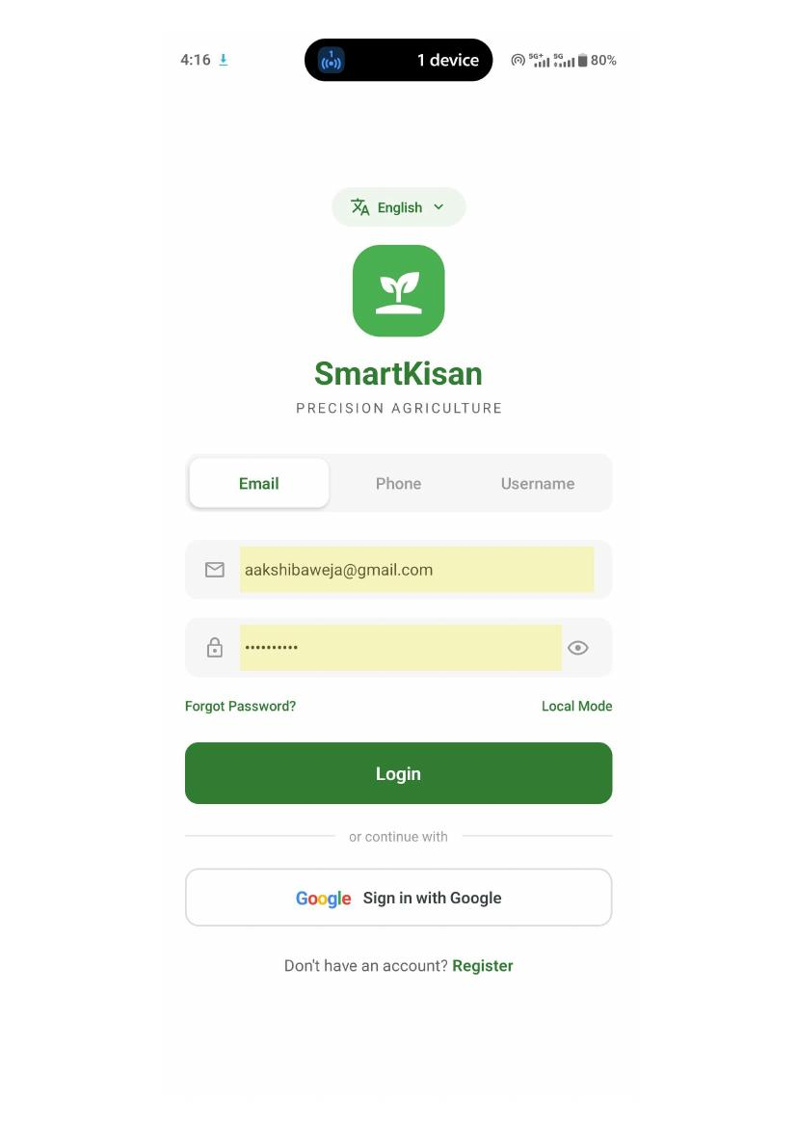
Application screen evidence

Application screen evidence

TC-006 — Login with email
Test Scenario | entering the email and password invalid
Expected Result | Entering invalid credentials should get the error
Actual Result | It is showing the error
Status | PASS — Working Fine
Remarks | Not recorded

Application Evidence
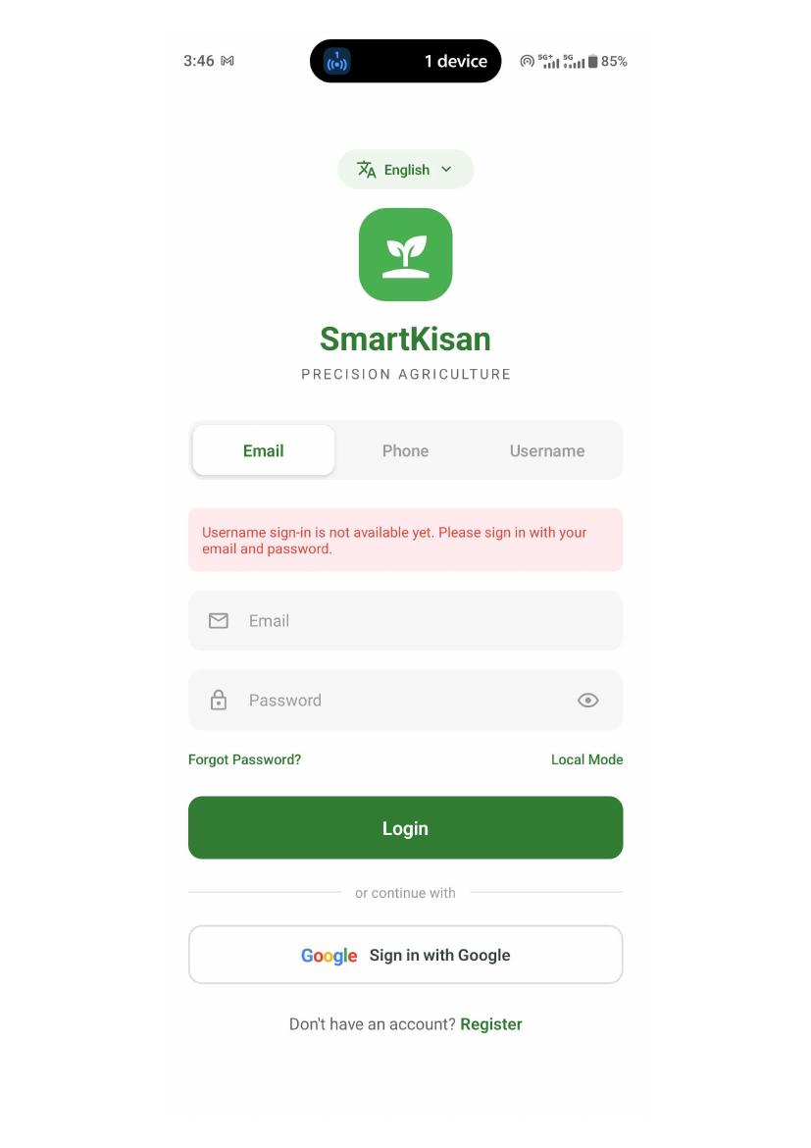
Application screen evidence

TC-007 — Login with phone
Test Scenario | Enter valid phone number
Expected Result | Entering valid number and getting the otp .
Actual Result | It is not sending the otp and not able to login from phone
Status | OPEN — Needs Implementation
Remarks | The error if my otp is wrong it should only on the screen on phone but it is also showing on the other pages of login like email and username

Application Evidence
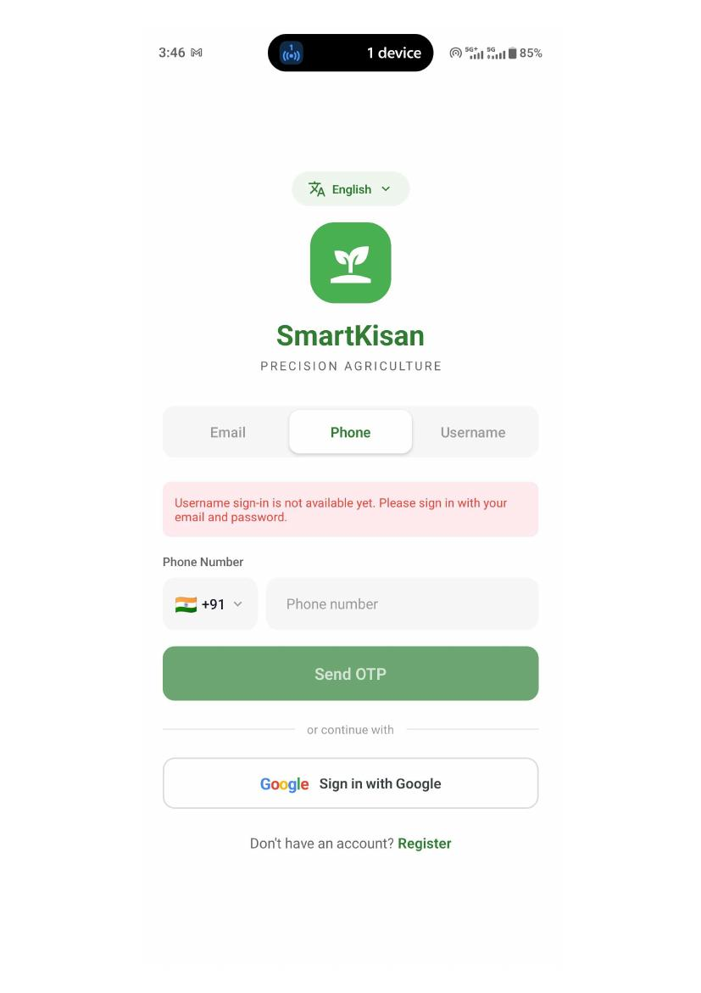
Application screen evidence

TC-008 — Login with username
Test Scenario | Enter the valid username and password
Expected Result | Entering valid user name and password and login into
Actual Result | It is not working
Status | OPEN — Needs Implementation
Remarks | Not recorded

Evidence: No supporting application screen is included for this test case.

TC-009 — Sign in through google
Test Scenario | signing in directly from google
Expected Result | signing through google it should land on the stup farm
Actual Result | it is landing to that pages
Status | PASS — Working Fine
Remarks | Not recorded

Application Evidence

Application screen evidence

TC-010 — main dashboard
Test Scenario | data in main dashboard
Expected Result | getting the data according to the user login how many pumps are there . Water used power used
Actual Result | it is showing the data but it is dummy data because in every login it is showing the same data
Status | OPEN — Needs Checking
Remarks | Not recorded

Application Evidence

Application screen evidence

Application screen evidence

TC-011 — my pumps
Test Scenario | There are options in my pumps which pump is to be selected
Expected Result | It should show the all the types of pumps in the form of list
Actual Result | It is showing all the pumps in the list as well as in single according to the category .Showing the dummy data
Status | PASS — Working Fine
Remarks | Not recorded

Application Evidence
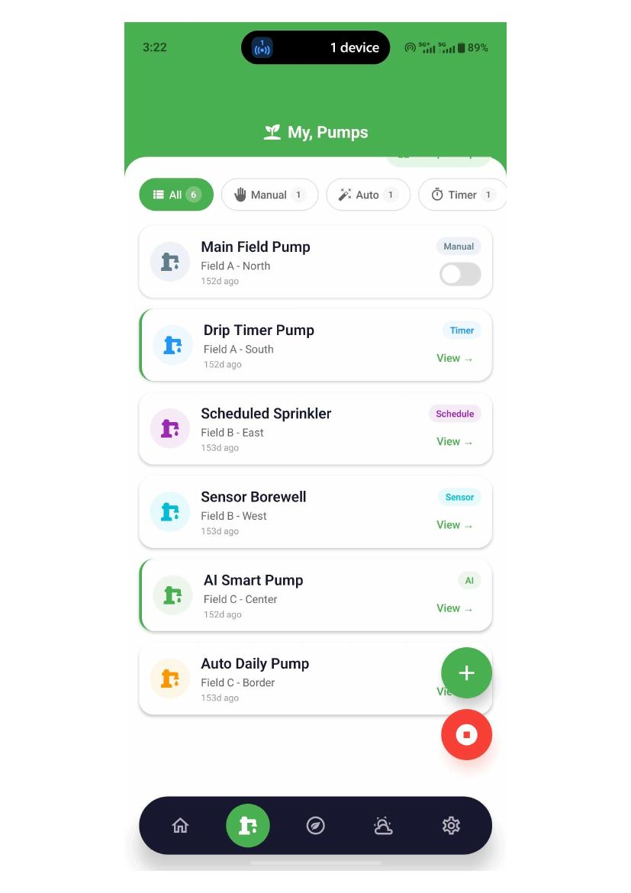
Application screen evidence
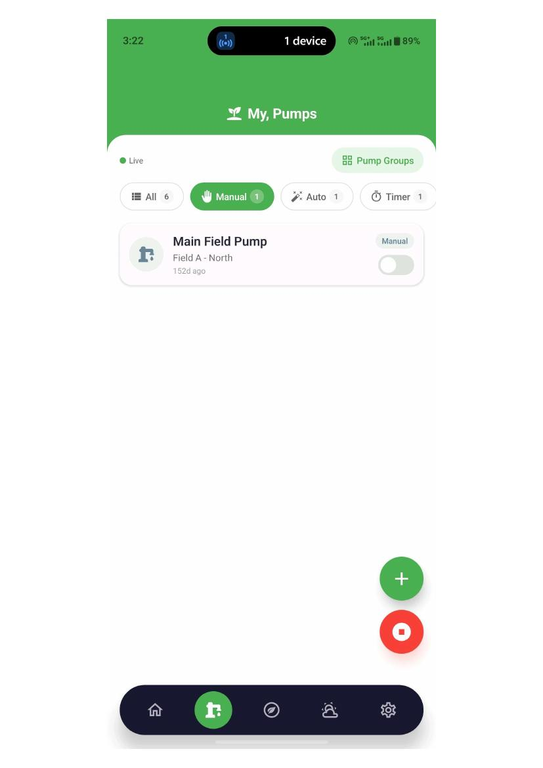
Application screen evidence
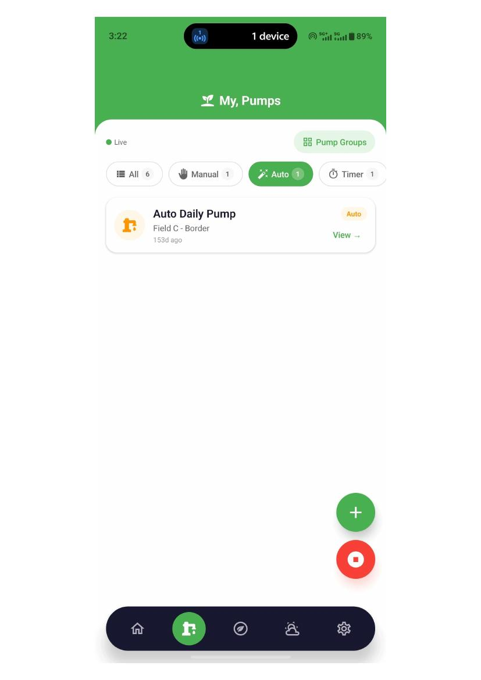
Application screen evidence
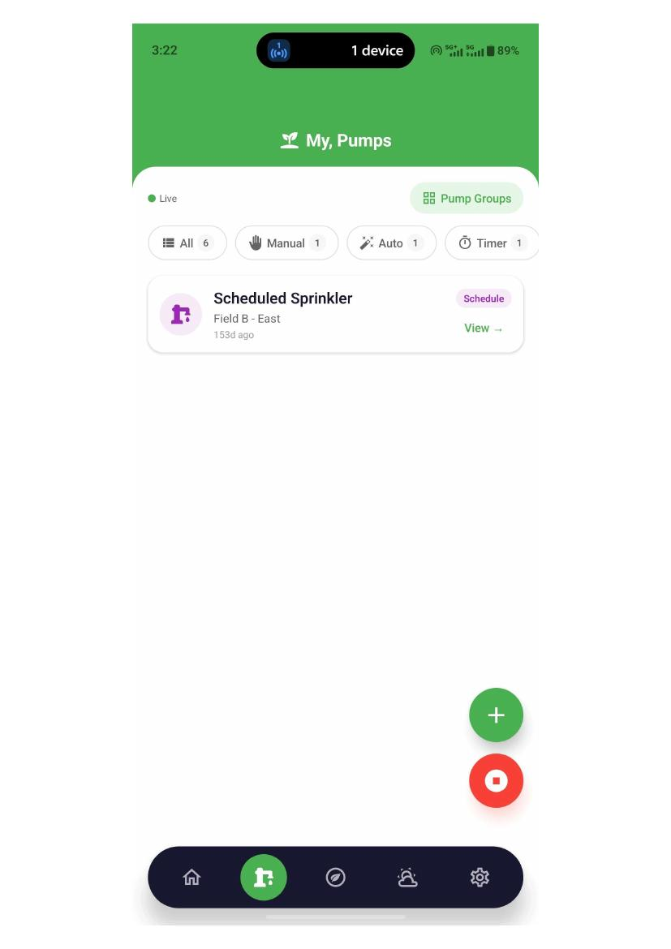
Application screen evidence
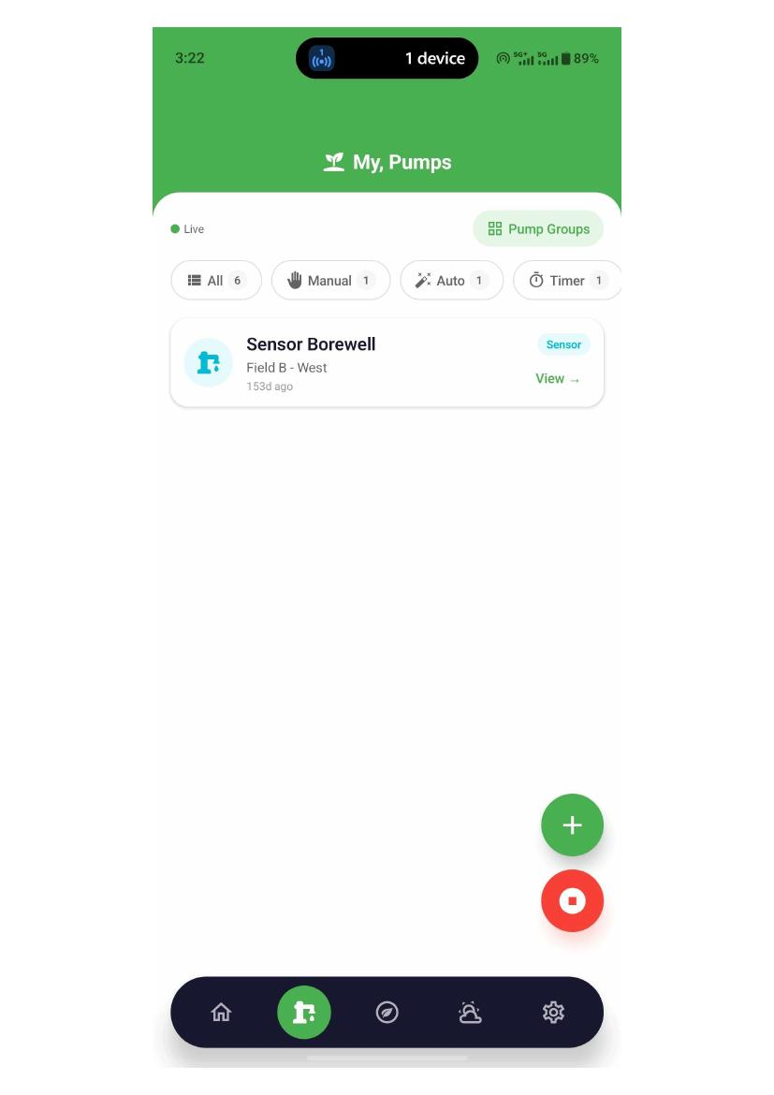
Application screen evidence
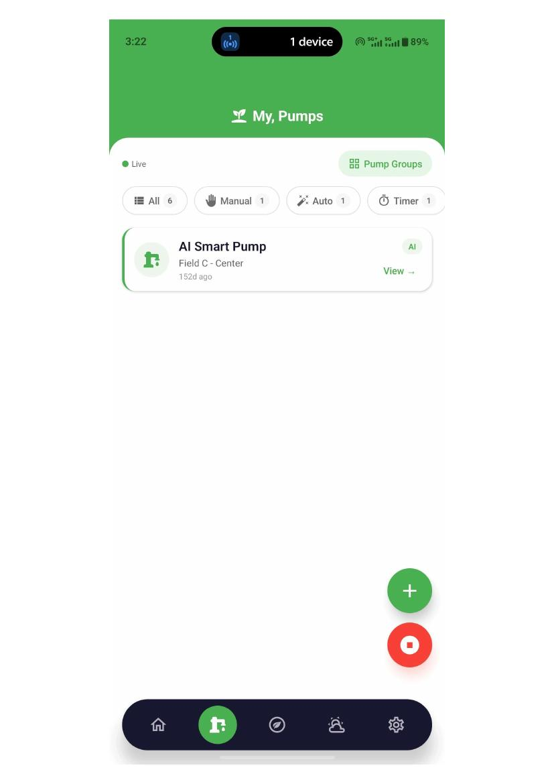
Application screen evidence
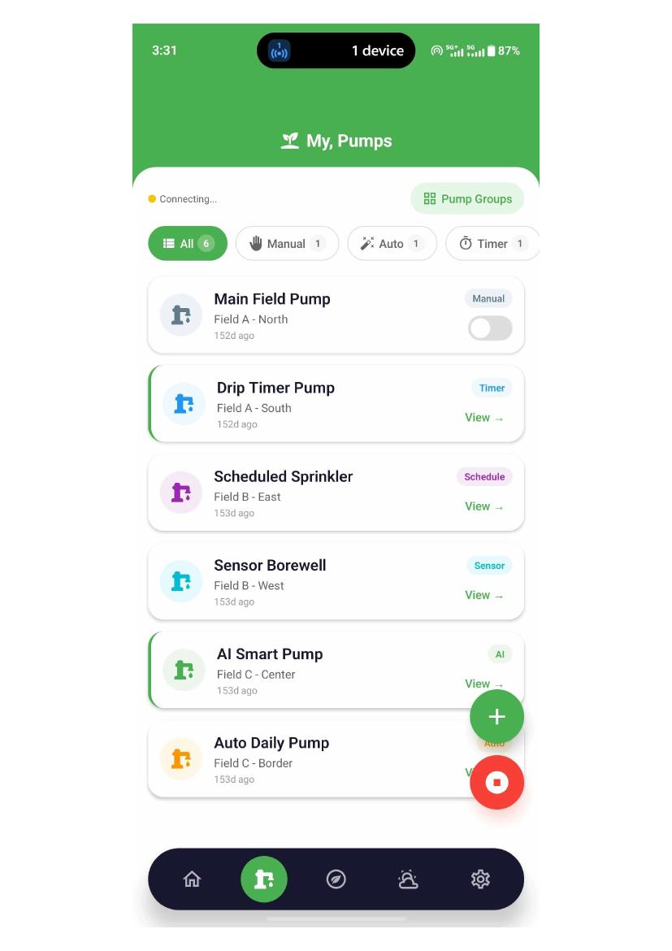
Application screen evidence

TC-012 — Add pump
Test Scenario | Adding pump
Expected Result | Adding the pump with the specific details and with selecting the type of pump
Actual Result | adding the new pump is working and after adding it is showing in the list . but if the user by chance come out from the app it does not show the pump in the list
Status | OPEN — Needs Checking
Remarks | But in the form heading it is showing edit plant it is needed to be corrected

Application Evidence

Application screen evidence

TC-013 — add soil reading
Test Scenario | adding the soil readings
Expected Result | Add the soil reading like nitrogen,organic carbon soil texture
Actual Result | it is not adding the soil reading in it
Status | OPEN — Needs Checking
Remarks | If i am coming out from the app . Without logging out it should show the data that I added. But it is not showing

Application Evidence
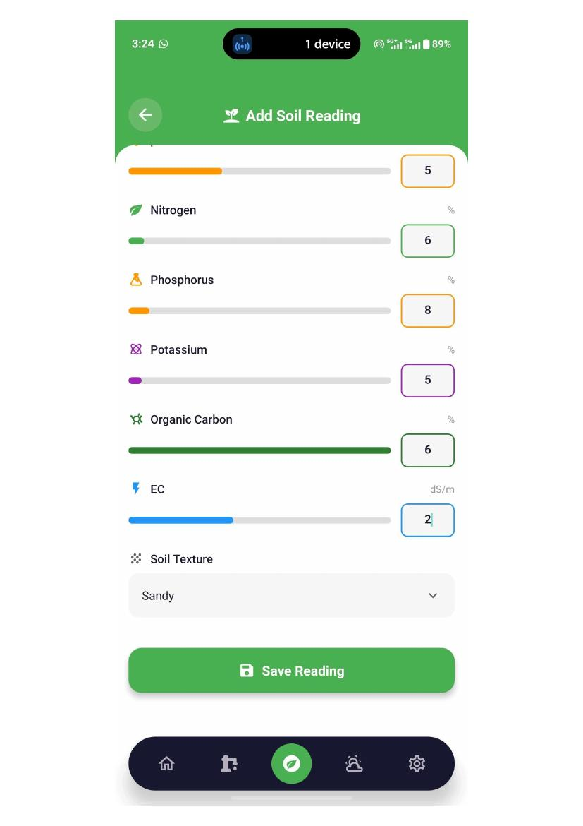
Application screen evidence
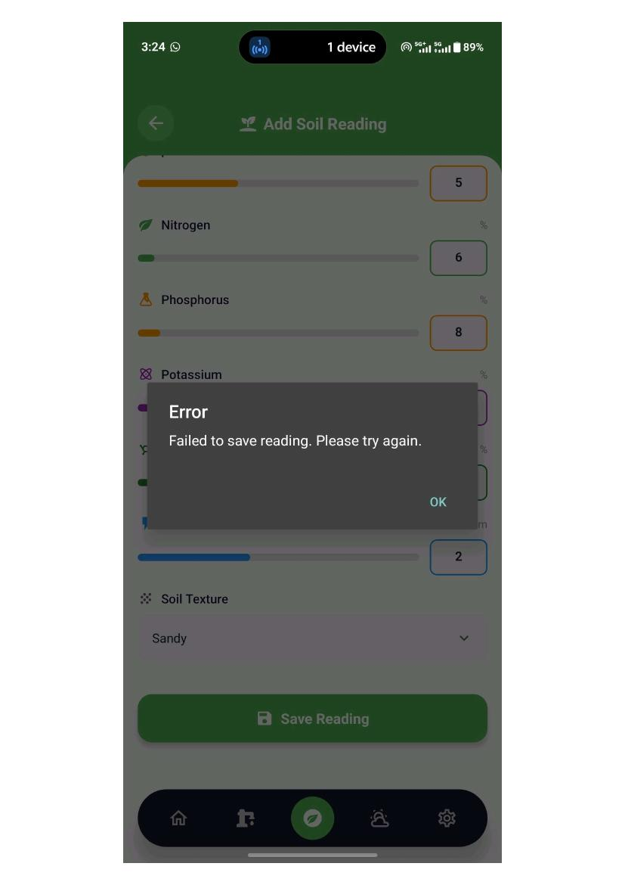
Application screen evidence

TC-014 — The weather
Test Scenario | Shows the weather according to the farm situated
Expected Result | it should show the weather like temprature of that place, the humidity of that place
Actual Result | it is showing the weather but not for the location which is being there selceted while creating the farm
Status | OPEN — Needs Checking
Remarks | Not recorded

Application Evidence
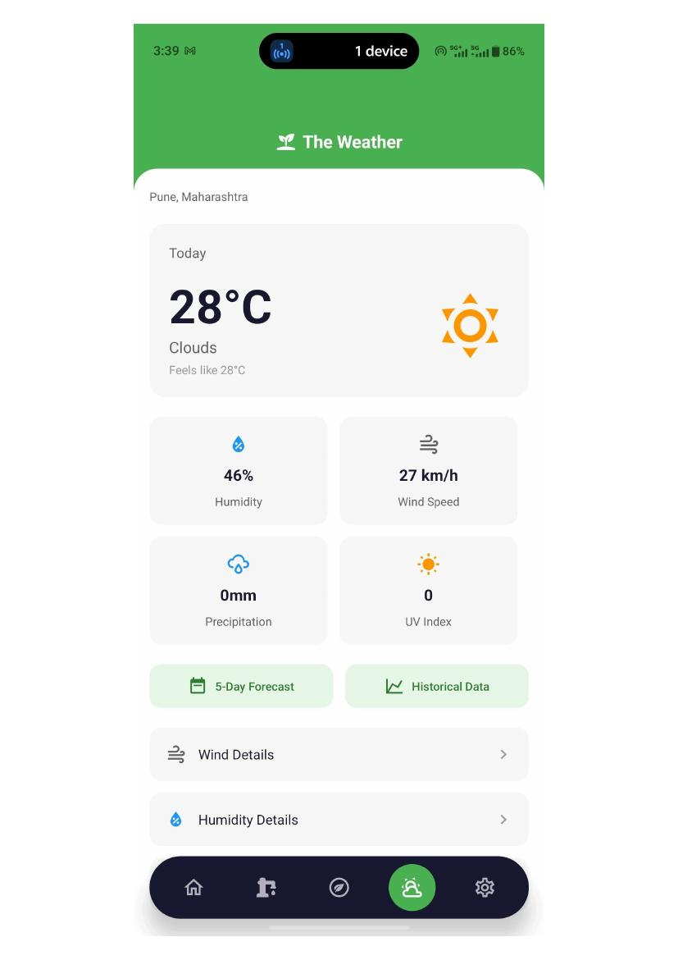
Application screen evidence
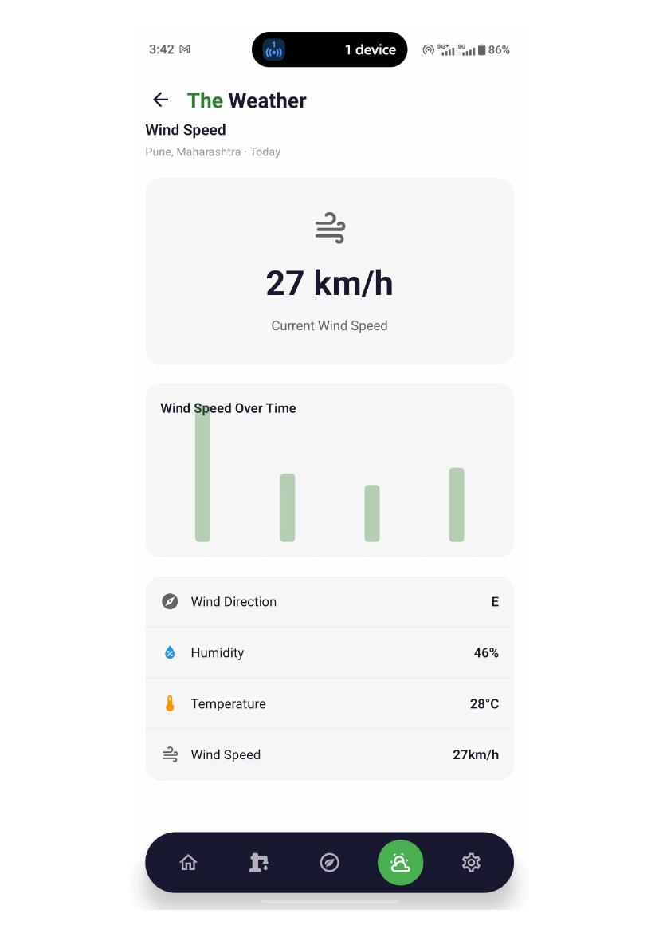
Application screen evidence
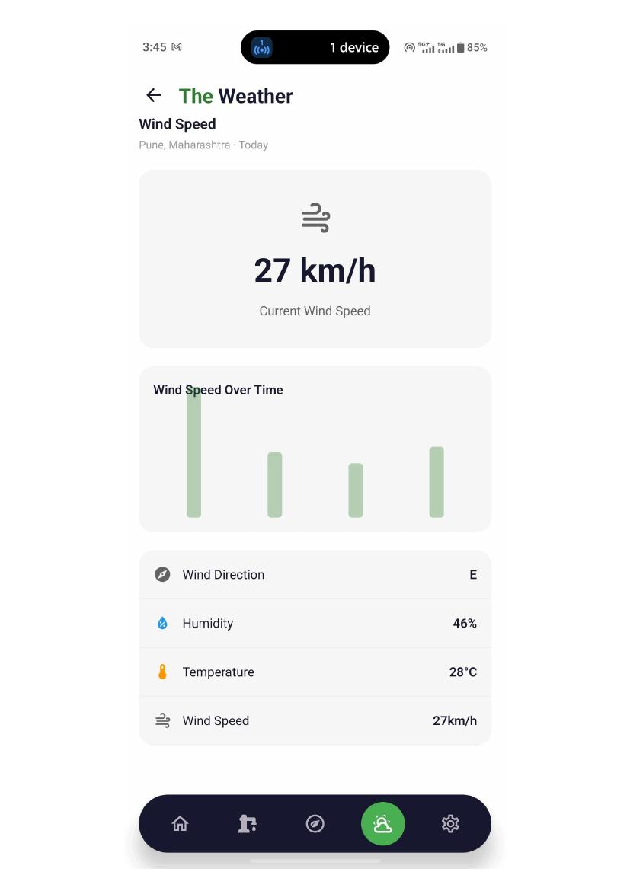
Application screen evidence

TC-015 — Settings
Test Scenario | crop suitability
Expected Result | it should show the data of the crop like which things are importent what are the parameters needed to yeild the crop
Actual Result | it is showing the dummy data right now
Status | OPEN — Needs Checking
Remarks | Not recorded

Application Evidence
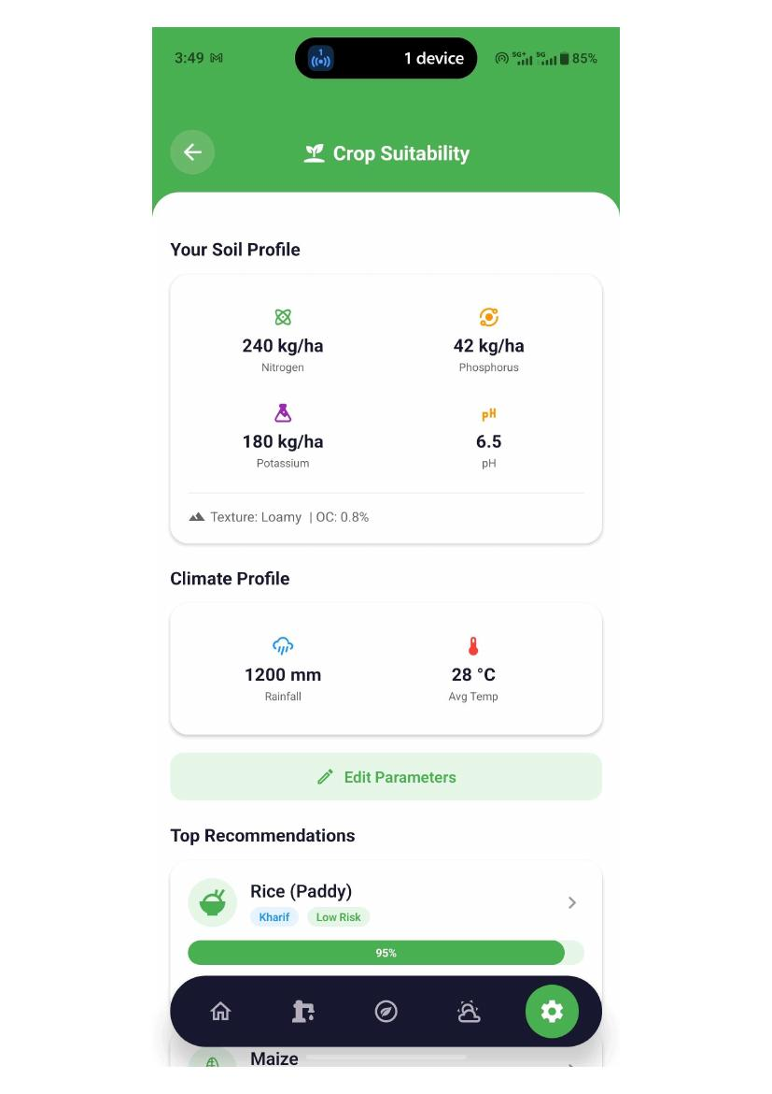
Application screen evidence
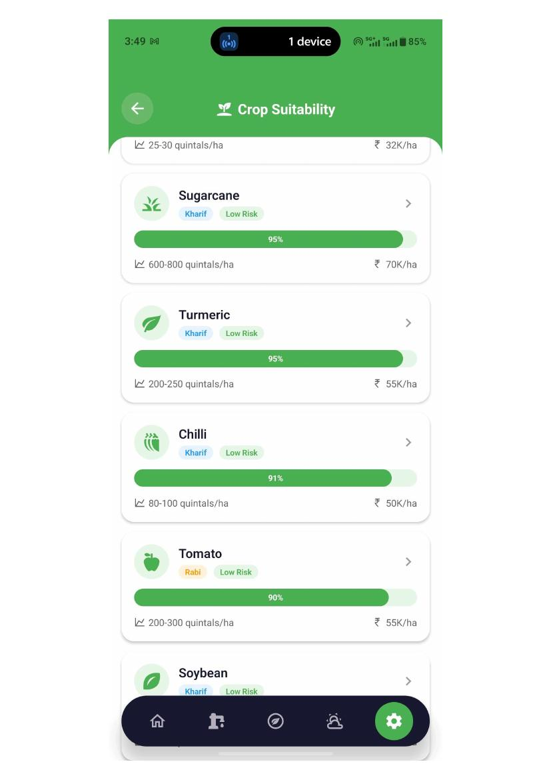
Application screen evidence

TC-016 — Settings
Test Scenario | Disease detection
Expected Result | we can scan the plant through the picture from the camera or from our gallery . and it should show the result
Actual Result | it is not working right now . it is showing the rejection for this
Status | OPEN — Needs Checking
Remarks | Not recorded

Application Evidence
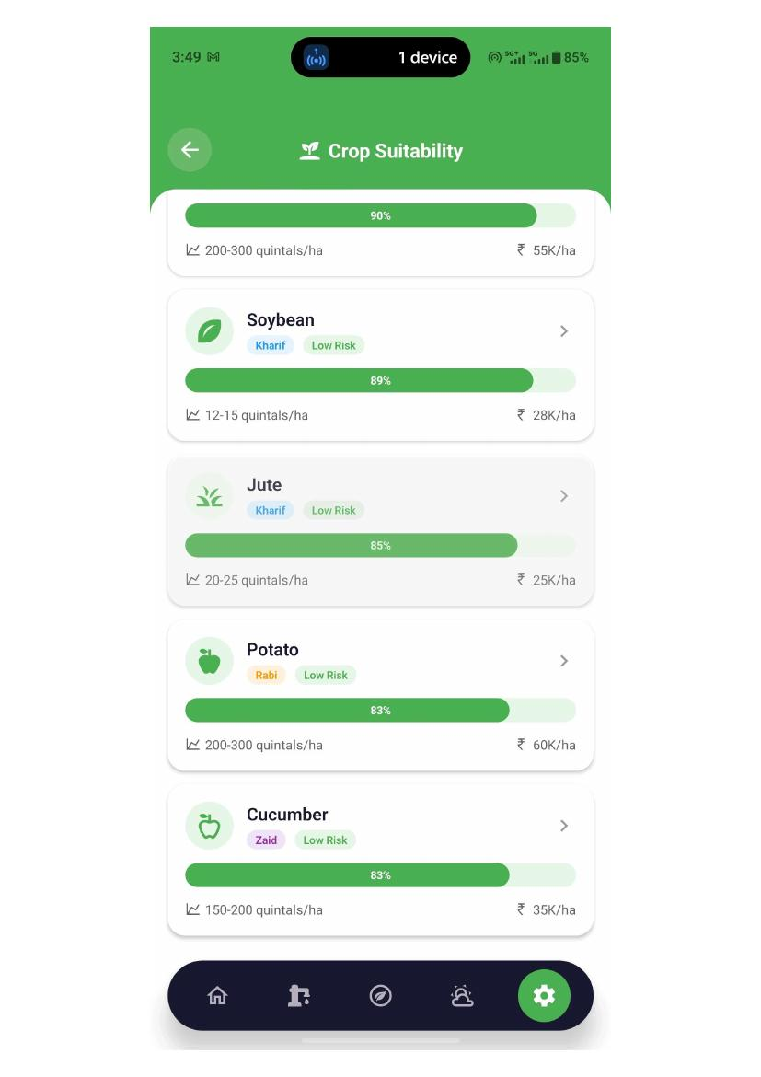
Application screen evidence
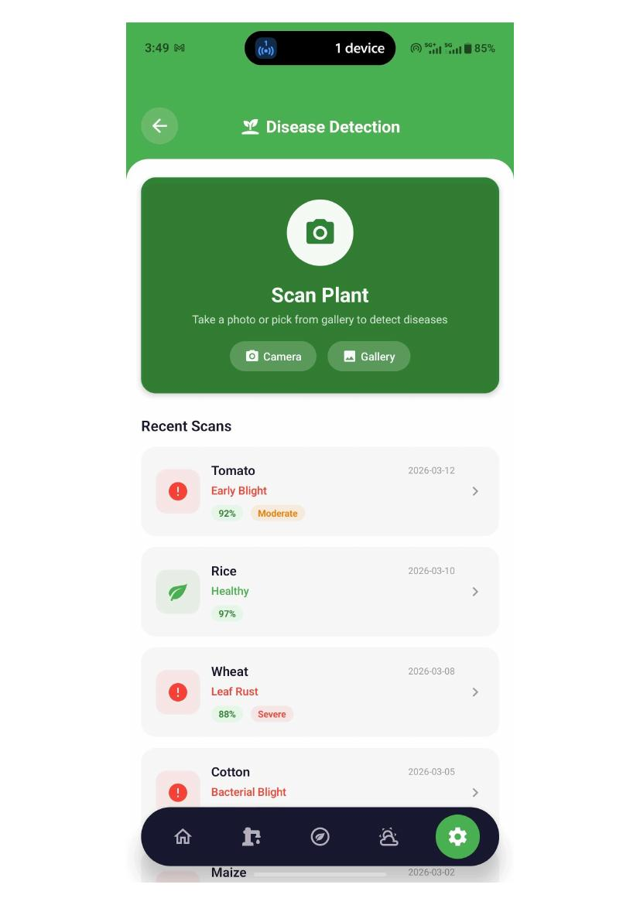
Application screen evidence
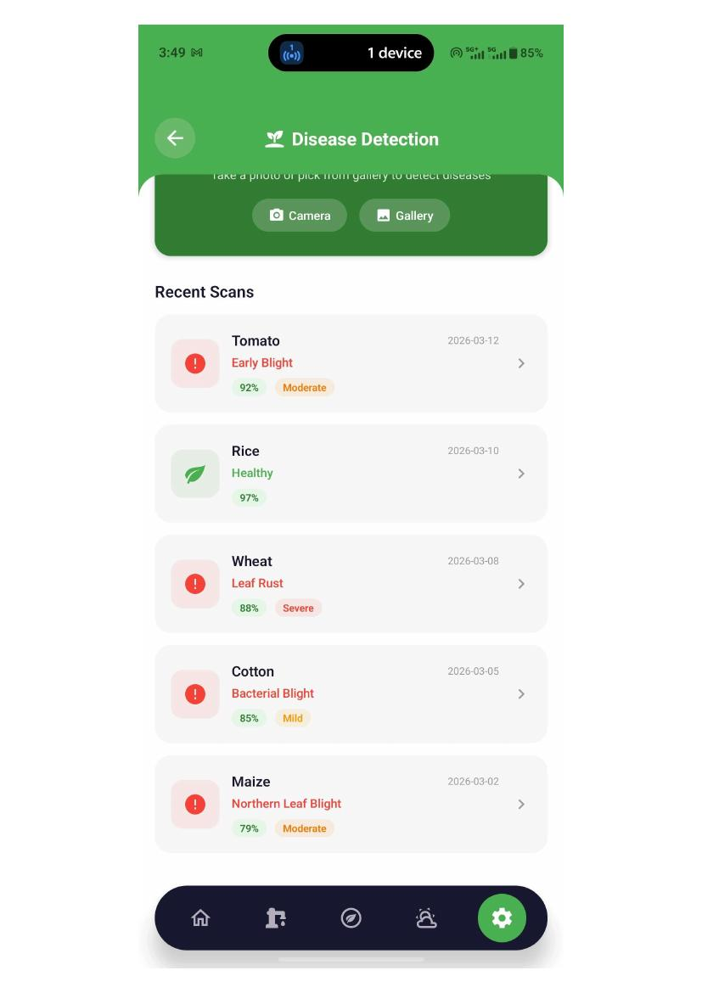
Application screen evidence
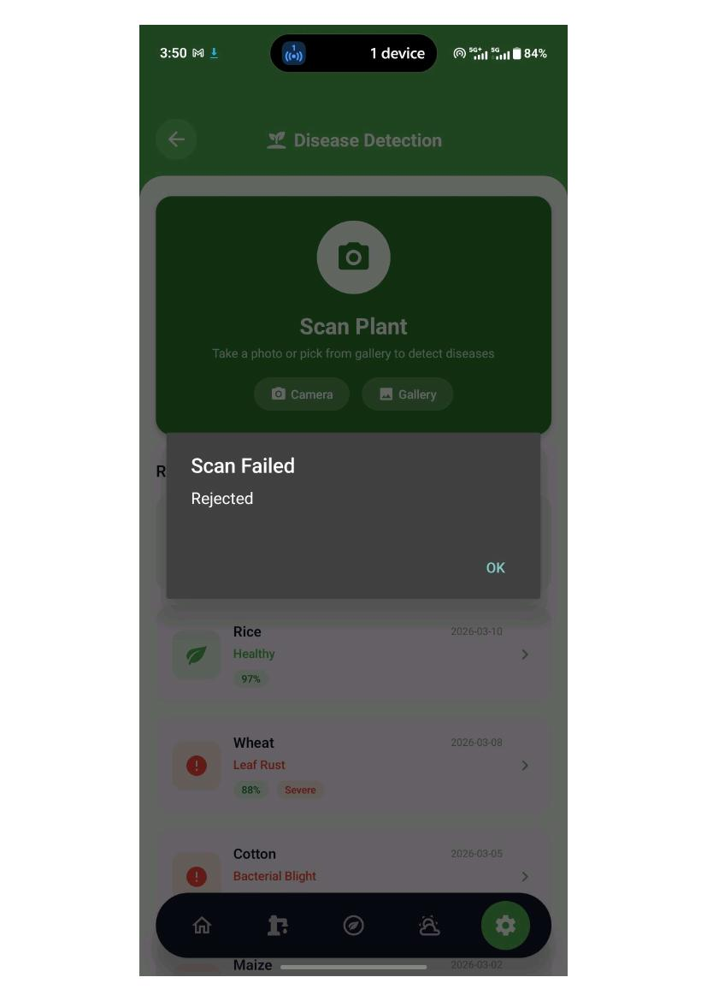
Application screen evidence

TC-017 — settings
Test Scenario | fertilizer calculate
Expected Result | select the crop and target the yield and field area then it will calculate the how much npk is requiored and what would be it costing
Actual Result | it is showing the data . with the calculations
Status | PASS — Working Fine
Remarks | Not recorded

Application Evidence
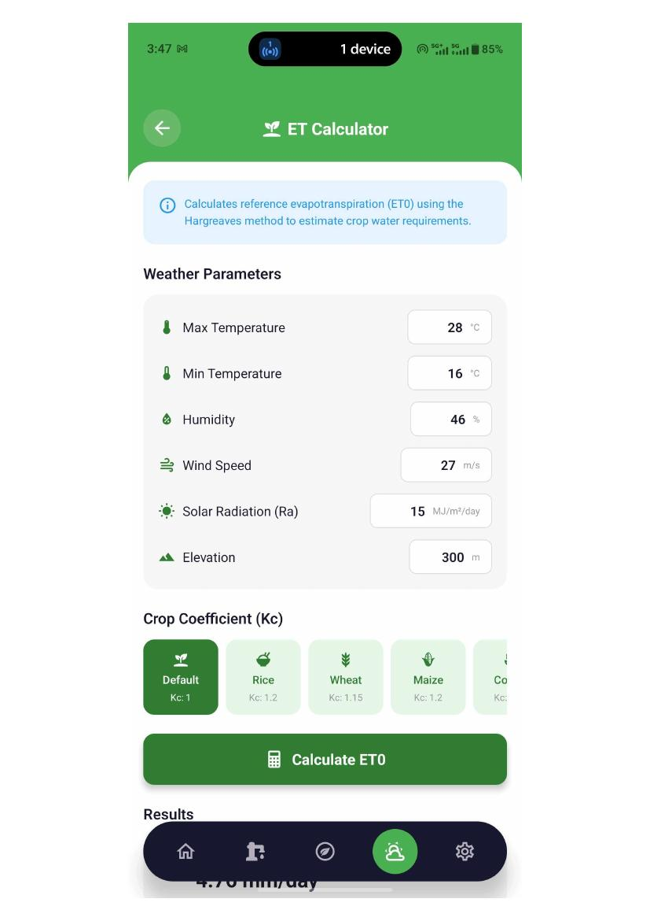
Application screen evidence
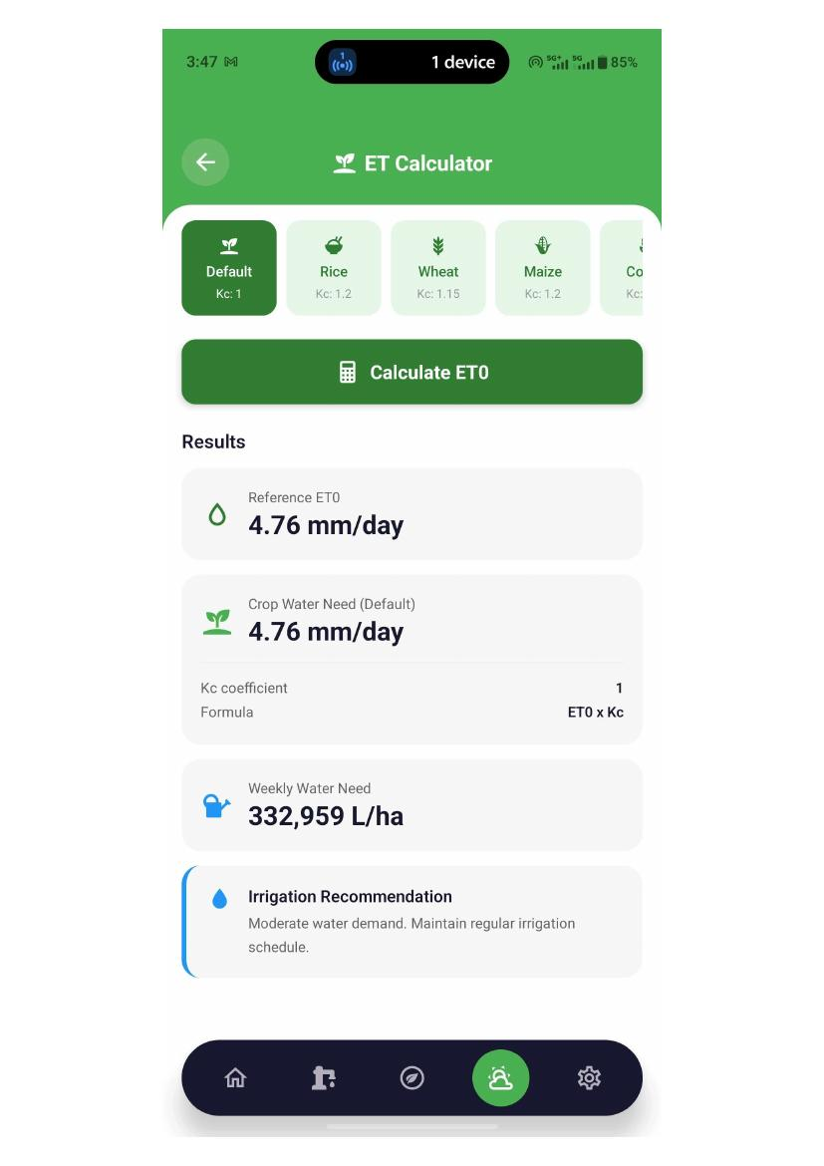
Application screen evidence
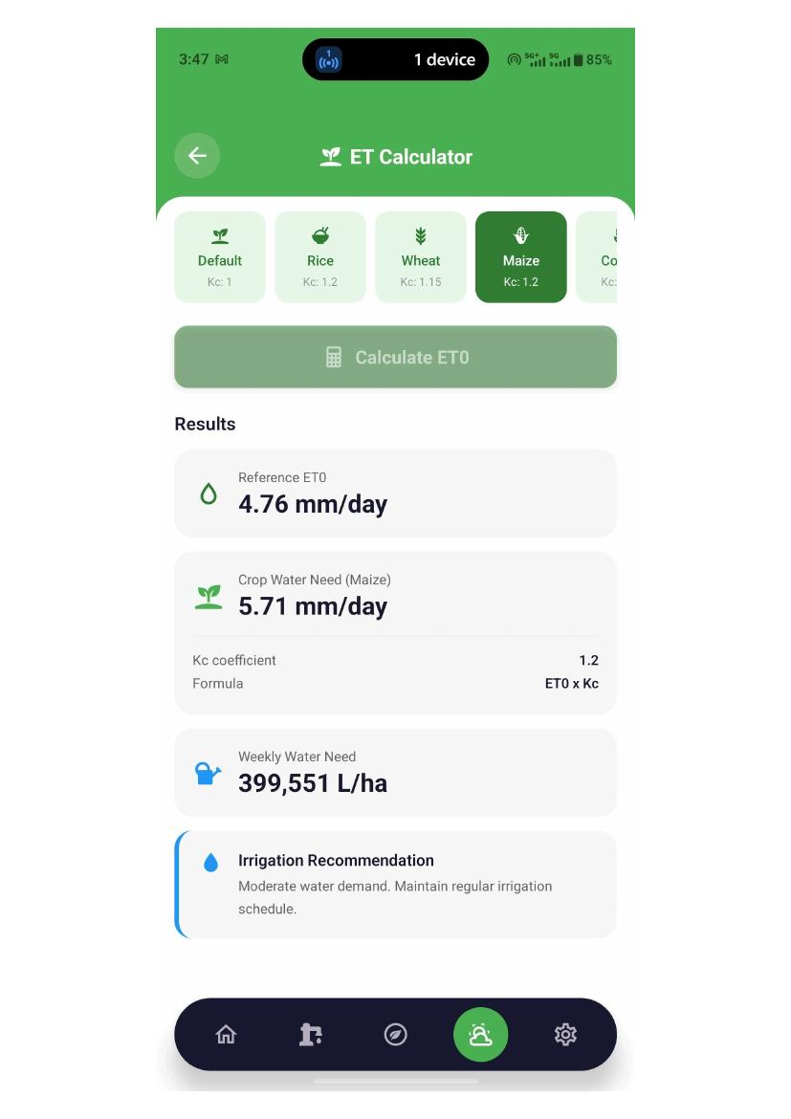
Application screen evidence

TC-018 — settings
Test Scenario | ai field monitor
Expected Result | there are two options green on green and yellow on green we can scan the field through the camera and also from gallery .
Actual Result | it is not working it is taking the picture but it is not giving the result
Status | OPEN — Needs Checking
Remarks | Not recorded

Application Evidence
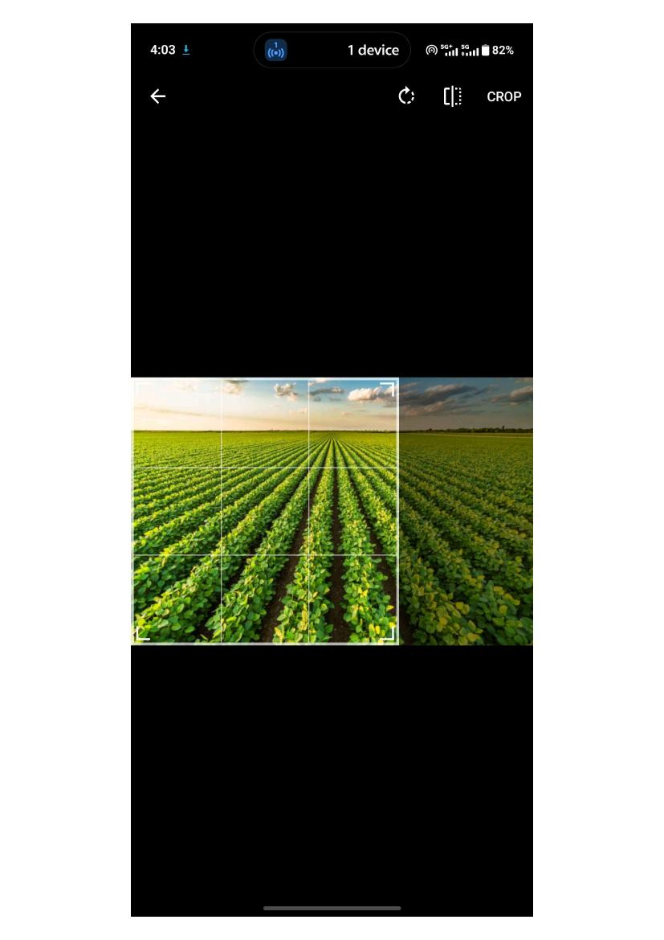
Application screen evidence
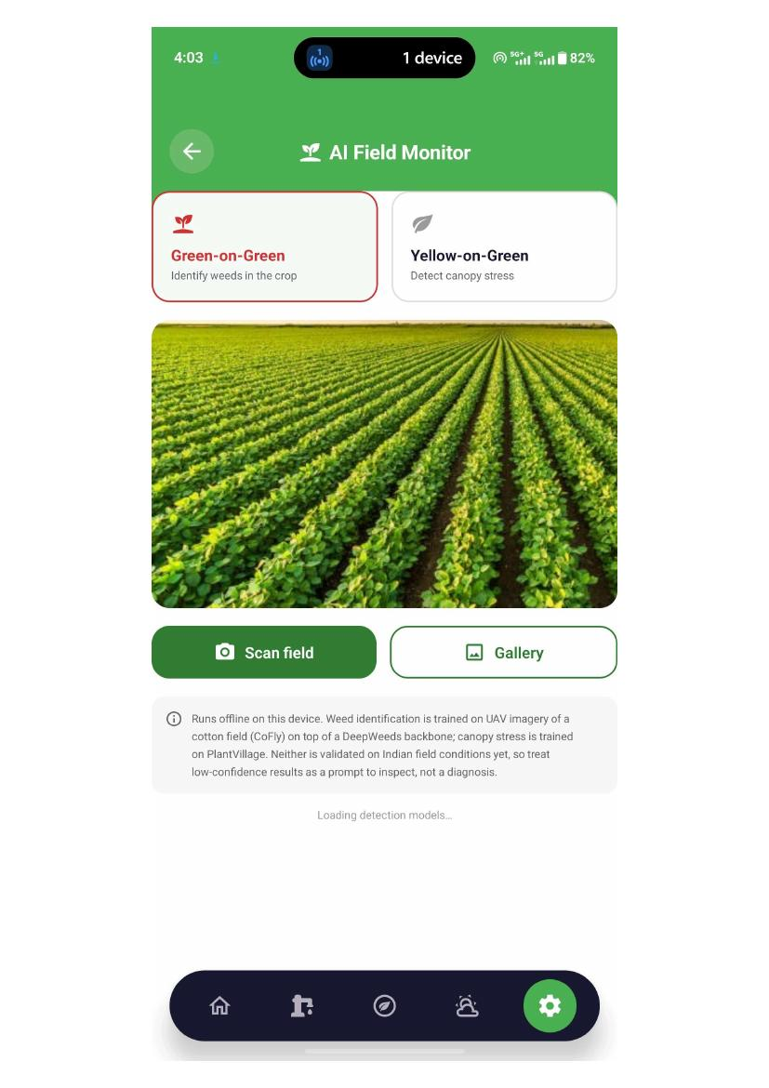
Application screen evidence
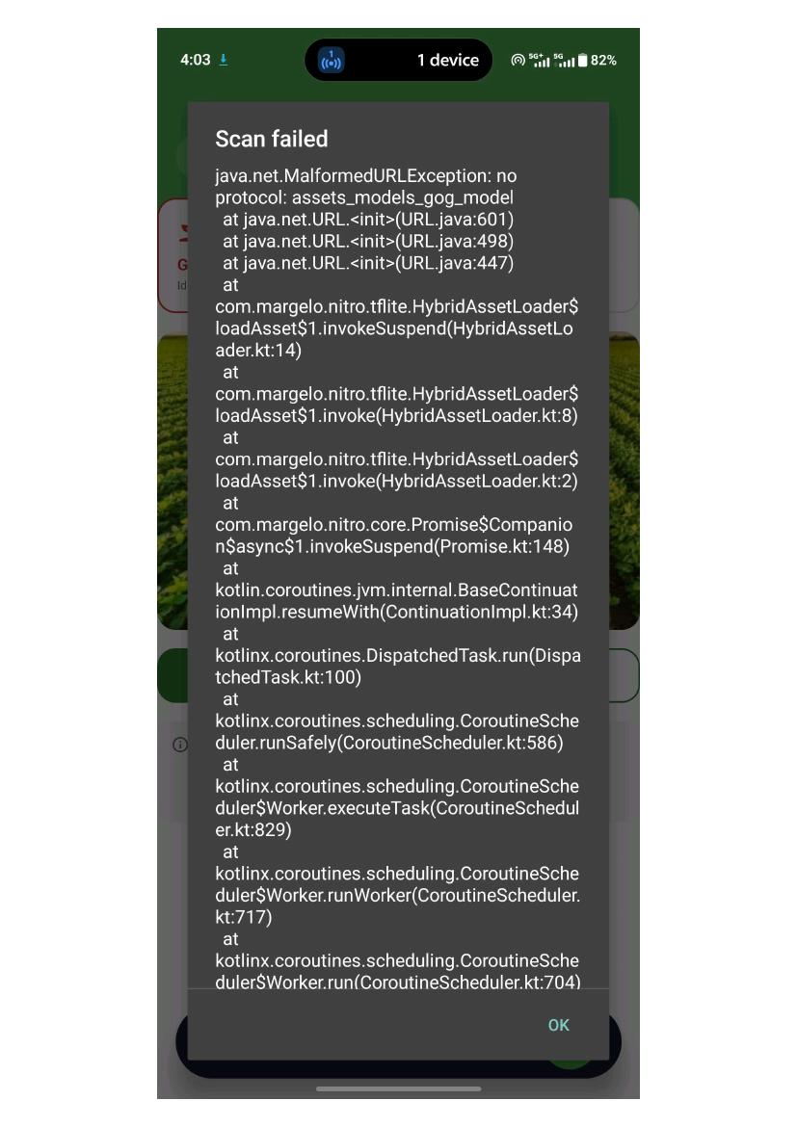
Application screen evidence
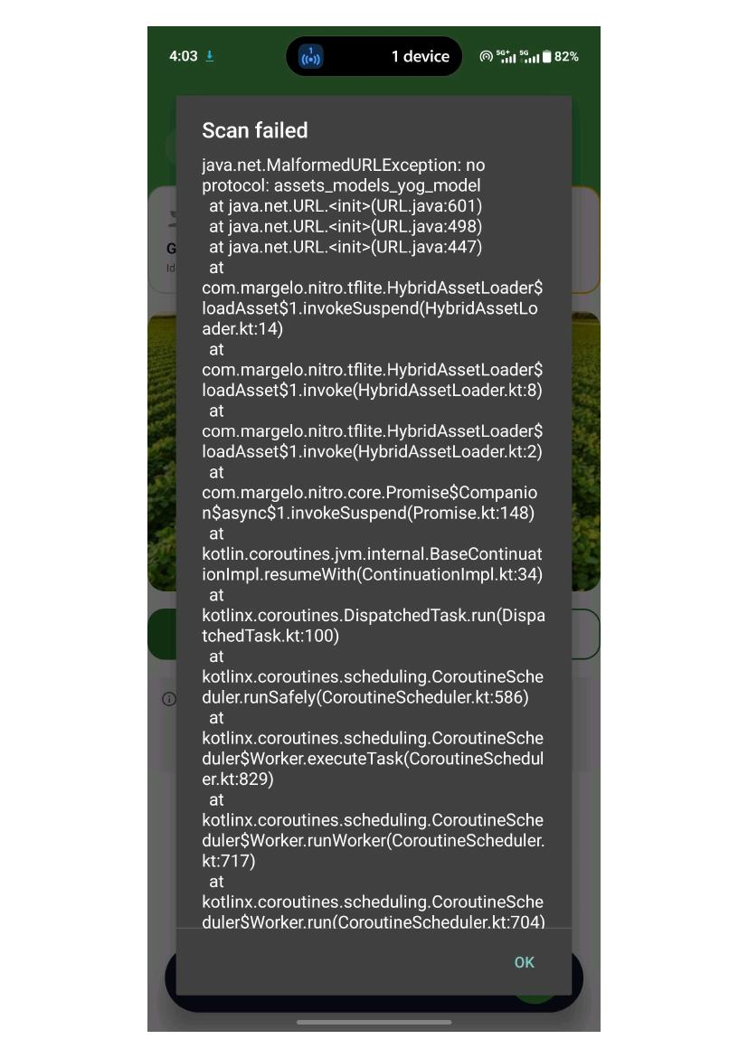
Application screen evidence

TC-019 — profile update
Test Scenario | the user can update the details
Expected Result | the user can update the phone number or the farm name or the farm location
Actual Result | it is not working properly as it is not showing the data because when we register we setup the farm so farm name the place should be shown in it . and the missing of validations are there
Status | OPEN — Needs Checking
Remarks | Not recorded

Application Evidence
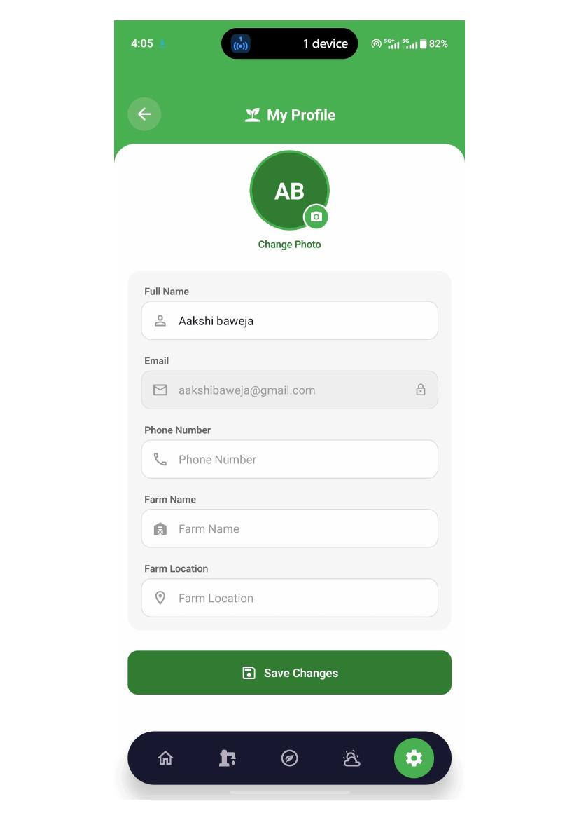
Application screen evidence
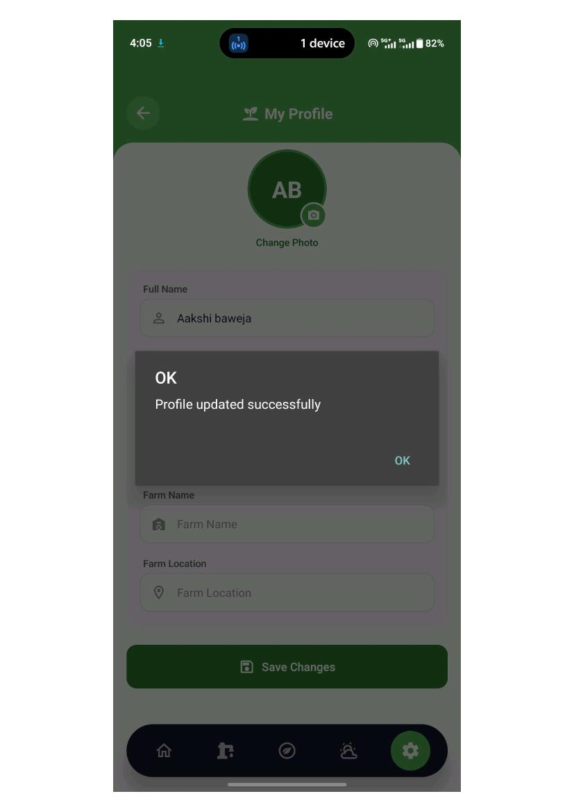
Application screen evidence
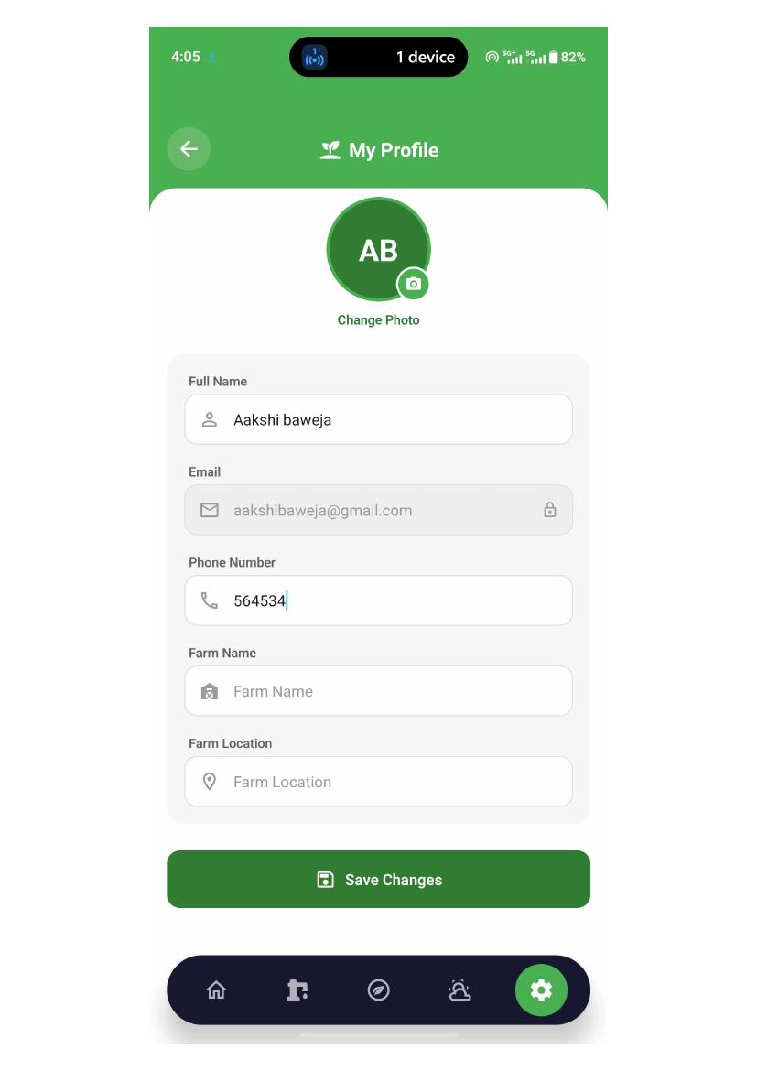
Application screen evidence

TC-020 — farm management
Test Scenario | farm management
Expected Result | it should show the data of the farm
Actual Result | it is showing the dummy data for this
Status | OPEN — Needs Checking
Remarks | Not recorded

Application Evidence
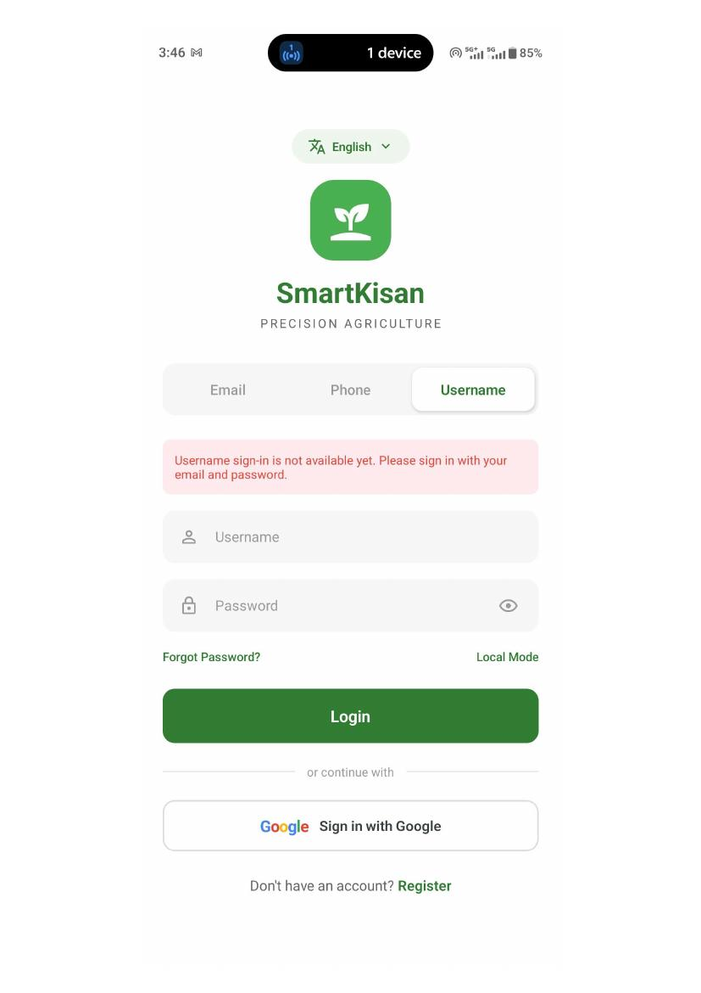
Application screen evidence
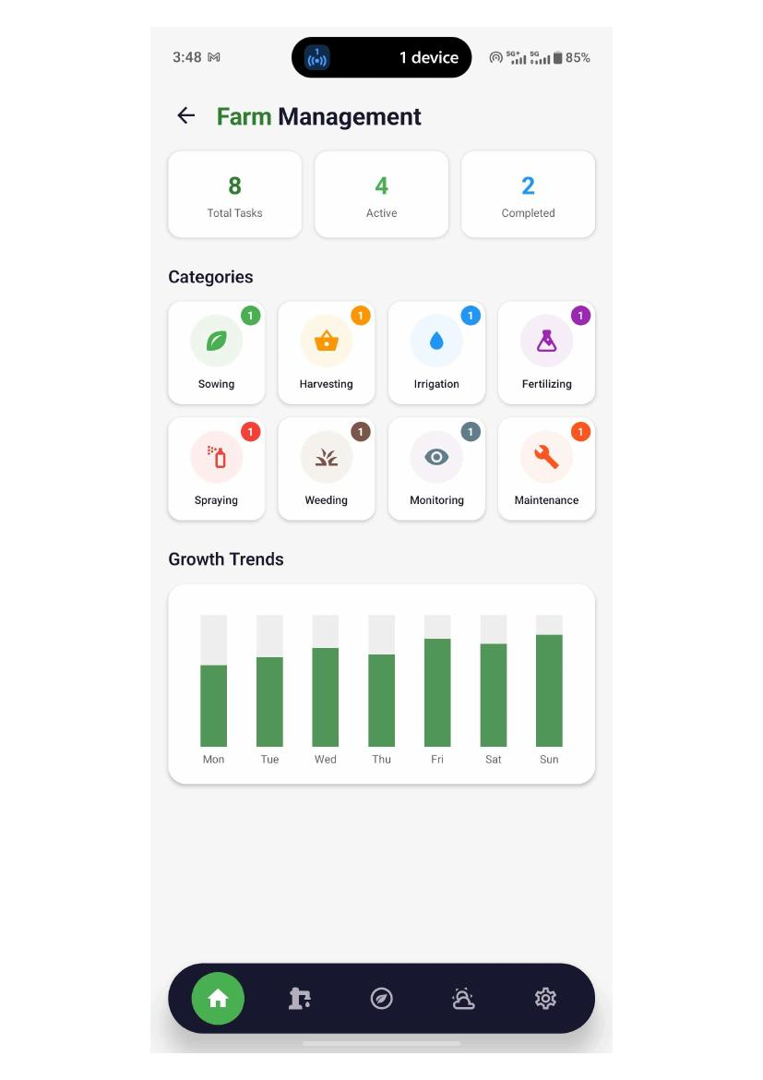
Application screen evidence

TC-021 — devices
Test Scenario | devcices
Expected Result | it should show the list of the devices
Actual Result | as of now there is no device
Status | NOT RECORDED
Remarks | Not recorded

Application Evidence
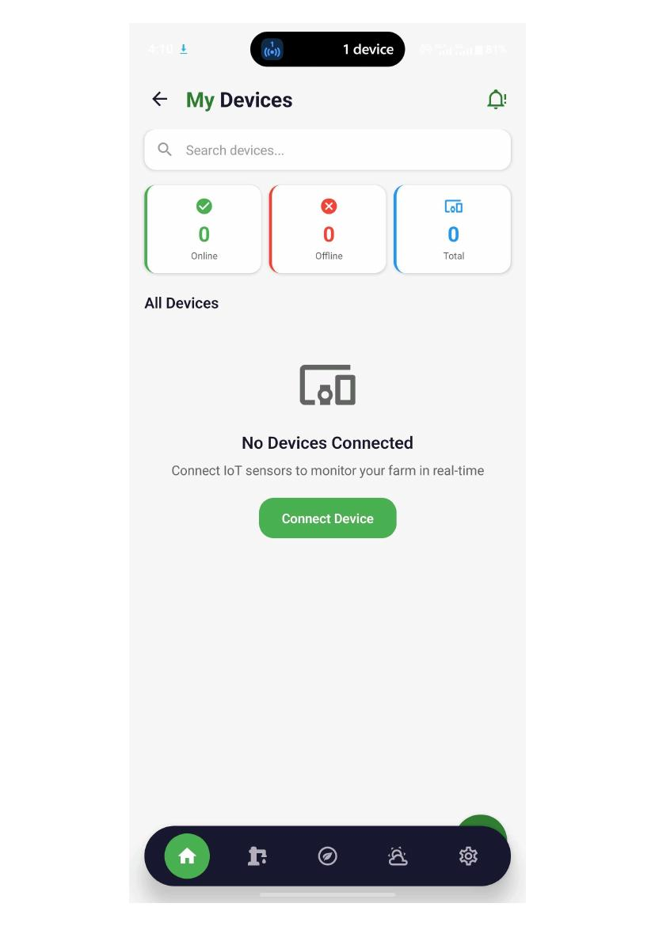
Application screen evidence

6. Management Action Summary
The following areas should be prioritised for development correction and QA retesting based on the recorded test results.
Area | Recommended Action
Registration & Validation | Resolve registration failure and implement validation for duplicate usernames, email format and phone number format.
Authentication | Complete phone OTP login and username/password login. Ensure authentication errors are isolated to the relevant login method.
Data Persistence | Ensure farm, pump and soil-reading information remains available after leaving and reopening the application without requiring re-entry.
User-Specific Dashboard Data | Replace repeated dummy dashboard values with data associated with the authenticated user and their configured farm.
Location-Based Weather | Ensure weather information corresponds to the farm location selected during farm setup.
Agricultural Intelligence | Replace dummy crop-suitability information with actual data and resolve disease-detection and AI Field Monitor result failures.
Profile & Farm Information | Populate registered farm details in the profile and complete required field validations.
Devices | Complete device integration/listing when device functionality is available.

7. Conclusion
The SmartKisan mobile application demonstrates a functional foundation across the primary navigation and several core agricultural workflows. The test results also identify a number of areas that require development attention before the application can be considered ready for a complete functional sign-off.
The highest-priority follow-up areas are authentication, validation, user-specific data persistence, dashboard data accuracy, location-based weather, image-based disease detection, AI Field Monitor processing and profile/farm data consistency. Once these items are addressed, the affected scenarios should be retested and the results updated for final QA approval.
QA STATUS — FUNCTIONAL RETEST RECOMMENDED FOR OPEN ITEMS

