SMARTKISAN · DISEASE MODEL ACCURACY · 14 SEPTEMBER 2026
Where it stands
DISEASE IDENTIFIED  87%  Old model: 28% | CROP IDENTIFIED  99%  Old model: 49% | HEALTHY PLANT CALLED DISEASED  8%  Old model: 42% | CROPS COVERED  9  Old model: 7
Names the right disease, on 1,581 photographs | Knows which plant it is looking at | Sent the farmer to buy a fungicide he did not need | Wheat and rice are new — most of our users grow them

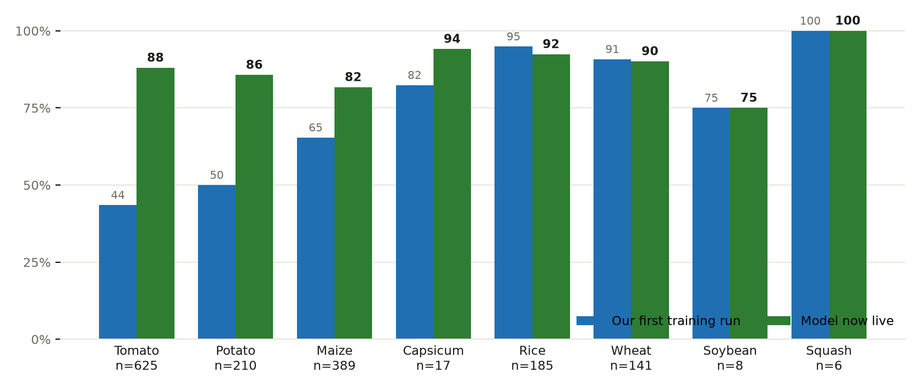
Both bars are our own training runs - the first one, and the one now live. The three crops on the left were the ones failing, and adding real field photographs is what fixed them. Rice and wheat worked from the first run and held. Soybean and squash have too few test images to read anything into. The model the app used until today is not on this chart: it had no rice or wheat classes, so there is no per-crop figure to set against these.

Crop | First run | Now | Test images
Tomato  The crop the testing team will reach for first | 43.5% | 88.0% | 625
Potato  Early blight against late blight was the failure | 50.0% | 85.7% | 210
Maize  Leaf blight against gray leaf spot | 65.4% | 81.7% | 389
Capsicum | 82.4% | 94.1% | 17
Rice | 94.9% | 92.4% | 185
Wheat | 90.8% | 90.1% | 141
Soybean | 75.0% | 75.0% | 8
Squash | 100.0% | 100.0% | 6

One caveat before quoting the crop figures. Tomato, potato and maize are measured largely on newly added collections whose train/test splits we made ourselves, so they are the optimistic end. On the one split published by outside authors, the model scores 57%.
And on the 28% figure. A fifth of the test set is rice and wheat, which the old model had no classes for and so could never have answered. Leaving those out, the old model scores about 35% and the new one about 86%. Both comparisons are real: 35% to 86% is the like-for-like one, and 28% to 87% is what a farmer actually experiences, since the rice and wheat photographs are ones he would have taken anyway.

When the app declines to answer
The app withholds a diagnosis below a confidence threshold and asks for a clearer photograph instead.
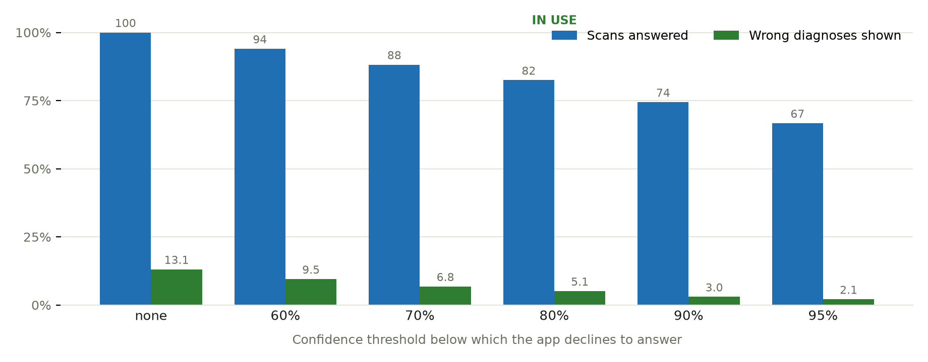
Set to 80%: a quarter fewer wrong diagnoses reach the farmer, for six points of coverage. The previous model answered only 47% of scans at its 70% threshold, against 88% for this one at the same cut.
SmartKisan · Hbeonlabs Technologies Pvt. Ltd. · Measured on 1,581 held-out photographs

