Q1) Write a Java program to print "Hello, World!" to the console.

Program

package demo;

public class Hello{

public static void main(String[] args){

System.out.println(“Hello World”);

}

}

Output:

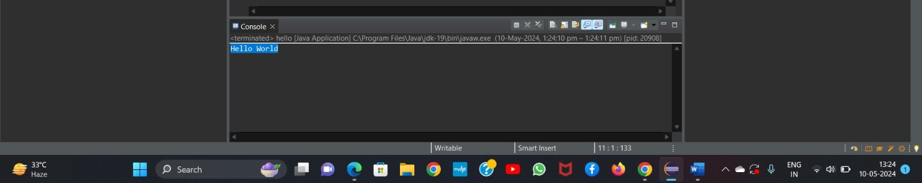

Q2) Write a program to find the sum of two numbers entered by the user

Program

package demo;

import java.util.Scanner;

public class Addition{

public static void mail(String[] args){

Scanner s=new Scanner(System.in);

System.out.println(“Enter 1st number”);

int a=s.nextInt();

System.out.println(“Enter 2nd number”);

int b=s.nextInt();

int c=a+b;

System.out.println(“The sum of the” +a+ “and” +b+ “is:” +c);

s.close();

}

}

Output:

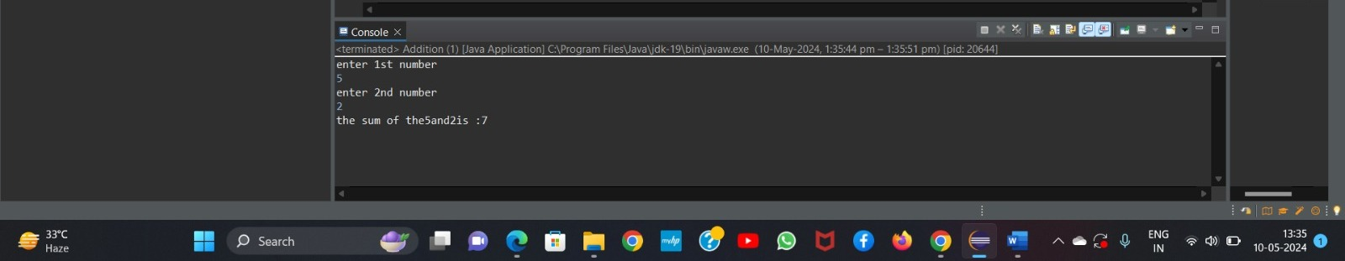

Q3) Write a Java program to check whether a given number is even or odd.

Program

package demo;

import java.util.Scanner;

public class Evenodd{

public static void main(String[] args){

Scanner s=new Scanner(System.in);

System.out.println(“Enter any number :”);

int n=s.nextInt();

if(n %2==0)

{

System.out.println(“even”)

}else{

System.out.println(“odd”)

s.close();

}

}

Output:

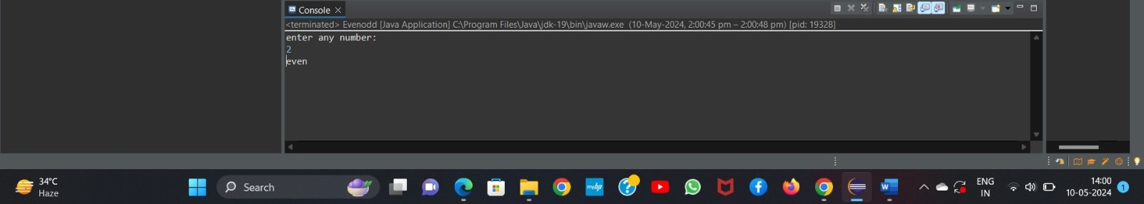

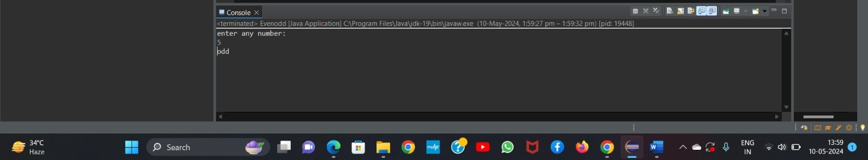

Q4 Write a program to calculate the factorial of a number using recursion.

Program

package demo;

import java.util.Scanner;

public class Factorial

public static int fact(String [] args){

if (n==0)

return 1;

else

return n\*fact(n-1);

}

public static void main(Sting[] args){

Scanner s=new Scanner(System.in);

System.out.println(“enter a number:”);

int num=s.nextInt();

int result=fact(num);

System.out.println(“factorial of number” +num+ ”is:” +fact);

s.close();

}

Output:

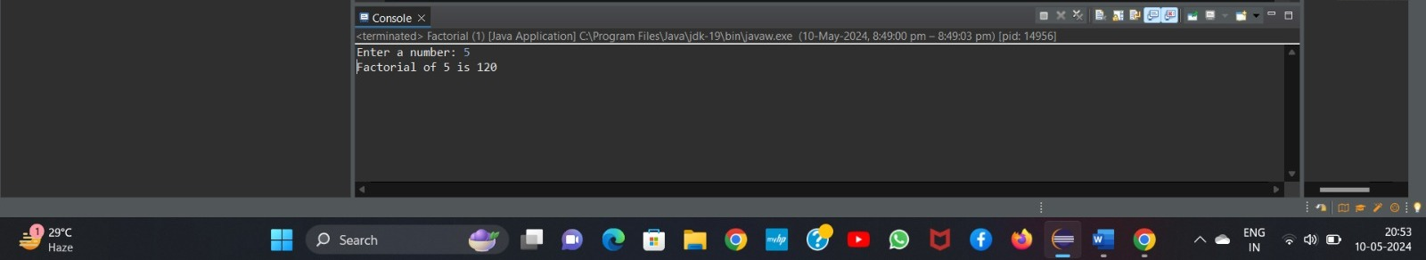

Q5 Write a java program to find greatest of 2 numbers.

Program

package demo;

import java.util.Scanner;

public class GreatestOfTow{

public static void main(String[] args){

Scanner s=new Scanner(System.in);

System.out.println(“Enter the first number :”);

double num1=s.nextDouble();

System.out.println(“Enter the second number :”);

double num2=s.nextDouble();

double max=Math.max(num1,num2);

System.out.println(“Greatest of tow number is :”+ max);

s.close();

}

}

Output:

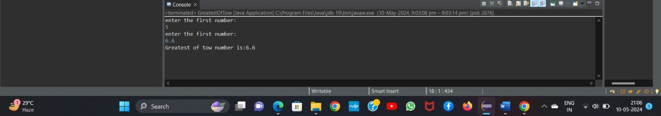

Q6 Write a program to implement a basic calculator that takes input as a string expression and evaluates it.

Program

package demo;

import java.util.Scanner;

public class BasicCalculator{

public static void main(String[] args){

Scanner s=new Scanner(System.in);

System.out.println(“Enter the first number :”);

double num1=s.nextDouble();

System.out.println(“Enter the operator :”);

char operator=s.next().charAt(0);

System.out.println(“Enter the second number :”);

double num2=s.nextDouble();

double result=0;

switch (operator){

case ‘+’:

result=num1+num2;

break;

case ‘-’:

result=num1-num2;

break;

case ‘\*’:

result=num1\*num2;

break;

case ‘/’:

if(num2 !=0)

result=num1/num2;

else

System.out.println(“Cannot divisible by zero!”);

break;

default:

System.out.println(“Invalid operator !”)

}

System.out.println(“Result:”+result);

s.close();

}

}

Output

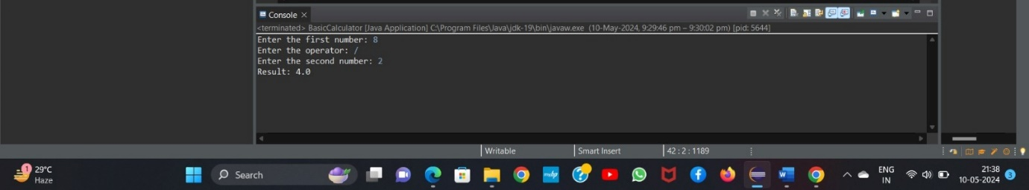

Q7) Create a Java program that compares two numbers and prints the larger one.

Program

Package demo;

public class CompareNumbers {

public static void main(String[] args) {

int num1 = 10;

int num2 = 20;

if (num1 > num2) {

System.out.println("The larger number is: " + num1);

} else {

System.out.println("The larger number is: " + num2);

}

}

}

Output

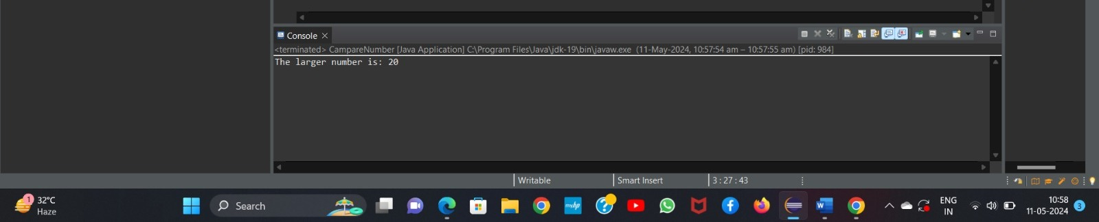

Q8) Write a Java program that takes an age input from the user and determines if they are eligible to vote (considering the legal voting age).

Program

Package demo;

Import java.util.Scanner;

public class ComareNumber{

public static void main(String[] args){

Scanner s=new Scanner(System.in);

System.out.println(“enter the voter’s age:”);

int age=s.nextInt();

if(age>=18){

System.out.println(“voter is eligible for voting”);

}else{

System.out.println(“voter is not eligible for voting”);

}s.close();

}

} Output