**Lab-2**

Q1.     Write a program that takes a student's score as input and outputs the corresponding grade based on the following scale:

A: 90-100

B: 80-89

C: 70-79

D: 60-69

F: 0-59

Program:-

package demo

import java.util.Scanner;

public class calculateGrade{

public static void main(String[] args){

Scanner s=new Scanner(System.in);

System.out.println(“Enter the score of student”);

double score=s.nextDouble();

char grade=calculateGrade(score);

System.out.println(“the students grade is:”+grade);

s.close()

}

Public static char calculateGrade(double score){

char grade;

if(score>=90 &&score<=100){

grade=’A’;

}else if(score>=80 && score<=89){

grade=’B’;

}else if(score>=70 && score<=79){

grade=’C’;

}else if(score>=60 && score<=69){

grade=’D’;

}else{

grade=’F’;

}

return grade;

}

Output:

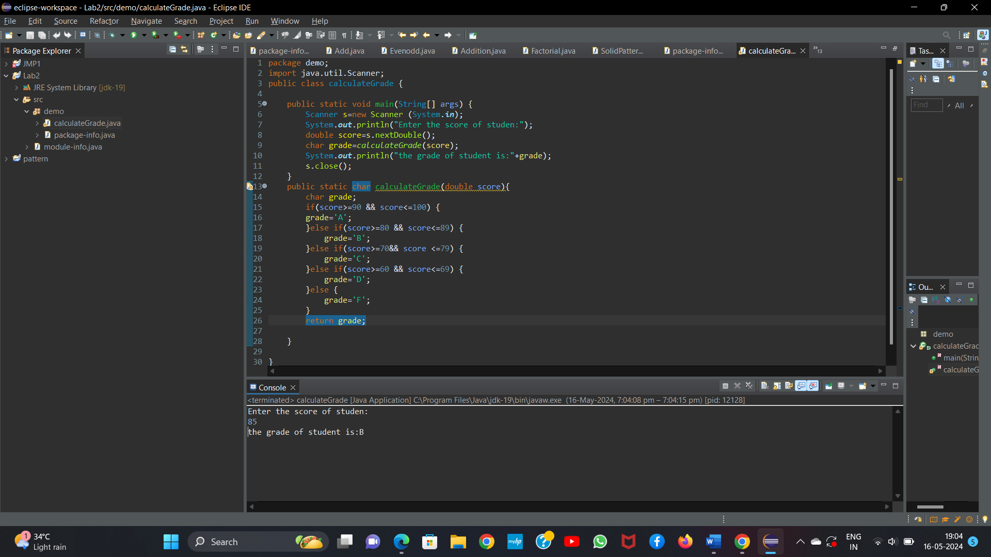

Q2.     Write a program to check if a given year is a leap year. (A year is a leap year if it is divisible by 4 but not by 100, or it is divisible by 400.)

Program

package demo;

import java.util.Scanner;

public class LeapYear(){

public static void main(string[] args){

scanner s=new Scanner(System.in)

System.out.println(“Enter a year:”);

int year=s.nextInt();

if(isLeapYear(year)){

System.out.println(year+ “is a leap year”);

}else{

System.out.println(year+ “is not a leap year”);

}

s.close();

}

Public static boolean isleapYear(int year){

If((year %4==0&& year%100!=0 || year%400==0)){

return true;

}else{

return false;

}

}

}

Output:-

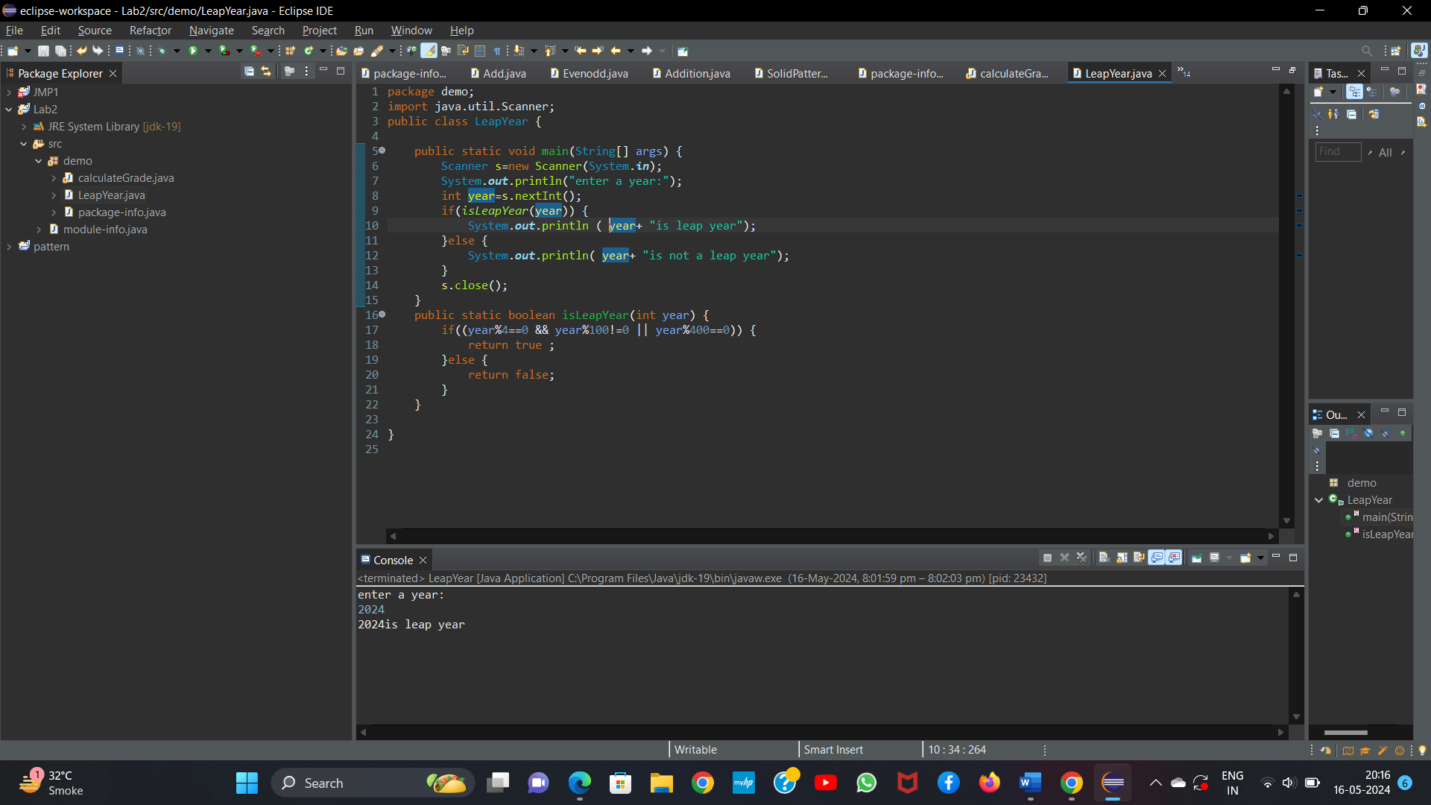

Q3.     Write a program that takes an integer as input and checks if it is positive, negative, or zero.

Program

package demo;

import java.util.Scanner;

public class PosNegZero{

public static void main(String[] args)

Scanner s=new Scanner(System.in);

System.out.println(“enter a number:”);

Int num=s.nextInt();

checkNumber(num);

s.close();

}

Public static void checkNumber(int num){

If(num>0){

System.out.println(“the number is a positive number”);

}else if(num<0){

System.out.println(“the number is a negative number”);

}else{

System.out.println(“zero”);

}

}

Output

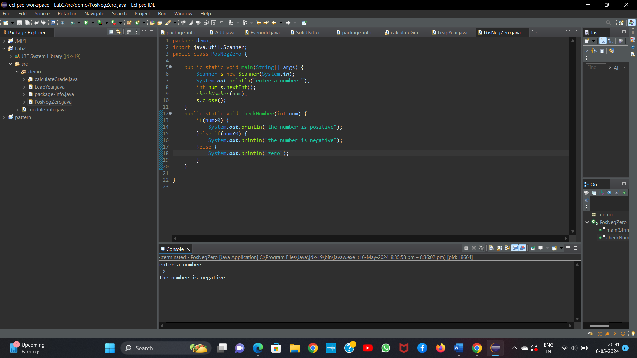

Q4) Write a program that prints numbers from 1 to 10 using a loop.

Program:-

package demo;

public class printNumber{

public static void main(String[] args){

//loop for printing number from 1 to 10

for(int i=1;i<=10;i++){

System.out.println(i);

}

}

}

Output:

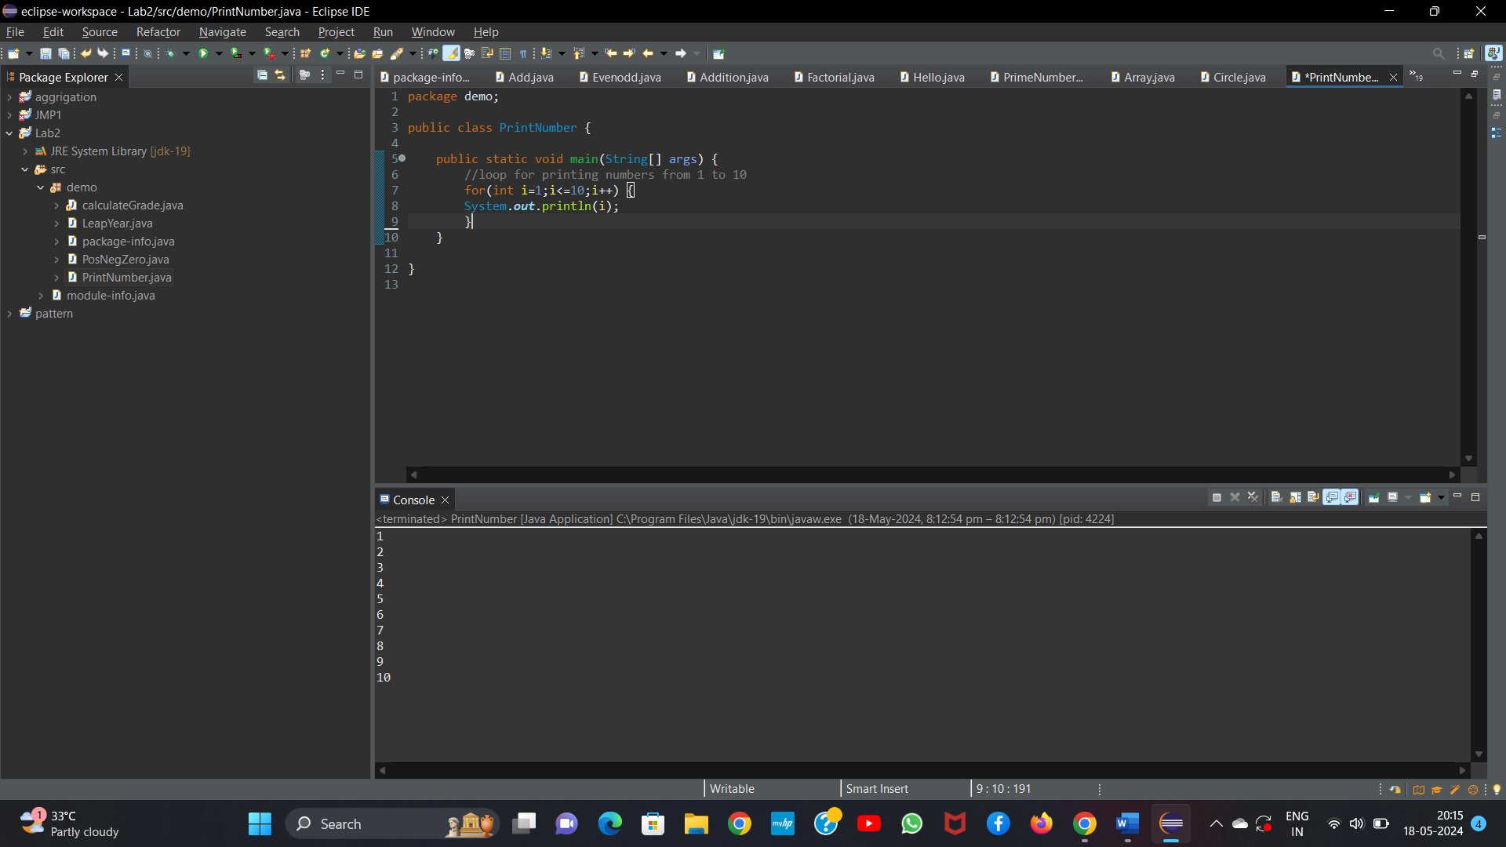

5.     Write a program that takes an integer N as input and calculates the sum of entered numbers.

Program

package demo;

import java.util.Scanner;

public class SumOfNumber{

public static void main(String[] args){

System.out.println(“Enter the number of N:”);

Scanner s=new Scanner(System.in);

int N=s.nextInt();

int sum=0;

System.out.println(“Enter ”+N+ “ Numbers”:);

//loop of calculating sum of n number

for(int i=0;i<N;i++){

int num=s.nextInt();

sum+=num;

}

System.out.println(“the sum of the N numbers is ”+sum);

s.close();

}

}

Output:

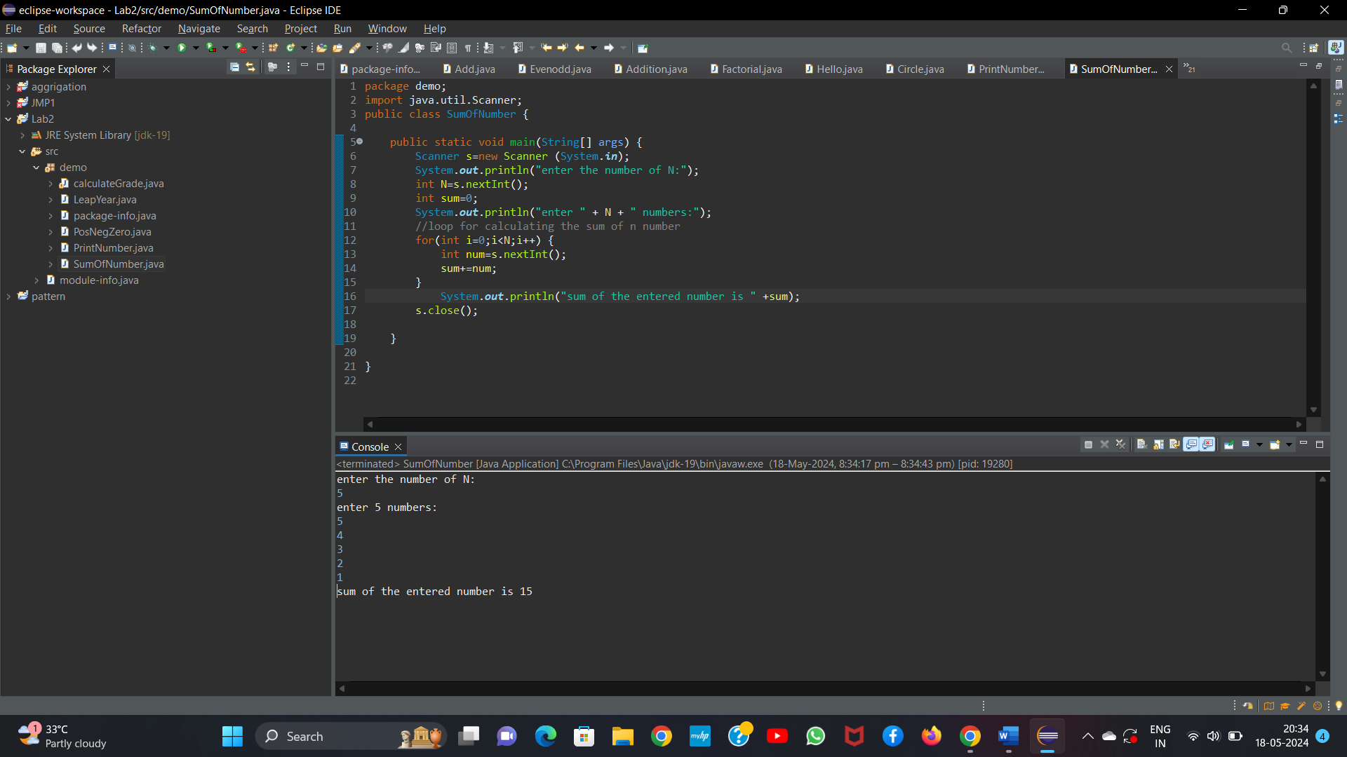

6.     Write a program that takes an integer as input and prints its multiplication table up to 10.

Program

package demo;

import java.util.Scanner;

public class MultiplicationTable{

public static void main(String[] args){

Scanner s=new Scanner(System.in);

System.out.println(“Enter a number”);

int num=s.nextInt();

//loop for multiplication of number table

for(int i=1;i<=10;i++){

System.out.println(num+ “*” +i+ “=”+(num*i));

}

s.close();

}

}

Output:

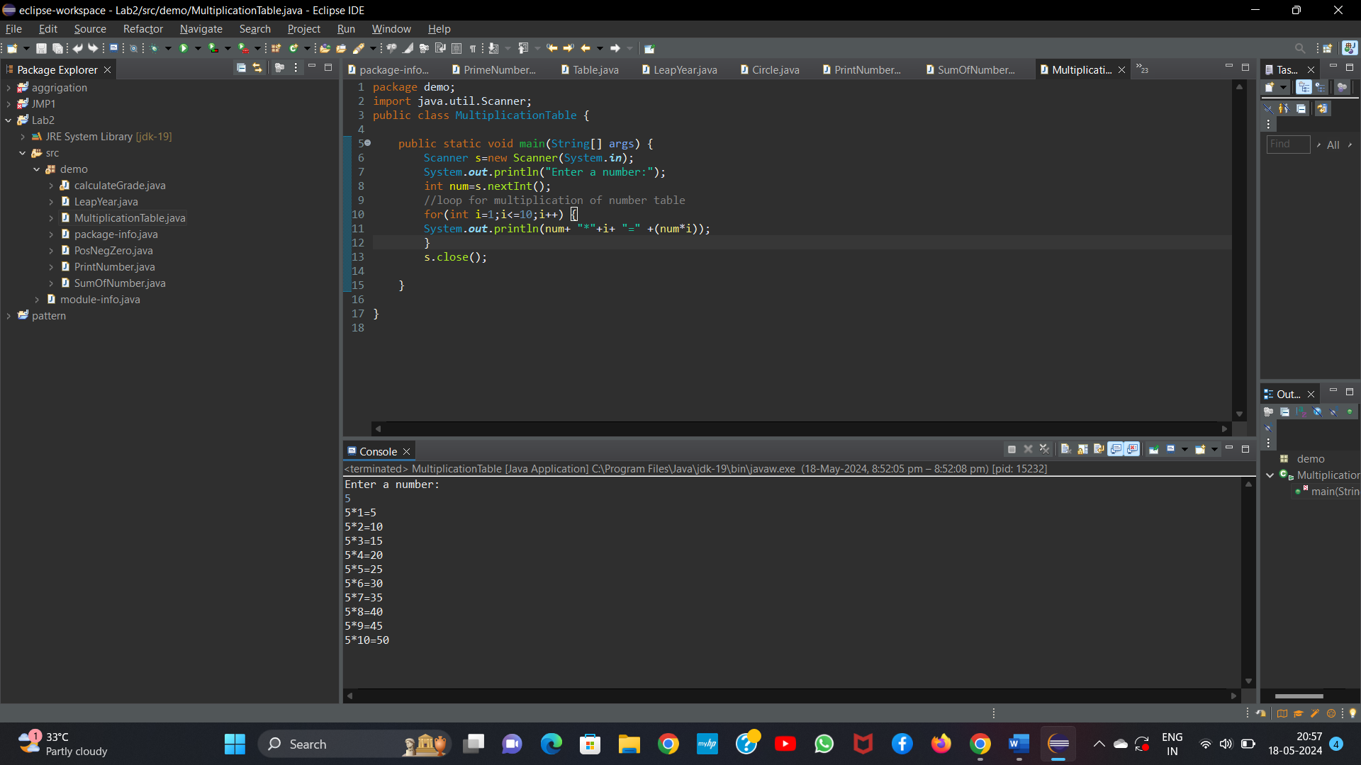

7.     Write a program that takes a positive integer as input and prints its digits in reverse order.

Program:

package demo;

import java.util.Scanner;

public class ReverseDigits {

public static void main(String[] args) {

Scanner scanner = new Scanner(System.in);

System.out.print("Enter a positive integer: ");

int number = scanner.nextInt();

// Check if the number is positive

if (number <= 0) {

System.out.println("Invalid input! Please enter a positive integer.");

} else {

// Reverse the digits of the number

int reversedNumber = reverseDigits(number);

System.out.println("Digits in reverse order: " + reversedNumber);

]

scanner.close();

}

public static int reverseDigits(int num) {

int reversed = 0;

while (num != 0) {

int digit = num % 10;

reversed = reversed * 10 + digits;

num /= 10;

}

return reversed;

}

}

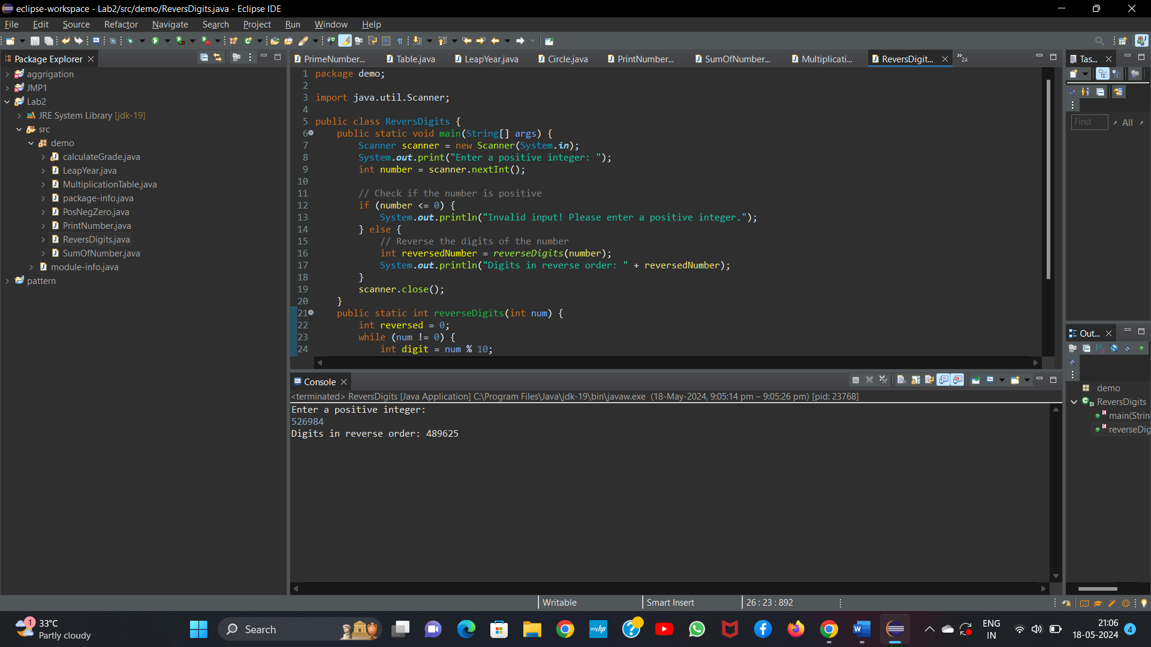

8.     Create a class Animal with a method makeSound() that prints "Some generic animal sound". Create another class Dog that extends Animal and overrides the makeSound() method to print "Bark". Write a main method to demonstrate calling the makeSound() method on an Animal reference holding a Dog object.

Progarm:

package demo;

class Animal {

// Method to make sound

public void makeSound() {

System.out.println("Some generic animal sound");

}

}

class Dog extends Animal {

// Override method to make sound

public void makeSound() {

System.out.println("Bark");

}

}

// Main class to demonstrate calling makeSound() method

public class Main {

public static void main(String[] args) {

// Creating an Animal reference holding a Dog object

Animal animal = new Dog();

// Calling makeSound() method on Animal reference

animal.makeSound();

}

}

Output:

