**LAB-2**

1. Write a program that takes a student's score as input and outputs the corresponding grade based on the following scale:

A: 90-100

B: 80-89

C: 70-79

D: 60-69

F: 0-59

Program-

**package** demo;

**import** java.util.Scanner;

**public** **class** grade {

**public** **static** **void** main(String[] args) {

// **TODO** Auto-generated method stub

Scanner sc=**new** Scanner(System.***in***);

System.***out***.println("Enter Student's Score:");

//Takes the user input

**int** score=sc.nextInt();

**char** grade;

**if**(score>=90 && score<=100) {

grade='A';

}

**else** **if**(score>=80) {

grade='B';

}

**else** **if**(score>=70) {

grade='C';

}

**else** **if**(score>=60) {

grade='D';

}

**else** {

grade='F';

}

System.***out***.println("Grade of Student is: "+ grade);

sc.close();

}

}

Output-

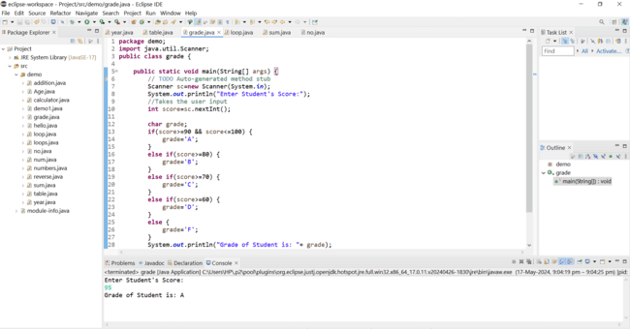

1. Write a program to check if a given year is a leap year. (A year is a leap year if it is divisible by 4 but not by 100, or it is divisible by 400.)

Program-

**package** demo;

**import** java.util.Scanner;

**public** **class** year {

**public** **static** **void** main(String[] args) {

// **TODO** Auto-generated method stub

**int** year;

Scanner sc=**new** Scanner(System.***in***);

System.***out***.println("Enter year: ");

//Takes user input

year=sc.nextInt();

//checks if the year is divisible by 4 and not by 100 or the year is divisible by 400

**if**(((year%4==0)&&(year%100!=0))|| (year%400==0))

{

//Prints the result if it is leap year

System.***out***.println(year+ " is a leap year");

}

**else**

{

//Prints the result if it is not a leap year

System.***out***.println(year+ " is not a leap year");

}

}

}

Output -

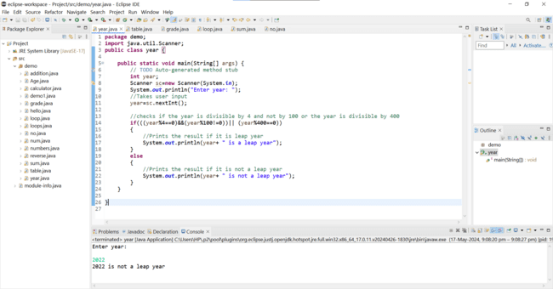

1. Write a program that takes an integer as input and checks if it is positive, negative, or zero.

Program-

**package** demo;

**import** java.util.Scanner;

**public** **class** numbers {

**public** **static** **void** main(String args[]) {

// **TODO** Auto-generated constructor stub

**int** k;

Scanner s=**new** Scanner(System.***in***);

System.***out***.println("Enter a number:");

//Takes input from user

k=s.nextInt();

//checks if the number is less than zero

**if**(k<0)

{

//Prints it is a negative integer

System.***out***.println(" It is a negative integer");

}

//checks if the number is greater than 0

**else** **if**(k>0)

{

//Prints it is a positive integer

System.***out***.println(" It is a positive integer");

}

**else**

{

//Prints it is zero

System.***out***.println(" It is zero");

}

}

}

Output-

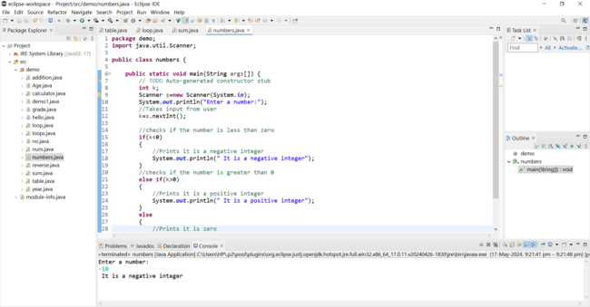

4.Write a program that prints numbers from 1 to 10 using a loop.

Program-

**package** demo;

**import** java.util.Scanner;

**public** **class** loop {

**public** **static** **void** main(String[] args) {

// **TODO** Auto-generated method stub

System.***out***.println(" FOR LOOP ");

**int** n;

//Loop from 0 to 10

**for**(n=0;n<=10;n++)

{

//Prints the value of n

System.***out***.println("Value is:" + n);

}

}

}

Output -

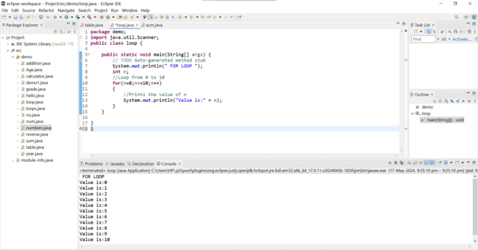

5.Write a program that takes an integer N as input and calculates the sum of entered numbers.

Program-

**package** demo;

**import** java.util.Scanner;

**public** **class** sum {

**public** **static** **void** main(String[] args) {

// **TODO** Auto-generated method stub

**int** n,digit,sum=0;

Scanner sc=**new** Scanner(System.***in***);

//For taking user input

System.***out***.println(" Enter a number: ");

n=sc.nextInt();

//Accepts a no as input from user

**while**(n>0)

{

//finds the last digit of the given number

digit=n%10;

//adds last digit to variable sum

sum=sum+digit;

//removes the last digit from the number

n=n/10;

}

//prints the result

System.***out***.println(" Sum of digits is: " + sum);

}

}

Output-

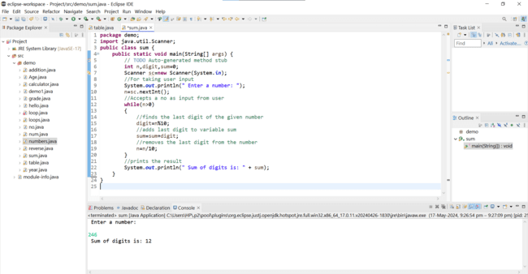

1. Write a program that takes an integer as input and prints its multiplication table up to 10.

Program-

**package** demo;

**import** java.util.Scanner;

**public** **class** table {

**public** **static** **void** main(String[] args) {

// **TODO** Auto-generated method stub

**int** a;

Scanner sc=**new** Scanner(System.***in***);

System.***out***.println("Enter a number:");

//Takes user input

a=sc.nextInt();

//Loop from 1 to 10

**for**(**int** i=1;i<=10;i++)

{

//Prints the mutiplication result

System.***out***.println(a + " * "+ i +" = "+ (a*i));

}

}

}

**package** demo;

**import** java.util.Scanner;

**public** **class** table {

**public** **static** **void** main(String[] args) {

// **TODO** Auto-generated method stub

**int** a;

Scanner sc=**new** Scanner(System.***in***);

System.***out***.println("Enter a number:");

//Takes user input

a=sc.nextInt();

//Loop from 1 to 10

**for**(**int** i=1;i<=10;i++)

{

//Prints the multiplication result

System.***out***.println(a + " * "+ i +" = "+ (a*i));

}

}

}

Output-

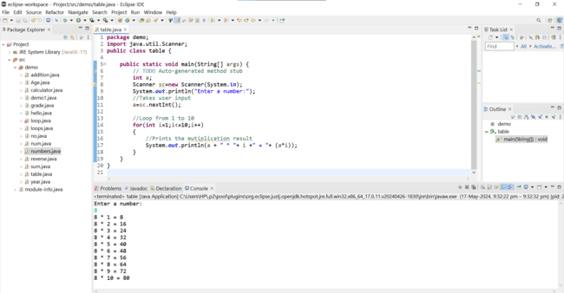

1. Write a program that takes a positive integer as input and prints its digits in reverse order.

Program-

**package** demo;

**import** java.util.Scanner;

**public** **class** reverse {

**public** **static** **void** main(String[] args) {

// **TODO** Auto-generated method stub

**int** a,rev=0,rem;

Scanner sc=**new** Scanner(System.***in***);

System.***out***.println("Enter number:");

//Takes user input

a=sc.nextInt();

**int** n=a;

//run loop until become 0

**while**(a!=0)

{

//gets last digit from num

rem=rev*10;

rev=rem+a%10;

//remove the last digit from a

a = a/10;

}

System.***out***.println("Reverse of "+ n + " is "+ rev);

}

}

Output-

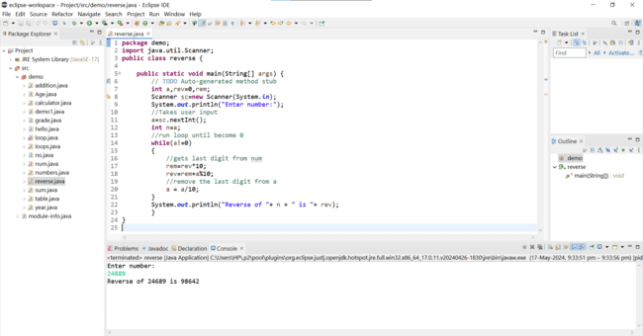

1. Create a class Animal with a method makeSound() that prints "Some generic animal sound". Create another class Dog that extends Animal and overrides the makeSound() method to print "Bark". Write a main method to demonstrate calling the makeSound() method on an Animal reference holding a Dog object.

Program-

**package** demo;

//Define the Animal class

**class** Animal

{//method to make a generic animal sound

**public** **void** makeSound() {

System.***out***.println("Some generic animal sounds");

}

}

//Define the Dog class that extends animal

**class** Dog **extends** Animal

{//Override the makeSound() method

**public** **void** makeSound() {

System.***out***.println("Bark");

}

}

**public** **class** Inheritance {

**public** **static** **void** main(String[] args) {

// **TODO** Auto-generated method stub

//Create an Dog reference holding a d object

Dog d=**new** Dog();

d.makeSound();

//This will call the overridden method in Dog class and print "Bark"

}

}

Output-

