HACKERRENK QUESTIONS

1)Query a list of CITY names from STATION for cities that have an even ID number. Print the results in any order, but exclude duplicates from the answer.  
The STATION table is described as follows:

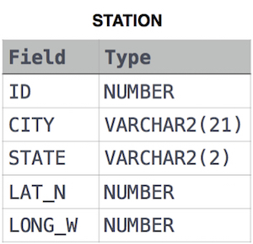

SELECT DISTINCT CITY FROM STATION

WHERE MOD(ID,2)=0;

MOD is a type of function to check the reminder:

To find rows where a specified column has even values:

SELECT *

FROM table_name

WHERE mod(column_name,2) = 0;

* To find rows where a specified column has odd values:

SELECT *

FROM table_name

WHERE mod(column_name,2) <> 0;

In MS SQL Server, there is no MOD function and you can use %.

* To find rows where a specified column has even values:

SELECT *

FROM table_name

where column_name % 2 = 0;

2)Find the difference between the total number of CITY entries in the table and the number of distinct CITY entries in the table.  
The STATION table is described as follows:



where LAT_N is the northern latitude and LONG_W is the western longitude.

For example, if there are three records in the table with CITY values 'New York', 'New York', 'Bengalaru', there are 2 different city names: 'New York' and 'Bengalaru'. The query returns , because . TOTAL NUMBER OF RECORDS – NUMBER OF UNIQUE CITY NAMES = 3-2=1.

SELECT COUNT(CITY)-COUNT(DISTINCT CITY)

FROM STATION;

Query the two cities in STATION with the shortest and longest CITY names, as well as their respective lengths (i.e.: number of characters in the name). If there is more than one smallest or largest city, choose the one that comes first when ordered alphabetically.  
The STATION table is described as follows:



SELECT CITY,LENGTH(CITY) FROM STATION ORDER BY LENGTH(CITY) ASC,CITY ASC LIMIT 1;

SELECT CITY,LENGTH(CITY) FROM STATION ORDER BY LENGTH(CITY) DESC,CITY DESC LIMIT 1;

ALTERNATIVE WAY

SELECT CITY,LENGTH(CITY) FROM STATION

WHERE LENGTH(CITY) IN (SELECT MAX(LENGTH(CITY)) FROM STATION

UNION

SELECT MIN(LENGTH(CITY)) FROM STATION)

ORDER BY LENGTH(CITY) DESC,CITY ASC LIMIT 2;

2)Query the list of CITY names starting with vowels (i.e., a, e, i, o, or u) from STATION. Your result cannot contain duplicates.

Input Format

The STATION table is described as follows:



SELECT DISTINCT CITY FROM STATION WHERE CITY LIKE'A%'

UNION

SELECT DISTINCT CITY FROM STATION WHERE CITY LIKE'E%'

UNION

SELECT DISTINCT CITY FROM STATION WHERE CITY LIKE'I%'

UNION

SELECT DISTINCT CITY FROM STATION WHERE CITY LIKE'O%'

UNION

SELECT DISTINCT CITY FROM STATION WHERE CITY LIKE'U%';

3_)Query the list of CITY names from STATION which have vowels (i.e., a, e, i, o, and u) as both their first and last characters. Your result cannot contain duplicates.

Input Format

The STATION table is described as follows:



SELECT DISTINCT CITY FROM STATION WHERE CITY REGEXP '^[aeiou].*[aeiou]$';

^ start of string

[aeiou] a single vowel

. any single charactor

* ...repeated any number of times

[aeiou] another vowel

$ end of string

3)Query the list of CITY names from STATION that do not start with vowels. Your result cannot contain duplicates.

Input Format

The STATION table is described as follows:



SELECT DISTINCT CITY

FROM STATION

WHERE CITY REGEXP '^[^AEIOU].*';

4)Query the list of CITY names from STATION that do not end with vowels. Your result cannot contain duplicates.

Input Format

The STATION table is described as follows:



where LAT_N is the northern latitude and LONG_W is the western longitude.

5)SELECT DISTINCT CITY FROM STATION WHERE CITY REGEXP '[^aeiou]$';

Query the list of CITY names from STATION that either do not start with vowels or do not end with vowels. Your result cannot contain duplicates.

Input Format

The STATION table is described as follows:



SELECT DISTINCT CITY FROM STATION WHERE CITY REGEXP '^[^AEIOU]|[^aeiou]$';

or is mentioned on question so we have used pie ‘|’ either not staring with vowels or nor end with vowels : **Pelahatchie**

id starting with vowel it will not end with vowel like avove it ends with vowel one condition need to mach as per or condition

6)Query the list of CITY names from STATION that do not start with vowels and do not end with vowels. Your result cannot contain duplicates.

SELECT DISTINCT CITY FROM STATION WHERE CITY REGEXP '^[^AEIOU].*[^aeiou]$';

Query the Name of any student in STUDENTS who scored higher than  Marks. Order your output by the last three characters of each name. If two or more students both have names ending in the same last three characters (i.e.: Bobby, Robby, etc.), secondary sort them by ascending ID.

Input Format

The STUDENTS table is described as follows: 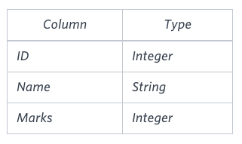 The Name column only contains uppercase (A-Z) and lowercase (a-z) letters.

Sample Input

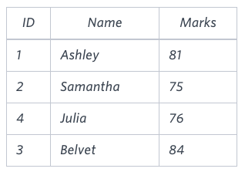

SELECT NAME FROM STUDENTS

WHERE MARKS > 75

ORDER BY RIGHT(NAME,3), ID;

Generate the following two result sets:

1. Query an alphabetically ordered list of all names in OCCUPATIONS, immediately followed by the first letter of each profession as a parenthetical (i.e.: enclosed in parentheses). For example: AnActorName(A), ADoctorName(D), AProfessorName(P), and ASingerName(S).
2. Query the number of ocurrences of each occupation in OCCUPATIONS. Sort the occurrences in ascending order, and output them in the following format:

There are a total of [occupation_count] [occupation]s.

where [occupation_count] is the number of occurrences of an occupation in OCCUPATIONS and [occupation] is the lowercase occupation name. If more than one Occupation has the same [occupation_count], they should be ordered alphabetically.

Note: There will be at least two entries in the table for each type of occupation.

Input Format

The OCCUPATIONS table is described as follows: 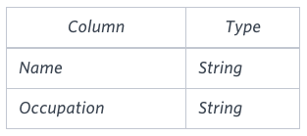 Occupation will only contain one of the following values: Doctor, Professor, Singer or Actor.

Sample Input

An OCCUPATIONS table that contains the following records:

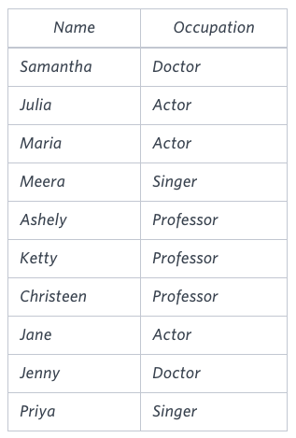

SELECT CONCAT(NAME,'(',LEFT(OCCUPATION,1),')') FROM OCCUPATIONS ORDER BY NAME;

SELECT CONCAT('There are a total of ',' ',count(OCCUPATION),' ',lower(OCCUPATION),'s.') from OCCUPATIONS

GROUP BY OCCUPATION

ORDER BY count(OCCUPATION), OCCUPATION;