DOCUMENTATION – Sales Process Automation (TecMantras)

This project showcases an end-to-end Sales Process Automation solution built in Python for TecMantras. The goal was to automate the process of lead generation, email outreach, and analytics.

# Objective

Automate the sales pipeline using:  
- Google search scraping   
- Excel export of leads  
- Personalized email creation  
- Automated email sending in batches  
- Campaign analytics and lead categorization

# Libraries Used

- googlesearch  
- BeautifulSoup (bs4)  
- pandas  
- requests, re  
- smtplib, email.mime  
- time, random

# Project Structure

- scraper.py – Scrapes company/contact info from Google search.  
- export_to_excel.py – Exports data to Excel.  
- email_template.html – Dynamic email structure using placeholders.  
- email_sender.py – Sends personalized emails using SMTP.

# Scraping with Google Search

Advanced queries like 'site:linkedin.com "CEO" "India" "SaaS"' were used to find potential leads via Google search. BeautifulSoup was used to parse and extract data from result pages without any paid API.

# Email Automation

HTML-based emails were personalized and sent using smtplib. Batch sending with delay was implemented to avoid spam filters. Multiple sender IDs were rotated.

# Challenges & Learning

- Scraping data directly from Google without triggering captchas.  
- Structuring unstructured search result data.  
- Managing deliverability during bulk email sending.

# SCREENSHOTS :-

1. INSTALLATION

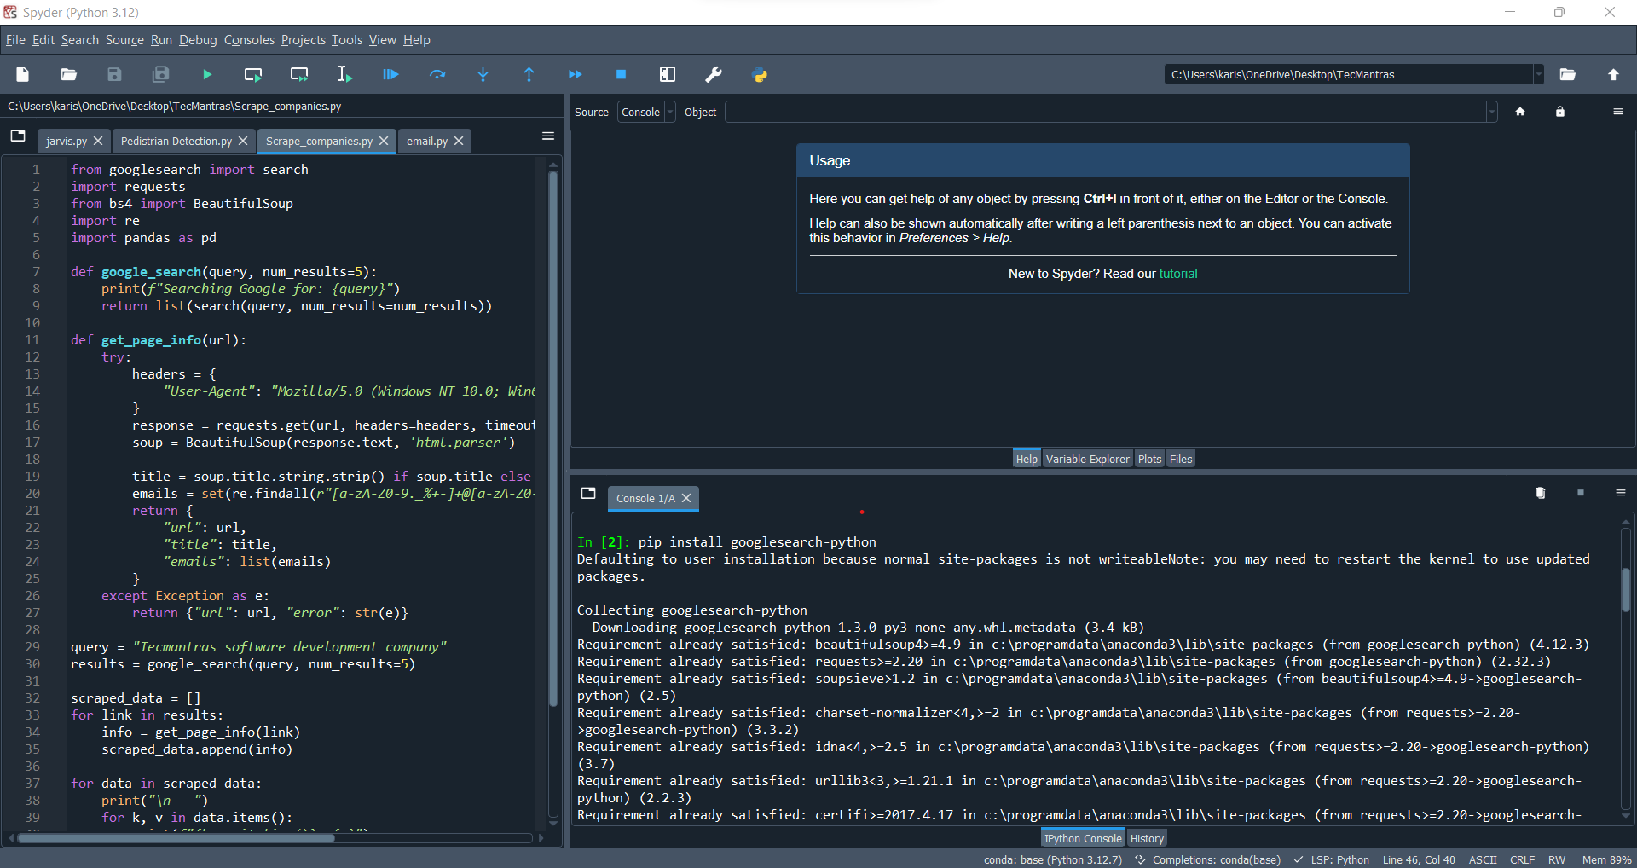

1. RUNNING THE CODE

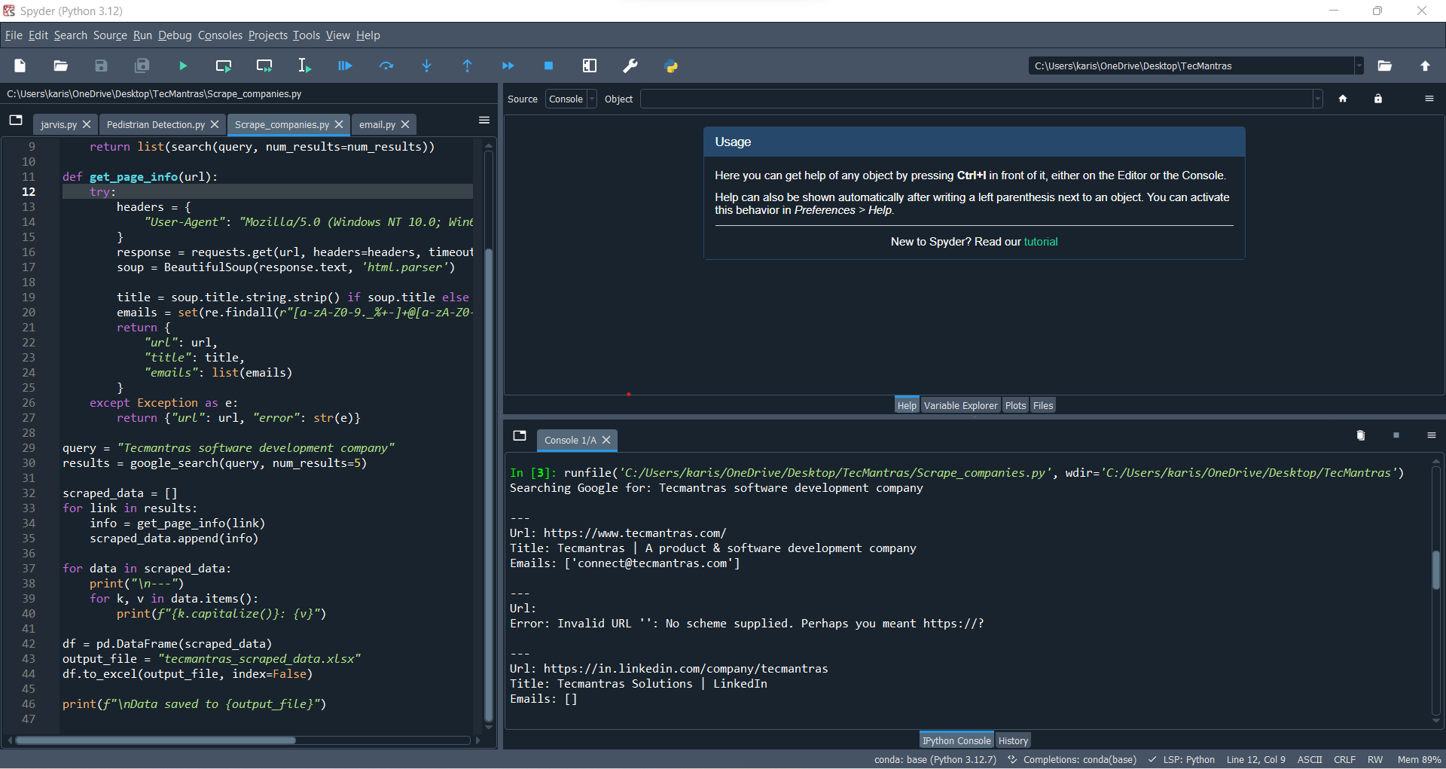

3.SUCCESSFULLY DATA SAVED TO EXCEL

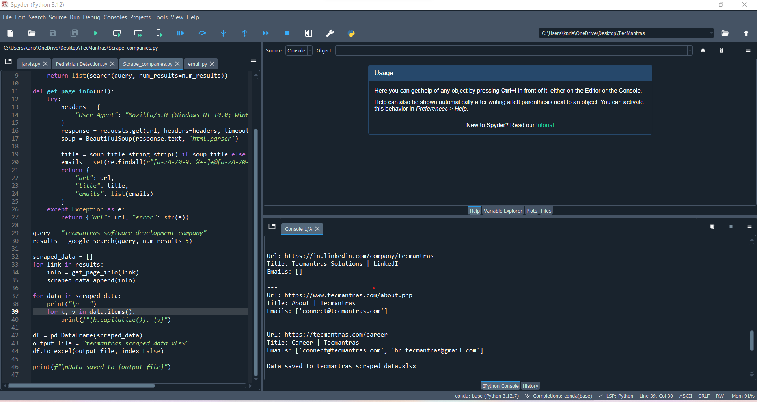

1. EMAIL TEMPLATE:-

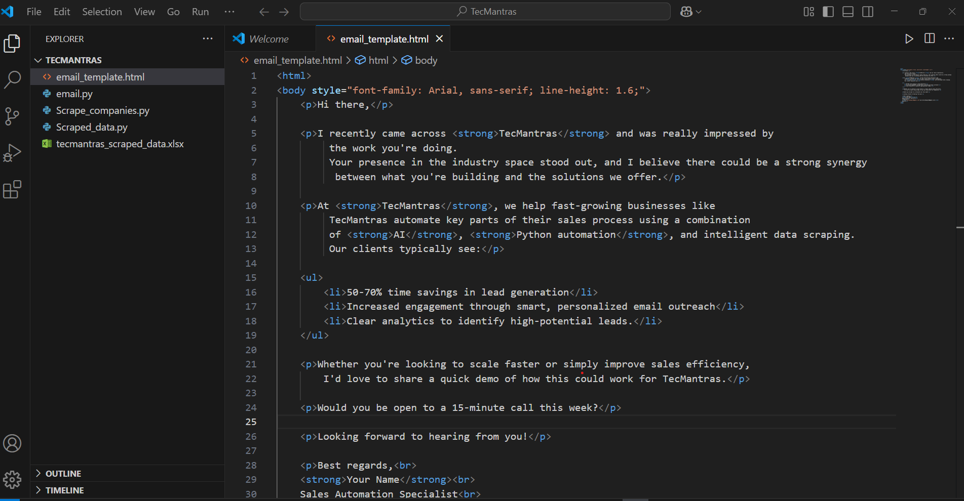

1. EMAIL BATCH CODE:-

