VELALAR COLLEGE OF ENGINEERING AND TECHNOLOGY
Erode– 630012

Department of Computer Science and Engineering

25CST31 – DATABASE MANAGEMENT SYSTEMS

ASSIGNMENT – 3
SQL Query Practice

Student Name: KARISHMAA MOORTHY
Register Number: 732925CSR073
Course Name: 25CST31 – Database Management Systems Assignment Title: Assignment_3 - SQL Query Practice
Date of Assignment: 07.09.2026
Date of Submission: 11.09.2026

Employee Table:
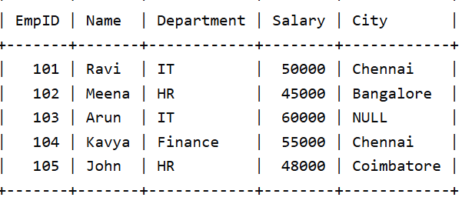
- Display all records from the Employee table
Query:
SELECT * FROM Karishmaamoo;
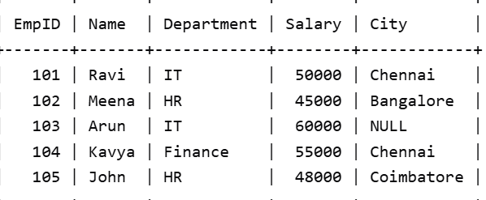
- Display only the Name and Salary of employees
Query:
SELECT Name, Salary FROM Karishmaamoo;
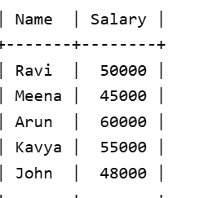
- Display employees whose salary is greater than 50,000
Query:
SELECT * FROM Karishmaamoo WHERE Salary > 50000;
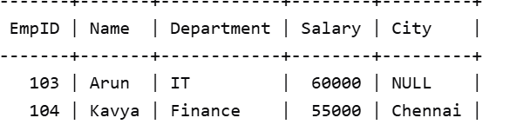
- Display employees who belong to the IT department
Query:
SELECT * FROM Karishmaamoo WHERE Department = 'IT';
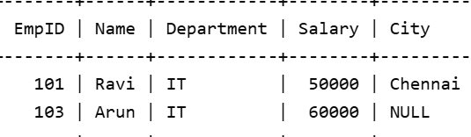
- Display employees whose city is Chennai
Query:
SELECT * FROM Karishmaamoo WHERE City = 'Chennai';
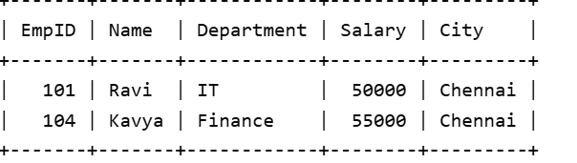
- Display employees whose salary is between 40,000 and 60,000
Query:
SELECT * FROM Karishmaamoo WHERE Salary BETWEEN 40000 AND 60000;
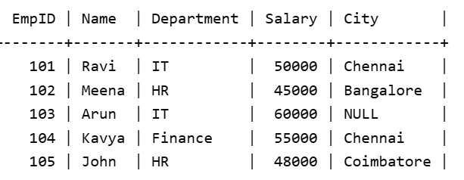
- Display employee names that start with 'A' using LIKE
Query:
SELECT Name FROM Karishmaamoo WHERE Name LIKE 'A%';

- Display distinct departments
Query:
SELECT DISTINCT Department FROM Karishmaamoo;
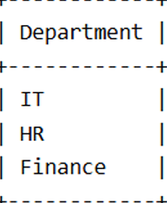

- Display employees whose City value is NULL
Query:
SELECT * FROM Karishmaamoo WHERE City IS NULL;
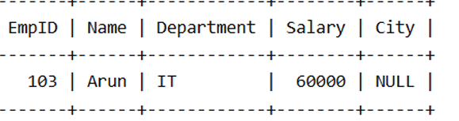
- Find the total salary paid to all employees
Query:
SELECT SUM(Salary) AS Total_Salary FROM Karishmaamoo;
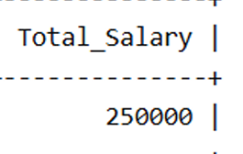
- Find the average salary of employees in the IT department
Query:
SELECT AVG(Salary) AS Average_Salary FROM Karishmaamoo WHERE Department = 'IT';
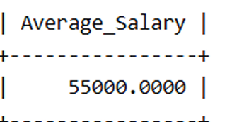
- Count the number of employees in each department using GROUP BY
Query:
SELECT Department, COUNT(*) AS Employee_Count FROM Karishmaamoo GROUP BY Department;
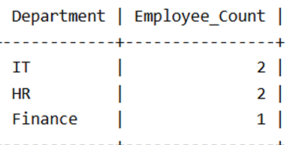
- Display employees whose salary is greater than the average salary
Query:
SELECT * FROM Karishmaamoo WHERE Salary > (SELECT AVG(Salary) FROM Karishmaamoo);
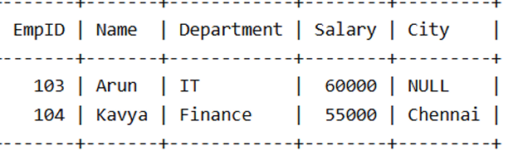
- Insert a new employee record
Query:
INSERT INTO Karishmaamoo(EmpID, Name, Department, Salary, City) VALUES (106, 'Priya', 'IT', 52000, 'Chennai');
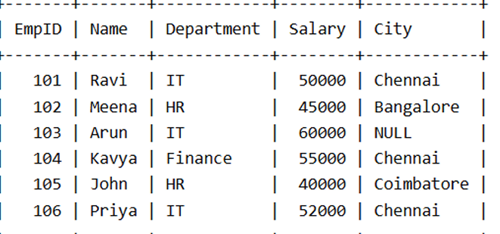
- Update the salary of EmpID 105 to 48000
Query:
UPDATE Karishmaamoo SET Salary = 48000 WHERE EmpID = 105;
