
Name: Karishma Vaishal Bakre
Reg No.: 2648319
Class: 2 MDS
Subject: Full Stack Development

Lab 1 - Create a basic webpage using HTML & CSS - for the domain chosen.
Index.html
{% load static %}
<!DOCTYPE html>
<html lang="en">

<head>
<meta charset="UTF-8">
<meta name="viewport" content="width=device-width, initial-scale=1.0">
<meta name="description" content="Wareloom is a smart warehouse inventory and order management system for connected warehouse operations.">
<meta name="keywords" content="warehouse management, inventory management, order management, logistics, supply chain">
<meta name="author" content="Wareloom">
<title>Wareloom | Smart Warehouse Management</title>
<link href="https://cdn.jsdelivr.net/npm/bootstrap@5.3.3/dist/css/bootstrap.min.css" rel="stylesheet">
<link href="https://cdn.jsdelivr.net/npm/bootstrap-icons@1.11.3/font/bootstrap-icons.min.css" rel="stylesheet">
<link rel="stylesheet" href="{% static 'css/style.css' %}">
</head>

<body>
<div class="site-shell">
<header class="container">
<nav class="navbar navbar-expand-lg" aria-label="Main navigation">
<a class="brand" href="{% url 'home' %}" aria-label="Wareloom home">
<span class="brand-mark"><i class="bi bi-box-seam" aria-hidden="true"></i></span>
<span class="brand-name">Wareloom</span>
</a>
<button class="navbar-toggler" type="button" data-bs-toggle="collapse" data-bs-target="#mainMenu"
aria-controls="mainMenu" aria-expanded="false" aria-label="Open navigation menu">
<i class="bi bi-list" aria-hidden="true"></i>
</button>
<div class="collapse navbar-collapse" id="mainMenu">
<ul class="navbar-nav mx-auto">
<li class="nav-item"><a class="nav-link" href="#features">Features</a></li>
<li class="nav-item"><a class="nav-link" href="#workflow">How it works</a></li>
<li class="nav-item"><a class="nav-link" href="#dashboard">Dashboard</a></li>
<li class="nav-item"><a class="nav-link" href="#solutions">Solutions</a></li>
<li class="nav-item"><a class="nav-link" href="#contact">Contact</a></li>
</ul>
<div class="nav-actions">
<a href="{% url 'login' %}" class="btn btn-quiet">Log in</a>
<a href="{% url 'signup' %}" class="btn btn-primary-custom">Sign up</a>
</div>
</div>
</nav>
</header>
<main id="home">
<section class="container hero">
<div class="row align-items-center g-5">
<div class="col-lg-6">
<h1>Warehouse work,<br><em>in perfect flow.</em></h1>
<p class="lead">A connected command center for inventory, orders, shipments, and every movement
between warehouse and customer.</p>
<div class="hero-buttons">
<a href="{% url 'signup' %}" class="btn btn-primary-custom btn-lg">Start managing
<i class="bi bi-arrow-right" aria-hidden="true"></i>
</a>
</div>
</div>
</div>
</section>

<section class="container cta" id="contact">
<div>
<div class="eyebrow">Ready to move smarter?</div>
<h2>Make every<br><em>move count.</em></h2>
<p>Bring visibility, control, and momentum to your warehouse operations.</p>
<div class="cta-buttons">
<a href="{% url 'signup' %}" class="btn btn-light btn-lg">Get started
<i class="bi bi-arrow-right" aria-hidden="true"></i></a>
<a href="mailto:hello@wareloom.example" class="btn btn-outline-light btn-lg">Contact us</a>
</div>
</div>
</section>
</main>
<footer class="container">
<div class="row gy-5">
<div class="col-lg-5">
<a class="brand footer-brand" href="{% url 'home' %}">
<span class="brand-mark"><i class="bi bi-box-seam" aria-hidden="true"></i></span>
<span class="brand-name">Wareloom</span>
</a>
<p>Clarity for the people behind every perfectly delivered order.</p>
</div>
<div class="col-6 col-lg-2">
<b>Product</b>
<a href="#features">Features</a>
<a href="#workflow">Workflow</a>
<a href="#dashboard">Dashboard</a>
<a href="#solutions">Solutions</a>
</div>
<div class="col-6 col-lg-2">
<b>Company</b>
<a href="#contact">Contact</a>
<a href="#">Privacy</a>
<a href="#">Terms</a>
</div>
</div>
<div class="footer-bottom">
<span>&copy; 2026 Wareloom. All rights reserved.</span>
<span>Warehouse Inventory &amp; Order Management System</span>
</div>
</footer>
</div>
<script src="https://cdn.jsdelivr.net/npm/bootstrap@5.3.3/dist/js/bootstrap.bundle.min.js"></script>
<script src="{% static 'js/script.js' %}"></script>
</body>
</html>

Login.html
{% load static %}
<!DOCTYPE html>
<html lang="en">

<head>
<meta charset="UTF-8">
<meta name="viewport" content="width=device-width, initial-scale=1.0">
<title>Login | Wareloom</title>
<link rel="preconnect" href="https://fonts.googleapis.com">
<link rel="preconnect" href="https://fonts.gstatic.com" crossorigin>
<!-- <link href="https://fonts.googleapis.com/css2?family=DM+Mono:wght@400;500&family=Manrope:wght@400;500;600;700;800&display=swap" rel="stylesheet"> -->
<link href="https://cdn.jsdelivr.net/npm/bootstrap-icons@1.11.3/font/bootstrap-icons.min.css" rel="stylesheet">
<link rel="stylesheet" href="{% static 'css/auth.css' %}?v=2">
</head>

<body>
<main class="auth-page">
<div class="orb orb-one" aria-hidden="true"></div>
<div class="orb orb-two" aria-hidden="true"></div>
<a class="brand" href="{% url 'home' %}" aria-label="Wareloom home">
<span><i class="bi bi-box-seam" aria-hidden="true"></i></span>
<b>Wareloom</b>
</a>

<section class="auth-card" aria-labelledby="login-title">
<div aria-labelledby="login-title">
<h1 id="login-title">Log in to your<br>Wareloom <em>workspace.</em></h1>
<form id="login-form" novalidate>
<label for="login-email">Email address<input id="login-email" type="email" name="email"
placeholder="you@company.com" autocomplete="email" required></label>
<label for="login-password">Password
<div class="password-field">
<input id="login-password" type="password" name="password" placeholder="Enter your password"
autocomplete="current-password" required>
<button type="button" class="toggle-password" aria-label="Show password">
<i class="bi bi-eye" aria-hidden="true"></i>
</button>
</div>
</label>
<div class="form-row">
<label class="check">
<input type="checkbox" name="remember">
<span>Remember me</span>
</label>
<a href="#">Forgot password?</a>
</div>
<button class="submit" type="submit">Log in
<i class="bi bi-arrow-right" aria-hidden="true"></i>
</button>
<p class="form-message" role="status" aria-live="polite"></p>
</form>
<p class="back">
<a href="{% url 'home' %}">
<i class="bi bi-arrow-left" aria-hidden="true"></i>
Back to website
</a>
</p>
<p class="switch">New to Wareloom? <a href="{% url 'signup' %}">Create an account</a></p>
</div>
</section>
</main>
<script src="{% static 'js/auth.js' %}"></script>
</body>
</html>
Signup.html
{% load static %}
<!DOCTYPE html>
<html lang="en">

<head>
<meta charset="UTF-8">
<meta name="viewport" content="width=device-width, initial-scale=1.0">
<title>Create Account | Wareloom</title>
<link rel="preconnect" href="https://fonts.googleapis.com">
<link rel="preconnect" href="https://fonts.gstatic.com" crossorigin>
<!-- <link href="https://fonts.googleapis.com/css2?family=DM+Mono:wght@400;500&family=Manrope:wght@400;500;600;700;800&display=swap" rel="stylesheet"> -->
<link href="https://cdn.jsdelivr.net/npm/bootstrap-icons@1.11.3/font/bootstrap-icons.min.css" rel="stylesheet">
<link rel="stylesheet" href="{% static 'css/auth.css' %}?v=2">
</head>
<body>
<main class="auth-page">
<div class="orb orb-one" aria-hidden="true"></div>
<div class="orb orb-two" aria-hidden="true"></div>
<a class="brand" href="{% url 'home' %}" aria-label="Wareloom home">
<span><i class="bi bi-box-seam" aria-hidden="true"></i></span>
<b>Wareloom</b>
</a>
<div class="auth-card" aria-labelledby="signup-title">
<h1 id="signup-title">A smarter warehouse<br>starts <em>here.</em></h1>
<p>Set up your Wareloom workspace in just a few moments.</p>
<form id="signup-form" novalidate>
<div class="input-grid">
<label for="first-name">
First name <input id="first-name" type="text" name="firstName" placeholder="Enter first name"
autocomplete="given-name" required>
</label>
<label for="last-name">
Last name <input id="last-name" type="text" name="lastName" placeholder="Enter last name"
autocomplete="family-name" required>
</label>
</div>
<label for="signup-email">
Work email <input id="signup-email" type="email" name="email"
placeholder="Enter email in proper format" autocomplete="email" required>
</label>
<label for="signup-password">
Password
<div class="password-field">
<input id="signup-password" type="password" name="password" placeholder="At least 8 characters"
autocomplete="new-password" minlength="8" required>
<button type="button" class="toggle-password" aria-label="Show password">
<i class="bi bi-eye" aria-hidden="true"></i>
</button>
</div>
</label>
<label class="check terms">
<input type="checkbox" name="terms" required>
<span>I agree to the<a href="#">Terms</a>and<a href="#">Privacy Policy</a>.</span>
</label>
<button class="submit" type="submit">
Create my account<i class="bi bi-arrow-right" aria-hidden="true"></i>
</button>
<p class="form-message" role="status" aria-live="polite"></p>
</form>
<div>
<p class="back">
<a href="{% url 'home' %}"><i class="bi bi-arrow-left" aria-hidden="true"></i>Back to website</a>
</p>
<p class="switch">Already have an account?<a href="{% url 'login' %}">Log in</a></p>
</div>
</div>
</main>
<script src="{% static 'js/auth.js' %}"></script>
</body>
</html>

Style.css
:root {
--primary: #0b3d5c;
--primary-dark: #082f46;
--teal: #102a43;
--teal-light: #e8f5f6;
--ink: #102a43;
--text: #243b53;
--muted: #6b7c93;
--background: #f4f8fa;
--surface: #ffffff;
--surface-soft: #edf5f7;
--line: #d9e5e9;
--success: #087e8b;
--warning: #e6a23c;
--danger: #d9534f;
--shadow-sm: 0 4px 14px rgba(16, 42, 67, 0.06);
--shadow-md: 0 8px 24px rgba(16, 42, 67, 0.08);
}
* {
box-sizing: border-box;
}

html {
scroll-behavior: smooth;
}

body {
margin: 0;
color: var(--text);
background: var(--background);
font-family: "Times New Roman", Arial, sans-serif;
line-height: 1.6;
}

a {
color: inherit;
text-decoration: none;
}

button,
input,
textarea,
select {
font-family: "Times New Roman", Arial, sans-serif;
}

.site-shell {
min-height: 100vh;
position: relative;
overflow: hidden;
background: var(--background);
}

header.container {
padding-top: 18px;
}

.navbar {
padding: 13px 18px !important;
background: var(--surface);
border: 1px solid var(--line);
border-radius: 8px;
box-shadow: var(--shadow-sm);
}

.brand {
display: flex;
align-items: center;
gap: 9px;
color: var(--ink);
font-size: 30px;
font-weight: 800;
letter-spacing: -0.8px;
text-decoration: none;
}

.brand:hover {
color: var(--primary);
}

.brand-mark {
width: 34px;
height: 34px;
display: grid;
place-items: center;
color: #ffffff;
background: var(--teal);
border-radius: 7px;
}

.brand-mark i {
font-family: "Times New Roman", Arial, sans-serif;
font-size: 25px;
}
.brand-name {
color: var(--ink);

}
.navbar-nav {
gap: 4px;
height: 100%;
display: flex;
align-items: center;
}
.nav-link {
padding: 10px 14px ;
color: var(--text) !important;
font-size: 16px;
font-weight: 600;
border-radius: 6px;
}
.nav-link:hover {
color: var(--teal) !important;
background: var(--teal-light);
}
.nav-actions {
display: flex;
align-items: center;
gap: 9px;
font-size: 18px;
}
/* .btn {
padding: 10px 17px;
border-radius: 7px;
font-size: 11px;
font-weight: 700;
transition:
background 0.2s ease,
color 0.2s ease,
border-color 0.2s ease;
}
.btn-primary-custom {
color: #ffffff;
background: var(--teal);
border: 1px solid var(--teal);
box-shadow: none;
}
.btn-primary-custom:hover {
color: #ffffff;
background: var(--primary);
border-color: var(--primary);
}
.btn-quiet {
color: var(--ink);
background: #ffffff;
border: 1px solid var(--line);
}
.btn-quiet:hover {
color: var(--teal);
background: var(--teal-light);
border-color: #b8d8dd;
}
.btn-lg {
padding: 12px 20px;
font-size: 16px;
}
.btn-light {
color: var(--primary);
background: #ffffff;
border: 1px solid #ffffff;
}
.btn-light:hover {
color: var(--primary);
background: #f2f6f7;
border-color: #f2f6f7;
}
.btn-outline-light {
color: #ffffff;
background: transparent;
border: 1px solid rgba(255, 255, 255, 0.6);
}
.btn-outline-light:hover {
color: var(--primary);
background: #ffffff;
border-color: #ffffff;
} */
.navbar-toggler {
padding: 7px 10px;
color: var(--primary);
background: #ffffff;
border: 1px solid var(--line);
border-radius: 6px;
}
.navbar-toggler:focus {
box-shadow: 0 0 0 2px rgba(8, 126, 139, 0.15);
}
.eyebrow {
display: flex;
align-items: center;
gap: 8px;
margin-bottom: 17px;
color: var(--teal);
font-size: 10px;
font-weight: 600;
letter-spacing: 1.2px;
text-transform: uppercase;
}
/* .eyebrow>span is used to style the small dot/icon before the eyebrow text. */
.eyebrow>span {
width: 8px;
height: 8px;
display: inline-block;
background: var(--teal);
border-radius: 50%;
}

.hero h1 {
margin: 0;
color: var(--ink);
font-size:
clamp(48px,
6.5vw,
88px);
font-weight: 800;
letter-spacing: -5px;
line-height: 0.95;
}

.hero h1 em {
color: var(--teal);
font-family: "Times New Roman", Arial, sans-serif;
font-style: italic;
font-weight: 600;
letter-spacing: -3px;
}
.hero .lead {
max-width: 620px;
margin: 25px 0 30px;
color: var(--muted);
font-size: 15px;
line-height: 1.8;
}
.hero-buttons {
display: flex;
flex-wrap: wrap;
gap: 12px;
}
footer {
padding: 0 24px 25px;
}
footer .brand {
margin-bottom: 15px;
}
footer p {
max-width: 300px;
margin: 10px 0 0;
color: var(--muted);
font-size: 15px;
line-height: 1.8;
}
footer b {
display: block;
margin-bottom: 13px;
color: var(--ink);
font-size: 11px;
}
footer>.row>div:not(:first-child) a {
display: block;
margin-bottom: 8px;
color: var(--muted);
font-size: 15px;
text-decoration: none;
}
footer>.row>div:not(:first-child) b {
display: block;
margin-bottom: 8px;
color: var(--text);
font-size: 15px;
text-decoration: none;
}
/* Style the footer navigation links, but don't style links in the first footer column. */
footer>.row>div:not(:first-child) a:hover {
color: var(--teal);
}
.footer-bottom {
display: flex;
justify-content: space-between;
gap: 20px;
padding-top: 22px;
margin-top: 45px;
border-top: 1px solid var(--line);
color: #8490a4;
font-size: 15px;
}

a:focus-visible,
button:focus-visible,
input:focus-visible {
outline:
2px solid var(--teal);
outline-offset: 2px;
}
Auth.css
:root {
--primary: #0b3d5c;
--primary-dark: #082f46;
--teal: #087e8b;
--teal-light: #e8f5f6;
--ink: #102a43;
--text: #243b53;
--muted: #6b7c93;
--background: #f4f8fa;
--surface: #ffffff;
--surface-soft: #edf5f7;
--line: #d9e5e9;
--success: #087e8b;
--warning: #e6a23c;
--danger: #d9534f;
--shadow-sm: 0 4px 14px rgba(16, 42, 67, 0.06);
--shadow-md: 0 8px 24px rgba(16, 42, 67, 0.08);
}
* {
box-sizing: border-box;
}
html {
scroll-behavior: smooth;
}
body {
margin: 0;
color: var(--text);
background: var(--background);
font-family: "Times New Roman", Arial, sans-serif;
line-height: 1.6;
overflow-x: hidden;
}
a {
color: inherit;
text-decoration: none;
}
button,
input {
font-family: inherit;
}
.auth-page {
min-height: 100vh;
display: grid;
place-items: center;
padding: 90px 20px 60px;
background: #f4f8fa;
}
.brand {
position: absolute;
top: 28px;
left: clamp(22px, 6vw, 82px);
display: flex;
align-items: center;
gap: 9px;
color: var(--ink);
font-size: 30px;
font-weight: 800;
letter-spacing: -1px;
}
.brand span {
width: 34px;
height: 34px;
display: grid;
place-items: center;
color: #fff;
background: var(--primary);
border-radius: 6px;
font-size: 16px;
}
.brand b {
color: var(--secondary);
}
.eyebrow {
margin-bottom: 12px;
color: var(--secondary);
font-size: 10px;
font-weight: 700;
letter-spacing: 1px;
text-transform: uppercase;
}
.auth-card {
width: min(100%, 450px);
padding: 38px;
position: relative;
background: var(--white);
border: 1px solid var(--border);
border-radius: var(--radius-md);
box-shadow: var(--shadow);
}
.signup-card {
width: min(100%, 520px);
}
.auth-card::before {
content: "";
position: absolute;
top: -1px;
left: 24px;
right: 24px;
height: 3px;
background: var(--secondary);
border-radius: 0 0 2px 2px;
}
.auth-card {
position: relative;
width: min(100%, 450px);
padding: 38px;
background: #ffffff;
border: 1px solid var(--border);
border-radius: 10px;
box-shadow: 0 8px 24px rgba(16, 42, 67, 0.08);
}
.auth-card h1 {
margin: 0;
color: var(--ink);
font-size: 32px;
font-weight: 800;
letter-spacing: -1.5px;
line-height: 1.05;
}
.auth-card h1 em {
color: var(--secondary);
font-style: normal;
}
.auth-card > p {
margin: 13px 0 27px;
color: var(--muted);
font-size: 12px;
line-height: 1.7;
}
form {
width: 100%;
}
label {
display: block;
margin-bottom: 16px;
color: var(--ink);
font-size: 11px;
font-weight: 800;
}
input {
display: block;
width: 100%;
margin-top: 7px;
padding: 11px 12px;
color: var(--ink);
background: #d9dde4;
border: 1px solid var(--border);
border-radius: var(--radius-sm);
outline: none;
font-size: 12px;
}
.input-grid {
display: grid;
grid-template-columns: 1fr 1fr;
gap: 13px;
}
input:focus {
border-color: var(--secondary);
box-shadow: 0 0 0 2px rgba(8, 126, 139, 0.10);
}
.password-field {
position: relative;
}
.password-field input {
padding-right: 45px;
}
.toggle-password {
position: absolute;
right: 7px;
bottom: 5px;
width: 32px;
height: 32px;
display: grid;
place-items: center;
padding: 0;
color: var(--muted);
background: transparent;
border: 0;
border-radius: 5px;
font-size: 15px;
cursor: pointer;
}
.toggle-password:hover {
color: var(--secondary);
background: #f0f7f8;
}
.form-row {
display: flex;
align-items: center;
justify-content: space-between;
gap: 10px;
margin: -1px 0 20px;
}
.form-row > a,
.switch a,
.terms a {
color: var(--secondary);
font-size: 10px;
font-weight: 800;
}
.form-row > a:hover,
.switch a:hover,
.terms a:hover {
color: var(--primary);
}
.check {
display: flex;
align-items: center;
gap: 7px;
margin: 0;
color: var(--muted);
font-size: 10px;
font-weight: 600;
}
.check input {
width: 13px;
height: 13px;
margin: 0;
accent-color: var(--secondary);
}
.terms {
margin: 2px 0 20px;
align-items: flex-start;
line-height: 1.6;
}
.submit {
width: 100%;
display: flex;
align-items: center;
justify-content: center;
gap: 5px;
padding: 12px 18px;
color: #fff;
background: var(--primary);
border: 0;
border-radius: 6px;
font-size: 11px;
font-weight: 800;
cursor: pointer;
}
.submit:hover {
background: var(--primary-dark);
}
.submit:disabled {
opacity: 0.65;
cursor: not-allowed;
}
.submit i {
margin-left: 4px;
}
.form-message {
min-height: 17px !important;
margin: 10px 0 -15px !important;
color: var(--danger) !important;
font-size: 10px !important;
text-align: center;
}
.switch {
margin: 10px 0 0 !important;
color: var(--muted);
text-align: center;
font-size: 10px !important;
}
.back {
margin: 22px 0 0;
font-size: 10px;
text-align: center;
}
.back a {
color: var(--muted);
}
.back a:hover {
color: var(--secondary);
}
.back i {
margin-right: 5px;
}
a:focus-visible,
button:focus-visible,
input:focus-visible {
outline: 2px solid rgba(8, 126, 139, 0.35);
outline-offset: 2px;
}
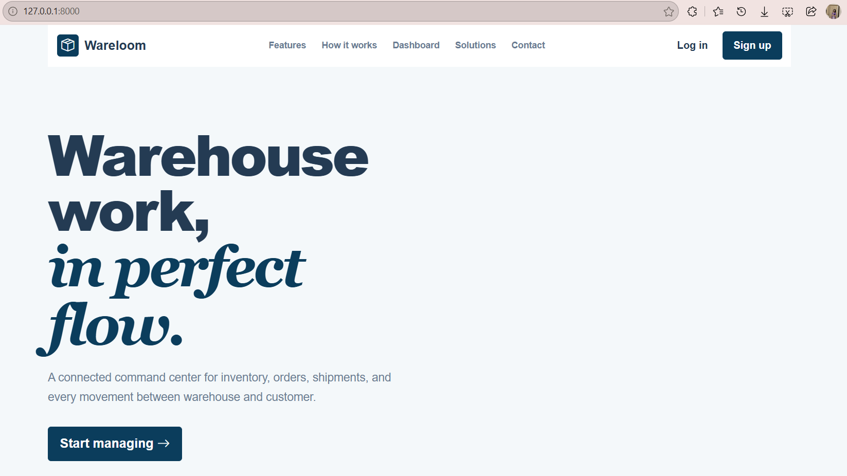
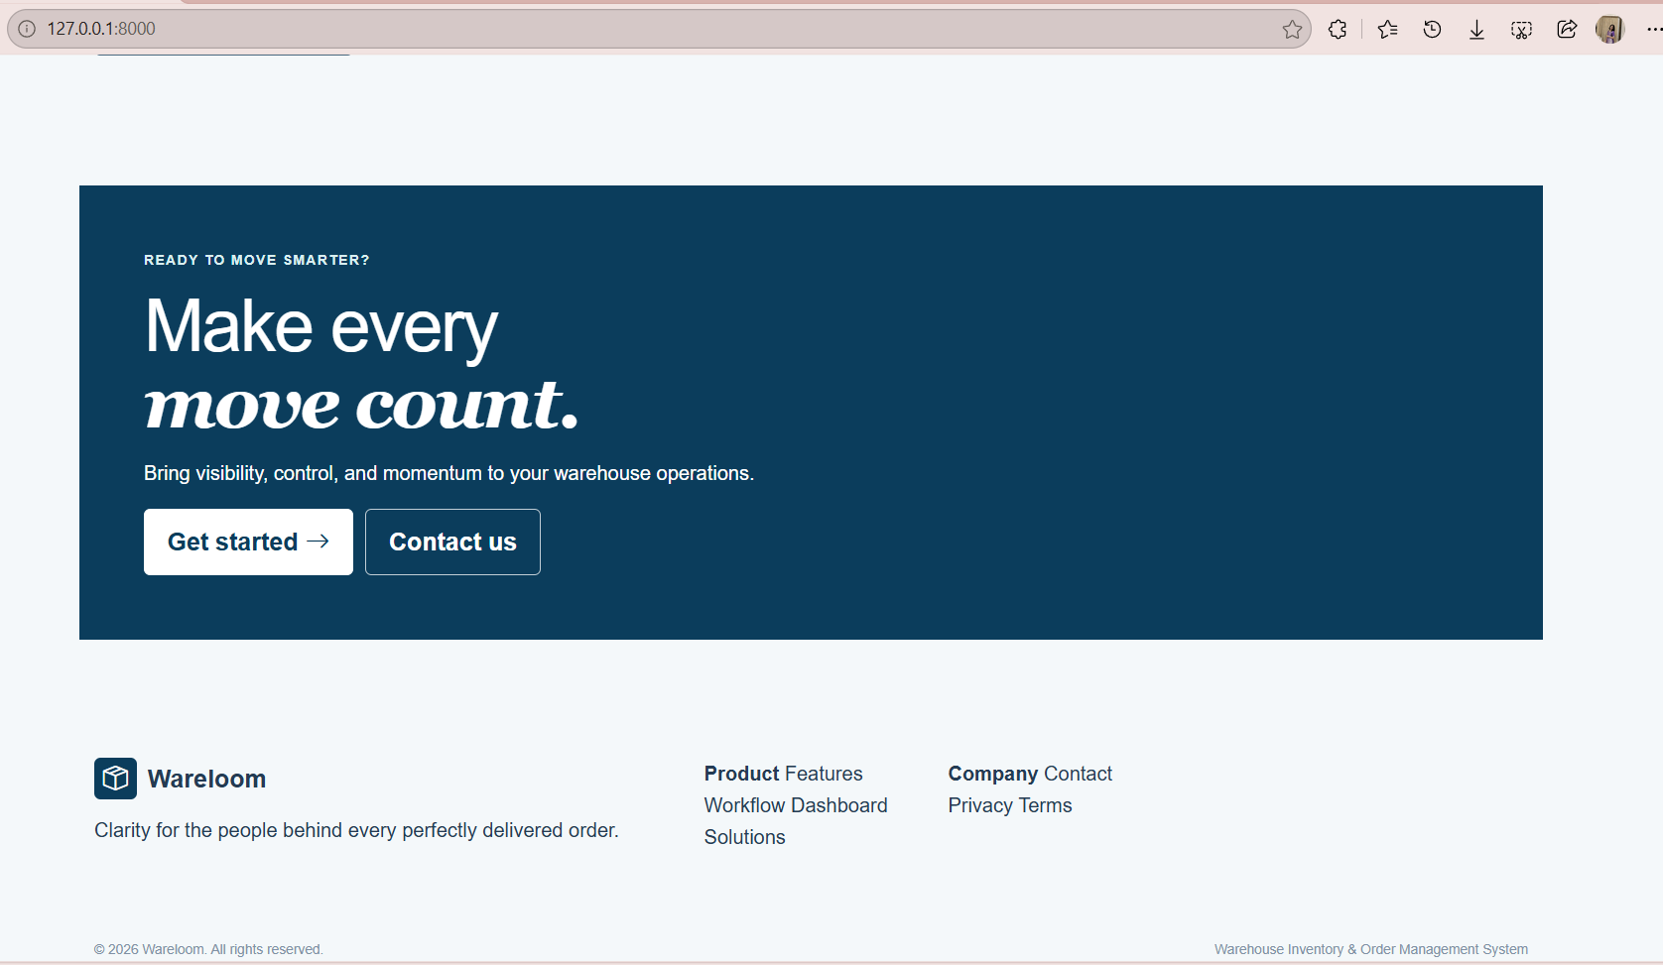

Lab 2 - Implement a form validation using JavaScript.
Auth.java
//querySelectorAll - used to find all HTML elements that match a CSS selector.
//previousElementSibling - used to get the HTML element immediately before the current element at the same level in the HTML structure
document.querySelectorAll('.toggle-password').forEach((button) => {
button.addEventListener('click', () => {
const field = button.previousElementSibling;
if (field.type === 'password') {
field.type = 'text';
button.firstElementChild.className = 'bi bi-eye-slash';
} else {
field.type = 'password';
button.firstElementChild.className = 'bi bi-eye';
}
});
});
document.querySelectorAll('form').forEach((form) => {
form.addEventListener('submit', (event) => {
event.preventDefault();
const message = form.querySelector('.form-message');
message.textContent = '';
message.style.color = '';
const email = form.elements.email;
const password = form.elements.password;
if (!email.value.trim()) {
showError(message, 'Please enter your email address.');
email.focus();
return;
}
if (!password.value.trim()) {
showError(message, 'Please enter your password.');
password.focus();
return;
}
const emailPattern = /^[^\s@]+@[^\s@]+\.[^\s@]+$/; //[ ] - in between add some character
if (!emailPattern.test(email.value.trim())) {
showError(message, 'Please enter a valid email address.');
email.focus();
return;
}
if (password.value.length < 8) {
showError(message, 'Password must contain at least 8 characters.');
password.focus();
return;
}
if (form.id === 'signup-form') {
const name = form.elements.name;
const confirmPassword = form.elements.confirm_password;
if (!name.value.trim()) {
showError(message,'Please enter your name.');
name.focus();
return;
}
const namePattern = /^[A-Za-z ]+$/;
if (!namePattern.test(name.value.trim())) {
showError(message,'Name should contain only letters and spaces.');
name.focus();
return;
}
if (password.value !== confirmPassword.value) {
showError(message,'Passwords do not match.');
confirmPassword.focus();
return;
}
const strongPassword = /^(?=.*[a-z])(?=.*[A-Z])(?=.*\d)(?=.*[@$!%*?&]).{8,}$/;
if (!strongPassword.test(password.value)) {
showError( message, 'Password must contain uppercase, lowercase, number and special character.');
password.focus();
return;
}
}
localStorage.setItem(
'stockloomUser',
email.value.trim()
);
message.style.color = '#198978';
if (form.id === 'signup-form') {
message.textContent = 'Account created — welcome to Wareloom!';
} else {
message.textContent = 'Welcome back — you are signed in!';
}
const submitButton =form.querySelector('.submit');
if (submitButton) {
submitButton.disabled = true;
}
});
});
function showError(message, text) {
message.style.color = '#d9534f';
message.textContent = text;
}
