**Tableau Homework-**

*How many trips have been recorded total during the chosen period?

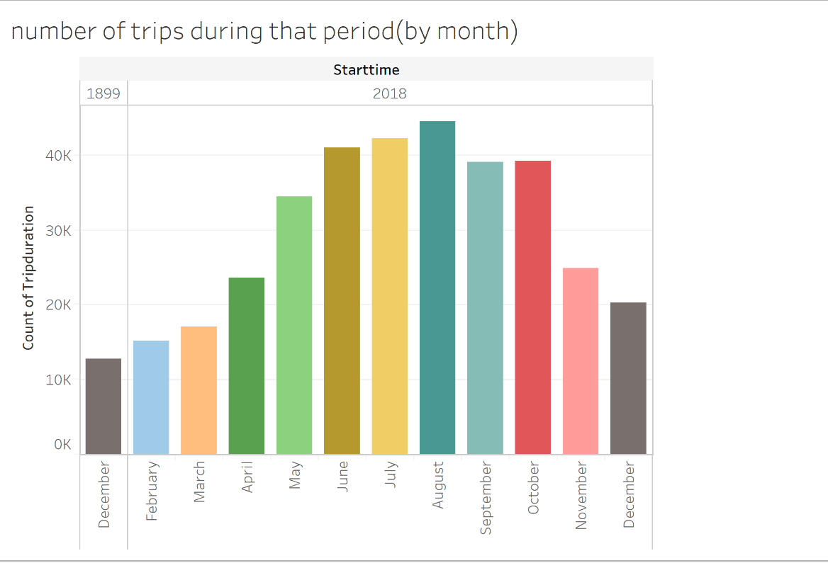

* By what percentage has total ridership grown?

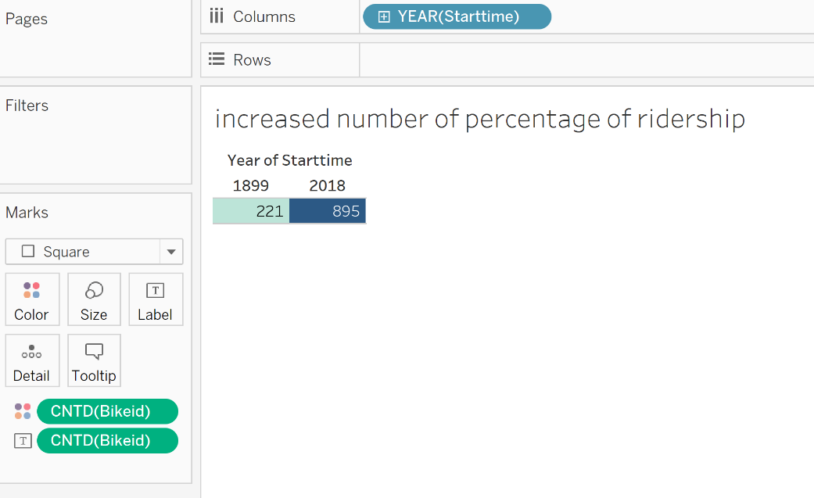

*How has the proportion of short-term customers and annual subscribers changed?

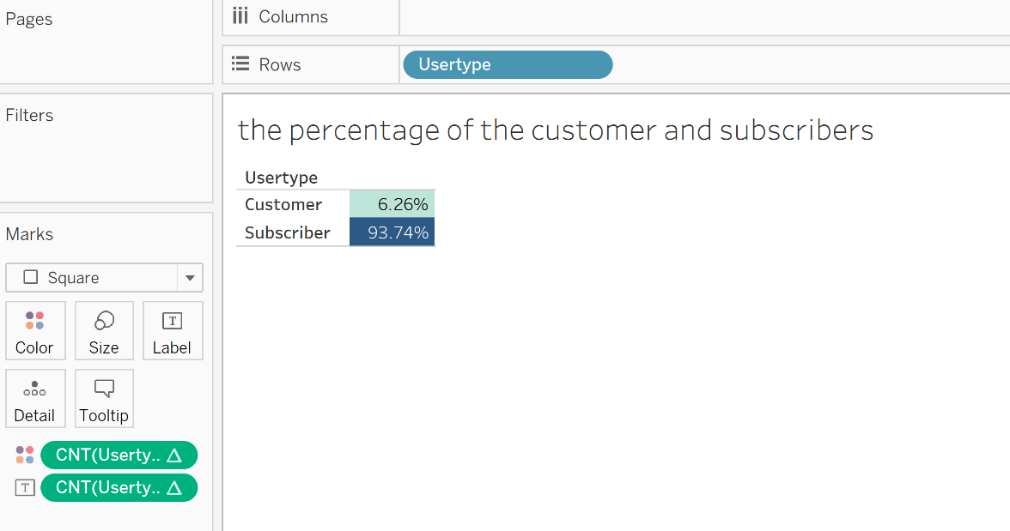

*What are the peak hours in which bikes are used during summer months?

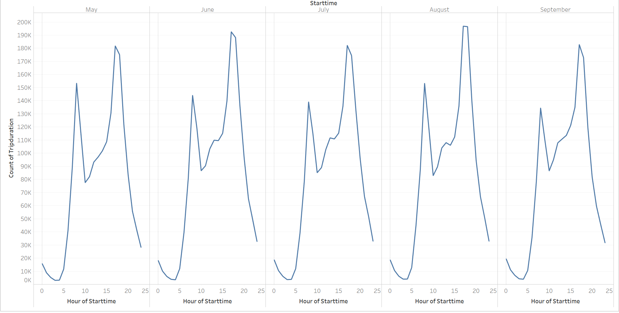

*What are the peak hours in which bikes are used during winter months?

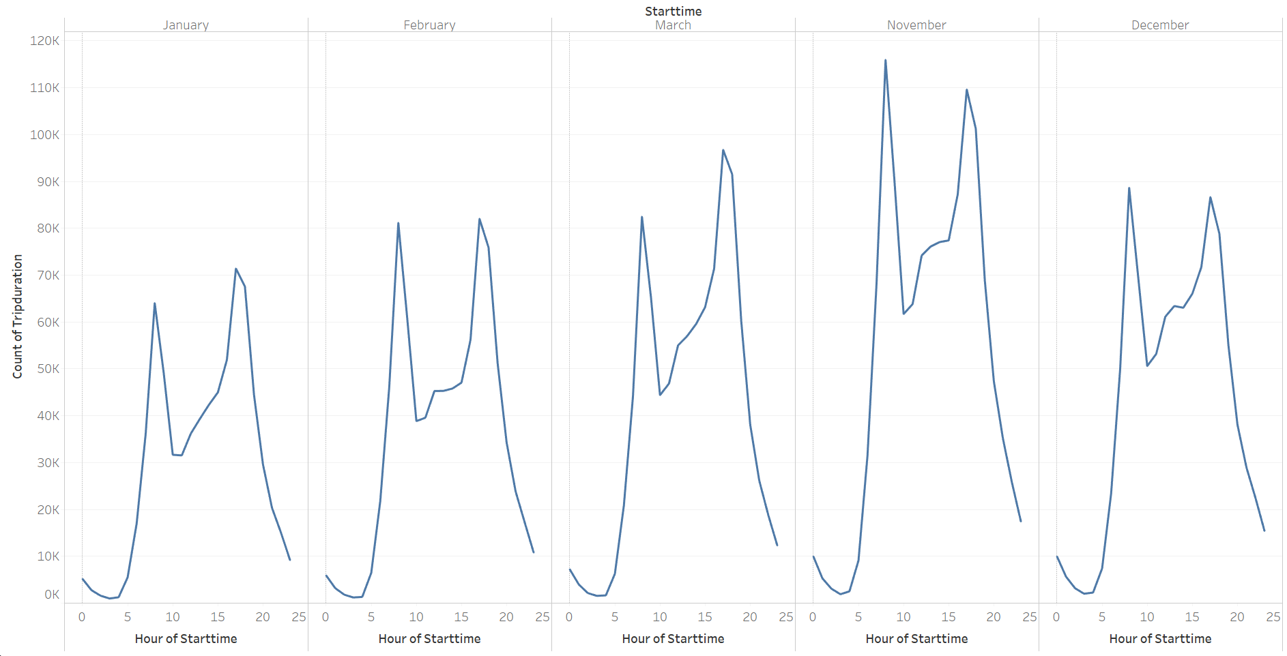

*Today, what are the top 10 stations in the city for starting a journey? (Based on data, why do you hypothesize these are the top locations?)

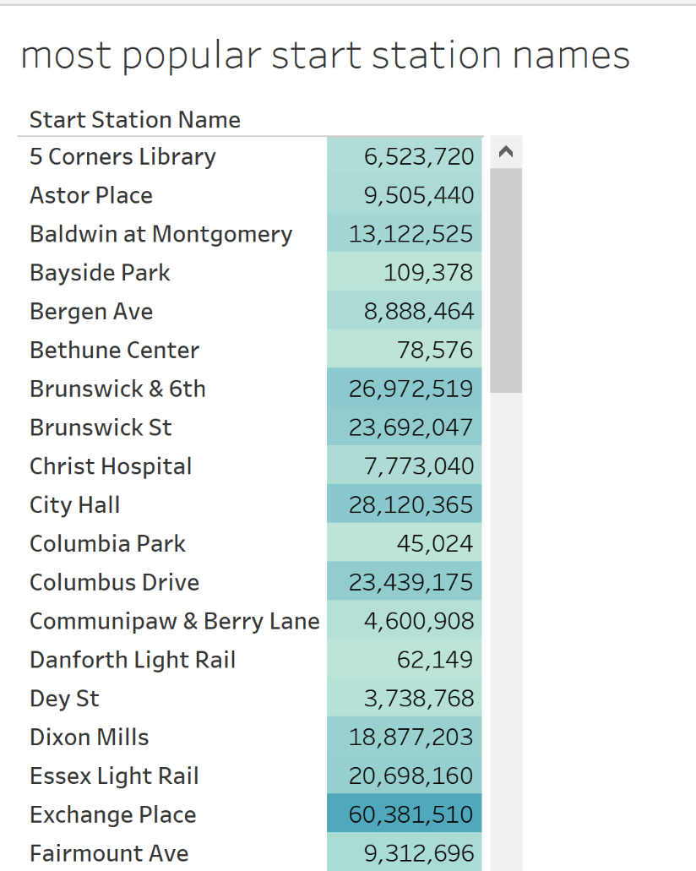

*Today, what are the top 10 stations in the city for ending a journey? (Based on data, why?)

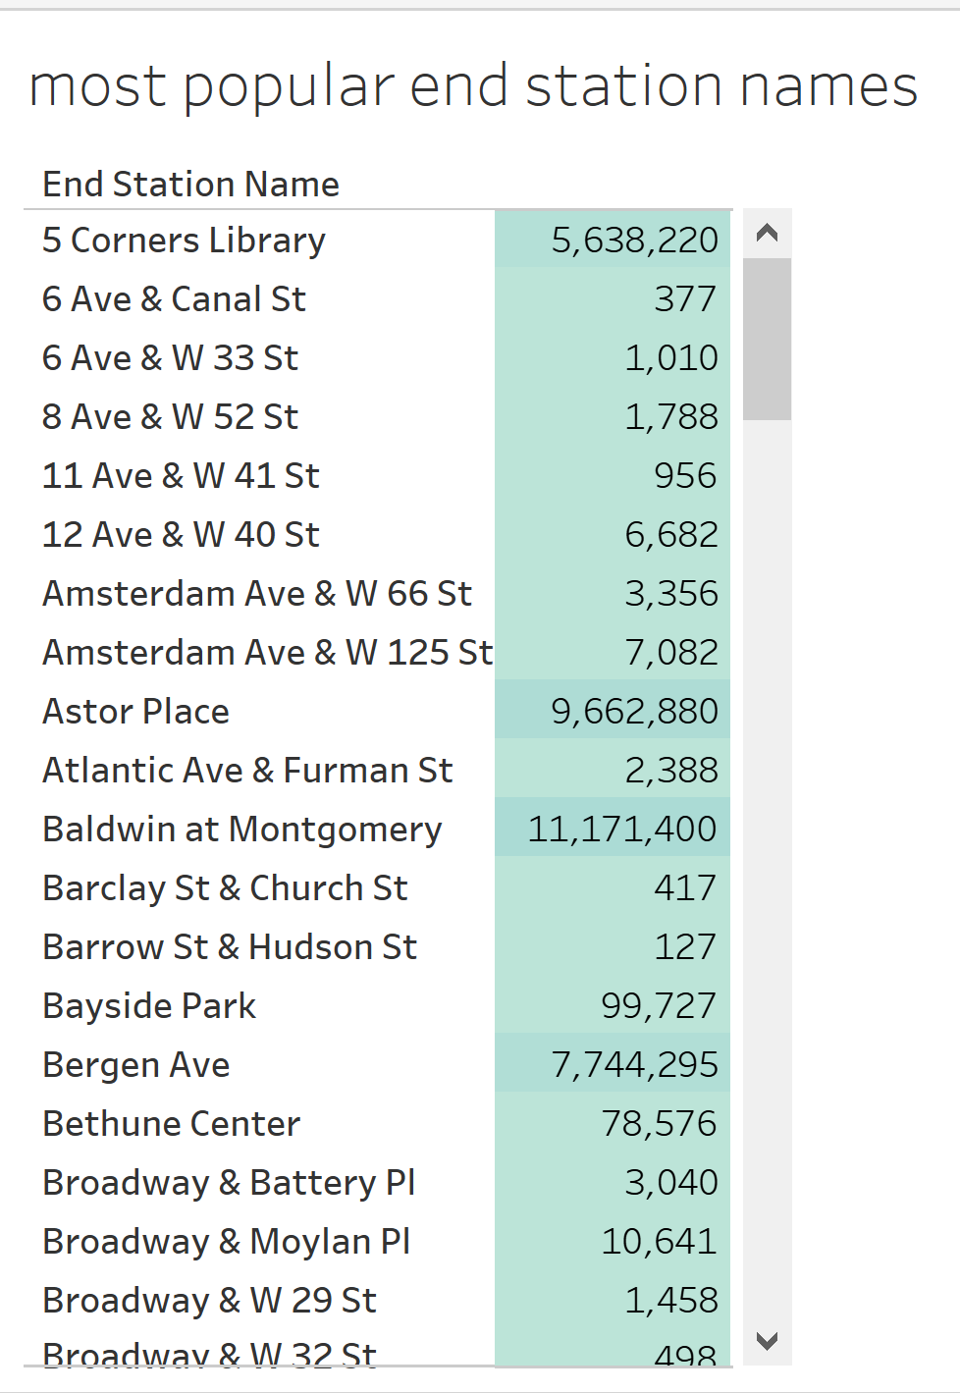

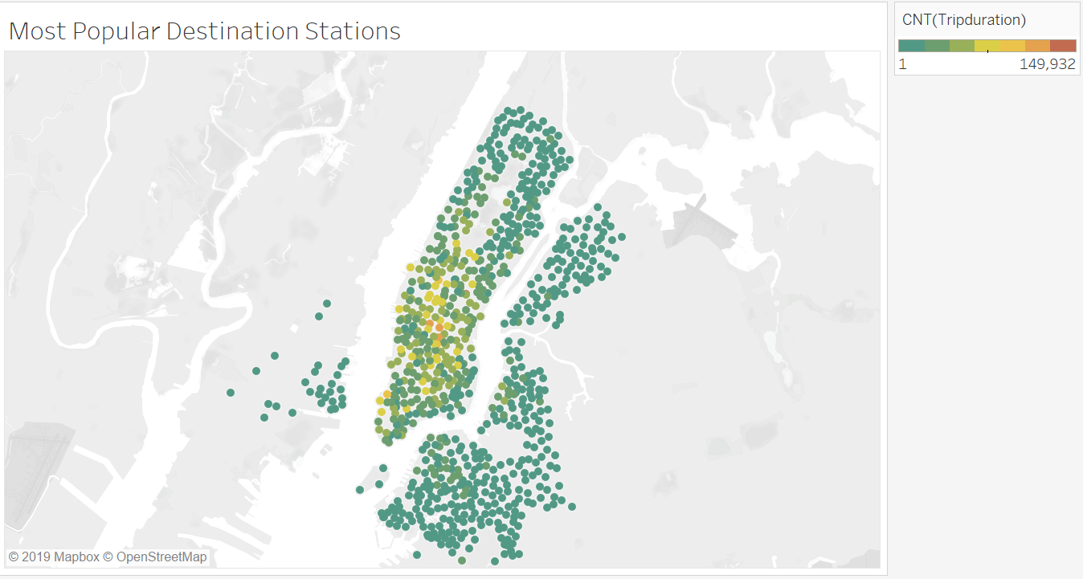

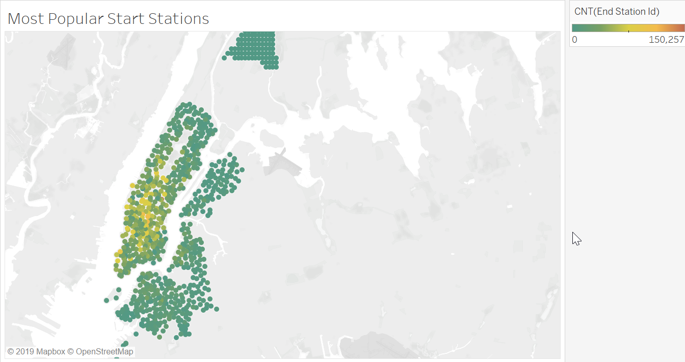

*Today, what is the gender breakdown of active participants (Male v. Female)?

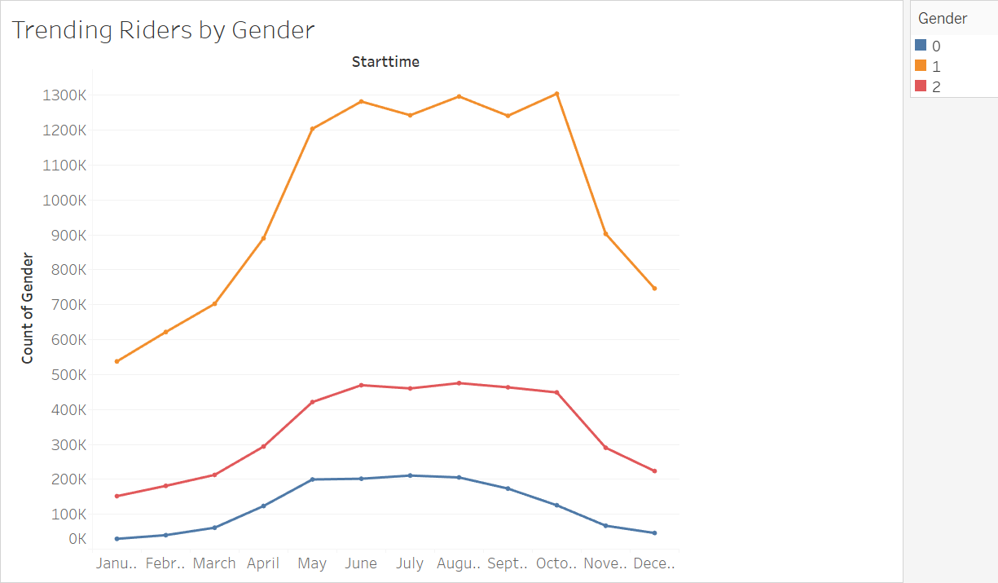

*How effective has gender outreach been in increasing female ridership over the timespan?

As shown in the graph the code 2 of gender is for female and we can anticipate from the graph that the

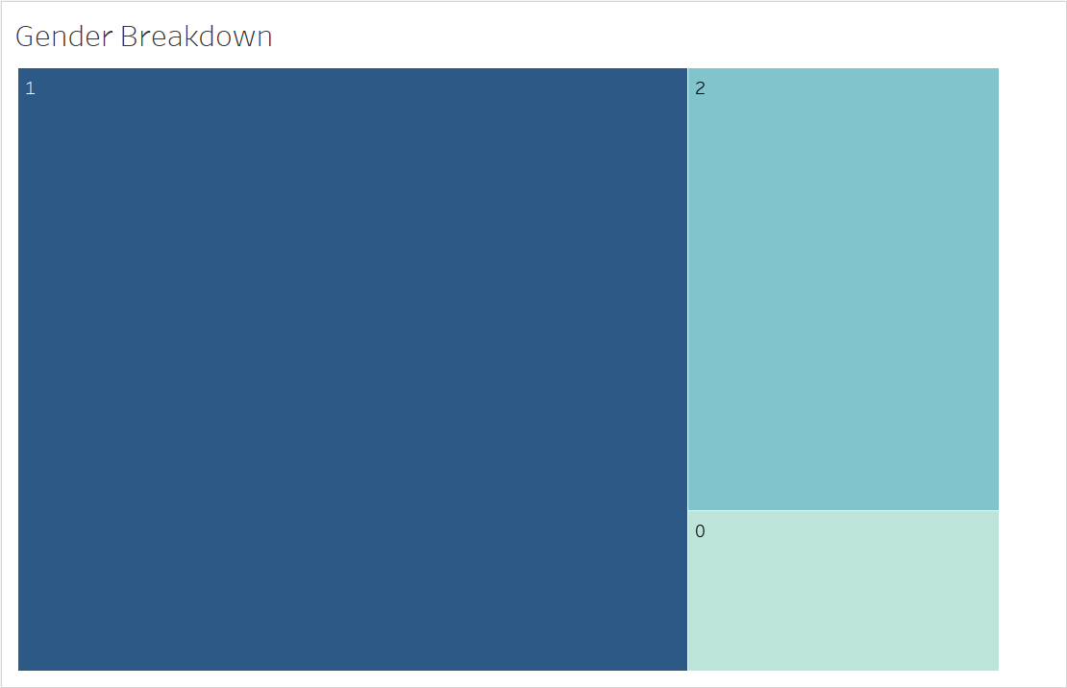

* How does the average trip duration change by age?

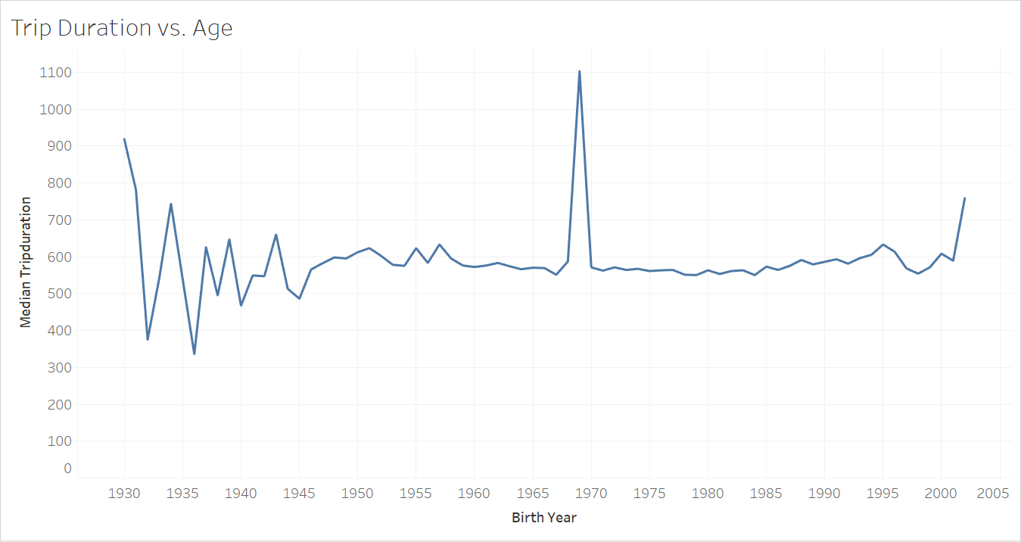

* What is the average distance in miles that a bike is ridden?

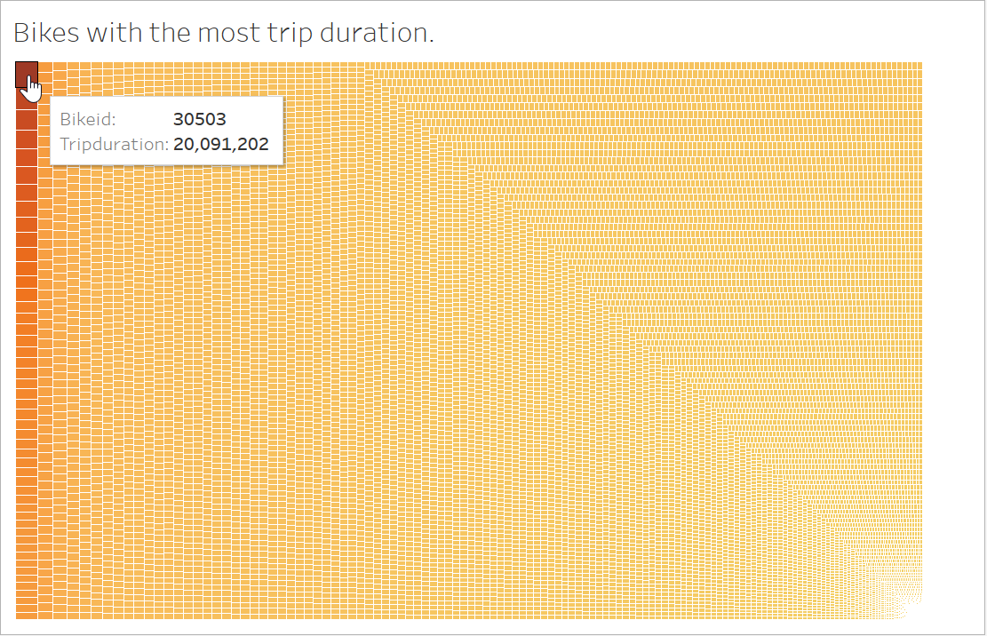

* What is the average distance in miles that a bike is ridden?

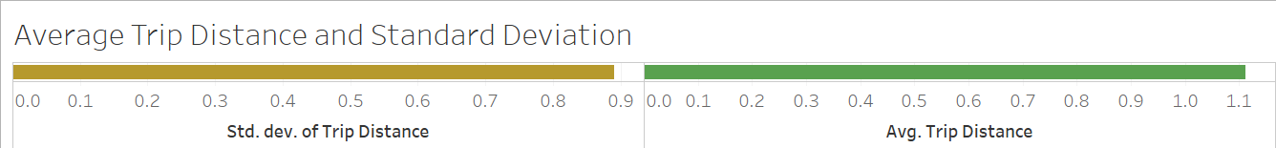

* Which bikes (by ID) are most likely due for repair or inspection in the timespan?

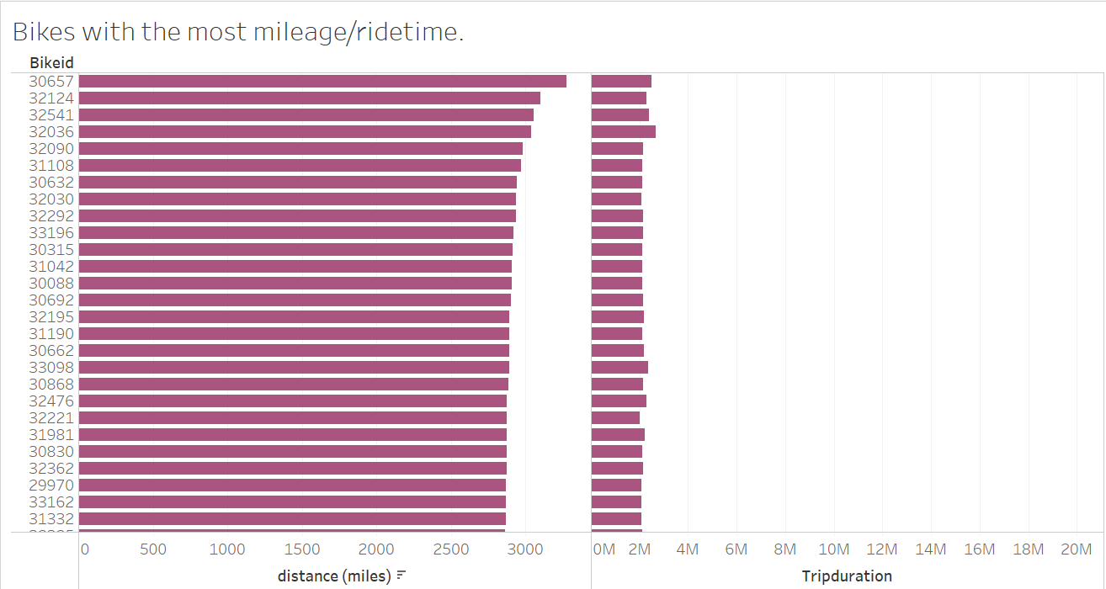

**Additionally, city officials would like to see the following visualizations:**

