1. In abstract invalid Scenario ,Abstract method using extend keyword

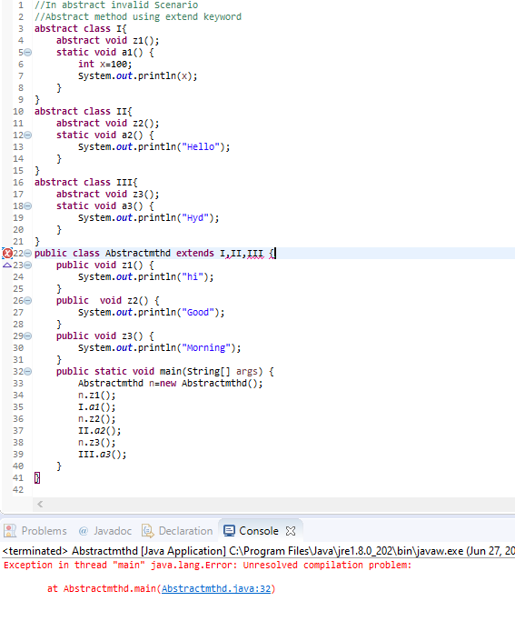

1. Abstract method using extend keyword

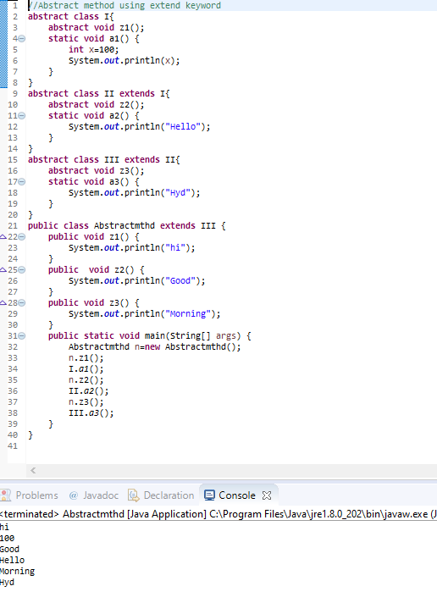

1. Interface with implement keyword

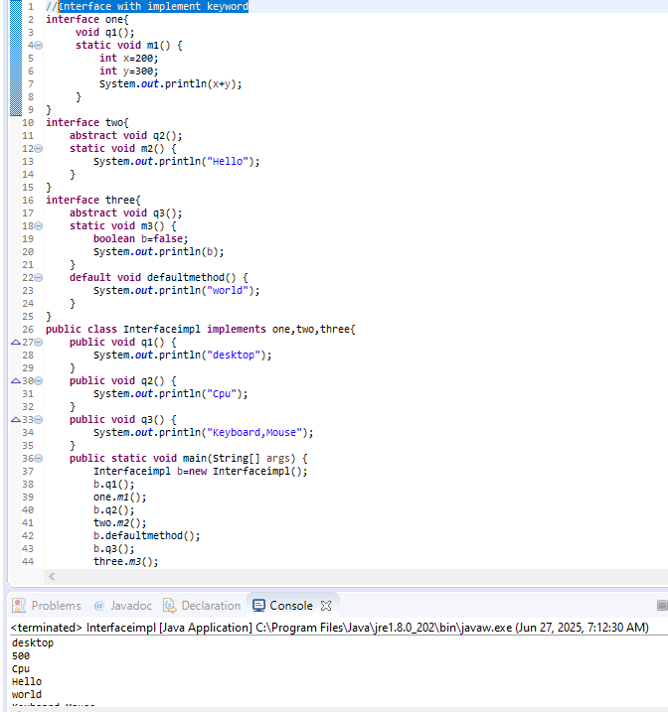

1. Interface with extend using implement keyword

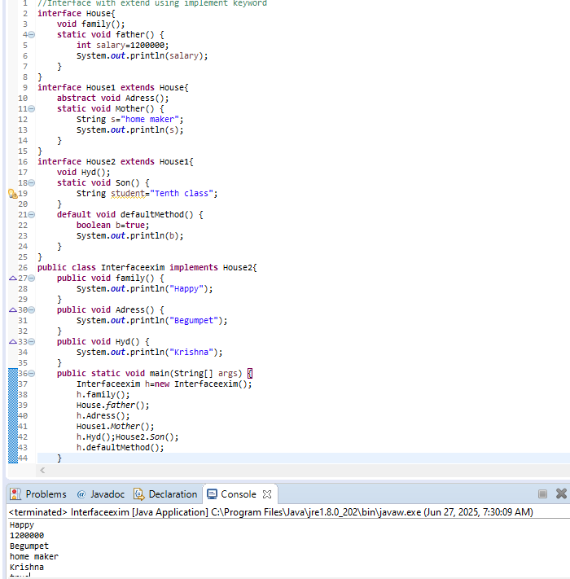

1. Combination of interface, abstract class and normal class

