1.Write a program using combination of static variables, non-static Variables and local variables?

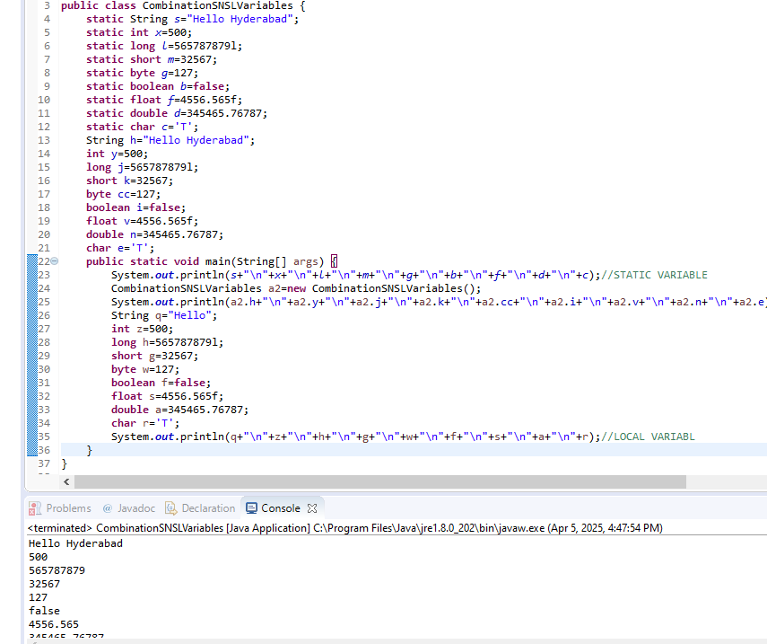

2.Program on static method?

