Difference between Structured Programming And Object Oriented Programming

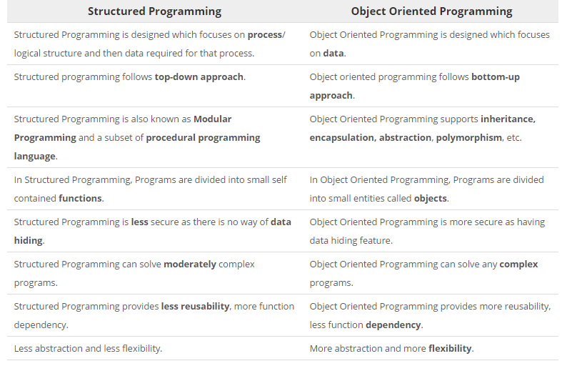

Features Of C#
Boolean Conditions:
Boolean expressions appear within many control flow statements. Their key characteristic is that they always evaluate to true or false. For input<9 to be allowed as a Boolean expression, it must result in a bool. The compiler disallows x=42, for example, because it assigns x and results in the value that was assigned, instead of checking whether the value of the variable is 42.

Automatic Garbage Collection:
.NET's garbage collector manages the allocation and release of memory for your application. Each time you create a new object, the common language runtime allocates memory for the object from the managed heap. As long as address space is available in the managed heap, the runtime continues to allocate space for new objects. However, memory is not infinite. Eventually the garbage collector must perform a collection in order to free some memory. The garbage collector's optimizing engine determines the best time to perform a collection, based upon the allocations being made.

Standard Libraries:
The Common Language Infrastructure (CLI) includes the Standard Libraries in order to encapsulate a large number of common functions, such as file reading and writing, XML document manipulation, exception handling, application globalization, network communication, threading and reflection, which makes the programmer's job easier.

Assembling Versioning:
Whenever a new .NET assembly is created in the .Net environment, a file named AssemblyInfo is created that contains attributes used to define the version of the assembly during compilation. All versioning of assemblies that use the common language runtime is done at the assembly level. The AssemblyVersion attribute assigns the version number of the assembly, and this is embedded in the manifest. Version information for an assembly consists of the following four values : a major and minor version number, and two further optional build and revision numbers.

Properties And Events:
A property is a member that provides a flexible mechanism to read, write, or compute the value of a private field. Properties can be used as if they are public data members, but they are actually special methods called accessors. This enables data to be accessed easily and still helps promote the safety and flexibility of methods.

Delegates And Events Management:
Delegates and events are fundamental to any Windows or Web Application, allowing the developer to "subscribe" to particular actions carried out by the user. Therefore, instead of expecting everything and filtering out what you want, you choose what you want to be notified of and react to that action.
A delegate is a way of telling C# which method to call when an event is triggered. For example, if you click a Button on a form, the program would call a specific method. It is this pointer that is a delegate. Delegates are good, as you can notify several methods that an event has occurred, if you wish so.
An event is a notification by the .NET framework that an action has occurred. Each event contains information about the specific event, e.g., a mouse click would say which mouse button was clicked where on the form.
Easy To Use Generics:
In c# introduce new concept is Indexer. This is very useful for some situation. Let as discuss something about Indexer.

- Indexer Concept is object act as an array.
- Indexer an object to be indexed in the same way as an array.
- Indexer modifier can be private, public, protected or internal.
- The return type can be any valid C# types.
- Indexers in C# must have at least one parameter. Else the compiler will generate a compilation error.

What is Namespace and Keywords?
→ Namespace is designed for providing a way to keep one set of names separate from another. The class names declared in one namespace does not conflict with the same class names declares in another.
The class keyword is used for declaring a class.

What is Value Type?
→ Value types are fixed in size. Value types are made in system stack. Actual values of data are stored in stack.

What is Reference Type?
→ Reference types are not fixed in size. They are maintained in system managed heap but it also uses stack to store reference of heap.

Implicit conversions:
No special syntax is required because the conversion is type safe and no data will be lost.
Examples include conversions from smaller to larger integral types, and conversions from derived classes to base classes.

// Implicit conversion. num long can // hold any value an int can hold, and more!
int num = 2147483647;
long bigNum = num;

Explicit Conversions
if a conversion cannot be made without a risk of losing information, the compiler requires that you perform an explicit conversion, which is called a cast.
A cast is a way of explicitly informing the compiler that you intend to make the conversion and that you are aware that data loss might occur.
To perform a cast, specify the type that you are casting to in parentheses in front of the value or variable to be converted. The following program casts a double to an int. The program will not compile without the cast.

Encapsulation:
Encapsulation is the procedure of covering up of data and functions into a single unit (called class). An encapsulated object is often called an abstract data type.

NEED FOR ENCAPSULATION
The need of encapsulation is to protect or prevent the code (data) from accidental corruption due to the silly little errors that we are all prone to make. In Object oriented programming data is treated as a critical element in the program development and data is packed closely to the functions that operate on it and protects it from accidental modification from outside functions.

Access Modifier:
An access modifier allows you to specify the visibility of code outside a type or assembly. Access modifiers can be applied to either types or type members.

Polymorphism

polymorphism means having many forms. In object-oriented programming, polymorphism is often expressed as 'one interface, multiple functions‘
Polymorphism can be static or dynamic. In static polymorphism, the response to a function is determined at the compile time. In dynamic polymorphism , it is decided at run-time.
C# provides two techniques to implement static polymorphism. They are:
Function overloading
Operator overloading

void print(int i)
{
Console.WriteLine("Printing int: {0}", i );
}

void print(double f)
{
Console.WriteLine("Printing float: {0}" , f);
}

public static Box operator+ (Box b, Box c) {
Box box = new Box();
box.length = b.length + c.length;
box.breadth = b.breadth + c.breadth;
box.height = b.height + c.height;
return box;
}

public static bool operator == (Box lhs, Box rhs) {
bool status = false;
if (lhs.length == rhs.length && lhs.height == rhs.height
&& lhs.breadth == rhs.breadth) {

status = true;
}
return status;
}

Iterface
An interface looks like a class, but has no implementation.
The only thing it contains are declarations of events, indexers, methods and/or properties.
The reason interfaces only provide declarations is because they are inherited by classes and structs,
which must provide an implementation for each interface member declared.
Defining Interface:
Public interface IMyInterface
{ void MethodToImplement();
}
class InterfaceImplementer : IMyInterface
{
static void Main()
{
InterfaceImplementer iImp = new InterfaceImplementer();
iImp.MethodToImplement();
}

public void MethodToImplement()
{
Console.WriteLine("MethodToImplement() called.");
}
}

Advantages of graphical user interface:-
Easiness for non-technical people:-
For non-technical people or for beginners good GUI’s tends to make easiness in life. For example with few clicks on buttons user can easily make his work done. Software in shops for calculation of products sold and inventory can be better managed by an even non-technical guy. Similarly listening songs in the car is easy for everyone.
Drag and drop feature:-
In most of the software, we have drag and drop functionality by which complex tasks are managed easily. Like dragging and dropping folders. And in mobile games, it is also nice to use. In much graphical software, drag and drop are awesome.
Looks nicer than text interface:-
In text interface, we have limited options to choose from and navigation is difficult. For non-educated people, text interface is difficult to understand and use. In GUI user can use any tool by detecting symbols or buttons.
Hotkeys usage:-
Sometimes we want a couple of functionality performed by single click then we use hotkeys. Like we see some buttons or mouse clicks/movements by which a couple of actions performed. This is very handy for speeding up tasks.
User-friendly:-
A user can easily navigate to the system without knowing a lot of details. Easy setup and ready to start working are awesome. Most of the software hides the complexity of actions from the users and display only required information is key to good interface.
Disadvantages of graphical user interface:-
Difficult to develop and high cost:-
Nice looking designs are difficult to make and may also cost extra hardware support. Like high-quality games consume a lot of device space and memory and it also required very skilled people to develop.
Slower than command line tools:-
In command line tools like MS dos, we perform some commands which do the work quickly. But if we do the same task in GUI then it takes extra time to complete the task.
Extra attention required:-
If we are driving a car then controlling music/radio in the car requires attention which makes our driving disturbed.

Using flat screen:-
Some graphical things do not display accurately on flat screens. In airplanes, sticks are used to control most of the things because flat screen display is not very handy. This makes the limitation of GUI.
Time consumption:-
It takes a lot of time to develop and design a good looking interface. If some bad interface builds then it makes difficult for the user to understand and use.
Memory resources:-
I see a lot of good GUI’s consuming lot of memory resources which make system/device slow to perform.
Implementation:-
Testing and implementation take a lot of time. Like we may require extra software for running GUI’s

