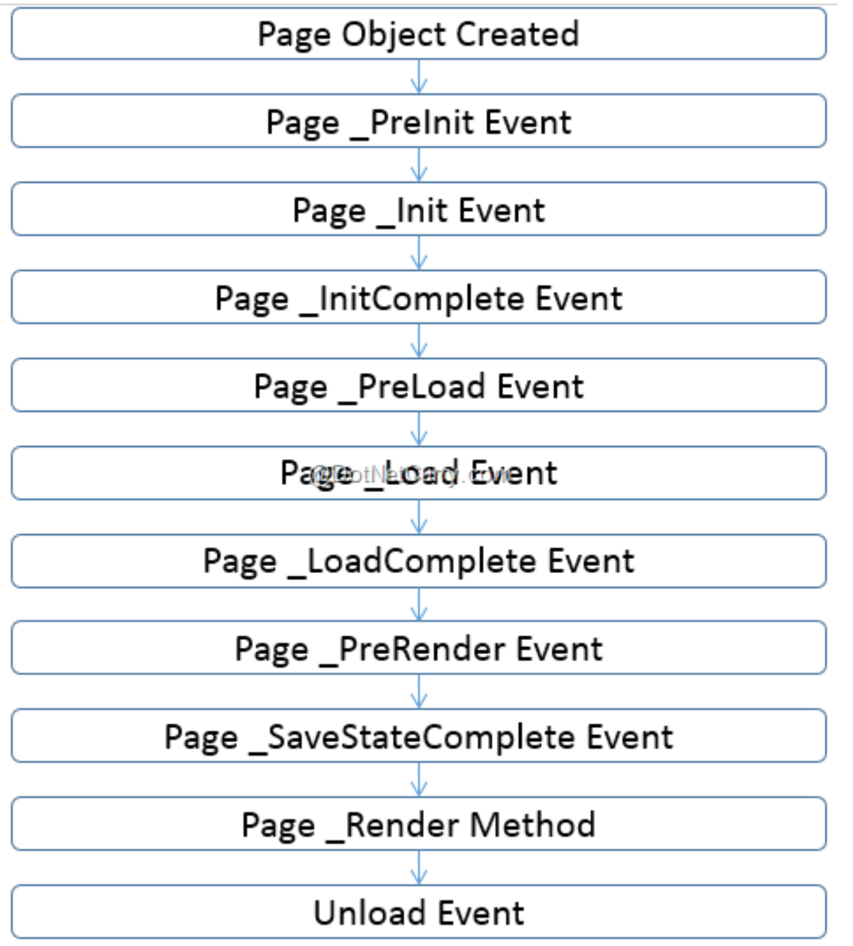
Page Life Cycle

1. Page_PreInit Event - This event is the first event which gets executed during the page life cycle. This event can be used to change Master Page and Theme of the page. change the Profile properties under this event.
2. Page_Init Event –
This event fires after each control has been initialized.
Each control's UniqueID is set and any skin settings have been applied.
Use this event to read or initialize control properties.
3. Page_InitComplete –
Until now the viewstate values are not yet loaded, hence you can use this event to make changes to the view state that you want to ensure are persisted after the next postback.
Raised by the Page object.
Use this event for processing tasks that require all initialization to be complete
4. Page_PreLoad Event –
Raised after the page loads view state for itself and all controls, and after it processes postback data that is included with the Request instance.
Before the Page instance raises this event, it loads view state for itself and all controls, and then processes any postback data included with the Request instance.
Loads ViewState: ViewState data are loaded to controls.
Loads Postback data: Postback data are now handed to the page controls.
5. Page_Load Event
The Page object calls the OnLoad method on the Page object, and then recursively does the same for each child control until the page and all controls are loaded. The Load event of individual controls occurs after the Load event of the page.
This is the first place in the page lifecycle that all values are restored.
Most code checks the value of IsPostBack to avoid unnecessarily resetting state.
You may also call Validate and check the value of IsValid in this method.
You can also create dynamic controls in this method.
Use the OnLoad event method to set properties in controls and establish database connections.–
6. Page_LoadComplete –
Raised at the end of the event-handling stage.
Use this event for tasks that require that all other controls on the page be loaded.
7. Page_PreRender –
Allows final changes to the page or its control.
This event takes place before saving ViewState, so any changes made here are saved.
8. Page_SaveStateComplete Event –
Raised after view state and control state have been saved for the page and for all controls.
Before this event occurs, ViewState has been saved for the page and for all controls.
Any changes to the page or controls at this point will be ignored.
Use this event perform tasks that require the view state to be saved, but that do not make any changes to controls.
9. Page_Render Method –
This is a method of the page object and its controls (and not an event).
The Render method generates the client-side HTML, Dynamic Hypertext Markup Language (DHTML), and script that are necessary to properly display a control at the browser
10. Page_Unload Event –
This event is used for cleanup code.
At this point, all processing has occurred and it is safe to dispose of any remaining objects, including the Page object.
During the unload stage, the page and its controls have been rendered, so you cannot make further changes to the response stream.

MVC Architecture:

In this section, you will get an overview of MVC architecture. The MVC architectural pattern has existed for a long time in software engineering. All most all the languages use MVC with slight variation, but conceptually it remains the same.
Let's understand the MVC architecture in ASP.NET.
MVC stands for Model, View and Controller. MVC separates application into three components - Model, View and Controller.
Model: Model represents shape of the data and business logic. It maintains the data of the application. Model objects retrieve and store model state in a database.
Model is a data and business logic.
View: View is a user interface. View display data using model to the user and also enables them to modify the data.
View is a User Interface.
Controller: Controller handles the user request. Typically, user interact with View, which in-turn raises appropriate URL request, this request will be handled by a controller. The controller renders the appropriate view with the model data as a response.
Controller is a request handler.
The following figure illustrates the interaction between Model, View and Controller.
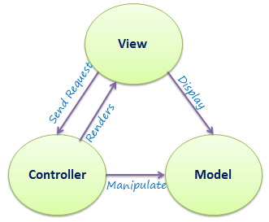
The following figure illustrates the flow of the user's request in ASP.NET MVC.
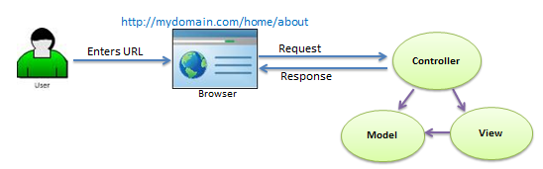
As per the above figure, when the user enters a URL in the browser, it goes to the server and calls appropriate controller. Then, the Controller uses the appropriate View and Model and creates the response and sends it back to the user. We will see the details of the interaction in the next few sections.
Entity Framework:
Entity Framework is an Object Relational Mapper (ORM) which is a type of tool that simplifies mapping between objects in your software to the tables and columns of a relational database.
Entity Framework (EF) is an open source ORM framework for ADO.NET which is a part of .NET Framework.

Entity Framework Features
- Cross-platform: EF Core is a cross-platform framework which can run on Windows, Linux and Mac.

- Modelling: EF (Entity Framework) creates an EDM (Entity Data Model) based on POCO (Plain Old CLR Object) entities with get/set properties of different data types. It uses this model when querying or saving entity data to the underlying database.

- Querying: EF allows us to use LINQ queries (C#/VB.NET) to retrieve data from the underlying database. The database provider will translate this LINQ queries to the database-specific query language (e.g. SQL for a relational database). EF also allows us to execute raw SQL queries directly to the database.

- Change Tracking: EF keeps track of changes occurred to instances of your entities (Property values) which need to be submitted to the database.

- Saving: EF executes INSERT, UPDATE, and DELETE commands to the database based on the changes occurred to your entities when you call the SaveChanges() method. EF also provides the asynchronous SaveChangesAsync() method.

- Concurrency: EF uses Optimistic Concurrency by default to protect overwriting changes made by another user since data was fetched from the database.

- Transactions: EF performs automatic transaction management while querying or saving data. It also provides options to customize transaction management.

- Caching: EF includes first level of caching out of the box. So, repeated querying will return data from the cache instead of hitting the database.

- Built-in Conventions: EF follows conventions over the configuration programming pattern, and includes a set of default rules which automatically configure the EF model.

- Configurations: EF allows us to configure the EF model by using data annotation attributes or Fluent API to override default conventions.

- Migrations: EF provides a set of migration commands that can be executed on the NuGet Package Manager Console or the Command Line Interface to create or manage underlying database Schema.

