Report On Mero Lens Project

Mero Lens:

Mero Lens is a Dubai based company and the website for the respective company is being developed by Fabulous IT And Engineering Pvt. Ltd.
The design and development was done with the reference of the following company:

- https://www.lens.me/

The company works on the following sectors:
- Sales and purchase of lens

Services:
- Secure Database
- User friendly Design
- About Us
- Contact Us
- Billing
- Add To Cart
- Order Detail
- Product List
- Location
- Categories
- Login
- Register

The design of the project looks as following:

Navbar
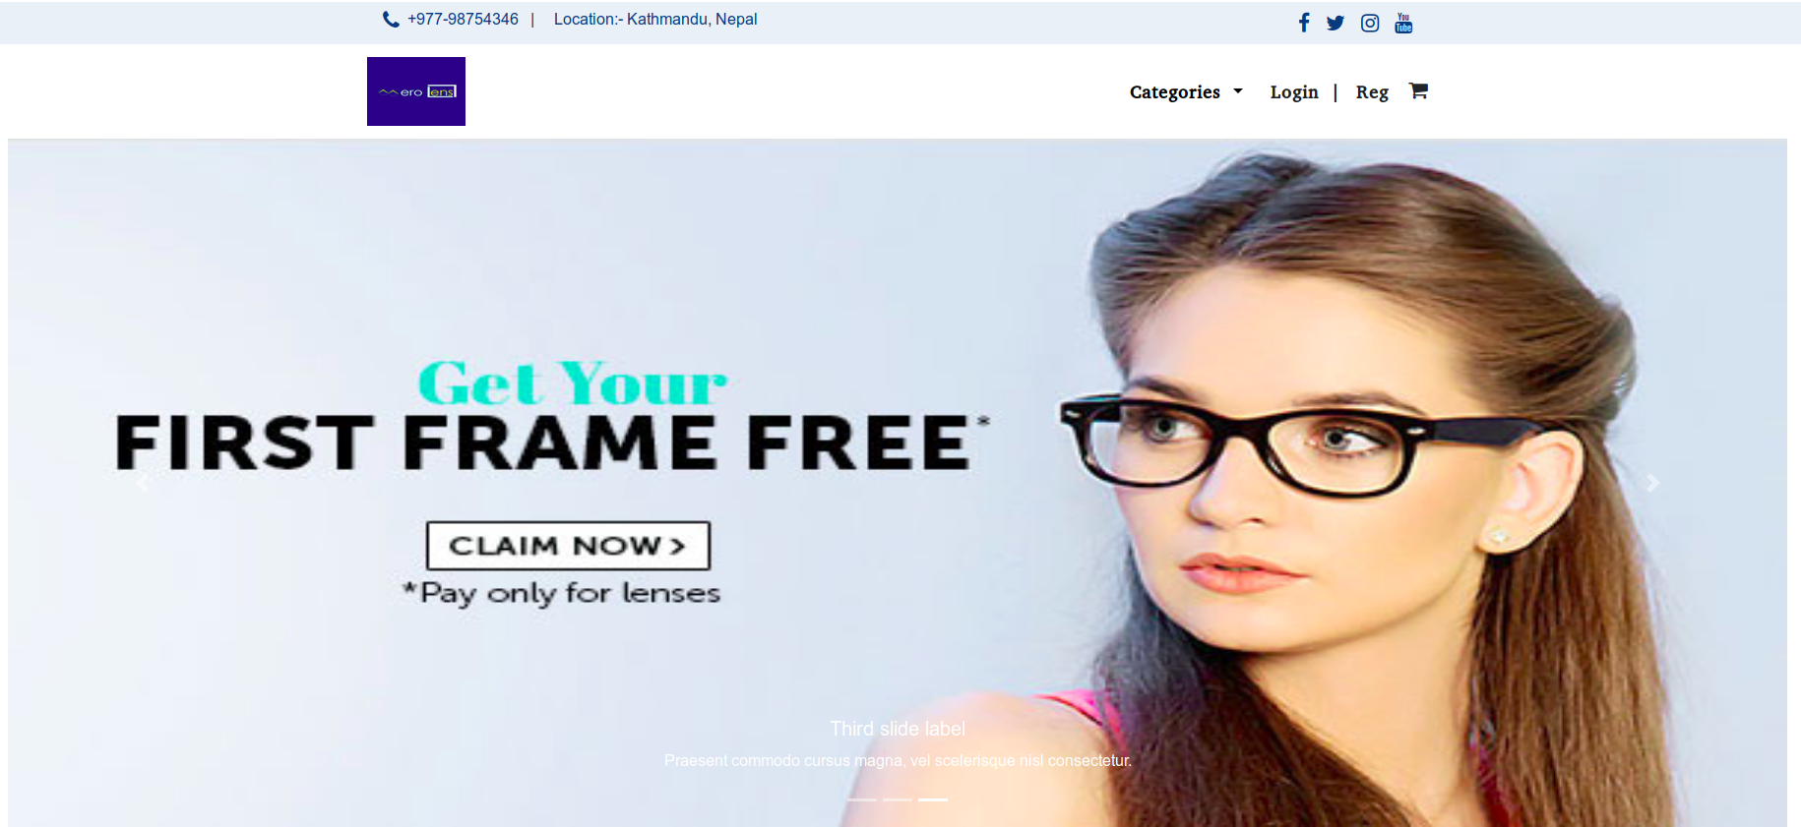

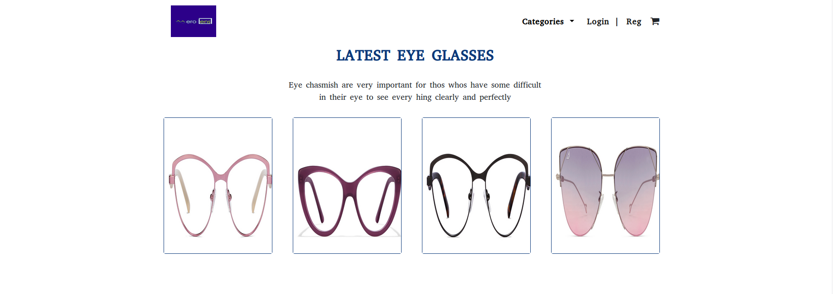
Latest Eye Glass

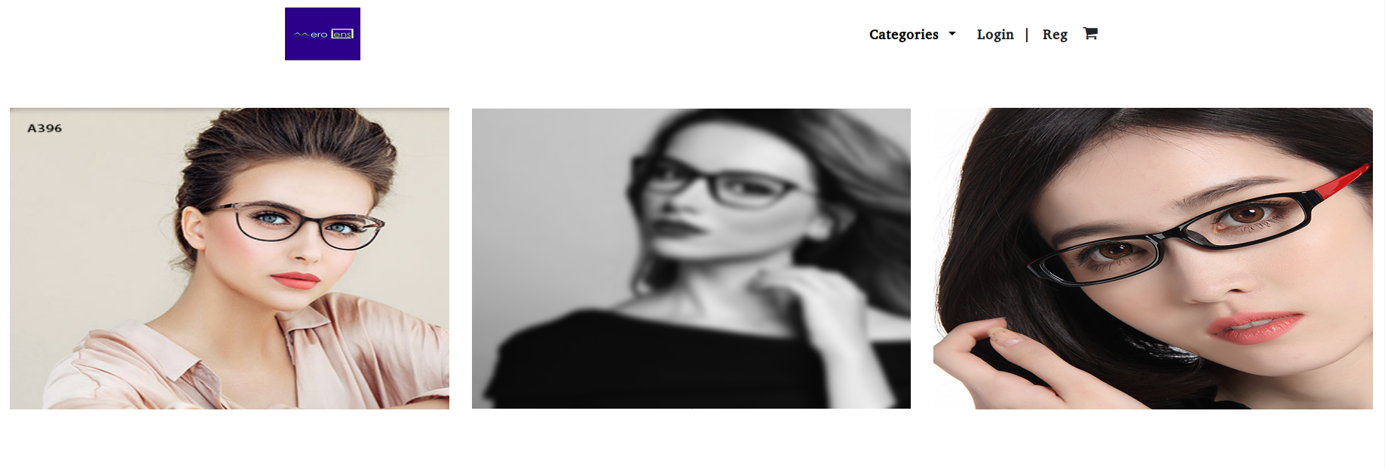

New Arrival
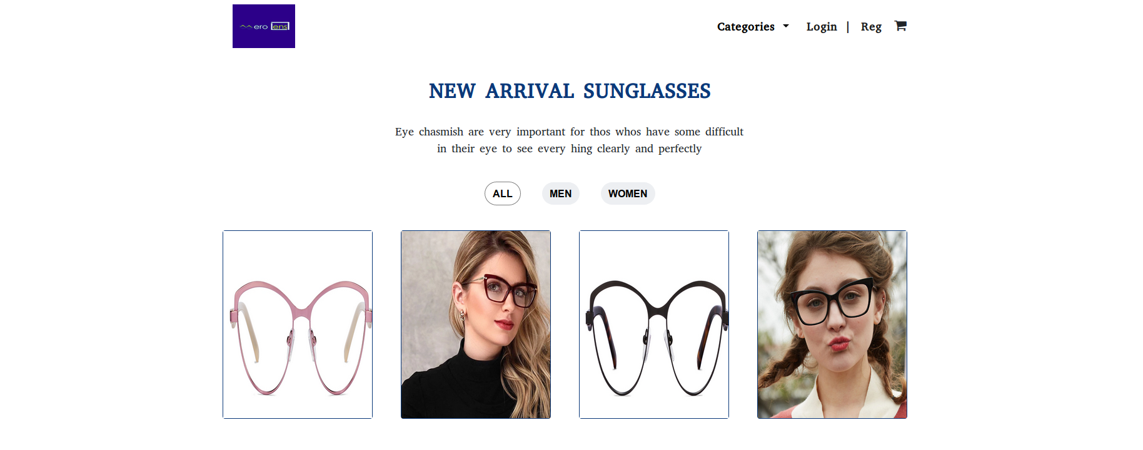

Product Categories
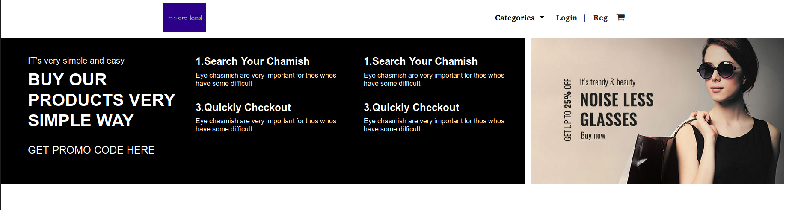

Shop

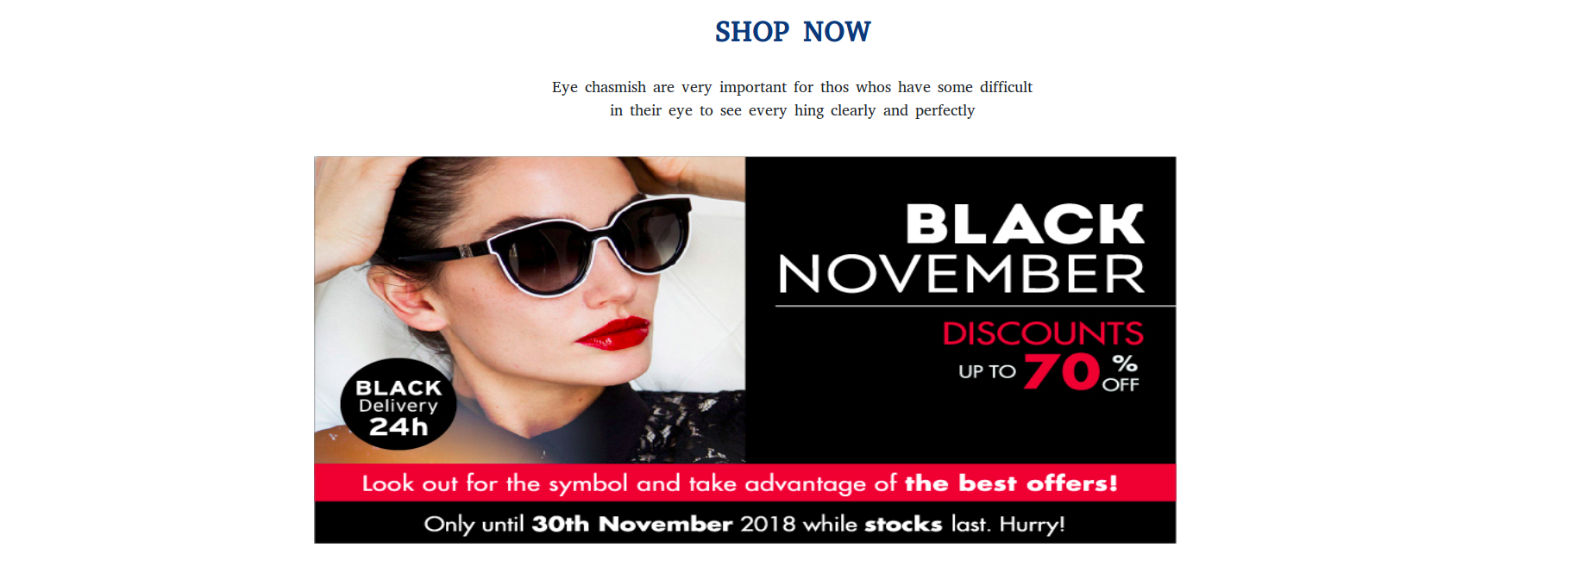

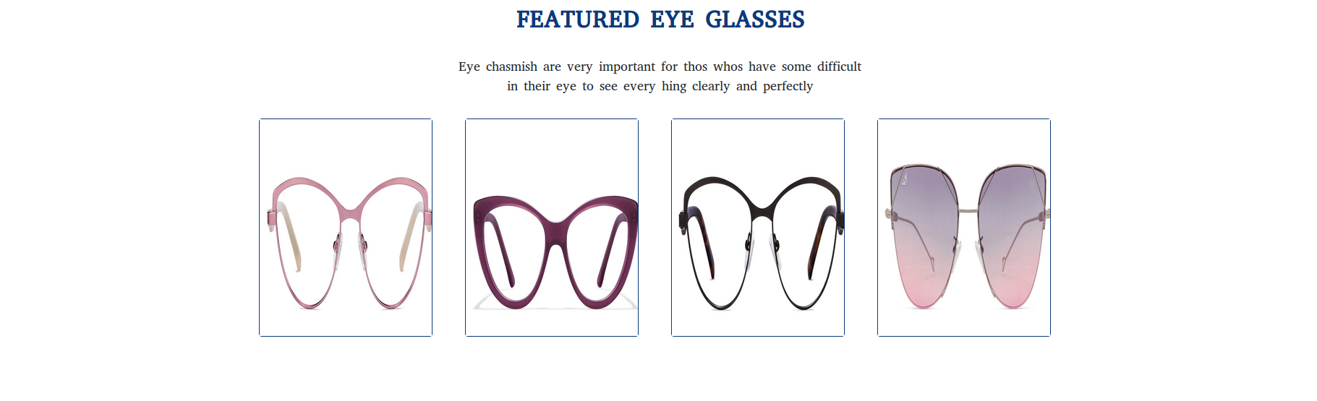
Featured Product

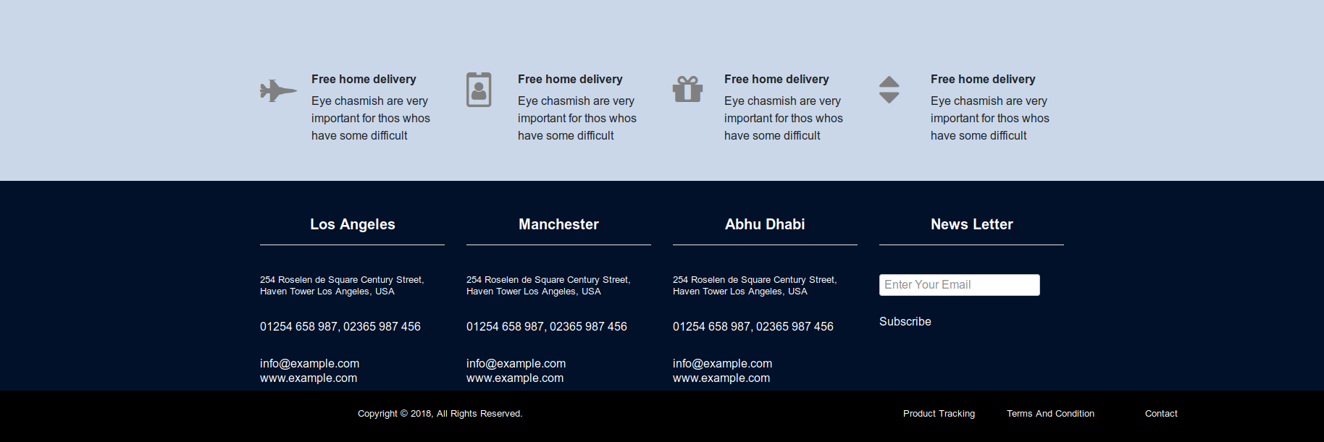
Footer

Here, we have shown a complete design of your project. If you have any queries regarding the design or any sort of changes you want in it please feel free to share it with our team. We are always at your service thank you for choosing us.

With Regards,
Fabulous IT And Engineering Pvt. Ltd.

