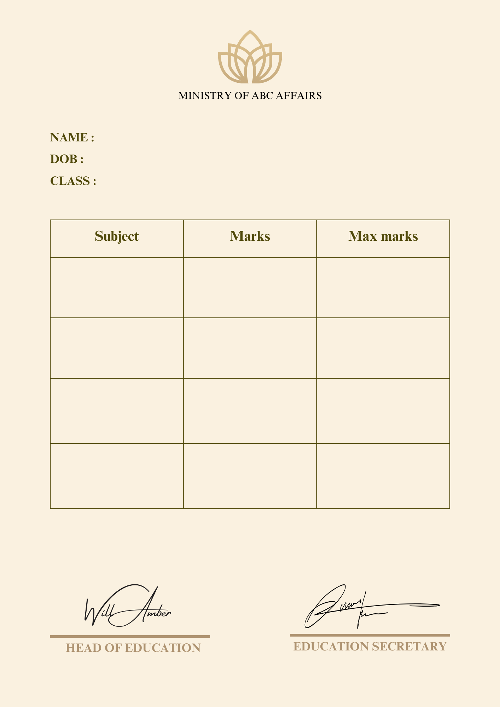

Certificate ID: {{id}}

{{max4}}

{{max3}}

{{max2}}

{{max1}}

{{marks4}}

{{marks3}}

{{marks2}}

{{marks1}}

{{subject4}}

{{subject3}}

{{subject2}}

{{subject1}}

{{class}}

{{dob}}

{{name}}