Week 6 R Functions

Karis Kim (A16378938)

2024-04-21

This week we are introducing **R functions** and how to write our own R functions.

Questions to answer:

Q1. Write a function grade() to determine an overall grade from a vector of student homework assignment scores dropping the lowest single score. If a student misses a homework (i.e. has an NA value) this can be used as a score to be potentially dropped. Your final function should be adquately explained with code comments and be able to work on an example class gradebook such as this one in CSV format: “<https://tinyurl.com/gradeinput>” [3pts]

plot(1:10)

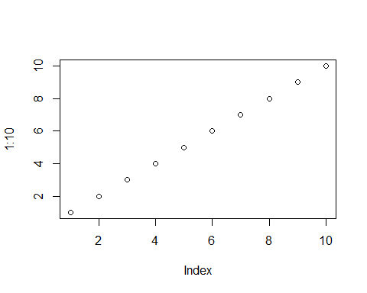

# Example input vectors to start with   
student1 <- c(100, 100, 100, 100, 100, 100, 100, 90)   
  
student2 <- c(100, NA, 90, 90, 90, 90, 97, 80)  
  
student3 <- c(90, NA, NA, NA, NA, NA, NA, NA)

Follow the guidelines from class

-Write a working snippet of code that solves a simple problem

# Straight forward mean()  
student1 <- c(100, 100, 100, 100, 100, 100, 100, 90)  
  
mean(student1)

## [1] 98.75

But… we need to drop the lowest score. First, we need to identify the lowest score.

which.min(student1)

## [1] 8

What I want is to now drop (i.e. exclude) this lowest score from my mean() calculation.

student1[-8]

## [1] 100 100 100 100 100 100 100

Now we can use the answer from which.min() to return all other elements of the vector.

# This is for our first working snippet  
mean( student1[-which.min(student1)] )

## [1] 100

What about the other example students? Will this work for them?

student2 <- c(100, NA, 90, 90, 90, 90, 97, 80)   
mean(student2, na.rm=TRUE)

## [1] 91

student3 <- c(90, NA, NA, NA, NA, NA, NA, NA)  
mean(student3, na.rm=TRUE)

## [1] 90

Another approach is to mask (i.e. replace) all NA values with zero.

First we need to find the NA elements of the vector? How do we find the NA elements?

student2 <- c(100, NA, 90, 90, 90, 90, 97, 80)   
x <- student2  
  
is.na(x)

## [1] FALSE TRUE FALSE FALSE FALSE FALSE FALSE FALSE

which( is.na(x) )

## [1] 2

Now we have identified the NA elements we want to mask them. Replace them with zero? We will make the NA elements zero.

x[is.na(x)] <- 0  
x

## [1] 100 0 90 90 90 90 97 80

mean(x)

## [1] 79.625

Recall we should drop the lowest score now…

x[is.na(x)] <- 0  
mean( x[-which.min(x)] )

## [1] 91

student3 <- c(90, NA, NA, NA, NA, NA, NA, NA)  
x <- student3  
x[is.na(x)] <- 0  
mean( x[-which.min(x)] )

## [1] 12.85714

## Now We Can Make Our Function

Take the snippet and turn into a function. Every function has three parts: 1. A Name ( in our case grade() ) 2. Input Arguments ( a vector of student scores ) 3. The Body ( i.e our working snippet )

Using RStudio I will select Code > Extract Function

grade <- function(x) {  
 x[is.na(x)] <- 0  
 mean ( x[-which.min(x)] )  
}

grade(student1)

## [1] 100

grade(student2)

## [1] 91

grade(student3)

## [1] 12.85714

This looks great! Now we need to add comments to explain this function to our future selves and others who want to use this function.

#' Calculate the average score for a vector of student   
#' dropping the lowest score.   
#' Missing values will be treated as zero.  
#'   
#' @param x A numeric vector of homework scores  
#'  
#' @return An average score  
#' @export   
#'  
#' @examples  
#' student <- (100, NA, 90, 97)  
#' grade(Student)  
#'   
  
grade <- function(x) {  
 # Mask NA with zero  
 # Treat missing values as zero  
 x[is.na(x)] <- 0  
 # Exclude lowest score from mean  
 mean ( x[-which.min(x)] )  
}

Now we can finally use our function on our real whole class data from the CSV format file: “<http://tinyurl.com/gradeinput>”

url <- "http://tinyurl.com/gradeinput"  
gradebook <- read.csv(url, row.names = 1)

apply(gradebook, 1, grade)

## student-1 student-2 student-3 student-4 student-5 student-6 student-7   
## 91.75 82.50 84.25 84.25 88.25 89.00 94.00   
## student-8 student-9 student-10 student-11 student-12 student-13 student-14   
## 93.75 87.75 79.00 86.00 91.75 92.25 87.75   
## student-15 student-16 student-17 student-18 student-19 student-20   
## 78.75 89.50 88.00 94.50 82.75 82.75

Q2. Using your grade() function and the supplied gradebook, Who is the top scoring student overall in the gradebook? [3pts]

To answer this question, we will run the apply() function and save the results.

results <- apply(gradebook, 1, grade)  
sort(results, decreasing = TRUE)

## student-18 student-7 student-8 student-13 student-1 student-12 student-16   
## 94.50 94.00 93.75 92.25 91.75 91.75 89.50   
## student-6 student-5 student-17 student-9 student-14 student-11 student-3   
## 89.00 88.25 88.00 87.75 87.75 86.00 84.25   
## student-4 student-19 student-20 student-2 student-10 student-15   
## 84.25 82.75 82.75 82.50 79.00 78.75

which.max(results)

## student-18   
## 18

Q3. From your analysis of the gradebook, which homework was toughest on students (i.e. obtained the lowest scores overall? [2pts]

gradebook

## hw1 hw2 hw3 hw4 hw5  
## student-1 100 73 100 88 79  
## student-2 85 64 78 89 78  
## student-3 83 69 77 100 77  
## student-4 88 NA 73 100 76  
## student-5 88 100 75 86 79  
## student-6 89 78 100 89 77  
## student-7 89 100 74 87 100  
## student-8 89 100 76 86 100  
## student-9 86 100 77 88 77  
## student-10 89 72 79 NA 76  
## student-11 82 66 78 84 100  
## student-12 100 70 75 92 100  
## student-13 89 100 76 100 80  
## student-14 85 100 77 89 76  
## student-15 85 65 76 89 NA  
## student-16 92 100 74 89 77  
## student-17 88 63 100 86 78  
## student-18 91 NA 100 87 100  
## student-19 91 68 75 86 79  
## student-20 91 68 76 88 76

ave.scores <- apply(gradebook, 2, mean, na.rm=TRUE)  
ave.scores

## hw1 hw2 hw3 hw4 hw5   
## 89.00000 80.88889 80.80000 89.63158 83.42105

which.min(ave.scores)

## hw3   
## 3

med.scores <- apply(gradebook, 2, median, na.rm=TRUE)  
med.scores

## hw1 hw2 hw3 hw4 hw5   
## 89.0 72.5 76.5 88.0 78.0

which.min(med.scores)

## hw2   
## 2

boxplot(gradebook)

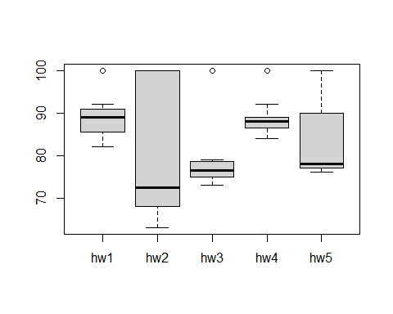

Q4. Optional Extension: From your analysis of the gradebook, which homework was most predictive of overall score (i.e. highest correlation with average grade score)? [1pt]

Q5. Make sure you save your Quarto document and can click the “Render” (or Rmarkdown”Knit”) button to generate a PDF foramt report without errors. Finally, submit your PDF to gradescope. [1pt]

Knit the document to make a PDF.