**README**

The following are steps involved in completing the assessment, which mainly include acquiring the required data files, creating database and tables, loading data, and generating reports. The system environment requirements are listed at the end of this file.

**STEP ONE: Download data files.**

1. Download the required data files and put them into a folder. The folder name used here is PostgreSQL, but you may use any folder that is appropriate.
2. There are three data files, and the file names are: Consumer_Complaints.csv, g20135us.csv and 20135us0015000.zip.
3. Delete the header information, i.e., the first row, from the file Consumer_Complaints.csv for importing data purpose.
4. Save all the database creation, table creation, and data importing files into the aforementioned same folder PostgreSQL.

**STEP TWO: Create database and tables, and load data.** Please run all the files or commands in the following sequence (1-4) in the isql environment.

1. Execute file dbCreation.txt or the commands inside the file to create database CFPBreport.
2. Login into isql with the database created in the last step and your credentials. Type the following command, where CFPBreport is the name of the database:

*[prompt]$ psql CFPBreport*

1. Create table in the database just created by running the files or the commands inside the files.

Here is an example of the command:

*psql -h hostname -U username -f CreateTBL_ACSSF_Consumer.txt CFPBreport*

CreateTBL_ACSSF_Consumer.txt

1. Load data into the created tables by running the files or the commands inside the files.

Root permission might be asked when running these files. If no privilege is available, you can use the import functionality from pgAdmin to load the data.

Load_data_ACSSF.txt

An example of using the import function of pgadMin to populate data is shown below.

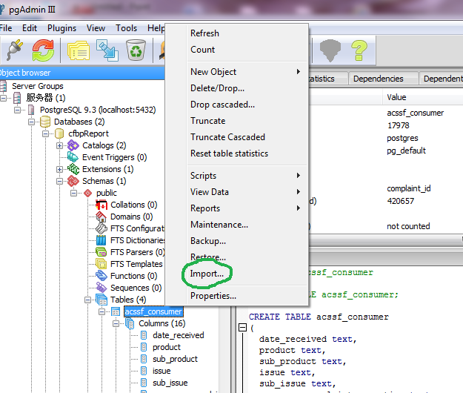

Figure 1. Screenshot of IMPORT_DATA

**STEP THREE: Generate reports.**

1. Run the following file, which contains queries to generate desired information, in the isql environment.

File name: Report_credit_card_transaction_2014.txt

Below is a part of a screenshot of report result showed in isql

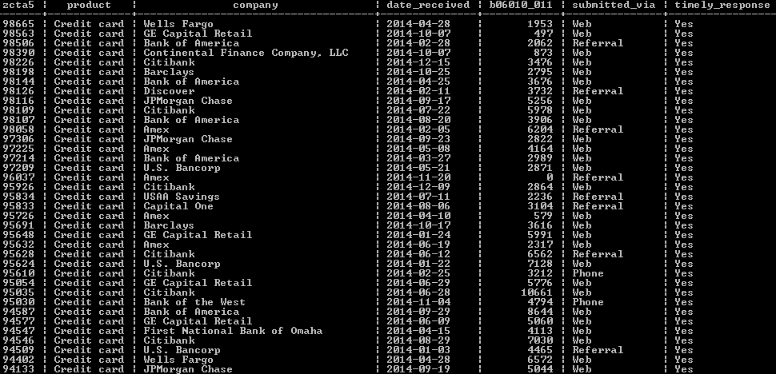

Figure 2. Screenshot of RUN_QUERY_ISQL

1. The HTML reports are generated by pgAdmin.

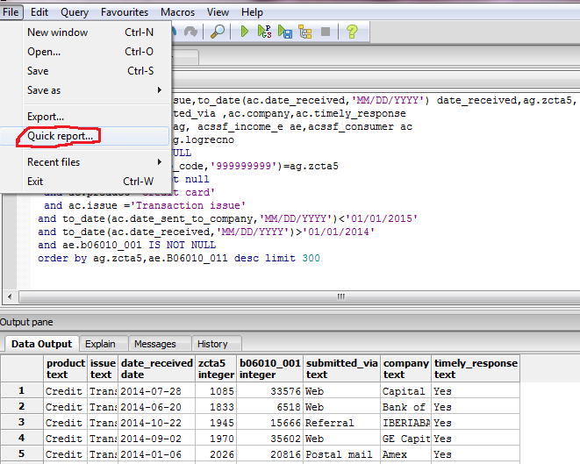

Figure 3. Screenshot of HTML_REPORT_GENERATION

1. The next two tasks involve analysis of complaints from areas with annual median income lower than $15,000 and higher than $50,000, respectively.
2. Report_Median_Income_15000.txt

This yields data of those complaints from low-income areas (controlled by zip codes).

1. Report_Median_Income_50000.txt

This gives data of those complaints from high-income areas (controlled by zip codes).

The reports particularly show the complaint categories and the number of complaints every quarter from December 2011 to July 2015 from the selected two groups.

**Appendix**

Required running environments:

Operating system: Linux 6

Database software: PostgreSQL 9.3

Other software: Excel