CSD310– Database Development and Use

Group 4 Bacchus

Karissa Flora, Joshua Ramsey, and Jeremy Ginter

**Milestone #1:**

**Business Rules:**

* A company can have none or many orders.
* An order is placed by only one company.
* A supplier can only supply inventory.
* Supplies are turned into many products.
* Products can only be in one category.
* A product category is one or many products.
* An order can have one or many order details.
* An order detail can only have one or many orders.
* An order can have one or many products.
* A product can have only one order detail.
* A company can see many employees' time clocks.
* Employees can log many clock-ins on the time clock for each quarter.

**ERD:**

**Milestone #2:**

**Updated ERD:**

**Screenshots of Python Script:**

**Milestone #3:**

**Python Screenshots:**

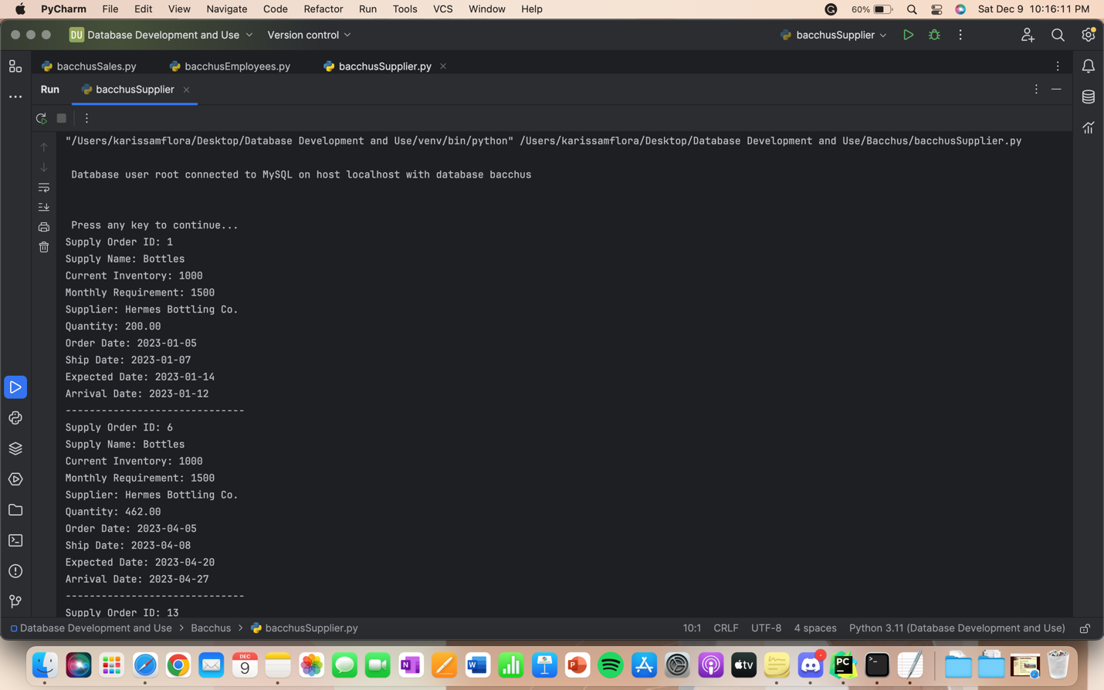

**NEW ERD:**

