# Discussion of Regional Models

* + Lefsky et al. (2002) were successful at developing a unified equation for predicting aboveground biomass in multiple biomes (Temperate Deciduous Broadleaf, Temperate Coniferous Needleleaf, Boreal Coniferous Needleleaf), there was no replication in each biome. When all sites are considered together, mean height squared is the best overall predictor of above-ground biomass. (Lefsky et al 2002)
  + Lefsky et al 2005 A we were able to look at 5 sites within the Temperate Coniferous Needleleaf biome, using sites with varying environment and composition. They created equations that predicted stand structure variables (e.g. aboveground biomass and LAI) across an environmental and compositional gradient. Aboveground biomass were consistently predictable along a productivity and species composition gradient from the true fir forests of Mt. Rainier to Ponderosa pine forests at Metolius, and at the high productivity forests of Cascade Head, the coast range, and H.J. Andrews (Lefsky et al 2005 A).
  + (Lefsky et al 2005 A and 2002) offer a regional confirmation of the continental-scale hypothesis offered in Lefsky et al. (2002), in which the geographic generality of an equation predicting aboveground biomass was demonstrated.
  + Lefsky et al 2005 A found broad consistency in lidar-stand structure relationship over this region, and a relative lack of importance of environmental conditions (Lefsky et al 2005 A).
  + While the range of environmental conditions and composition examined in this paper is narrower than in Lefsky et al. (2002), the number of site locations examined is larger, and thus confirms the result for the Pacific Northwest region of the USA (Lefsky et al 2005 A).

Given this wide range of conditions, and the earlier results of Lefsky et al. (2002 and 2005 A), it is reasonable to ask if, in forests dominated by coniferous species, tree architecture is constrained to the point where a unified relationship between lidar measurements and stand structure might exist for these forests generally. In existing studies of this type (Lefsky et al. 2002 and 2005 A) there has been an attempt to have a structural or temporal sequence of stands at one or more study locations.

Density is mass/volume.

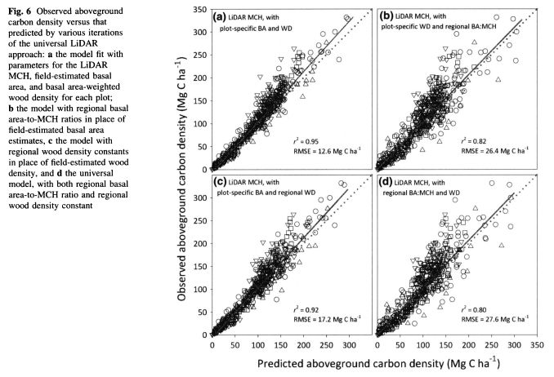Asner 2012

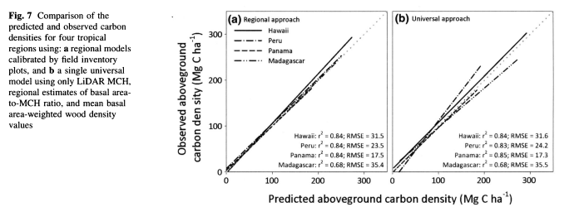

Asner 2012

* Plot size
  + The relationship between precision on small plots and entire stands illustrates two important aspects. Plot size has a strong influence on the model error (RMSE), with larger plots typically resulting in lower errors, although above 0.1 ha there is little influence on model coefficients (Mascaro et al. [2011b](https://link.springer.com/article/10.1007/s00442-011-2165-z#CR40), Zolkos, Sheridan). First, small areas are subject to substantial inherent variation around canopy height quantiles leading to highly variable predictions (cf. [Magnussen & Boudewyn, 1998](http://www.sciencedirect.com/science/article/pii/S0034425701002905" \l "BIB17), Naesset 2002, Zolkos **). The standard deviations between predicted and ground-truth values of the plots revealed by cross-validation were up to 160% larger than the corresponding standard deviations obtained for entire stands(Naesset 2002).
  + On the other hand, extended plot size will increase the inventory costs. Thus, traditional cost/benefit analysis could be used to balance precision and costs. (Naesset 2002).
  + Sheridan (image below)
  + 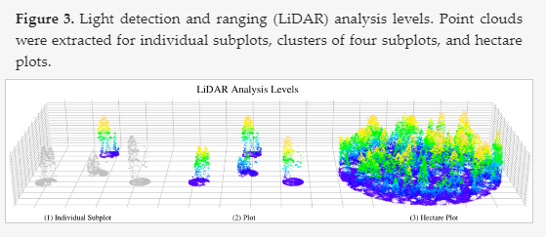
* Variation by forest types:
  + different age classes exhibit distinct laser canopy height distribution forms [(Lefsky, Cohen, et al., 1999)](http://www.sciencedirect.com/science/article/pii/S0034425701002905" \l "BIB15).

Relationships of stand characteristics to lidar metrics vary between tree species [(Næsset, 1997a; Nelson, Oderwald, & Gregoire, 1997)](http://www.sciencedirect.com/science/article/pii/S0034425701002905" \l "BIB23). crown shape differs between species and translates to differences in lidar metrics [(Nelson, 1997)](http://www.sciencedirect.com/science/article/pii/S0034425701002905#BIB28). It is possible that a more successful method for estimating deciduous basal area could be created using a combination of conventional optical remote sensing to detect the presence of deciduous trees (e.g. Maiersperger et al., 2001), and lidar to estimate their basal area (Lefsky et al 2005 A). For the boreal coniferous site, the product of cover and several of the height indices performed better than the height indices alone; at the temperate deciduous site, the reverse was true, again due probably to the low range of canopy cover, and the resulting non-significant correlation between cover and biomass (Lefksy 2002). Narrow range of canopy cover conditions observed in those plots 🡪 few deciduous trees.

General:

Issues influenced the analysis of this data set: 1) the potential for multicollinearity when a large number of independent variables are involved; 2) the choice of variables for, and the comprehensibility of, regression equations.

Latent variables – overfitting may occur, independent (validation) data used to determine the optimal number of latent variables (?? Maybe Naesset e tal 2005). Close agreement in magnitude between RMSE and RMSEcrossval suggests that the model is not overfit and suitable for generalization.

Iid - linear issues: Over predicted low values (Li et al 2008, Kim et al 2009)

* Stratified sample –
  + Commonly used stratification criteria such as age class and site quality, which is correlated with at least the dominant conifer tree species in Norway, may therefore be useful for an efficient stratification of inventories. In the present study, stratification according to age class and site quality was efficient to represent distinct forest types in practical inventories (Naesset 2002).
* Plots with small biomass, tree dbh threshold
  + The consequence of excluding trees with a small dbh from plots is that the biomass estimate may not be representative of the distributions of laser canopy heights, especially those with few trees.