# Discussion of Regional Models

* + Lefsky et al. (2002) were successful at developing a unified equation for predicting aboveground biomass in multiple biomes (Temperate Deciduous Broadleaf, Temperate Coniferous Needleleaf, Boreal Coniferous Needleleaf), there was no replication in each biome. When all sites are considered together, mean height squared is the best overall predictor of above-ground biomass. (Lefsky et al 2002)
  + Lefsky et al 2005 A we were able to look at 5 sites within the Temperate Coniferous Needleleaf biome, using sites with varying environment and composition. They created equations that predicted stand structure variables (e.g. aboveground biomass and LAI) across an environmental and compositional gradient. Aboveground biomass were consistently predictable along a productivity and species composition gradient from the true fir forests of Mt. Rainier to Ponderosa pine forests at Metolius, and at the high productivity forests of Cascade Head, the coast range, and H.J. Andrews (Lefsky et al 2005 A).
  + (Lefsky et al 2005 A and 2002) offer a regional confirmation of the continental-scale hypothesis offered in Lefsky et al. (2002), in which the geographic generality of an equation predicting aboveground biomass was demonstrated.
  + Lefsky et al 2005 A found broad consistency in lidar-stand structure relationship over this region, and a relative lack of importance of environmental conditions (Lefsky et al 2005 A).
  + While the range of environmental conditions and composition examined in this paper is narrower than in Lefsky et al. (2002), the number of site locations examined is larger, and thus confirms the result for the Pacific Northwest region of the USA (Lefsky et al 2005 A).

Given this wide range of conditions, and the earlier results of Lefsky et al. (2002 and 2005 A), it is reasonable to ask if, in forests dominated by coniferous species, tree architecture is constrained to the point where a unified relationship between lidar measurements and stand structure might exist for these forests generally. In existing studies of this type (Lefsky et al. 2002 and 2005 A) there has been an attempt to have a structural or temporal sequence of stands at one or more study locations.

Density is mass/volume.

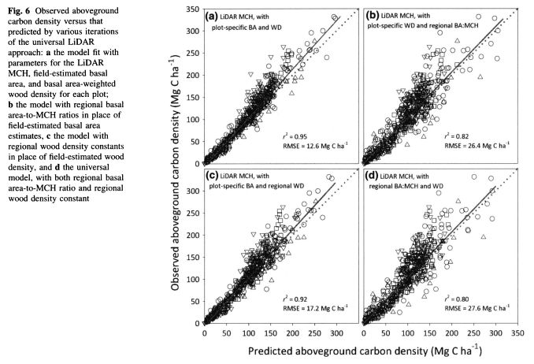Asner 2012

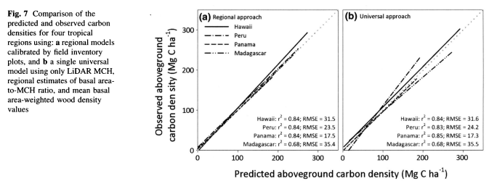

Asner 2012

* Plot size - Sheridan (image below)
  + 