Log-log Median model

Coefficients:

Estimate Std. Error t value Pr(>|t|)

(Intercept) -2.184e+00 1.798e+00 -1.215 0.224573

Elev_L4 1.149e+00 5.731e-01 2.004 0.045217 *

Elev_LCV -1.194e+01 4.085e+00 -2.923 0.003516 **

Elev_Lskewness 3.979e+00 1.048e+00 3.795 0.000153 ***

Elev_Lkurtosis -3.477e+00 1.517e+00 -2.292 0.022004 *

log(Elev_mode) -3.150e-01 1.616e-01 -1.949 0.051477 .

log(Elev_P01) -4.141e+00 1.786e+00 -2.319 0.020492 *

log(Elev_P30) 5.440e+00 4.136e+00 1.315 0.188642

log(Elev_P60) -5.228e+00 5.100e+00 -1.025 0.305427

log(Elev_P90) 5.172e+00 2.865e+00 1.805 0.071266 .

log(Pct_all_returns_above_ht) 1.735e+00 1.701e+00 1.020 0.307792

elevation -3.816e-04 1.489e-04 -2.562 0.010485 *

NDVI_Amp -1.751e+00 9.185e-01 -1.907 0.056717 .

R3ERUlabelB -7.084e-01 4.870e-01 -1.454 0.145997

R3ERUlabelE -5.881e-01 1.379e-01 -4.266 2.10e-05 ***

R3ERUlabelF -7.519e-01 1.296e-01 -5.803 7.74e-09 ***

R3ERUlabelG -8.682e-01 1.416e-01 -6.129 1.09e-09 ***

log(All_returns_above_mode_div_Total_first_returns_x_100) -2.693e-01 5.340e-01 -0.504 0.614156

log(Elev_P05) 1.357e+00 1.426e+00 0.952 0.341442

log(pct_all_returns_above_mean) 6.608e-01 2.011e+00 0.329 0.742516

log(Elev_P10) -4.171e-01 1.672e+00 -0.249 0.803035

log(Elev_P01):log(Pct_all_returns_above_ht) 1.905e+00 8.847e-01 2.153 0.031429 *

log(Elev_P01):log(All_returns_above_mode_div_Total_first_returns_x_100) -9.611e-01 7.068e-01 -1.360 0.174086

log(Pct_all_returns_above_ht):log(Elev_P05) -2.666e+00 9.819e-01 -2.715 0.006698 **

log(Elev_P05):log(pct_all_returns_above_mean) 1.819e+00 7.414e-01 2.454 0.014229 *

log(All_returns_above_mode_div_Total_first_returns_x_100):log(Elev_P05) 8.181e-01 5.029e-01 1.627 0.103975

log(Pct_all_returns_above_ht):log(Elev_P10) -5.093e-02 4.041e-01 -0.126 0.899710

log(Elev_P30):log(Pct_all_returns_above_ht) -1.649e+00 1.210e+00 -1.363 0.172933

log(Elev_P60):log(Pct_all_returns_above_ht) -1.710e+00 1.485e+00 -1.152 0.249629

log(Elev_P60):log(pct_all_returns_above_mean) 4.088e+00 8.274e-01 4.941 8.54e-07 ***

log(Elev_P90):log(Pct_all_returns_above_ht) 2.364e+00 1.018e+00 2.321 0.020395 *

log(Elev_P90):log(pct_all_returns_above_mean) -3.959e+00 9.020e-01 -4.389 1.21e-05 ***

---

Signif. codes: 0 ‘***’ 0.001 ‘**’ 0.01 ‘*’ 0.05 ‘.’ 0.1 ‘ ’ 1

(Dispersion parameter for gaussian family taken to be 0.1770348)

Number of Fisher Scoring iterations: 2

Log-log Median model

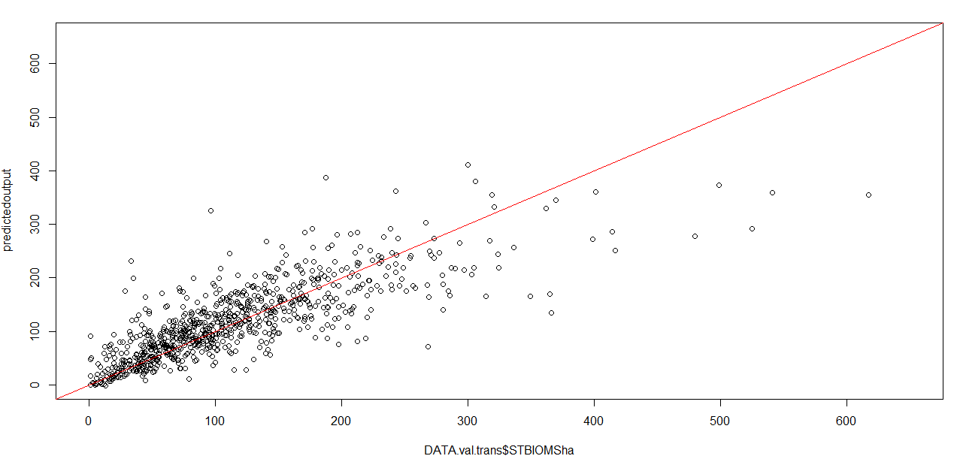

Log-log HPM

Coefficients:

Estimate Std. Error t value Pr(>|t|)

(Intercept) -3.1772248 1.6309042 -1.948 0.051562 .

Elev_L4 0.9400860 0.5682242 1.654 0.098224 .

Elev_LCV -8.4165892 2.5518409 -3.298 0.000993 ***

Elev_Lskewness 3.5586297 0.9067578 3.925 9.03e-05 ***

Elev_Lkurtosis -3.0998862 1.3850561 -2.238 0.025343 *

log(Elev_mode) -0.3252435 0.1531688 -2.123 0.033861 *

log(Elev_P01) -2.2750142 1.3615737 -1.671 0.094930 .

log(Elev_P30) 5.7686855 3.3879333 1.703 0.088803 .

log(Elev_P60) -5.5195488 4.6361656 -1.191 0.233999

log(Elev_P90) 4.8515884 2.4635521 1.969 0.049074 *

log(Pct_all_returns_above_ht) 1.8266535 1.3793225 1.324 0.185576

log(pct_all_returns_above_mean) 0.9460587 1.7507022 0.540 0.589000

log(All_returns_above_mode_div_Total_first_returns_x_100) -0.4432546 0.4583461 -0.967 0.333644

log(Elev_P05) -0.0545117 1.1920486 -0.046 0.963531

elevation -0.0003818 0.0001598 -2.389 0.016994 *

aspect 0.0002756 0.0002943 0.936 0.349229

NDVI_Amp -1.9053985 0.9519682 -2.002 0.045492 *

R3ERUlabelB -0.7322585 0.4960406 -1.476 0.140072

R3ERUlabelE -0.5799139 0.1362764 -4.255 2.20e-05 ***

R3ERUlabelF -0.7695284 0.1360414 -5.657 1.81e-08 ***

R3ERUlabelG -0.8834056 0.1440967 -6.131 1.08e-09 ***

log(Elev_P01):log(pct_all_returns_above_mean) 1.3307288 0.6822379 1.951 0.051275 .

log(Elev_P01):log(All_returns_above_mode_div_Total_first_returns_x_100) -0.6417683 0.6113773 -1.050 0.294000

log(Pct_all_returns_above_ht):log(Elev_P05) -0.6295545 0.5464526 -1.152 0.249451

log(All_returns_above_mode_div_Total_first_returns_x_100):log(Elev_P05) 0.6564522 0.4742074 1.384 0.166443

log(Elev_P30):log(Pct_all_returns_above_ht) -1.6996811 1.0031025 -1.694 0.090367 .

log(Elev_P60):log(Pct_all_returns_above_ht) -1.9402509 1.4747343 -1.316 0.188464

log(Elev_P60):log(pct_all_returns_above_mean) 4.4226774 0.8382077 5.276 1.49e-07 ***

log(Elev_P90):log(Pct_all_returns_above_ht) 2.3939042 1.0411663 2.299 0.021611 *

log(Elev_P90):log(pct_all_returns_above_mean) -4.0587815 0.9060166 -4.480 7.97e-06 ***

---

Signif. codes: 0 ‘***’ 0.001 ‘**’ 0.01 ‘*’ 0.05 ‘.’ 0.1 ‘ ’ 1

(Dispersion parameter for gaussian family taken to be 0.1794184)

Number of Fisher Scoring iterations: 2

Log-log HPM

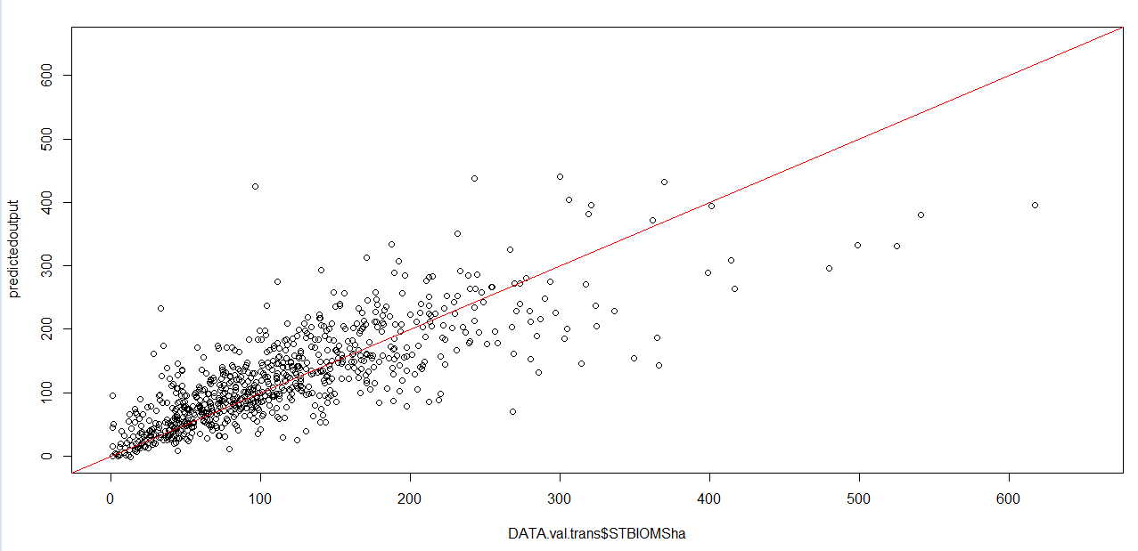

Log Median Model (same as HPM)

Coefficients:

Estimate Std. Error t value Pr(>|t|)

(Intercept) 3.1834844 0.6631757 4.800 1.72e-06 ***

Elev_MAD_median 0.0908088 0.0614971 1.477 0.139957

Elev_MAD_mode -0.1086685 0.0651424 -1.668 0.095465 .

Elev_L4 1.3887703 0.5014067 2.770 0.005671 **

Elev_Lskewness -2.1083064 0.9962046 -2.116 0.034460 *

Elev_P60 -0.1532117 0.0845130 -1.813 0.070026 .

Elev_P90 0.2344137 0.0592450 3.957 7.91e-05 ***

all_returns_above_ht_div_Total_first_returns_x_100 -0.0211609 0.0061904 -3.418 0.000645 ***

pct_all_returns_above_mean 0.1065762 0.0352432 3.024 0.002532 **

All_returns_above_mode_div_Total_first_returns_x_100 0.0228812 0.0127686 1.792 0.073310 .

elevation -0.0004565 0.0002213 -2.063 0.039305 *

aspect 0.0005380 0.0003902 1.379 0.168179

NDVI_Amp -1.3970010 0.9812436 -1.424 0.154714

Elev_mode 0.0061923 0.0327631 0.189 0.850113

Pct_all_returns_above_ht 0.0072933 0.0174897 0.417 0.676724

Elev_P01 -0.0194447 0.0678243 -0.287 0.774382

Elev_P30 0.0096037 0.0558150 0.172 0.863409

R3ERUlabelB -0.5180047 0.7001469 -0.740 0.459492

R3ERUlabelE -1.1708888 0.2567001 -4.561 5.44e-06 ***

R3ERUlabelF -1.0470326 0.1149613 -9.108 < 2e-16 ***

R3ERUlabelG -1.0791417 0.1160929 -9.296 < 2e-16 ***

Elev_mode:Pct_all_returns_above_ht 0.0040955 0.0024742 1.655 0.098049 .

pct_all_returns_above_mean:Elev_mode -0.0055044 0.0028315 -1.944 0.052061 .

all_returns_above_ht_div_Total_first_returns_x_100:Elev_mode -0.0006325 0.0002261 -2.797 0.005209 **

All_returns_above_mode_div_Total_first_returns_x_100:Elev_mode -0.0018632 0.0010438 -1.785 0.074433 .

all_returns_above_ht_div_Total_first_returns_x_100:Elev_P01 0.0021437 0.0010117 2.119 0.034237 *

Pct_all_returns_above_ht:Elev_P30 -0.0049645 0.0021035 -2.360 0.018378 *

all_returns_above_ht_div_Total_first_returns_x_100:Elev_P30 0.0023839 0.0006986 3.412 0.000659 ***

Elev_P60:All_returns_above_mode_div_Total_first_returns_x_100 0.0036727 0.0016805 2.185 0.028992 *

Elev_P90:All_returns_above_mode_div_Total_first_returns_x_100 -0.0032149 0.0009399 -3.420 0.000640 ***

---

Signif. codes: 0 ‘***’ 0.001 ‘**’ 0.01 ‘*’ 0.05 ‘.’ 0.1 ‘ ’ 1

(Dispersion parameter for gaussian family taken to be 0.2349552)

Number of Fisher Scoring iterations: 2

Log Median Model (same as HPM)

