REGRESSION ASSUMPTIONS AND DIAGNOSTICS
  - A DIAGNOSTIC REPORT ON A SIMPLE LINEAR REGRESSION MODEL

GABRIEL KARIUKI

ADM NO. : 202706117

STA6110Z: LINEAR AND NON-LINEAR MODELS

DUE DATE: FRI 10/2/26 11:59PM

Research Problem
This report investigates whether BMI Body Mass Index is linearly associated with diabetes disease progression, using the Diabetes dataset originally compiled by Efron, Hastie Johnstone and Tibshirani (2004) for their paper “Least Angle Regression” (Annals of Statistics, 32(2), 407-499). The dataset contains n = 442 patients and is distributed as a built in, citable dataset within the Scikit-learn Python Library, which sources it from the original public repository maintained in North Carolina State University.
Dependent variable (Y): Disease Progression Score – a quantitative measure of diabetes disease progression recorded one year after baseline (unitless composite clinical index).
Independent variable (X): Body Mass Index, measured in kg/m² at baseline.

Reasearch question: Does BMI have a statistically significsnt linear relationship with disease progression, and does a simple linear regression model satisfy the assumptions required to trust that result?

Model Output
A simple linear regression was fitted using the ordinary least squares (least-squares) method:

Ŷ = −117.77 + 10.23 × BMI

Statistic | Value
Sample size (n) | 442
Intercept (b0) | -117.77
Slope (b1) | 10.23
Standard error of slope | 0.674
T-statistic (slope) | 15.19
p-value (slope) | < 0.001 (≈ 3.47 × 10⁻⁴²)
R² | 0.344

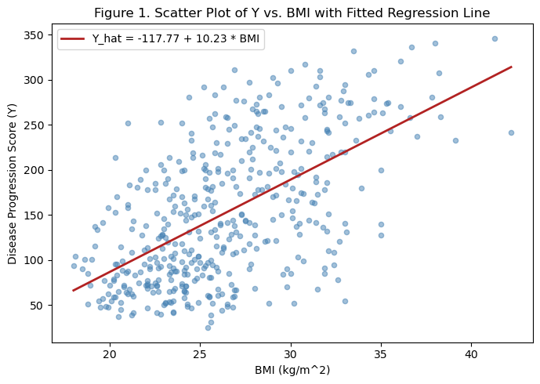
Figure 1: Scatter plot of Disease Progression Score against BMI, with the fitted regression line.
The slope is highly statistically significant (p<0.001), and BMI explains approximately 34.4% of the variance in disease progression scores (R² = 0.344). However, a significant slope and a moderate R² do not by themselves confirm the model is adequate – the assumption checks below determine whether this result can be trusted.

Diagnostic Checks

Linearity
Linearity was checked using the scatter plot in figure 1 and the residuals-vs-fitted-values plot in figure 2 below.
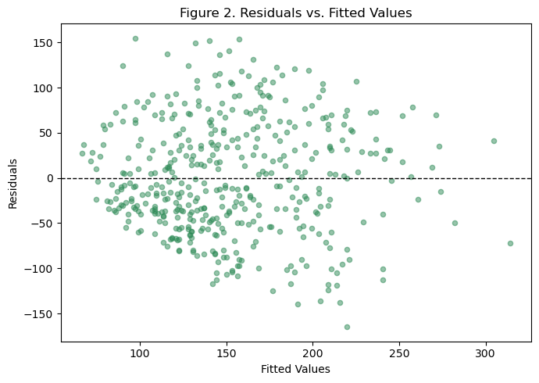
Figure 2. Residuals vs Fitted Values

The residuals scatter fairly randomly above and below the zero line across the range of fitted vvalues, with no strong curved (U-shaped or bowed) pattern. This supports the linearity assumption: a straight lne relationship between BMI and disease progression is a reasonable description of the data, and ni obvious non-linear term (such as a quadratic BMI term) appears necessary from this plot alone.

3.2 Homoscedasticity (Equal Variance)
Homoscedasticity was checked visually using Figure 2 above and the scale -location plot in Figure 3, and formally using Breusch-Pagan-type test (regressing the squared residuals on BMI and testing the resulting Lagrange Multiplier statistic against a chi-square distribution with 1 degree of freedom).
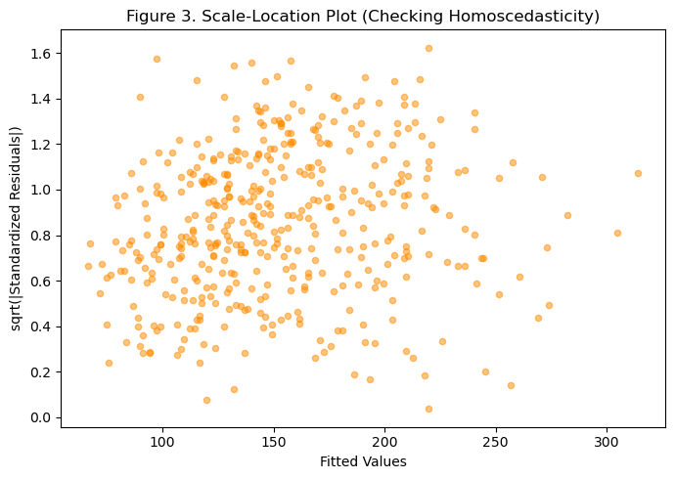
Figure 3. Scale-Location plot (square root of absolute standardized residuals vs. fitted values).

Test | Statistic | p-value
Breusch-Pagan (manual,1 df) | LM = 1.12 | 0.0009

The Breusch-Pagan test result (p = 0.0009) indicates statistically heteroscedasticity: the variance of the residuals is not perfectly constant across the range of fitted values. Visually figures 2 & 3 show a subtle widening of the residual spread rather than a dramatic funnel, meaning the violation is real but moderate rather than severe.

3.3. Normality of Residuals
Normality was assessed using a normal Q-Q plot (Figure 4) and the Shapiro-Wilk test.
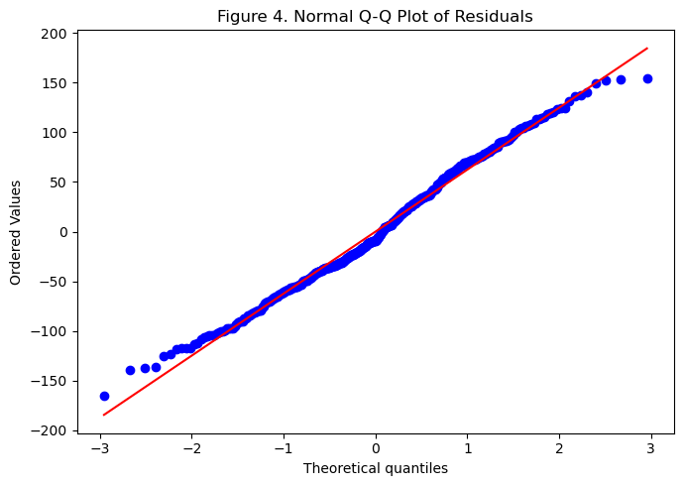
Figure 4. Normal Q-Q plot of Residuals

Test | Statistic | p-value
Shapiro-Wilk | W = 0.9904 | 0.0054


The Q-Q plot shows the residuals following the reference diagonal closely through the middle of the distribution, with only mid deviation in the tails. The Shapiro-Wilk test is formally significant ( p=0.0054), indicating a statistically detectable departure from perfect normality; however the estimated skewness (0.156) and excess kurtosis (-0.547) are both small in magnitude, usggesting the departure is mild rather than servere. With a sample size of n =442, the Central Limit Theorem provides reasonable robustness for the validity of the t-test and confidence interval reported in Section 2, despite the formally significant test result.

Diagnostic Issue Discussion
The most relevant diagnostic issue identified in this model is mild heteroscedasticity (section 3.2). This matters for model interpretation for two reasons. First, ordinary least squares coefficient estimates (b0 and b1) remain unbiased even when variance is non-constant, so the direction and approximate size of the BMI effect can still be trusted. Second, and more importantly, the standard errors, t-statistic, p-value and confidence interval reporteed for the slope in Section 2 assume contant variance; when that assumption is violated, those quantities can be understated or overstated, which risks an incorrect conclusion about statistical signifacance even though, in this case, the effect I significant by such a wide margin that the substantive conclusion is unlikely to change.
A secondary observation from the leverage analysis is that the patient with the highest BMI in the sample (42.2 kg/m²) has the largest leverage value in the dataset since leverage increases with the distance from the mean of X. No studentized residual exceeded the conventional |3| threshold for outliers, and no single observation exceeded a concerning Cook’s Distance, so no individual patient is judged to be unduly distorting the fitted line.

Recommendation
Given that the heteroscedasticity detected is statistically significant but visually moderate, and that the coefficient estimate themselves are not biased, the most proportionate remedy is to report heteroscedasticity-consistent (robust) standard for errors for the slope and intercept rather than re-specifying the model. Robust standard errors correct the influence (standard errors, t-statistics, p-values, and confidence intervals) without changing the fitted coeficients, and they void the interpretability cost of transforming the outcome variable (e.g., log-transforming the disease progression score), which would make the slope harder to explain in its original clinical units. A log transformation of Y or weighted least squares would be reasonable alternatives remedies if the heteroscedasticity were more severe, but they are not necessary here given the modest size of the violation.

Conclusion
Overall, the simple linear regression model is judged to be adequate for general explanation of the relationship between BMI and diabetes disease progression, and usable for prediction with appropriate caution. The linearity assumption is well supported by the residual plot, and the normality departure is mild enough that the Central Limit Theorem offers reasonable protectioin for inference at this sample size. The one genuine concern is mild but statistically detectable heteroscedasticity, which affects the precision of the reported standard errors rather than the direction or approximate size of the BMI effect; the recommended fix (robust standard errors) directly addresses this without requiring a more complex model. Given an R² of only 0.344, however, BMI alone leaves the majority of the variation in disease progression explained, so the model should be treated as a partial explanation rather than a precise individual-level predictive tool.

References
Efron, B., Hastie, T., Johnstone, I., & Tibshirani, R. (2004). Least Angle Regression. Annals of Statistics, 32 (2), 407-499.
Montgomery, D. C., Peck, E. A., & Vining, G. G. (2021). Introduction to linear regression analysis (6th.ed). Wiley.
Pedrogosa, F., et al. (2011). Sci-Kit Learn: Machine Learning in Python. Journal of Machine Learning Research, 12, 2825-2830.

Screenshot of notebook with values


Figure 5.Report showing model outputs; OLS REGRESSION RESULTS

Figure 6. Formal test of Shapiro-Wilk and Diagnostic Issue Value

