Week 3 Practical Group Assignment
Differencing, ACF, and PACF
STA6130: Time Series Analysis | USIU
Field | Details
Group name / number | [Insert group name or number]
Group members | Gabriel Kariuki (Reg. No. [insert]); [Add additional member names and registration numbers]
Dataset | Air Passengers (Kaggle: chirag19/air-passengers)
Software used | Python

Question 1: Dataset Selection and Description (1 Mark)
(a) Source of the dataset:
The dataset used is the classic “AirPassengers” dataset, available on Kaggle at kaggle.com/datasets/chirag19/air-passengers. It records the monthly total number of international airline passengers (in thousands) between January 1949 and December 1960. This dataset originates from Box and Jenkins' classic time series textbook and is widely used as a standard benchmark for teaching differencing, seasonality, and ARIMA-type modelling.
(b) Frequency of the data:
The data is monthly, with 144 observations covering exactly 12 years (1949–1960). This satisfies the assignment's minimum requirement of at least 40 observations, and it is long enough to show 12 full seasonal cycles, which is important for seasonal differencing.

Question 2: Plot and Describe the Original Series (2 Marks)
(a) Plot of the original series:
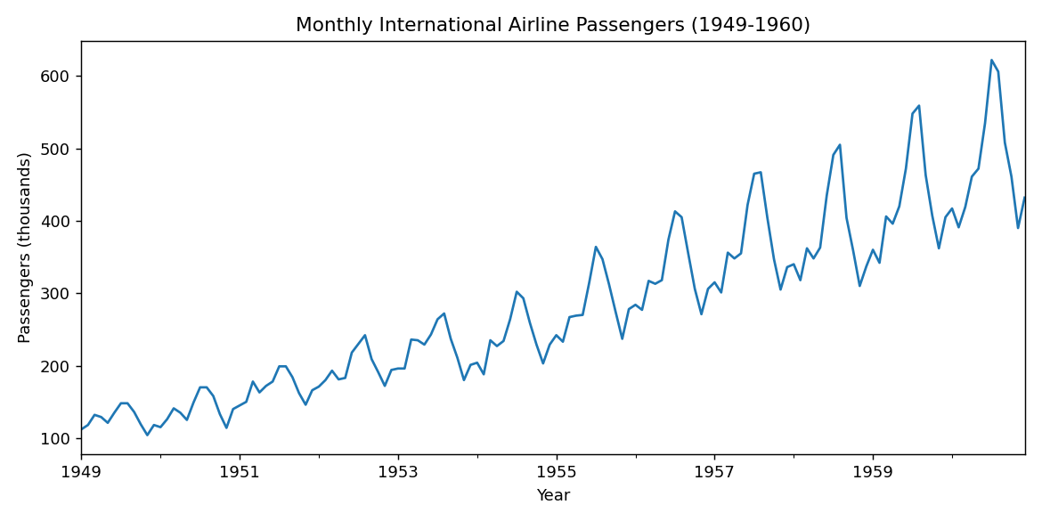
Figure 1: Monthly international airline passengers, 1949–1960.
(b) Description of the series:
- Trend: There is a clear, strong upward trend across the whole period — passenger numbers grow from around 112 thousand in January 1949 to over 600 thousand by 1960.
- Seasonality: A repeating yearly pattern is visible, with a peak around July–August each year (summer travel season) and a smaller trough in the following months.
- Irregular movement: There is some short-term fluctuation around the seasonal pattern, but it is modest compared to the trend and seasonal components.
- An important additional feature is that the size of the seasonal swings grows over time (larger peaks and troughs in later years than in earlier years). This is a sign of multiplicative rather than purely additive seasonality, which is a useful observation feeding into later modelling decisions.

Question 3: Differencing and Stationarity Check (3 Marks)
(a) First differencing:
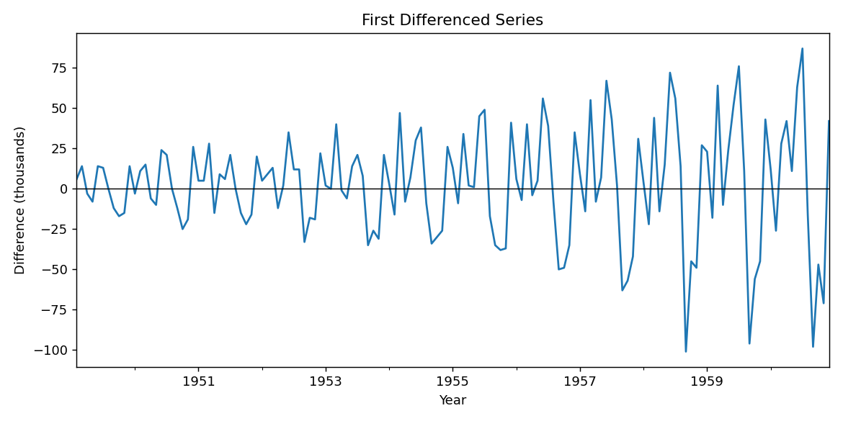
Figure 2: First differenced series (removes the overall upward trend).
(b) Seasonal differencing (period = 12):
Because the series clearly repeats on a 12-month cycle, seasonal differencing was applied with a seasonal period of 12.
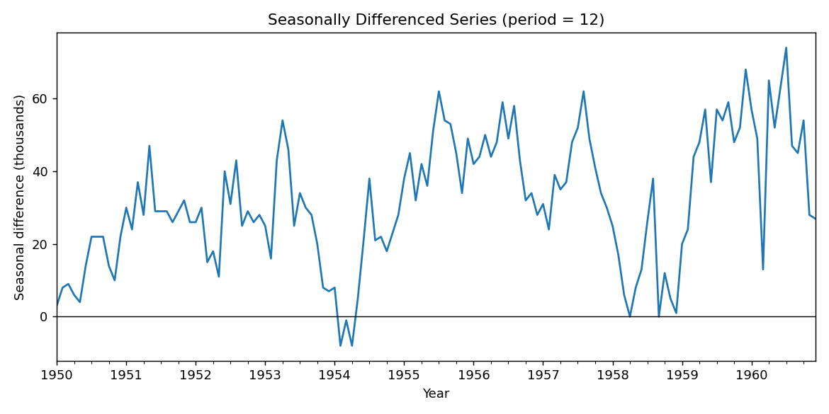
Figure 3: Seasonally differenced series (period = 12).
Since seasonal differencing alone still leaves a mild upward drift, a first difference was also applied on top of the seasonal difference:
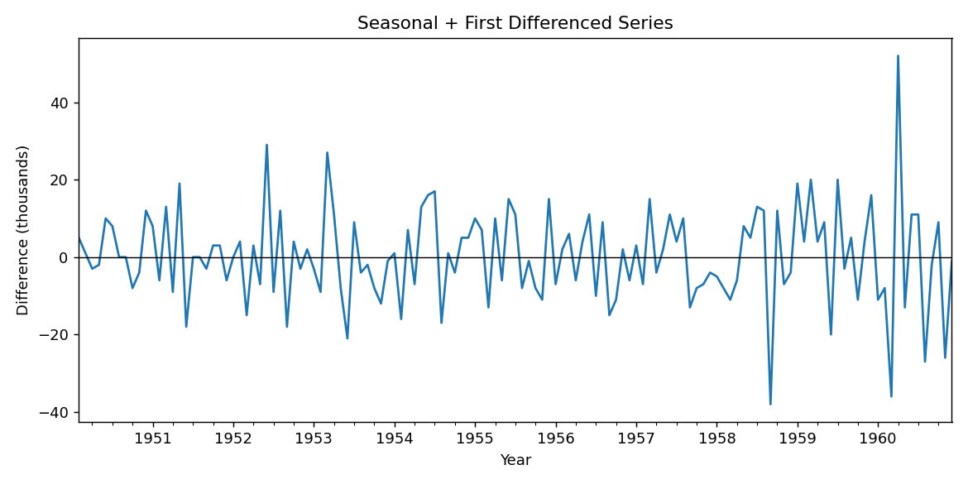
Figure 4: Seasonal + first differenced series — flattest, most stable-looking series of the four.
(c) Stationarity check (ADF test):
An Augmented Dickey-Fuller (ADF) test was run on the original series and on each differenced version. The null hypothesis (H₀) is that the series has a unit root (is non-stationary); the series is judged stationary at the 5% level when the test statistic is more negative than the 5% critical value (−2.86, constant/no-trend case).
Series | ADF test statistic | 5% critical value | Conclusion
Original series | 1.56 | -2.86 | Non-stationary
First difference | -2.83 | -2.86 | Still non-stationary (borderline)
Seasonal difference (12) | -2.43 | -2.86 | Still non-stationary
Seasonal + first difference | -3.51 | -2.86 | Stationary

The original series is clearly non-stationary, as expected given the strong visible trend and growing seasonal amplitude. Applying only first differencing or only seasonal differencing reduces non-stationarity but is not enough on its own — both test statistics remain above the 5% critical value. Only once both seasonal differencing and first differencing are applied together does the ADF test statistic (−3.51) fall below the 5% critical value (−2.86), so we conclude this combined transformation is stationary and ready for ACF/PACF analysis.

Question 4: ACF and PACF Analysis (2 Marks)
(a) ACF plot and interpretation:
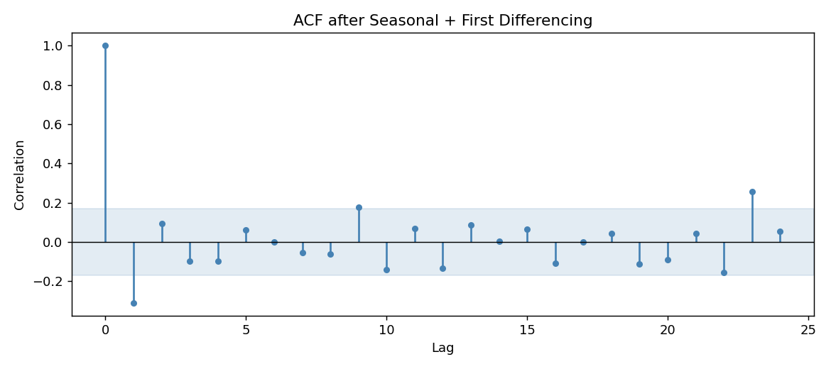
Figure 5: ACF of the seasonal + first differenced series.
The ACF shows a sharp, strong negative spike at lag 1 (around −0.31), which then decays into the confidence band for most subsequent lags, with a mild spike reappearing near lag 23 (close to the seasonal period, 24 = 2×12). The large lag-1 negative spike, combined with the “cuts off after lag 1” pattern, is a classic signature of a moving-average (MA) component at lag 1, consistent with an MA(1) or seasonal MA(1) term.
(b) PACF plot and interpretation:
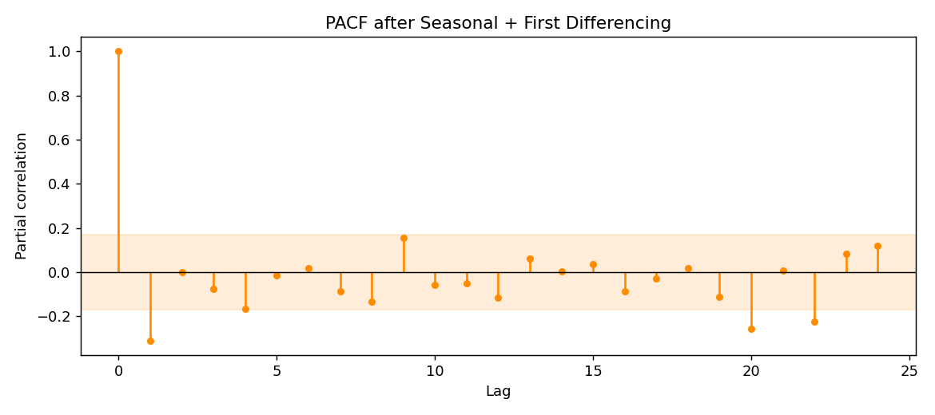
Figure 6: PACF of the seasonal + first differenced series.
The PACF also shows a strong negative spike at lag 1, with smaller, mostly insignificant spikes afterward (a mild one near lag 4 and lag 8). Because both ACF and PACF show their clearest signal concentrated at lag 1 rather than a slow geometric decay, this points toward a low-order MA structure rather than a high-order AR structure being the dominant dynamic in the differenced series.

Question 5: Model Thinking and Group Reflection (2 Marks)
(a) Suggested ARIMA terms:
- d = 1 (one round of ordinary/non-seasonal first differencing was needed)
- D = 1 (one round of seasonal differencing at period 12 was also needed)
- q = 1 (the strong lag-1 ACF spike suggests a first-order moving average term)
- p = 0 or 1 (the PACF does not show a long, slowly decaying tail, so a low AR order is more appropriate than a high one)
- Because the seasonal period is 12, this points toward a seasonal ARIMA specification in the region of SARIMA(0,1,1)(0,1,1)₁₂ as a reasonable starting candidate.
(b) Group reflection:
ACF and PACF plots are extremely useful for narrowing down plausible starting values for p, d, and q — they turn an otherwise blind search into an informed one. However, they should not be treated as a final, automatic answer. ACF and PACF are estimated from a finite, noisy sample, so spikes near the confidence band can be misleading, and different reasonable analysts might read the same plot slightly differently. In addition, these plots only capture linear, second-order dependence — they say nothing about whether a simpler or more complex model actually forecasts better out of sample. For that reason, our group's approach is to use ACF/PACF to propose two or three candidate ARIMA/SARIMA specifications, then fit and compare them formally using information criteria (such as AIC/BIC) and out-of-sample validation performance before selecting a final model.

Appendix: Python Code
The full Python script used to produce all outputs, plots, and test statistics in this report is included below. Note: because the assignment environment did not have internet access to install the statsmodels package, the ADF test, ACF, and PACF were implemented directly in NumPy/pandas rather than imported from statsmodels — the underlying statistical methods (augmented Dickey-Fuller regression, sample autocorrelation, and the Durbin-Levinson recursion for partial autocorrelation) are the same ones statsmodels uses internally.
import numpy as np
import pandas as pd
import matplotlib
matplotlib.use("Agg")
import matplotlib.pyplot as plt

plt.rcParams["figure.dpi"] = 130

# =================================================================
# 1. Dataset: AirPassengers (classic monthly international airline
# passenger totals, in thousands, Jan 1949 - Dec 1960), 144 obs
# =================================================================
values = [
112,118,132,129,121,135,148,148,136,119,104,118,
115,126,141,135,125,149,170,170,158,133,114,140,
145,150,178,163,172,178,199,199,184,162,146,166,
171,180,193,181,183,218,230,242,209,191,172,194,
196,196,236,235,229,243,264,272,237,211,180,201,
204,188,235,227,234,264,302,293,259,229,203,229,
242,233,267,269,270,315,364,347,312,274,237,278,
284,277,317,313,318,374,413,405,355,306,271,306,
315,301,356,348,355,422,465,467,404,347,305,336,
340,318,362,348,363,435,491,505,404,359,310,337,
360,342,406,396,420,472,548,559,463,407,362,405,
417,391,419,461,472,535,622,606,508,461,390,432
]
dates = pd.date_range("1949-01-01", periods=len(values), freq="MS")
series = pd.Series(values, index=dates, name="Passengers")
print(f"Number of observations: {len(series)}")

# =================================================================
# Manual ADF test (constant, no trend)
# =================================================================
DF_CRIT = {"1%": -3.43, "5%": -2.86, "10%": -2.57}

def adf_test(y, max_lag=12):
y = np.asarray(y, dtype=float)
dy = np.diff(y)
n = len(dy)
best = None
for p in range(0, max_lag + 1):
if n - p - 1 <= p + 2:
continue
y_dep = dy[p:]
y_lag1 = y[p:-1]
X_cols = [np.ones(len(y_dep)), y_lag1]
for i in range(1, p + 1):
X_cols.append(dy[p - i: n - i])
X = np.column_stack(X_cols)
beta, resid, rank, sv = np.linalg.lstsq(X, y_dep, rcond=None)
fitted = X @ beta
e = y_dep - fitted
k = X.shape[1]
nobs = X.shape[0]
sigma2 = (e @ e) / (nobs - k)
XtX_inv = np.linalg.inv(X.T @ X)
se = np.sqrt(np.diag(sigma2 * XtX_inv))
aic = nobs * np.log((e @ e) / nobs) + 2 * k
if best is None or aic < best["aic"]:
t_stat = beta[1] / se[1]
best = {"p": p, "aic": aic, "t_stat": t_stat, "beta": beta, "nobs": nobs}
return best

def adf_report(series_like, label, max_lag=12):
result = adf_test(series_like, max_lag=max_lag)
t_stat = result["t_stat"]
print(f"\nADF test: {label}")
print(f"Chosen lag order (by AIC): {result['p']}")
print(f"Test statistic: {t_stat:.4f}")
print("Approx. critical values (constant, no trend, Fuller 1976):")
for k, v in DF_CRIT.items():
print(f" {k}: {v}")
verdict = "likely stationary" if t_stat < DF_CRIT["5%"] else "likely non-stationary"
print(f"Conclusion (5% level): {verdict}")
return t_stat, verdict

# =================================================================
# Manual ACF and PACF (Durbin-Levinson)
# =================================================================
def acf_manual(x, nlags):
x = np.asarray(x, dtype=float)
n = len(x)
xbar = x.mean()
c0 = np.sum((x - xbar) ** 2) / n
r = np.zeros(nlags + 1)
r[0] = 1.0
for k in range(1, nlags + 1):
ck = np.sum((x[k:] - xbar) * (x[:n - k] - xbar)) / n
r[k] = ck / c0
return r

def pacf_durbin_levinson(r, nlags):
phi = np.zeros((nlags + 1, nlags + 1))
pacf_vals = np.zeros(nlags + 1)
pacf_vals[0] = 1.0
if nlags >= 1:
phi[1, 1] = r[1]
pacf_vals[1] = r[1]
for k in range(2, nlags + 1):
num = r[k] - sum(phi[k - 1, j] * r[k - j] for j in range(1, k))
den = 1 - sum(phi[k - 1, j] * r[j] for j in range(1, k))
phi[k, k] = num / den
for j in range(1, k):
phi[k, j] = phi[k - 1, j] - phi[k, k] * phi[k - 1, k - j]
pacf_vals[k] = phi[k, k]
return pacf_vals

def plot_acf_manual(x, nlags, title, path):
r = acf_manual(x, nlags)
n = len(x)
ci = 1.96 / np.sqrt(n)
fig, ax = plt.subplots(figsize=(9, 4))
lags = np.arange(nlags + 1)
ax.vlines(lags, 0, r, color="steelblue")
ax.plot(lags, r, "o", color="steelblue", markersize=4)
ax.axhline(0, color="black", linewidth=0.8)
ax.axhspan(-ci, ci, color="steelblue", alpha=0.15)
ax.set_title(title)
ax.set_xlabel("Lag")
ax.set_ylabel("Correlation")
plt.tight_layout()
plt.savefig(path)
plt.close()
return r

def plot_pacf_manual(x, nlags, title, path):
r = acf_manual(x, nlags)
p = pacf_durbin_levinson(r, nlags)
n = len(x)
ci = 1.96 / np.sqrt(n)
fig, ax = plt.subplots(figsize=(9, 4))
lags = np.arange(nlags + 1)
ax.vlines(lags, 0, p, color="darkorange")
ax.plot(lags, p, "o", color="darkorange", markersize=4)
ax.axhline(0, color="black", linewidth=0.8)
ax.axhspan(-ci, ci, color="darkorange", alpha=0.15)
ax.set_title(title)
ax.set_xlabel("Lag")
ax.set_ylabel("Partial correlation")
plt.tight_layout()
plt.savefig(path)
plt.close()
return p

# =================================================================
# 2. Plot the original series
# =================================================================
plt.figure(figsize=(9, 4.5))
series.plot()
plt.title("Monthly International Airline Passengers (1949-1960)")
plt.xlabel("Year")
plt.ylabel("Passengers (thousands)")
plt.tight_layout()
plt.savefig("/home/claude/fig1_original.png")
plt.close()

t_orig, v_orig = adf_report(series.values, "Original series")

# =================================================================
# 3. First differencing
# =================================================================
first_diff = series.diff().dropna()
plt.figure(figsize=(9, 4.5))
first_diff.plot()
plt.axhline(0, color="black", linewidth=0.8)
plt.title("First Differenced Series")
plt.xlabel("Year")
plt.ylabel("Difference (thousands)")
plt.tight_layout()
plt.savefig("/home/claude/fig2_first_diff.png")
plt.close()
t_first, v_first = adf_report(first_diff.values, "First differenced series")

# =================================================================
# 4. Seasonal differencing (period = 12)
# =================================================================
seasonal_diff = series.diff(12).dropna()
plt.figure(figsize=(9, 4.5))
seasonal_diff.plot()
plt.axhline(0, color="black", linewidth=0.8)
plt.title("Seasonally Differenced Series (period = 12)")
plt.xlabel("Year")
plt.ylabel("Seasonal difference (thousands)")
plt.tight_layout()
plt.savefig("/home/claude/fig3_seasonal_diff.png")
plt.close()
t_seas, v_seas = adf_report(seasonal_diff.values, "Seasonally differenced series")

# Seasonal + first difference
seasonal_first_diff = series.diff(12).diff().dropna()
plt.figure(figsize=(9, 4.5))
seasonal_first_diff.plot()
plt.axhline(0, color="black", linewidth=0.8)
plt.title("Seasonal + First Differenced Series")
plt.xlabel("Year")
plt.ylabel("Difference (thousands)")
plt.tight_layout()
plt.savefig("/home/claude/fig4_seasonal_first_diff.png")
plt.close()
t_sf, v_sf = adf_report(seasonal_first_diff.values, "Seasonal + first differenced series")

# =================================================================
# 5. ACF and PACF on the seasonal+first differenced series
# =================================================================
acf_vals = plot_acf_manual(seasonal_first_diff.values, 24,
"ACF after Seasonal + First Differencing",
"/home/claude/fig5_acf.png")
pacf_vals = plot_pacf_manual(seasonal_first_diff.values, 24,
"PACF after Seasonal + First Differencing",
"/home/claude/fig6_pacf.png")

print("\nACF values (lags 0-12):", np.round(acf_vals[:13], 3))
print("PACF values (lags 0-12):", np.round(pacf_vals[:13], 3))

with open("/home/claude/summary.txt", "w") as f:
f.write(f"n_obs={len(series)}\n")
f.write(f"adf_original_tstat={t_orig:.4f} verdict={v_orig}\n")
f.write(f"adf_first_diff_tstat={t_first:.4f} verdict={v_first}\n")
f.write(f"adf_seasonal_diff_tstat={t_seas:.4f} verdict={v_seas}\n")
f.write(f"adf_seasonal_first_diff_tstat={t_sf:.4f} verdict={v_sf}\n")
f.write(f"acf_lags_0_12={list(np.round(acf_vals[:13],3))}\n")
f.write(f"pacf_lags_0_12={list(np.round(pacf_vals[:13],3))}\n")

print("\nDone.")

