**Graphics – Assignment 1 (Moving Parts) Report - Kari McMahon**

**Motivation**

For the assignment I choose to create a robot, the motivation for the choice of a robot is because I found it easy to visualise in my mind the shapes to make the robot. It also has a range of interconnected parts which move together and independently of each other which I thought would be perfect for the assignment to demonstrate various moving parts.

**Design**

The design of the application is based on Iain Martin’s lab 2 example which I have then split up into various classes to make it easy to read and understand as the application was originally in the one cpp file which grew too large and became hard to read, understand and maintain. The main challenge with making the code more object oriented is that it’s been a while since I have used C++ and I was not sure if approached the design in the best possible way.

The classes for my application:

* Shape.cpp – Handles the creating and drawing of all the shapes in the application.
* Robot.cpp – Creates the robot and robot’s parts based on calls to the shape class and various transformations, rotations and scales as well as creating the robot’s pet and it’s parts.
* robotScene.cpp – Handles the scene view and the opengl calls such as initialisation, display and key callbacks.
* Wrapper_glfw.cpp – Wraps glfw functions

The headers for my application:

* robotScene.h – Contains global variables for the application
* wrapper_glfw.h – Sets glfw functions

The shader’s for my application:

* robotScene.vert – Handles the position and colour selection
* robotScene.frag - Handles the lighting

**Application**

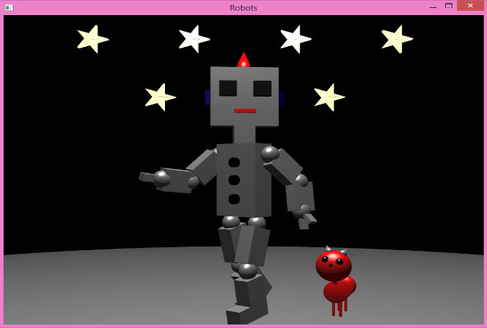

The initial view of the application is the front of the robot and its pet cat facing you under a starry sky. The whole scene can be rotated using various controls which are displayed in the console output. The robot can be rotated and do several movement’s, all the robot’s animations are based on key presses instead of automatic as it felt it was the best way to represent the robot’s movements as the user would be able to play around with the variation of movement. The robot’s arms and legs can move as if it was walking, you can move the arms and down as well as only moving the robots forearms or fingers as well as moving the robot’s arms. The robot’s pet cat has automatically animated movements where its head and tail moves side to side and the pet can also be rotated itself through key controls. The robot and pet is built using a stack making it possible to have several different interconnected parts. In the application I have several movement constraints to try and make the robot’s movements more realistic when the user is making the robot move.

The shapes that make up the scene are cubes and spheres which were developed from Iain Martin’s examples as well as cone, bolt, cylinder and star shapes. The lighting in the application sits in the one direction instead of moving with the view as I felt it gave a more realistic look to the robot and the pet. The lighting is phong lighting again because I felt it made the robot appear more realistic. The view has a perspective projection and can be rotated / zoomed. In the application I also added a ground to make the scene seem more realistic.

**Project’s Achievements And Challenges**

I feel the achievements in the project was understanding and being able to use the stack helped me to create a realistic object with a variation of different movement possibilities. I managed to create various different shapes for the application which helped bring my robot to life and now have a much better understanding of OpenGL. I also found separating the code into an object oriented format made it easier to reuse code already there. Considering I had no experience with OpenGL I feel I have achieved quite a lot with this project.

The challenges within in the project was getting to grips with the new version of OpenGL, it was hard to find examples in particular examples on the best ways to approach the stack which I struggled with for quite a while at the beginning of the project. Having very little examples available made it a lot harder to understand openGL meaning it was quite time consuming just to get minor things done. The biggest difficulty I had was with getting the lighting to look right in my project and setting the normals for shapes. I tried to create a spotlight for the objects in the scene but did not achieve this correctly, I have left the code I used to try and develop the spotlight in the fragment shader. I also feel that I did not create some of the objects in the best possible way and hope to gain feedback on this and improve on the next project.

**Conclusion**

Overall I am happy with the application as I feel it represents a realistic interconnected moving object. I have learnt a lot from the project about OpenGL and it has really increased my understanding about the core aspects of graphics.

Any example code that is used is referenced within the code, the majority of example code are used are based on Iain Martin’s lab examples e.g. the code layout, cube and sphere creation and phong lighting.

If you have an issues setting up or understanding the project please contact me.