### The System Usability Scale

The System Usability Scale is a 10 item questionnaire with 5 response options. 

1. I think that I would like to use this system frequently.

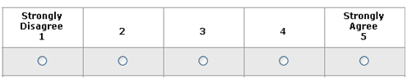

1. I found the system unnecessarily complex.



1. I thought the system was easy to use.



1. I think that I would need the support of a technical person to be able to use this system.



1. I found the various functions in this system were well integrated.



1. I thought there was too much inconsistency in this system.



1. I would imagine that most people would learn to use this system very quickly.



1. I found the system very cumbersome to use.



1. I felt very confident using the system.



1. I needed to learn a lot of things before I could get going with this system.

