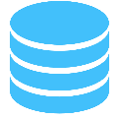

Notify

Update

User Input

Updates

**Controller**

Stores information between the model and view

**View**

Displays information and handles interaction

**Model**

Handles database communication