## Biller User App

Description: Biller an app for generating bills, adding products, managing clients and their accounts, etc.

## Module 1: Failure message for entire application:

1. **No Internet:** “Oops! It seems like there is no internet connection. Please check your Internet connectivity”
2. **No Data Found:** “No Data”
3. **Something went wrong:** “Oh no! Something went wrong, sit back and relax we are working on it, or come back after some time.”

## Module 2: Loader:

Show loader wherever there is fetching of the data from the server. 4 dots in a wave form, centre of the screen.

# Module 3: Splash Screen

* Logo
* Get Started button

# Module 4: Registration

* Inputs from user and their validations:
* Section 1 of 3: Personal Details (Show this at the top, with completion bar)

1. Mobile Number: (Single line text box)
   * + Mandatory field.
     + By default country code +91.
     + Only 10-digit number is allowed.
     + Should only allow numbers.

* Mobile Verification:
  + - Change Number option to change the number.
    - Send OTP button should be displayed (Location: Beside the text box) as soon as the user enters 10 digits mobile number.
    - After clicking on send OTP, “Alert message: OTP sent”,( Location: Toast) and a text box should be displayed (Location: below the mobile number text box) to enter the OTP & Send OTP button should turn to Resend OTP with 60 seconds timer which should be visible.
    - As soon as the user enters the OTP, verify button should be displayed (Location: beside OTP text box.)
    - Case 1: Valid OTP - Verify button should turn to verified with tick mark.
    - Case 2: Invalid OTP - “Alert message: Invalid OTP” (Location: Toast). User will click resend OTP button and OTP will be sent to user’s mobile number. “Alert message: OTP sent”, (Location: Toast) Further same continues.
    - Note: If possible, use auto verification of OTP. Resend OTP can be used max 5 times in an hour.

1. Your Name: (Single line text box)
   * + Mandatory field.
     + Max length 100 character.
     + Should allow Alphanumeric and special symbols.

Note: User can only proceed further is all mandatory field are entered correctly.

1. What do you want to do?
2. Add a new business (Continue to section 2)
3. Skip For now (Jump to Section 3)

* Section 2 of 3: Business Details (Show this at the top, with completion bar)

1. Company name: (Single line text box)
   * + Mandatory field.
     + Max length 100 character.
     + Should allow Alphanumeric and special symbols.
2. Company’s Contact Number: (Single line text box)
   * + Optional field.
     + By default country code +91.
     + Only 10-digit number is allowed.
     + Should only allow numbers.
3. Company Logo: (Upload/ capture)
   * + Optional field. By default, profile icon (Selected in splash screen) should be the logo
     + Max 1 file upload.
     + File size not more than 0.5MB.
     + File format: JPG, JPEG.
     + Can upload from device or use camera.
     + Cropping facility should be provided.
4. Office Address:

* + Address line 1 (Single line text box)
    1. Mandatory field.
    2. Max length 50 char
    3. Should allow Alphanumeric and special symbols.
  + Address Line 2 (Single line text box)
    1. Mandatory field.
    2. Max length 50 char
    3. Should allow Alphanumeric and special symbols.
  + Landmark (Single line text box)
    1. Optional field.
    2. Max length 50 char
    3. Should allow Alphanumeric and special symbols.
  + State
    1. Mandatory field.
    2. Should be drop down
  + City
    1. Mandatory field.
    2. Should be drop down
  + Pin code
    1. Mandatory field.
    2. Max length 6 char
    3. Should allow numbers
  + Country
    1. Mandatory field
    2. Should be Drop Down

Note: User can only proceed further is all mandatory field are entered correctly.

1. Section 3 of 3: Privacy Policy and agreement (Show this at the top, with completion bar)
2. Checkbox for agreeing privacy policy and terms & conditions:
   * + User can register only when he agrees to Privacy policy and Terms and conditions. A checkbox should be provided for the same.
     + Do not allow to register if the checkbox is not selected.
     + Open a separate page if user clicks on privacy policy/ terms and conditions.
3. Register Button:
   * + Register button should be displayed (Location: Bottom centre).
     + After clicking the register button, the user in registered with Biller. “Alert Message: Registration Success. Welcome to Biller!” (Location: Alert Dialogue, automatic disappear 1.5 seconds)

## Module 5: Login

* Inputs from user:

1. Username: (Single line text box) (Mobile number/email)
   * + Case 1: User is already registered. Allow to enter password.
     + Case 2: User is not registered, “Alert message: User not registered” (Location: Below username text box.) Do not allow to type password.
2. Password: (Single line text box)

Note: Eye symbol (Push type) to view the password, otherwise bullets should be shown. Eye symbol should work till the user holds it.

* Login Button: (Location: Below password)

User can login after entering registered username and password. After entering both the details, the user will tap LOGIN button.

* + - Case 1: Correct password. Allow login. “Alert message: Welcome, {First Name}!” (Location: Toast).
    - Case 2: Incorrect password. Don’t allow login. “Alert message: Incorrect password, red text” (Location: Below password text box).
* Forgot Password:

1. User will click here if he is not able to remember the password.
2. An Alert dialogue should appear asking for Registered username(email/phone).
   * + Case 1: If user enters registered username, Show ‘request password’ button (Location: Besides username text box). After user clicks ‘request password’ button, send the password which was entered by him while registering to his email address and mobile number. “Alert message: Password sent successfully to your mobile and email” (Location: Toast). Close the alert dialogue box after showing the message.

Note: Alert dialogue box can be closed by tapping anywhere outside the box, cancel button or by tapping back button

* + - Case 2: If user enters anything other than registered username. “Alert message: User not registered” (Location: Below Username text box).

Note: Alert dialogue box can be closed by tapping anywhere outside the box, cancel button or by tapping back button.

* Not registered Yet? Sign Up:

If user clicks here then take him to Module 4: Registration.

# Module 6: User Profile (View Edit)

1. Your Name: (Single line text box) Already entered before, auto fetch, can be edited.
   * + Mandatory field.
     + Max length 100 character.
     + Should allow Alphanumeric and special symbols.
2. Mobile Number: (Single line text box) Already entered before, auto fetch, can be Changed. Change number link to be provided and verification of the number should be done as mentioned in Module4.
   * + Mandatory field.
     + By default, country code +91.
     + Only 10-digit number is allowed.
     + Should only allow numbers.
3. Alternate Mobile Number: (Single line text box)
   * + Optional field.
     + By default, country code +91.
     + Only 10-digit number is allowed.
     + Should only allow numbers.
4. Email Address: (Single line text box)
   * + Optional field.
     + Valid email id
     + Should allow Alphanumeric and special symbols (@ _ -.)

* Email Verification:
  + - Send OTP button should be displayed (Location: Beside the text box) as soon as the user enters his/her email address.
    - After clicking on send OTP, “Alert message: OTP sent”,( Location: Toast) and a text box should be displayed (Location: below the email address text box) to enter the OTP & Send OTP button should turn to Resend OTP with 60 seconds timer which should be visible.
    - As soon as the user enters the OTP, verify button should be displayed (location: Beside OTP box)
    - Case 1: Valid OTP - Verify button should turn to verified with tick mark.
    - Case 2: Invalid OTP - “Alert message: Invalid OTP, please request again”(Location: Toast). User will click resend OTP button and OTP will be sent to user’s email. “Alert message: OTP sent”, (Location: Toast). Further same continues.
    - Note: Resend OTP can be used max 5 times in an hour.

1. Your Profile Photo: (Upload/ capture)
   * + Optional field. By default, profile icon
     + Max 1 file upload.
     + File size not more than 0.5MB.
     + File format: JPG, JPEG.
     + Can upload from device or use camera.
     + Cropping facility should be provided.
2. Date of birth: (Single line text box)
   * + Optional field.
     + DD MON YYYY format
     + Use calendar
3. Gender: (Radio Button)
   * + Optional field.
     + Male, Female

# Module 7: Company Profile (View, Edit)

1. Company name: (Single line text box)
   * + Mandatory field.
     + Max length 100 character.
     + Should allow Alphanumeric and special symbols.
2. Company’s Contact Number: (Single line text box)
   * + Optional field.
     + By default country code +91.
     + Only 10-digit number is allowed.
     + Should only allow numbers.
3. Company Logo: (Upload/ capture)
   * + Optional field. By default, profile icon (Selected in splash screen) should be the logo
     + Max 1 file upload.
     + File size not more than 0.5MB.
     + File format: JPG, JPEG.
     + Can upload from device or use camera.
     + Cropping facility should be provided.
4. Office Address:

* + Address line 1 (Single line text box)
    1. Mandatory field.
    2. Max length 50 char
    3. Should allow Alphanumeric and special symbols.
  + Address Line 2 (Single line text box)
    1. Mandatory field.
    2. Max length 50 char
    3. Should allow Alphanumeric and special symbols.
  + Landmark (Single line text box)
    1. Optional field.
    2. Max length 50 char
    3. Should allow Alphanumeric and special symbols.
  + State
    1. Mandatory field.
    2. Should be drop down
  + City
    1. Mandatory field.
    2. Should be drop down
  + Pin code
    1. Mandatory field.
    2. Max length 6 char
    3. Should allow numbers
  + Country
    1. Mandatory field
    2. Should be dropdown.

# Module 8: Add Parties

1. Party Name: (Single line text box)
   * + Mandatory field.
     + Max length 100 character.
     + Should allow Alphanumeric and special symbols.
2. Contact Number: (Single line text box)
   * + Mandatory field.
     + By default country code +91.
     + Only 10-digit number is allowed.
     + Should only allow numbers.
3. Party Address:

* + Address line 1 (Single line text box)
    1. Mandatory field.
    2. Max length 50 char
    3. Should allow Alphanumeric and special symbols.
  + Address Line 2 (Single line text box)
    1. Mandatory field.
    2. Max length 50 char
    3. Should allow Alphanumeric and special symbols.
  + Landmark (Single line text box)
    1. Optional field.
    2. Max length 50 char
    3. Should allow Alphanumeric and special symbols.
  + State
    1. Mandatory field.
    2. Should be drop down
  + City
    1. Mandatory field.
    2. Should be drop down
  + Pin code
    1. Mandatory field.
    2. Max length 6 char
    3. Should allow numbers
  + Country
    1. Mandatory field
    2. Should be dropdown.

1. Opening Balance in rupees:
   * + Optional field.
     + Should allow numbers
2. Credit Period in days:
   * 1. Optional field.
     2. Should allow numbers

# Module 9: Add Item

1. Item Name: (Single line text box)
   * + Mandatory field.
     + Max length 100 character.
     + Should allow Alphanumeric and special symbols.
2. Category: (Dropdown)
   * + Mandatory field.
     + Add category: open alert dialogue, enter category , save
     + Show existing category
3. Item Description:
   * + Optional field.
     + Max length 500 character.
     + Should allow Alphanumeric and special symbols.
4. Unit: (Dropdown)
   * + Mandatory field.
     + Add unit: open alert dialogue, enter unit , save
     + Show existing unit
5. Sales Price in Rupees:
   * + Mandatory field.
     + Should only allow numbers.

# Module 10: Add Bill

* + - * 1. Select party (Dropdown, with search bar):
    - Mandatory field.
    - Add Party: Module 8
    - Show existing Party

1. Select date (Calendar):
   * + Mandatory field.
     + By default select the day of bill generation
     + Can edit
2. Select Time (Clock):
   * + Mandatory field.
     + By default select the time of bill generation
     + Can edit
3. Select Items (open a new page of items, with search bar):
   * + - 1. Show + - with 0 by default. User can add the qty as required. Done button at the bottom to add all the products.
     + Mandatory field.
     + Add New Item: Module 9
     + Show existing Items
       - 1. Show all the products selected with “+ Items” button.

Ex: 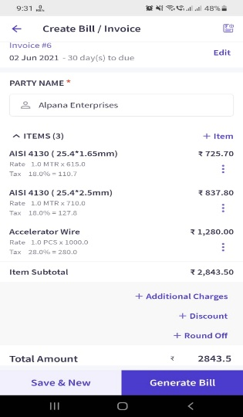

* + - * 1. User can edit the prices of the items will making a bill. The price edited should be only for the current bill generated. The price should not change of the original product.

1. Advance Button: (Single line text box)

* + - Mandatory field.
    - Numbers allowed

1. Balance amount: Automatically calculate = Total - Amount
2. Maths:
3. Qty x Unit price = Amount
4. Total: show total of qty and total price
5. Advance: Added by user
6. Balance: = Total – Advance

1. Remark: (Multi Line text box)
   * + Optional field.
     + Alphanumeric allowed
2. Generate bill Button: Generate a bill in following format and display.

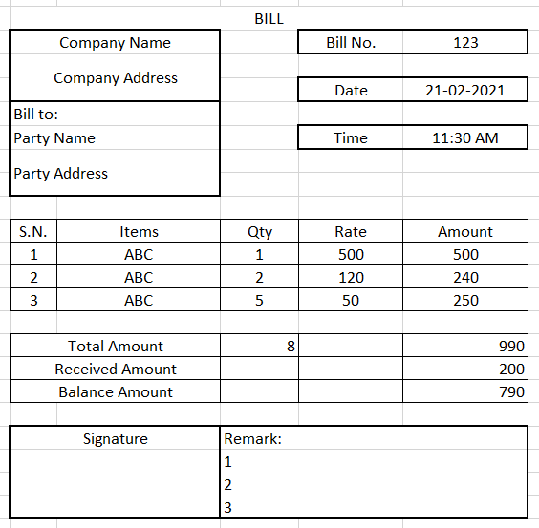

1. Save the bill and show print/Share button

# Module 11: View Parties

1. Show List of all the parties added by the user in the form of card.
2. Search bar to search party.
3. Sort:
   * + Balance low to high
     + Balance high to low
4. The card should have Party name, Address, balance amount in green (Down Arrow), Extra in red (Up Arrow)

Ex: 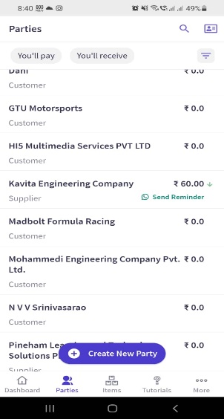

1. Tapping the card should open a new page.

Ex: 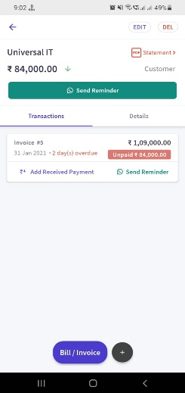

1. It should have the party card at the top.
2. It should have two tabs below the card, namely Transaction and Details.
3. Transaction tab will show all the bills of the party in a form of card.

* Date
* Time
* Bill number
* Total Amount
* Unpaid Amount
* Due in / over due in days.

(For eg. The user has added a party with a credit period of 30 days. He creates a bill of a certain amount on 21/02/21, then the ‘Due in’ should be 30 days from the day of bill generation i.e. 23/03/21. This Due in should reduce till 22/03/21. On 23/03/21 show ‘Due Today’. From 24/03/21 till the balance amount becomes zero show “Overdue {No of days} Days”

* Add payment in button on the card. (User can add the payment received for the particular bill. The bill should update accordingly. If the added amount is higher than balance amount, then deduct the balance amount from the received amount and add the remaining amount to extra or the next unpaid bill.)

1. Details Tab will show the details of the party entered by user. The details can be edited.
2. Fab icon for Add bill: Module: 11. Don’t ask for party name. The party name should be auto fetched from the screen where the fab is clicked.
3. Fab Icon for Record Payment In: The user can add payment received from his parties. The money which is received should clear the balance amount of the bills with oldest first and so on till the received money becomes zero. If all bills are paid and still the received money is not zero then add it to extra. Update the bills accordingly with the date and time.
4. Transaction History: Open a new page and show data in the following format. 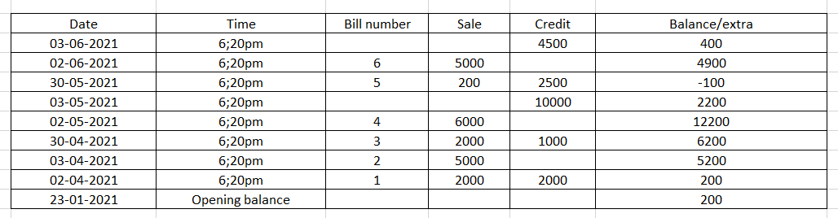

Tapping the bill number will open the bill generated. Download button to download the report in pdf format. Share button for sharing.

# Module 12: View Bills

Show all the bills in the form of cards with latest first. Cards show have following

* Date
* Time
* Bill number
* Total Amount
* Unpaid Amount
* Due in / over due in days.

(For eg. The user has added a party with a credit period of 30 days. He creates a bill of a certain amount on 21/02/21, then the ‘Due in’ should be 30 days from the day of bill generation i.e. 23/03/21. This Due in should reduce till 22/03/21. On 23/03/21 show ‘Due Today’. From 24/03/21 till the balance amount becomes zero show “Overdue {No of days} Days”

* Add payment in button on the card. (User can add the payment received for the particular bill. The bill should update accordingly. If the added amount is higher than balance amount, then deduct the balance amount from the received amount and add the remaining amount to extra or the next unpaid bill.)

Tapping the card should open the bill that was generated. Edit button to edit the bill to be provided. After editing, update changes and save.

# Module 13: View Items

1. Show list of all the items in form of cards. Card should have Item name, price/unit and category.
2. Tapping the card should open a detailed page with facility to edit.
3. Search bar to search the item.
4. Category dropdown. Selecting any category will apply that filter.
5. FAB to add item.

# Module 14: Subscription

1. There is yearly subscription for using the app. Once the user registers, the request goes to admin app for approval.
2. User status (Show depending upon his status, show validity)

* Inactive Subscription: First time registration. (Home page: Please take subscription.)
* Active subscription: Payment made. Can do everything
* Expired Subscription: Subscription expired. Cannot do anything. Hide all data (Home page: Please take subscription.)

1. Provide this link (Link) in the payment section for getting the payment.
2. A button to notify admin regarding payment.
3. Admin will approve or decline.

# Module 15: Add staff

Show already Added staff. Max 3 staff can be in any business. Means only 2 more staffs can be added. The First person to register any business becomes the owner of the app. He can add or remove staff.

A form should be displayed with following details:

1. Mobile Number: (Single line text box)
   * + Mandatory field.
     + By default, country code +91.
     + Only 10-digit number is allowed.
     + Should allow only numbers.
     + Can use contacts in mobile to add.
2. Name: (Single line text box)
   * + Mandatory field.
     + Max length 100 character.
     + Should allow Alphanumeric and special symbols.
     + Auto fetch name from contacts

# Module 16: Home Page

1. Business Name at the top
2. Balance Total
3. Bottom navigation:

Items: Module 13

Bills (Home): Module 12

Parties: Module 11

More:

Drawer:

1. Your Profile (Module 6)
2. Company Profile (Module 7)
3. Add Staff (Module 15)
4. Subscription (Module 14)
5. Change Password
6. Logout