
Department of CSE

B.Tech. CSE Trimester -5

Roll Number: 2520030105
Name: KARKALA SHIVA REDDY

Cloud Infrastructure and Services
25CS2206E

LAB RECORD
2026

Experiment -1

AIM: To create an AWS free tier account to provision the resources.

Description:
The AWS Free Tier is a program offered by Amazon Web Services (AWS) that allows new users to explore and use AWS cloud services free of cost for a limited period. It provides three types of offers: 12-Months Free (services such as Amazon EC2, Amazon S3 and Amazon RDS), Always Free (services such as AWS Lambda and Amazon DynamoDB) and Short-Term Trials (services such as Amazon SageMaker). To use these services, a user must first create an AWS account by providing an email address, password, contact details and a valid payment method for identity verification. After the account is activated, the user can sign in to the AWS Management Console and provision resources within the Free Tier limits.
Steps:
1. Open the AWS website (https://aws.amazon.com) and click on "Create an AWS Account".
2. Enter the email address, password and AWS account name, then click "Continue".
3. Select the account type as "Personal" and enter the required contact details.
4. Enter the billing information (debit/credit card details) for identity verification.
5. Verify the mobile number using the OTP received and complete the identity verification.
6. Select the "Basic Support - Free" plan and click "Complete Sign Up".
7. Sign in to the AWS Management Console using the newly created account.
8. Select a region and open the required service (for example, EC2 or S3) from the console.
9. Provision the required resources within the Free Tier limits and verify them in the console.
Result: Thus, an AWS free tier account was created successfully and the required resources were provisioned using the AWS Management Console.
Output:
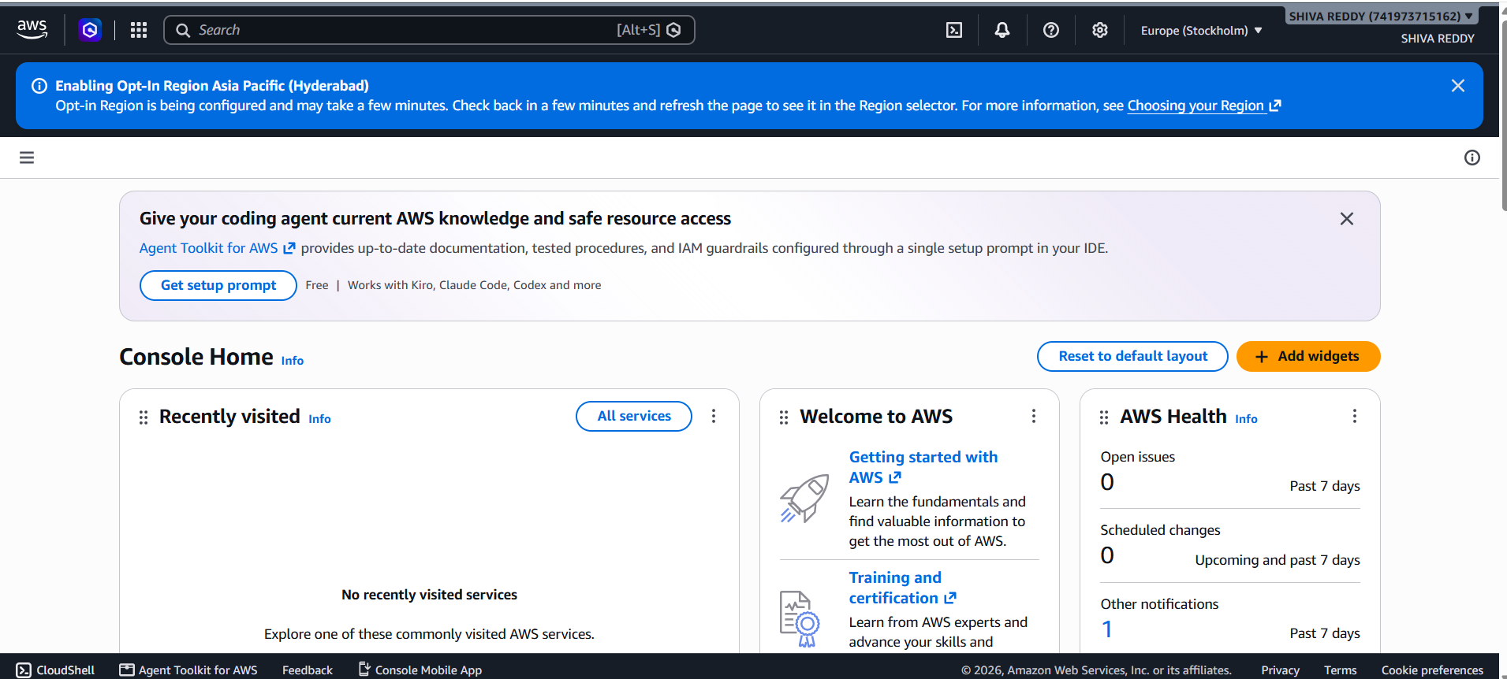

GITHUB
Practical Skills Repository: CDIS-Y25-PRATICAL-SKILL - https://github.com/karkalashivareddy/CDIS-Y25-PRATICAL-SKILL
Project Repository: CDIS-KLH-Y25-PROJECT - https://github.com/karkalashivareddy/CDIS-KLH-Y25-Project

