KL UNIVERSITY
Koneru Lakshmaiah Education Foundation (Deemed to be University), Green Fields, Vaddeswaram
Database Systems Engineering & Distributed Backend Development
LABORATORY PRACTICAL - WEEK 2
Relational Database Design and SQL Operations using MySQL
Field | Details
Student Name | KARKALA SHIVA REDDY
Roll Number | 2520030105
University | KL UNIVERSITY
Course | Database Systems Engineering & Distributed Backend Development
Laboratory | Database Systems (DB-DS) - Practical
Practical | Week-2 (Lab DB-DS)
Date of Experiment | 29 August 2026

Submitted to the Department in partial fulfilment of the Database Systems Engineering & Distributed Backend Development coursework.

1. Objective
The aim of this Week-2 laboratory practical is to design and implement a relational database in MySQL and to demonstrate the core SQL capabilities of the Database Systems syllabus. The specific objectives are:
- Create and select a MySQL database using DDL statements (CREATE DATABASE, USE, SHOW DATABASES).
- Define relational tables with PRIMARY KEY, NOT NULL, UNIQUE, CHECK and FOREIGN KEY constraints.
- Populate the tables with realistic records using INSERT statements.
- Retrieve and analyse data using SELECT, WHERE, ORDER BY, INNER JOIN, LEFT JOIN, GROUP BY and COUNT.
- Demonstrate referential and NOT-NULL constraint enforcement by MySQL.
- Demonstrate transaction control using START TRANSACTION and COMMIT.
- Create and use an index (CREATE INDEX, SHOW INDEX) to support an equi-select query.
- Verify the final database state with SELECT queries on every table.

2. System and Software Environment
All commands in this practical were executed on the student's own Windows machine using the MySQL command-line client (mysql) through Windows PowerShell. The actual environment and software versions verified during the practical are listed below.
Item | Details
Operating System | Microsoft Windows 11 Home Single Language (64-bit), Version 10.0.26200 (Build 26200)
Computer | HP Laptop 15-fd0xxx, 16 GB RAM
Windows user account | shiva\karka (computer hostname: shiva)
Shell | Windows PowerShell (Microsoft Windows [Version 10.0.26200.8973])
Database Server | MySQL 8.0.46 Community Server - GPL (Windows service: MySQL80)
MySQL client | mysql Ver 8.0.46 for Win64 on x86_64
MySQL client path | C:\Program Files\MySQL\MySQL Server 8.0\bin\mysql.exe
Java Runtime | Java 25 LTS (build 25+37-LTS-3491)
Node.js / npm | v24.18.1 / 11.16.0
Git | git version 2.53.0.windows.1

Note: the MySQL root account is secured with a password. All connections used the MYSQL_PWD environment variable so that the password is never typed on the command line, never stored in history, and never appears in any output or screenshot.

3. Practical Scenario: PharmaStock Database
A MySQL database named pharmastock_db was designed for a pharmaceutical ('PharmaStock') inventory system. It maintains the medicines handled by a pharmacy, the distributors who supply stock, and the individual inventory batches received. Three related relational tables were created:
Table | Purpose | Primary Key | Foreign Keys
Medicines | Master list of medicines with category, manufacturer and unit price | medicine_id | None
Suppliers | Distributor/supplier masters with unique e-mail | supplier_id | None
Batches | Stock batches received per medicine from a supplier (quantity, mfg/expiry dates) | batch_id | medicine_id, supplier_id

Relationships: one Medicine can appear in many Batches (1:N), and one Supplier can provide many Batches (1:N). The foreign keys on Batches enforce these relationships.

4. Step-by-Step Practical Execution

4.1 Connecting to MySQL from the System
The practical started by confirming the environment identity (user account and hostname) and the MySQL client version, followed by opening a MySQL command-line session as the root user. The connection was established with the password supplied through the MYSQL_PWD environment variable; the password itself is never displayed.
hostname
shiva
whoami
shiva\karka
mysql --version
mysql Ver 8.0.46 for Win64 on x86_64 (MySQL Community Server - GPL)
mysql -u root
Welcome to the MySQL monitor. Commands end with ; or \g.
Server version: 8.0.46 MySQL Community Server - GPL
A connection-verification query was then executed inside the MySQL session. Its real output is shown below.
SELECT VERSION() AS mysql_version, NOW() AS server_time
+---------------+---------------------+
| mysql_version | server_time |
+---------------+---------------------+
| 8.0.46 | 2026-08-29 15:49:02 |
+---------------+---------------------+
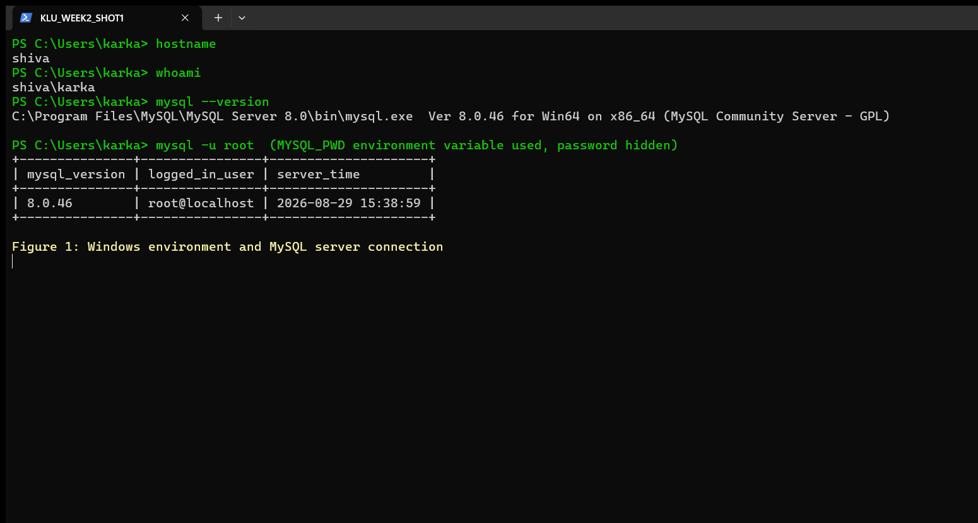
Figure 1: Windows environment and MySQL server connection

4.2 Creating and Selecting the Database
The database pharmastock_db was created and then selected with USE. (When the mysql client runs a statement file in verbose batch mode the USE statement performs quietly; the evidence that the database is active is the SHOW DATABASES listing and the SHOW TABLES result in Section 4.3.)
CREATE DATABASE pharmastock_db;
Query OK, 1 row affected (database created and verified below).
SHOW DATABASES;
+--------------------+
| Database |
+--------------------+
| bank_management |
| company |
| emp_klh |
| hospital_beds |
| information_schema |
| mysql |
| performance_schema |
| pharmastock_db |
| student |
| sys |
| test |
+--------------------+
The listing confirms that pharmastock_db exists alongside the server databases.

4.3 Creating Tables with Constraints
Three tables were created. The design uses PRIMARY KEY, NOT NULL, UNIQUE, CHECK and FOREIGN KEY constraints so that the database itself enforces data integrity.
CREATE TABLE Medicines (
medicine_id INT PRIMARY KEY,
name VARCHAR(100) NOT NULL,
category VARCHAR(50),
manufacturer VARCHAR(100),
unit_price DECIMAL(10,2) CHECK (unit_price > 0)
)
Query OK, 0 rows affected (Medicines created)
CREATE TABLE Suppliers (
supplier_id INT PRIMARY KEY,
supplier_name VARCHAR(100) NOT NULL,
city VARCHAR(50),
contact VARCHAR(15),
email VARCHAR(100) UNIQUE
)
Query OK, 0 rows affected (Suppliers created)
CREATE TABLE Batches (
batch_id INT PRIMARY KEY,
medicine_id INT,
supplier_id INT,
batch_no VARCHAR(20) UNIQUE,
quantity INT CHECK (quantity >= 0),
mfg_date DATE,
expiry_date DATE,
FOREIGN KEY (medicine_id) REFERENCES Medicines(medicine_id),
FOREIGN KEY (supplier_id) REFERENCES Suppliers(supplier_id)
)
Query OK, 0 rows affected (Batches created)
SHOW TABLES confirms that the three tables were created inside pharmastock_db:
SHOW TABLES
+--------------------------+
| Tables_in_pharmastock_db |
+--------------------------+
| batches |
| medicines |
| suppliers |
+--------------------------+
DESC Medicines shows the structure, types, nullability, key flags and defaults:
DESC Medicines
+--------------+---------------+------+-----+---------+-------+
| Field | Type | Null | Key | Default | Extra |
+--------------+---------------+------+-----+---------+-------+
| medicine_id | int | NO | PRI | NULL | |
| name | varchar(100) | NO | | NULL | |
| category | varchar(50) | YES | | NULL | |
| manufacturer | varchar(100) | YES | | NULL | |
| unit_price | decimal(10,2) | YES | | NULL | |
+--------------+---------------+------+-----+---------+-------+
Table | Constraint | Column(s) | Purpose
Medicines | PRIMARY KEY | medicine_id | Uniquely identifies each medicine
Medicines | NOT NULL | name | Every medicine must have a name
Medicines | CHECK (unit_price > 0) | unit_price | Prices must be positive
Suppliers | UNIQUE | email | No duplicate supplier e-mails
Batches | UNIQUE | batch_no | Batch numbers are unique
Batches | CHECK (quantity >= 0) | quantity | Stock cannot be negative
Batches | FOREIGN KEY | medicine_id | A batch must belong to an existing medicine
Batches | FOREIGN KEY | supplier_id | A batch must come from an existing supplier

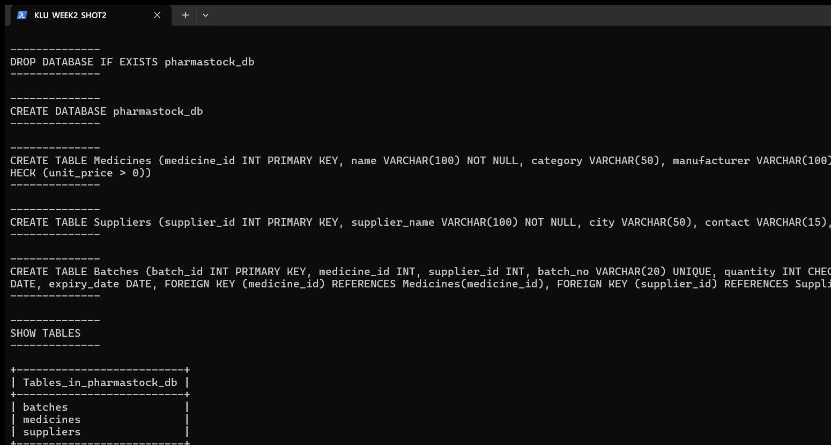
Figure 2: Medicines, Suppliers and Batches tables created and records inserted

4.4 Inserting Records
Realistic pharmaceutical records were inserted into the three tables. Each INSERT returned 'Query OK, N rows affected' together with the Records / Duplicates / Warnings summary.
INSERT INTO Medicines (medicine_id, name, category, manufacturer, unit_price) VALUES
(1, 'Paracetamol 500mg', 'Analgesic', 'Cipla Ltd', 12.50),
(2, 'Amoxicillin 250mg', 'Antibiotic', 'Sun Pharma', 45.00),
(3, 'Cetirizine 10mg', 'Antihistamine', 'Dr. Reddy\'s', 18.75),
(4, 'Metformin 500mg', 'Antidiabetic', 'Aurobindo Pharma', 22.00),
(5, 'Azithromycin 500mg', 'Antibiotic', 'Zydus Lifesciences', 58.50)
Query OK, 5 rows affected (Records: 5 Duplicates: 0 Warnings: 0)
INSERT INTO Suppliers (supplier_id, supplier_name, city, contact, email) VALUES
(101, 'MedLine Distributors', 'Hyderabad', '9848012345', 'medline@pharmasupply.in'),
(102, 'HealthCare Traders', 'Vijayawada', '9701234567', 'healthcare.traders@yahoo.com'),
(103, 'Global Meds Agency', 'Guntur', '9123456780', 'globalmeds@outlook.com'),
(104, 'Krishna Pharma Supplies', 'Visakhapatnam', '9000011223', 'krishnapharms@gmail.com')
Query OK, 4 rows affected (Records: 4 Duplicates: 0 Warnings: 0)
INSERT INTO Batches (batch_id, medicine_id, supplier_id, batch_no, quantity, mfg_date, expiry_date) VALUES
(1001, 1, 101, 'CPL2601', 500, '2026-01-15', '2028-01-14'),
(1002, 2, 102, 'SPH2602', 300, '2026-02-01', '2028-01-31'),
(1003, 3, 103, 'DRL2603', 400, '2026-01-20', '2027-12-31'),
(1004, 4, 104, 'AUB2604', 250, '2026-03-05', '2028-03-04'),
(1005, 5, 101, 'ZYD2605', 350, '2026-02-15', '2027-11-30'),
(1006, 1, 102, 'CPL2606', 600, '2026-04-10', '2028-04-09'),
(1007, 3, 101, 'DRL2607', 200, '2026-05-01', '2028-04-30'),
(1008, 2, 104, 'SPH2608', 450, '2026-06-01', '2028-05-31')
Query OK, 8 rows affected (Records: 8 Duplicates: 0 Warnings: 0)
Immediate verification of the inserted data:
SELECT * FROM Medicines
+-------------+--------------------+---------------+--------------------+------------+
| medicine_id | name | category | manufacturer | unit_price |
+-------------+--------------------+---------------+--------------------+------------+
| 1 | Paracetamol 500mg | Analgesic | Cipla Ltd | 12.50 |
| 2 | Amoxicillin 250mg | Antibiotic | Sun Pharma | 45.00 |
| 3 | Cetirizine 10mg | Antihistamine | Dr. Reddy's | 18.75 |
| 4 | Metformin 500mg | Antidiabetic | Aurobindo Pharma | 22.00 |
| 5 | Azithromycin 500mg | Antibiotic | Zydus Lifesciences | 58.50 |
+-------------+--------------------+---------------+--------------------+------------+
SELECT * FROM Suppliers
+-------------+-------------------------+---------------+------------+------------------------------+
| supplier_id | supplier_name | city | contact | email |
+-------------+-------------------------+---------------+------------+------------------------------+
| 101 | MedLine Distributors | Hyderabad | 9848012345 | medline@pharmasupply.in |
| 102 | HealthCare Traders | Vijayawada | 9701234567 | healthcare.traders@yahoo.com |
| 103 | Global Meds Agency | Guntur | 9123456780 | globalmeds@outlook.com |
| 104 | Krishna Pharma Supplies | Visakhapatnam | 9000011223 | krishnapharms@gmail.com |
+-------------+-------------------------+---------------+------------+------------------------------+
SELECT * FROM Batches
+----------+-------------+-------------+----------+----------+------------+-------------+
| batch_id | medicine_id | supplier_id | batch_no | quantity | mfg_date | expiry_date |
+----------+-------------+-------------+----------+----------+------------+-------------+
| 1001 | 1 | 101 | CPL2601 | 500 | 2026-01-15 | 2028-01-14 |
| 1002 | 2 | 102 | SPH2602 | 300 | 2026-02-01 | 2028-01-31 |
| 1003 | 3 | 103 | DRL2603 | 400 | 2026-01-20 | 2027-12-31 |
| 1004 | 4 | 104 | AUB2604 | 250 | 2026-03-05 | 2028-03-04 |
| 1005 | 5 | 101 | ZYD2605 | 350 | 2026-02-15 | 2027-11-30 |
| 1006 | 1 | 102 | CPL2606 | 600 | 2026-04-10 | 2028-04-09 |
| 1007 | 3 | 101 | DRL2607 | 200 | 2026-05-01 | 2028-04-30 |
| 1008 | 2 | 104 | SPH2608 | 450 | 2026-06-01 | 2028-05-31 |
+----------+-------------+-------------+----------+----------+------------+-------------+
Table | Rows Inserted
Medicines | 5
Suppliers | 4
Batches | 8

4.5 SQL Queries (Filtering, Sorting, Joins, Aggregation)
WHERE and ORDER BY: medicines priced below ₹25, sorted by unit price.
SELECT medicine_id, name, unit_price FROM Medicines WHERE unit_price < 25 ORDER BY unit_price
+-------------+-------------------+------------+
| medicine_id | name | unit_price |
+-------------+-------------------+------------+
| 1 | Paracetamol 500mg | 12.50 |
| 3 | Cetirizine 10mg | 18.75 |
| 4 | Metformin 500mg | 22.00 |
+-------------+-------------------+------------+
INNER JOIN: every batch together with the medicine name and the supplying distributor, sorted by medicine name. This joins Batches with Medicines and Suppliers on the foreign keys.
SELECT m.name AS medicine_name, s.supplier_name, b.batch_no, b.quantity, b.expiry_date
FROM Batches b
INNER JOIN Medicines m ON b.medicine_id = m.medicine_id
INNER JOIN Suppliers s ON b.supplier_id = s.supplier_id
ORDER BY m.name
+--------------------+-------------------------+----------+----------+-------------+
| medicine_name | supplier_name | batch_no | quantity | expiry_date |
+--------------------+-------------------------+----------+----------+-------------+
| Amoxicillin 250mg | HealthCare Traders | SPH2602 | 300 | 2028-01-31 |
| Amoxicillin 250mg | Krishna Pharma Supplies | SPH2608 | 450 | 2028-05-31 |
| Azithromycin 500mg | MedLine Distributors | ZYD2605 | 350 | 2027-11-30 |
| Cetirizine 10mg | MedLine Distributors | DRL2607 | 200 | 2028-04-30 |
| Cetirizine 10mg | Global Meds Agency | DRL2603 | 400 | 2027-12-31 |
| Metformin 500mg | Krishna Pharma Supplies | AUB2604 | 250 | 2028-03-04 |
| Paracetamol 500mg | MedLine Distributors | CPL2601 | 500 | 2028-01-14 |
| Paracetamol 500mg | HealthCare Traders | CPL2606 | 600 | 2028-04-09 |
+--------------------+-------------------------+----------+----------+-------------+
GROUP BY with COUNT: number of medicines in each therapeutic category, in descending order.
SELECT category, COUNT(*) AS total_medicines
FROM Medicines
GROUP BY category
ORDER BY total_medicines DESC
+---------------+-----------------+
| category | total_medicines |
+---------------+-----------------+
| Antibiotic | 2 |
| Analgesic | 1 |
| Antihistamine | 1 |
| Antidiabetic | 1 |
+---------------+-----------------+
LEFT JOIN with GROUP BY: number of batches available for every medicine (including any medicine with no batch yet).
SELECT m.name, COUNT(b.batch_id) AS num_batches
FROM Medicines m
LEFT JOIN Batches b ON b.medicine_id = m.medicine_id
GROUP BY m.name
ORDER BY num_batches DESC
+--------------------+-------------+
| name | num_batches |
+--------------------+-------------+
| Paracetamol 500mg | 2 |
| Amoxicillin 250mg | 2 |
| Cetirizine 10mg | 2 |
| Metformin 500mg | 1 |
| Azithromycin 500mg | 1 |
+--------------------+-------------+

4.6 Constraint Enforcement (Rejected Operations)
The constraint checks were verified by attempting two invalid inserts. MySQL rejected both and reported genuine errors:
- Inserting a batch whose supplier_id (999) does not exist in Suppliers violates the Batches.supplier_id FOREIGN KEY - rejected with error 1452.
INSERT INTO Batches (batch_id, medicine_id, supplier_id, batch_no, quantity, mfg_date, expiry_date)
VALUES (1010, 1, 999, 'XXX2610', 100, '2026-08-01', '2028-07-31')
ERROR 1452 (23000) at line 89: Cannot add or update a child row: a foreign key constraint fails (`pharmastock_db`.`batches`, CONSTRAINT `batches_ibfk_2` FOREIGN KEY (`supplier_id`) REFERENCES `suppliers` (`supplier_id`))
- Inserting a medicine with a NULL name violates the NOT NULL constraint - rejected with error 1048.
INSERT INTO Medicines (medicine_id, name, category, manufacturer, unit_price)
VALUES (6, NULL, 'Analgesic', 'Test Pharma', 10.00)
ERROR 1048 (23000) at line 92: Column 'name' cannot be null
Because both statements failed, no invalid record was stored and the subsequent data in the transaction and index steps remained consistent.

4.7 Transaction (START TRANSACTION ... COMMIT)
A transaction was opened with START TRANSACTION. A new batch record (1009 - Azithromycin 500mg from Global Meds Agency) was inserted inside the transaction and permanently saved with COMMIT.
START TRANSACTION
INSERT INTO Batches (batch_id, medicine_id, supplier_id, batch_no, quantity, mfg_date, expiry_date)
VALUES (1009, 5, 103, 'ZYD2609', 320, '2026-07-10', '2028-07-09')
COMMIT
Verification that the committed record is durably stored:
SELECT * FROM Batches WHERE batch_id = 1009
+----------+-------------+-------------+----------+----------+------------+-------------+
| batch_id | medicine_id | supplier_id | batch_no | quantity | mfg_date | expiry_date |
+----------+-------------+-------------+----------+----------+------------+-------------+
| 1009 | 5 | 103 | ZYD2609 | 320 | 2026-07-10 | 2028-07-09 |
+----------+-------------+-------------+----------+----------+------------+-------------+

4.8 Index Creation and Use
A secondary index was created on the Batches.expiry_date column, which is a frequent search key for near-expiry monitoring. SHOW INDEX lists all indexes of the Batches table:
CREATE INDEX idx_batches_expiry_date ON Batches(expiry_date)
SHOW INDEX FROM Batches
+---------+------------+-------------------------+--------------+-------------+-----------+-------------+----------+--------+------+------------+---------+---------------+---------+------------+
| Table | Non_unique | Key_name | Seq_in_index | Column_name | Collation | Cardinality | Sub_part | Packed | Null | Index_type | Comment | Index_comment | Visible | Expression |
+---------+------------+-------------------------+--------------+-------------+-----------+-------------+----------+--------+------+------------+---------+---------------+---------+------------+
| batches | 0 | PRIMARY | 1 | batch_id | A | 1 | NULL | NULL | | BTREE | | | YES | NULL |
| batches | 0 | batch_no | 1 | batch_no | A | 1 | NULL | NULL | YES | BTREE | | | YES | NULL |
| batches | 1 | medicine_id | 1 | medicine_id | A | 1 | NULL | NULL | YES | BTREE | | | YES | NULL |
| batches | 1 | supplier_id | 1 | supplier_id | A | 1 | NULL | NULL | YES | BTREE | | | YES | NULL |
| batches | 1 | idx_batches_expiry_date | 1 | expiry_date | A | 9 | NULL | NULL | YES | BTREE | | | YES | NULL |
+---------+------------+-------------------------+--------------+-------------+-----------+-------------+----------+--------+------+------------+---------+---------------+---------+------------+
A point query using the indexed column returns the matching batch:
SELECT * FROM Batches WHERE expiry_date = '2028-01-14'
+----------+-------------+-------------+----------+----------+------------+-------------+
| batch_id | medicine_id | supplier_id | batch_no | quantity | mfg_date | expiry_date |
+----------+-------------+-------------+----------+----------+------------+-------------+
| 1001 | 1 | 101 | CPL2601 | 500 | 2026-01-15 | 2028-01-14 |
+----------+-------------+-------------+----------+----------+------------+-------------+
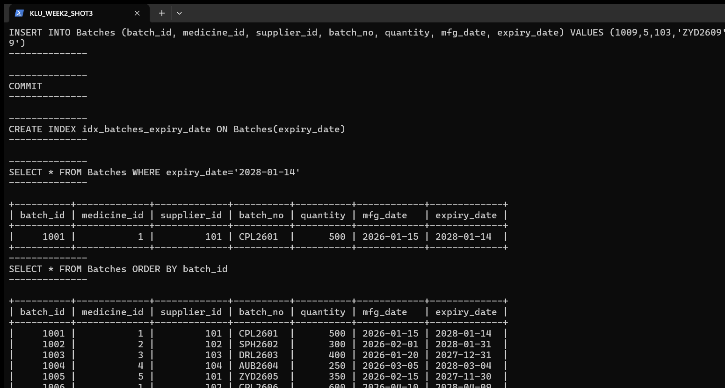
Figure 3: JOIN and GROUP BY queries, transaction commit, index and final verification

4.9 Final Verification of the Database State
The complete final state of every table is shown below. Note that the Medicines and Suppliers records are unchanged, while Batches now contains 9 records (the 8 original inserts plus batch 1009 committed in Section 4.7).
SELECT * FROM Medicines ORDER BY medicine_id
+-------------+--------------------+---------------+--------------------+------------+
| medicine_id | name | category | manufacturer | unit_price |
+-------------+--------------------+---------------+--------------------+------------+
| 1 | Paracetamol 500mg | Analgesic | Cipla Ltd | 12.50 |
| 2 | Amoxicillin 250mg | Antibiotic | Sun Pharma | 45.00 |
| 3 | Cetirizine 10mg | Antihistamine | Dr. Reddy's | 18.75 |
| 4 | Metformin 500mg | Antidiabetic | Aurobindo Pharma | 22.00 |
| 5 | Azithromycin 500mg | Antibiotic | Zydus Lifesciences | 58.50 |
+-------------+--------------------+---------------+--------------------+------------+
SELECT * FROM Suppliers ORDER BY supplier_id
+-------------+-------------------------+---------------+------------+------------------------------+
| supplier_id | supplier_name | city | contact | email |
+-------------+-------------------------+---------------+------------+------------------------------+
| 101 | MedLine Distributors | Hyderabad | 9848012345 | medline@pharmasupply.in |
| 102 | HealthCare Traders | Vijayawada | 9701234567 | healthcare.traders@yahoo.com |
| 103 | Global Meds Agency | Guntur | 9123456780 | globalmeds@outlook.com |
| 104 | Krishna Pharma Supplies | Visakhapatnam | 9000011223 | krishnapharms@gmail.com |
+-------------+-------------------------+---------------+------------+------------------------------+
SELECT * FROM Batches ORDER BY batch_id
+----------+-------------+-------------+----------+----------+------------+-------------+
| batch_id | medicine_id | supplier_id | batch_no | quantity | mfg_date | expiry_date |
+----------+-------------+-------------+----------+----------+------------+-------------+
| 1001 | 1 | 101 | CPL2601 | 500 | 2026-01-15 | 2028-01-14 |
| 1002 | 2 | 102 | SPH2602 | 300 | 2026-02-01 | 2028-01-31 |
| 1003 | 3 | 103 | DRL2603 | 400 | 2026-01-20 | 2027-12-31 |
| 1004 | 4 | 104 | AUB2604 | 250 | 2026-03-05 | 2028-03-04 |
| 1005 | 5 | 101 | ZYD2605 | 350 | 2026-02-15 | 2027-11-30 |
| 1006 | 1 | 102 | CPL2606 | 600 | 2026-04-10 | 2028-04-09 |
| 1007 | 3 | 101 | DRL2607 | 200 | 2026-05-01 | 2028-04-30 |
| 1008 | 2 | 104 | SPH2608 | 450 | 2026-06-01 | 2028-05-31 |
| 1009 | 5 | 103 | ZYD2609 | 320 | 2026-07-10 | 2028-07-09 |
+----------+-------------+-------------+----------+----------+------------+-------------+

5. Result
The Week-2 practical was completed successfully on MySQL 8.0.46. The pharmastock_db database was created with three related tables (Medicines, Suppliers, Batches) enforcing PRIMARY KEY, NOT NULL, UNIQUE, CHECK and FOREIGN KEY constraints. Five medicines, four suppliers and eight medicine batches were inserted and verified, and a ninth batch was added through a committed transaction. WHERE/ORDER BY filtering, INNER and LEFT joins, GROUP BY aggregation, and an index on expiry_date were all demonstrated with real query results. Two deliberately invalid inserts were correctly rejected by MySQL (errors 1452 and 1048), confirming that the database enforces referential and NULL constraints.

6. Conclusion
This practical established the full relational-database workflow in MySQL: database design, table creation with integrity constraints, data insertion, querying and analysis, transaction control, and index-based performance support. All operations produced verified results on the student's own Windows 11 machine (MySQL 8.0.46). The same relational constructs underpin the pharmaceutical medicine-stock database used for the course project.

