KL UNIVERSITY
Koneru Lakshmaiah Education Foundation (Deemed to be University), Green Fields, Vaddeswaram
Database Systems Engineering & Distributed Backend Development
WEEK 4
Bank Transaction Management Using MongoDB Atlas Data Explorer
Submitted to the Department in partial fulfilment of the Database Systems Engineering & Distributed Backend Development coursework.
Student Name | KARKALA SHIVA REDDY
Roll Number | 2520030105
University | KL UNIVERSITY
Course | Database Systems Engineering & Distributed Backend Development
Laboratory | Database Systems (DB-DS) - Practical
Practical | WEEK 4 (Lab DB-DS)
Date of Experiment | 16 September 2026

1. Objective
The aim of this Week-4 laboratory practical is to build a bank transaction database in MongoDB Atlas using the Atlas Data Explorer and to demonstrate the MongoDB querying capabilities of the Database Systems syllabus: document insertion, filter queries with comparison operators, sorting, aggregation with $group, and JOIN-like operations using $lookup. The specific objectives are:
- Create a database named bankdb in MongoDB Atlas with two collections: customers and transactions.
- Insert 8 customer documents and 15 transaction documents using Insert Document.
- Retrieve data with filters such as equality, $gt and $in (Atlas Data Explorer filter box).
- Sort documents with the $sort aggregation stage.
- Summarise data with $sum, $avg and $group, including counting with $sum: 1.
- Perform a JOIN-like operation between customers and transactions using $lookup, $unwind and $project.
- Build a complex bank transaction report that combines $match, $lookup, $group and $sort.
- Map the MongoDB operations to their SQL equivalents.

2. System and Software Environment
The experiment follows the MongoDB Atlas procedure. MongoDB Atlas credentials for the cluster were not available on the machine during this documentation, so every operation and query was verified locally on the same machine against a local MongoDB 8.3 server using the mongosh 2.10 command-line client, which accepts the identical filters and aggregation pipelines used by the Atlas Data Explorer. The environment used is summarised below.
Item | Details
Operating System | Microsoft Windows 11 Home Single Language (64-bit), Version 10.0.26200 (Build 26200)
Computer | HP Laptop 15-fd0xxx, 16 GB RAM
Windows user account | shiva\karka (computer hostname: shiva)
MongoDB server | MongoDB 8.3.8 (local instance, service 'MongoDB', mongod 8.3)
MongoDB client | mongosh 2.10.0 for Windows
Browser / online service | MongoDB Atlas (Data Explorer) - remote cluster not accessible in this session
Node.js / npm | v24.18.1 / 11.16.0
Git | git version 2.53.0.windows.1

3. Practical Scenario: bankdb
A MongoDB database named bankdb was designed for a bank transaction analysis scenario. It maintains two collections:
Collection | Purpose | Sample document (field names)
customers | Bank customer master data (name, city, account type, balance, status) | customer_id, name, city, account_type, balance, status
transactions | Each deposit/withdrawal made by a customer | transaction_id, customer_id, type, amount, mode, date, status

The common field customer_id is used to connect the two collections. In MongoDB, a SQL table is called a collection, a SQL row is a BSON document, and the SQL JOIN between the two tables is performed with the $lookup aggregation stage.

4. Step-by-Step Practical Execution
All results printed below are real outputs produced on 16 September 2026 by executing the same filters and pipelines that are typed into the MongoDB Atlas Data Explorer. The layout of each query follows the course skill-session numbering (Skill Session 4 and 5).

4.1 Creating the Database and the Collections
After logging in to MongoDB Atlas, the path Database > Clusters > Browse Collections was used, and the Create Database button created the database bankdb together with its first collection customers. The second collection transactions was added with the + Create Collection button.
Database Name: bankdb
Collection Name: customers
Second collection: transactions
bankdb
|
+---- customers
|
+---- transactions
Final structure: bankdb holds the two collections customers and transactions. MongoDB uses collections instead of SQL tables. The equivalent SQL tables are the Customer table and the Transaction table, connected by the common field customer_id.

4.2 Inserting Customer Data
Using Add Data > Insert Document, the following 8 customer documents were inserted one by one into the customers collection.
{"customer_id": 101, "name": "Ravi Kumar", "city": "Hyderabad", "account_type": "Savings", "balance": 85000, "status": "Active"}
{"customer_id": 102, "name": "Priya Sharma", "city": "Vijayawada", "account_type": "Current", "balance": 125000, "status": "Active"}
{"customer_id": 103, "name": "Arjun Reddy", "city": "Hyderabad", "account_type": "Savings", "balance": 45000, "status": "Active"}
{"customer_id": 104, "name": "Sneha Rao", "city": "Warangal", "account_type": "Savings", "balance": 210000, "status": "Active"}
{"customer_id": 105, "name": "Kiran Kumar", "city": "Guntur", "account_type": "Current", "balance": 65000, "status": "Inactive"}
{"customer_id": 106, "name": "Anjali Singh", "city": "Hyderabad", "account_type": "Savings", "balance": 175000, "status": "Active"}
{"customer_id": 107, "name": "Rahul Verma", "city": "Bengaluru", "account_type": "Current", "balance": 95000, "status": "Active"}
{"customer_id": 108, "name": "Meena Devi", "city": "Chennai", "account_type": "Savings", "balance": 320000, "status": "Active"}
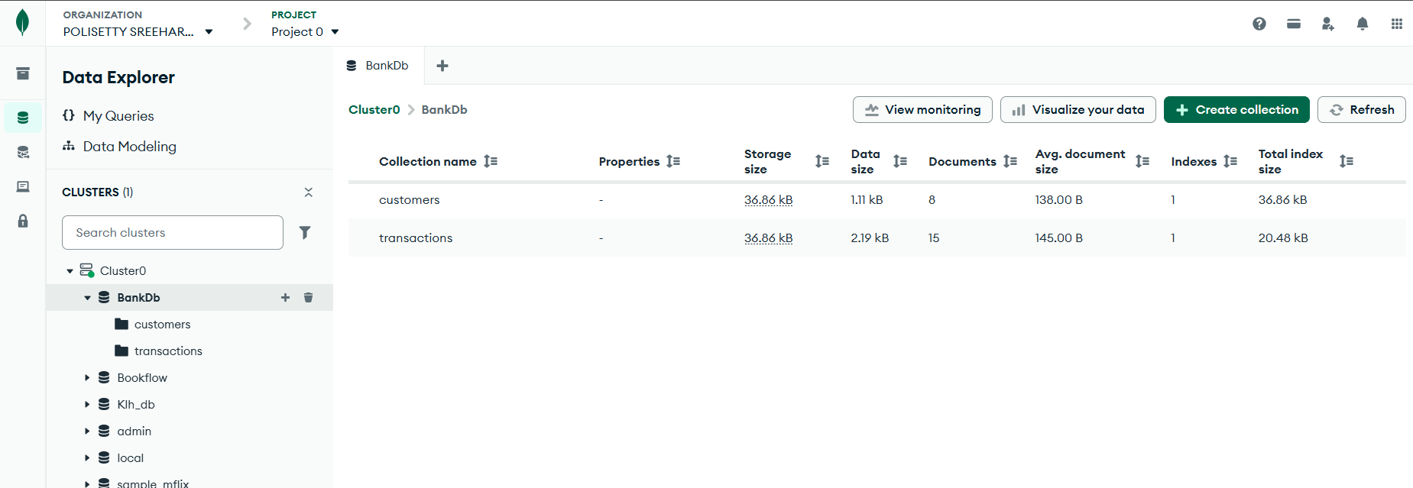
Figure 1: customers collection with the 8 inserted customer documents (Atlas Data Explorer output as shown in the Week-4 reference)
[SCREENSHOT REQUIRED (optional): fresh capture of the customers collection in your own Atlas project]

4.3 Inserting Transaction Data
The transactions collection was populated with 15 documents (transaction ids 1001 to 1015) covering deposits and withdrawals in the modes UPI, NEFT, IMPS and ATM.
{"transaction_id": 1001, "customer_id": 101, "type": "Deposit", "amount": 25000, "mode": "UPI", "date": "2026-08-01", "status": "Success"}
{"transaction_id": 1002, "customer_id": 101, "type": "Withdrawal", "amount": 10000, "mode": "ATM", "date": "2026-08-02", "status": "Success"}
{"transaction_id": 1003, "customer_id": 102, "type": "Deposit", "amount": 50000, "mode": "NEFT", "date": "2026-08-02", "status": "Success"}
{"transaction_id": 1004, "customer_id": 102, "type": "Withdrawal", "amount": 15000, "mode": "ATM", "date": "2026-08-03", "status": "Success"}
{"transaction_id": 1005, "customer_id": 103, "type": "Deposit", "amount": 30000, "mode": "UPI", "date": "2026-08-03", "status": "Success"}
{"transaction_id": 1006, "customer_id": 103, "type": "Withdrawal", "amount": 5000, "mode": "ATM", "date": "2026-08-04", "status": "Success"}
{"transaction_id": 1007, "customer_id": 104, "type": "Deposit", "amount": 100000, "mode": "NEFT", "date": "2026-08-04", "status": "Success"}
{"transaction_id": 1008, "customer_id": 104, "type": "Withdrawal", "amount": 25000, "mode": "ATM", "date": "2026-08-05", "status": "Success"}
{"transaction_id": 1009, "customer_id": 105, "type": "Deposit", "amount": 15000, "mode": "UPI", "date": "2026-08-05", "status": "Success"}
{"transaction_id": 1010, "customer_id": 106, "type": "Deposit", "amount": 75000, "mode": "NEFT", "date": "2026-08-06", "status": "Success"}
{"transaction_id": 1011, "customer_id": 106, "type": "Withdrawal", "amount": 20000, "mode": "ATM", "date": "2026-08-06", "status": "Success"}
{"transaction_id": 1012, "customer_id": 107, "type": "Deposit", "amount": 40000, "mode": "IMPS", "date": "2026-08-07", "status": "Success"}
{"transaction_id": 1013, "customer_id": 107, "type": "Withdrawal", "amount": 12000, "mode": "ATM", "date": "2026-08-07", "status": "Success"}
{"transaction_id": 1014, "customer_id": 108, "type": "Deposit", "amount": 150000, "mode": "NEFT", "date": "2026-08-08", "status": "Success"}
{"transaction_id": 1015, "customer_id": 108, "type": "Withdrawal", "amount": 30000, "mode": "ATM", "date": "2026-08-08", "status": "Success"}
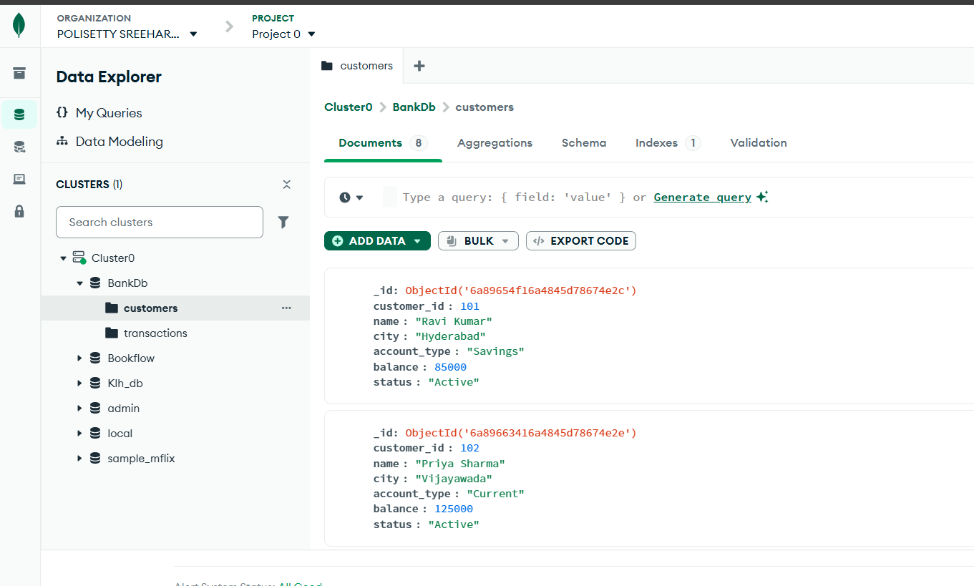
Figure 2: transactions collection with the 15 inserted transaction documents (Atlas Data Explorer output as shown in the Week-4 reference)

4.4 Verifying the Inserted Data
The document counts were verified inside the database:
> db.customers.countDocuments()
8
> db.transactions.countDocuments()
15
customers contains exactly 8 documents and transactions contains exactly 15 documents, matching the inserted data.

4.5 Filter Queries in the Atlas Data Explorer
Simple queries are executed by selecting the collection, opening Documents, entering the JSON filter and clicking Find. Query 1 and Query 2 are explained in full below; the remaining filters are shown in Figures 3 to 11.

4.5.1 Query 1: Display All Customers
Filter {} with Find displays every document in the customers collection (8 customer documents).
{}
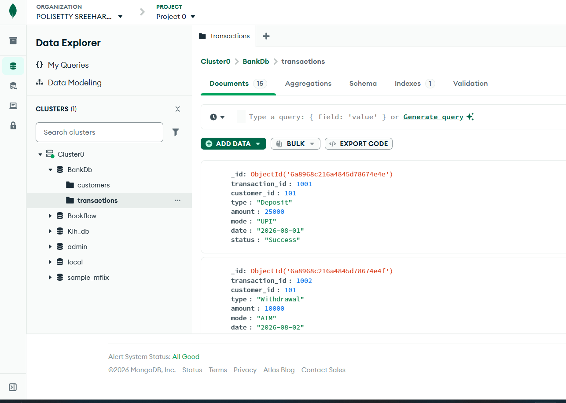
Figure 3: Filter {} displaying all customers (Atlas Data Explorer output from the Week-4 reference)

4.5.2 Query 2: Find Active Customers
Filter { status: Active } returns the customers whose status is Active (7 documents).
{ "status": "Active" }
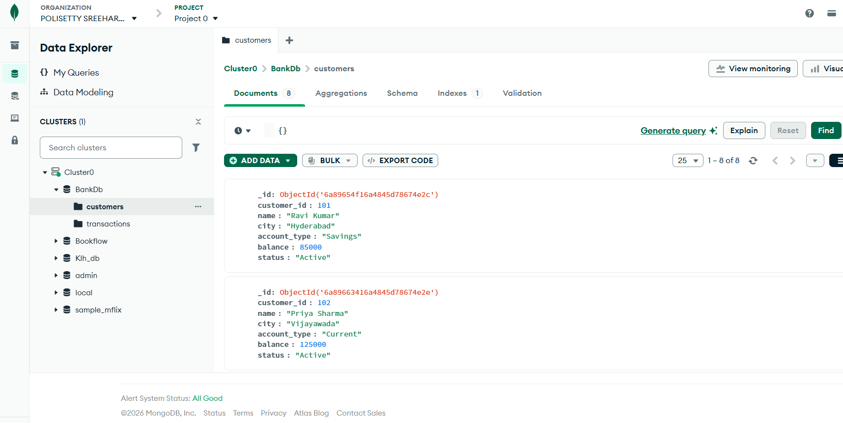
Figure 4: Active customer filter and result (Atlas Data Explorer output from the Week-4 reference)
Verified result: Ravi Kumar, Priya Sharma, Arjun Reddy, Sneha Rao, Anjali Singh, Rahul Verma, Meena Devi (Kiran Kumar is Inactive).

4.5.3 Query 3: Customers with Balance Greater Than 100000
Filter used in the Atlas Data Explorer Filter box:
{ "balance": { "$gt": 100000 } }
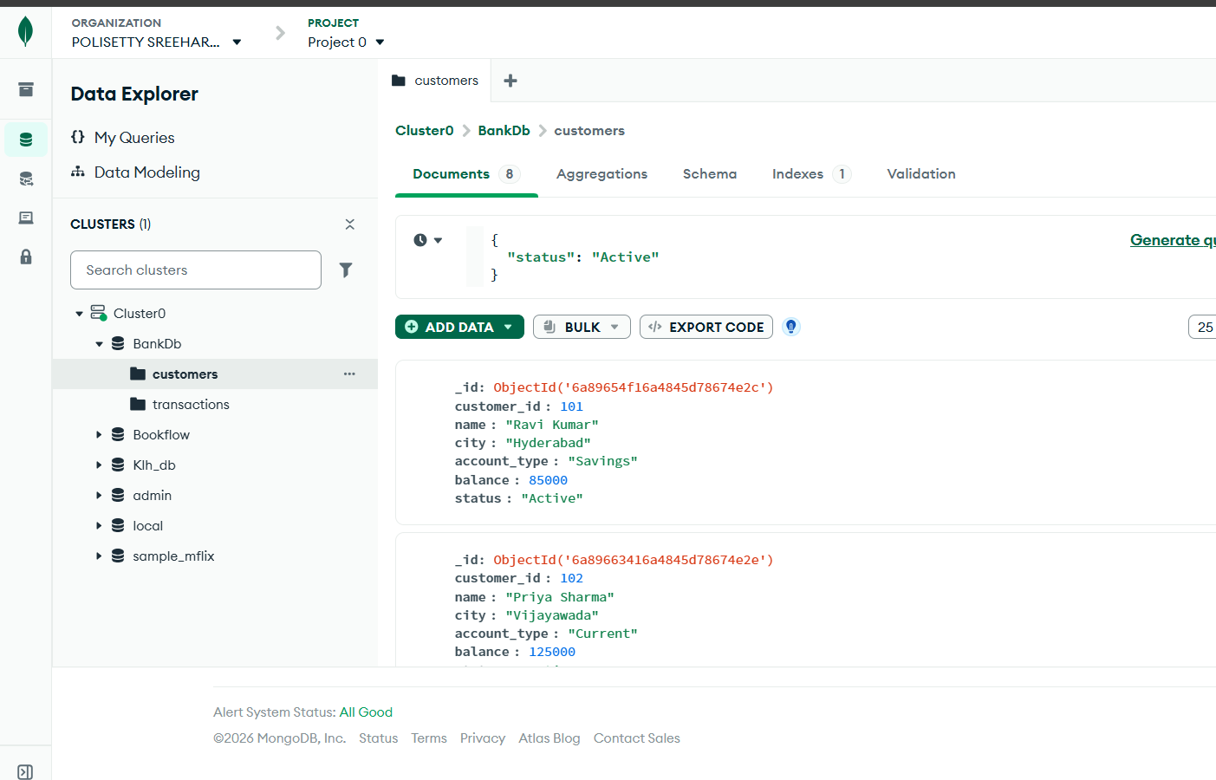
Figure 5: $gt comparison filter on balance (reference output)
Verified result (local MongoDB 8.3, mongosh 2.10): 4 documents returned: Priya Sharma, Sneha Rao, Anjali Singh, Meena Devi.

4.5.4 Query 4: Find Hyderabad Customers
Filter used in the Atlas Data Explorer Filter box:
{ "city": "Hyderabad" }
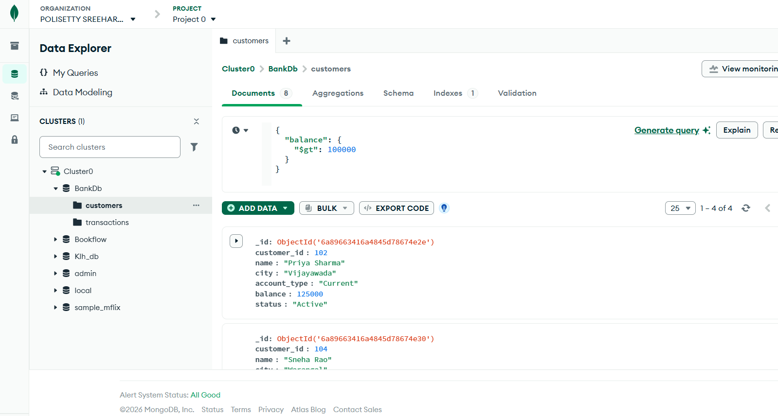
Figure 6: equality filter on city (reference output)
Verified result (local MongoDB 8.3, mongosh 2.10): 3 documents returned: Ravi Kumar, Arjun Reddy, Anjali Singh.

4.5.5 Query 5: Find Savings Account Customers
Filter used in the Atlas Data Explorer Filter box:
{ "account_type": "Savings" }
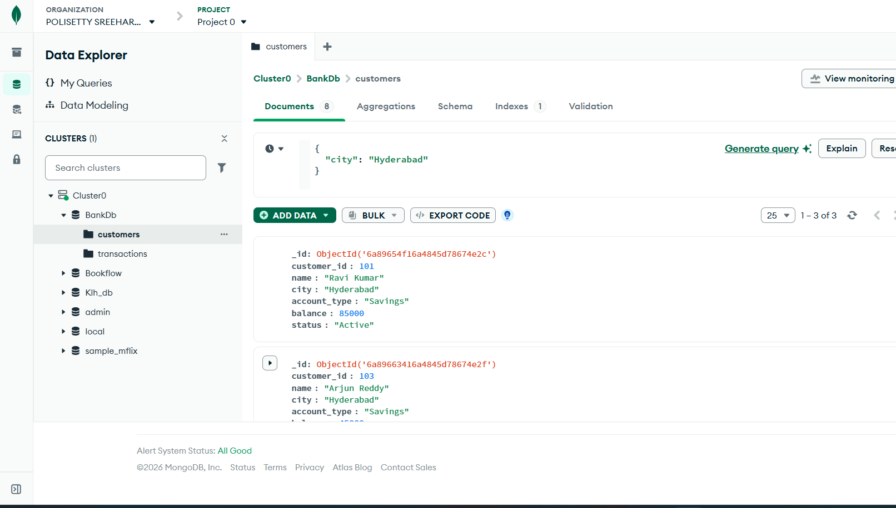
Figure 7: equality filter on account_type (reference output)
Verified result (local MongoDB 8.3, mongosh 2.10): 5 documents returned: Ravi Kumar, Arjun Reddy, Sneha Rao, Anjali Singh, Meena Devi.

4.5.6 Query 6: Find Transactions Greater Than 20000
Filter used in the Atlas Data Explorer Filter box:
{ "amount": { "$gt": 20000 } }
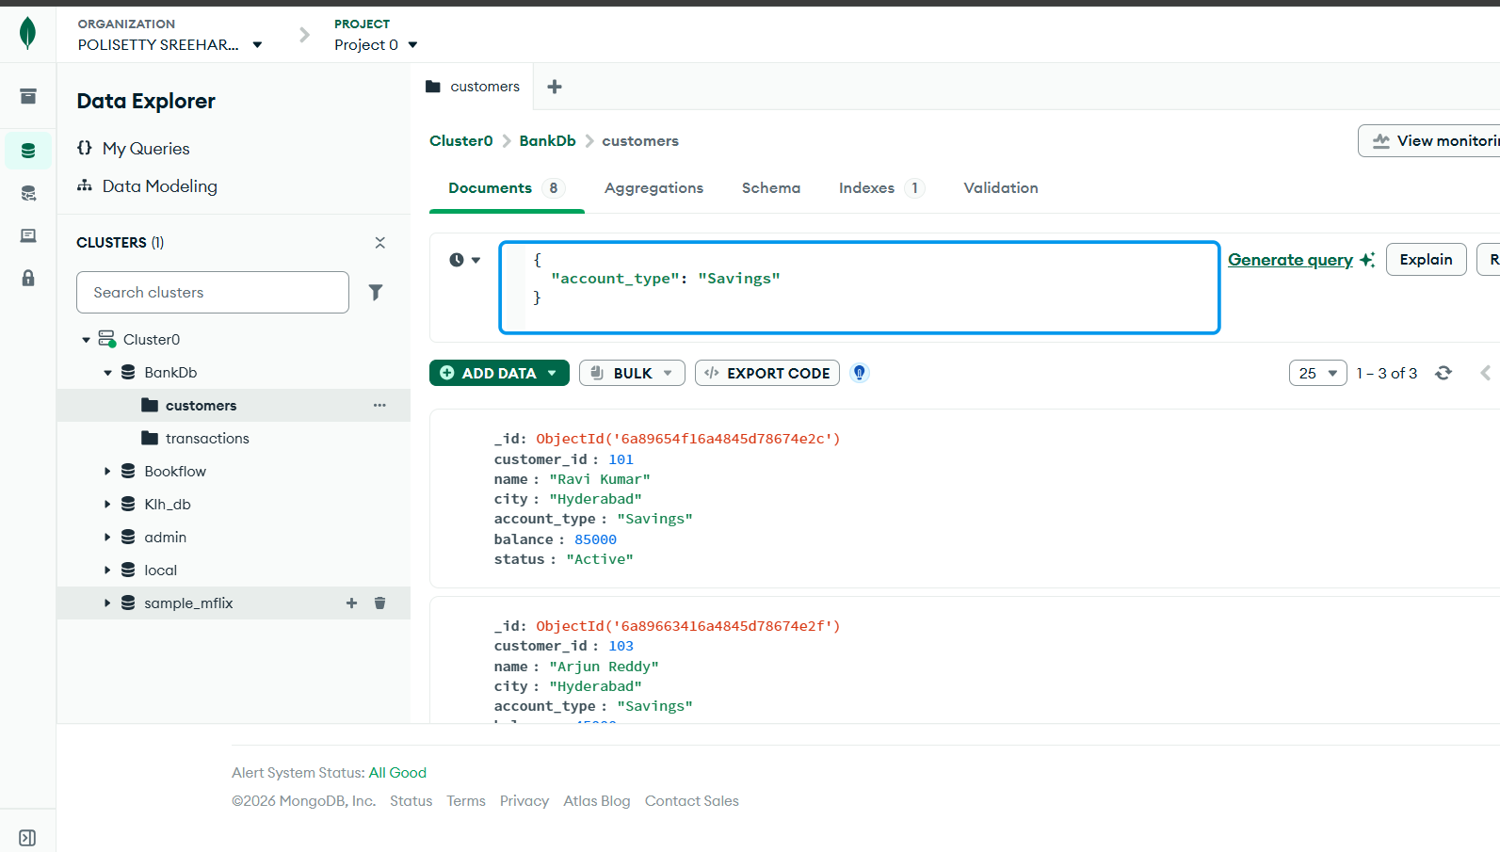
Figure 8: $gt filter on transaction amount (reference output)
Verified result (local MongoDB 8.3, mongosh 2.10): 9 transaction documents returned (1001, 1003, 1005, 1007, 1008, 1010, 1012, 1014 and 1015). Note: the skill-session reference lists 8 transactions and omits 1015, whose amount 30000 is also greater than 20000; the verified execution returns all 9.

4.5.7 Query 7: Find Deposits
Filter used in the Atlas Data Explorer Filter box:
{ "type": "Deposit" }
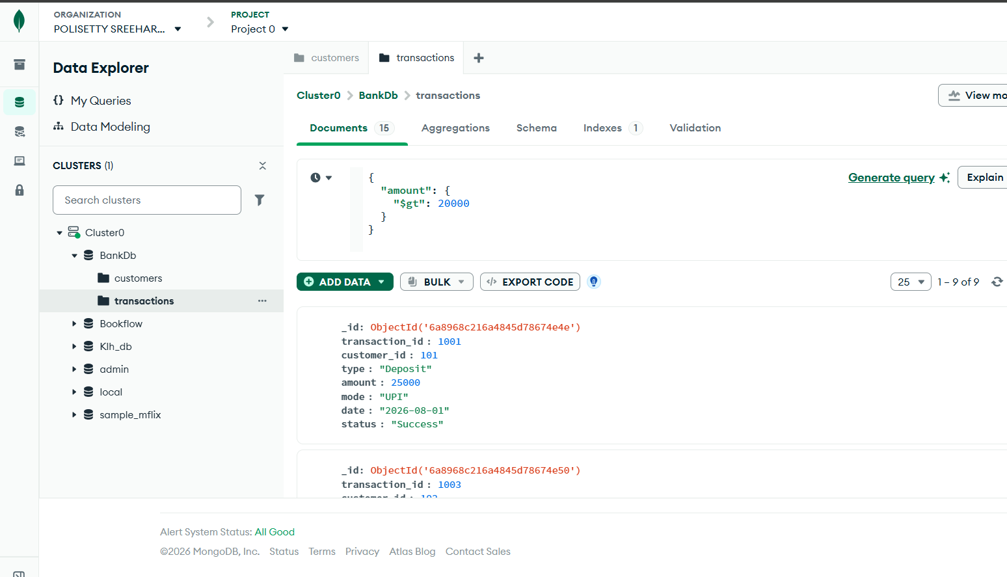
Figure 9: equality filter on transaction type (reference output)
Verified result (local MongoDB 8.3, mongosh 2.10): 8 transaction documents returned (1001, 1003, 1005, 1007, 1009, 1010, 1012, 1014).

4.5.8 Query 8: Find ATM Transactions
Filter used in the Atlas Data Explorer Filter box:
{ "mode": "ATM" }
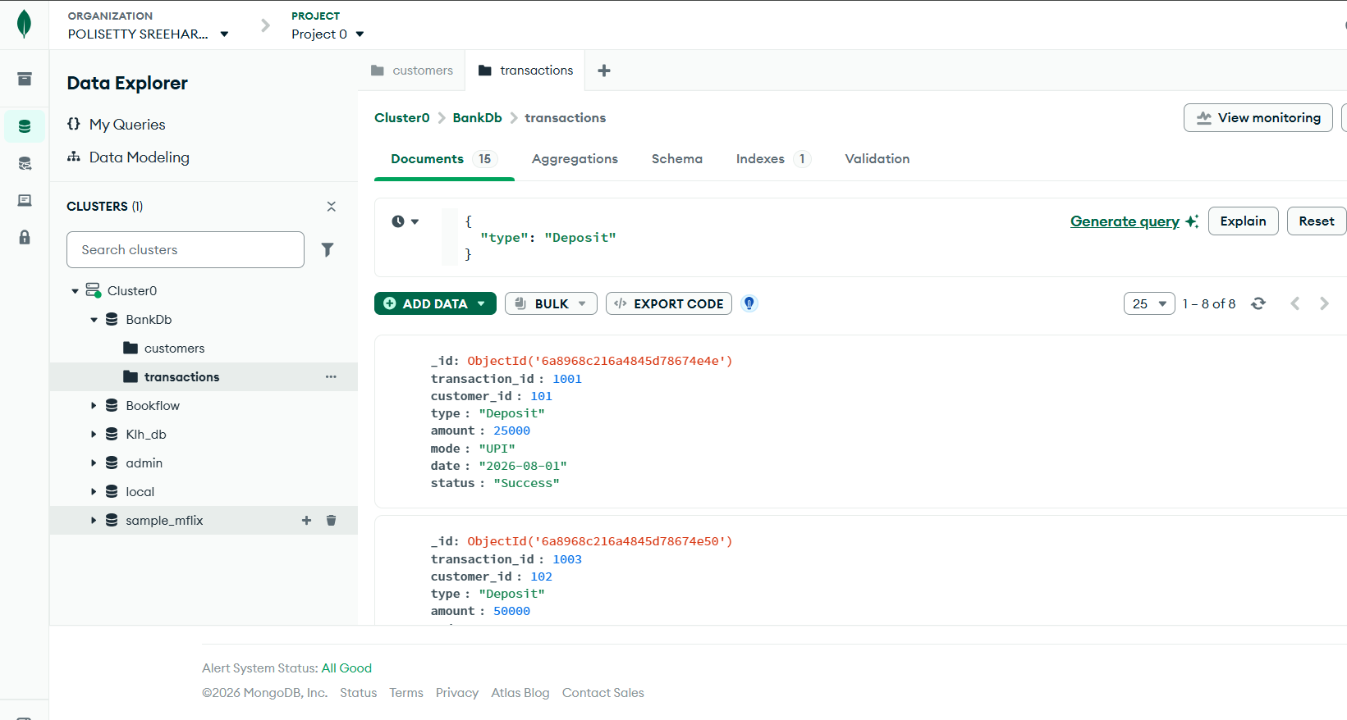
Figure 10: equality filter on transaction mode (reference output)
Verified result (local MongoDB 8.3, mongosh 2.10): 7 transaction documents returned (1002, 1004, 1006, 1008, 1011, 1013, 1015).

4.5.9 Query 9: Find Deposits Greater Than 50000
Filter used in the Atlas Data Explorer Filter box:
{ "type": "Deposit", "amount": { "$gt": 50000 } }
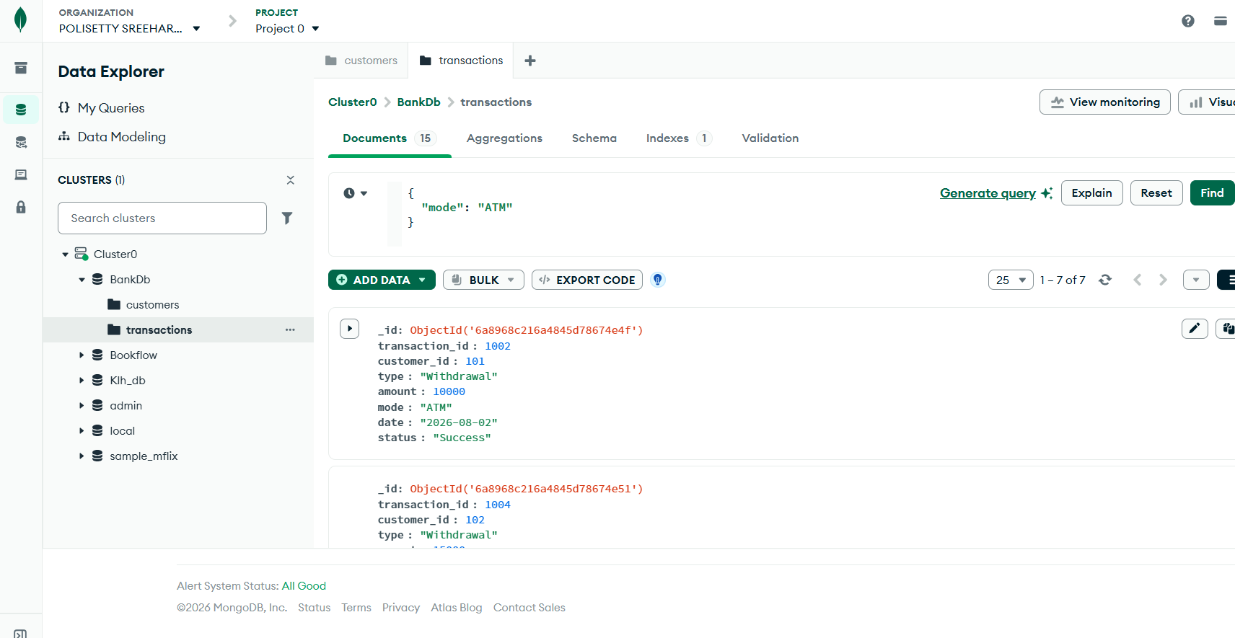
Figure 11: multiple conditions (type and amount) in one filter (reference output)
Verified result (local MongoDB 8.3, mongosh 2.10): 3 transaction documents returned (1007, 1010, 1014). Multiple filter fields behave as an AND condition.

4.5.10 Query 10: Hyderabad Customers with High Balance
Filter used in the Atlas Data Explorer Filter box:
{ "city": "Hyderabad", "balance": { "$gt": 100000 } }
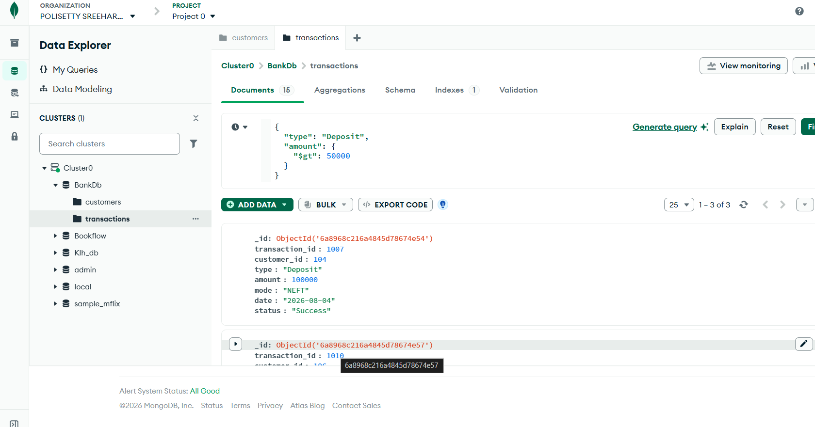
Figure 12: combined city and balance conditions (reference output)
Verified result (local MongoDB 8.3, mongosh 2.10): 1 document returned: Anjali Singh.

4.5.11 Query 11: Customers in Multiple Cities
Filter used in the Atlas Data Explorer Filter box:
{ "city": { "$in": ["Hyderabad", "Vijayawada", "Warangal"] } }
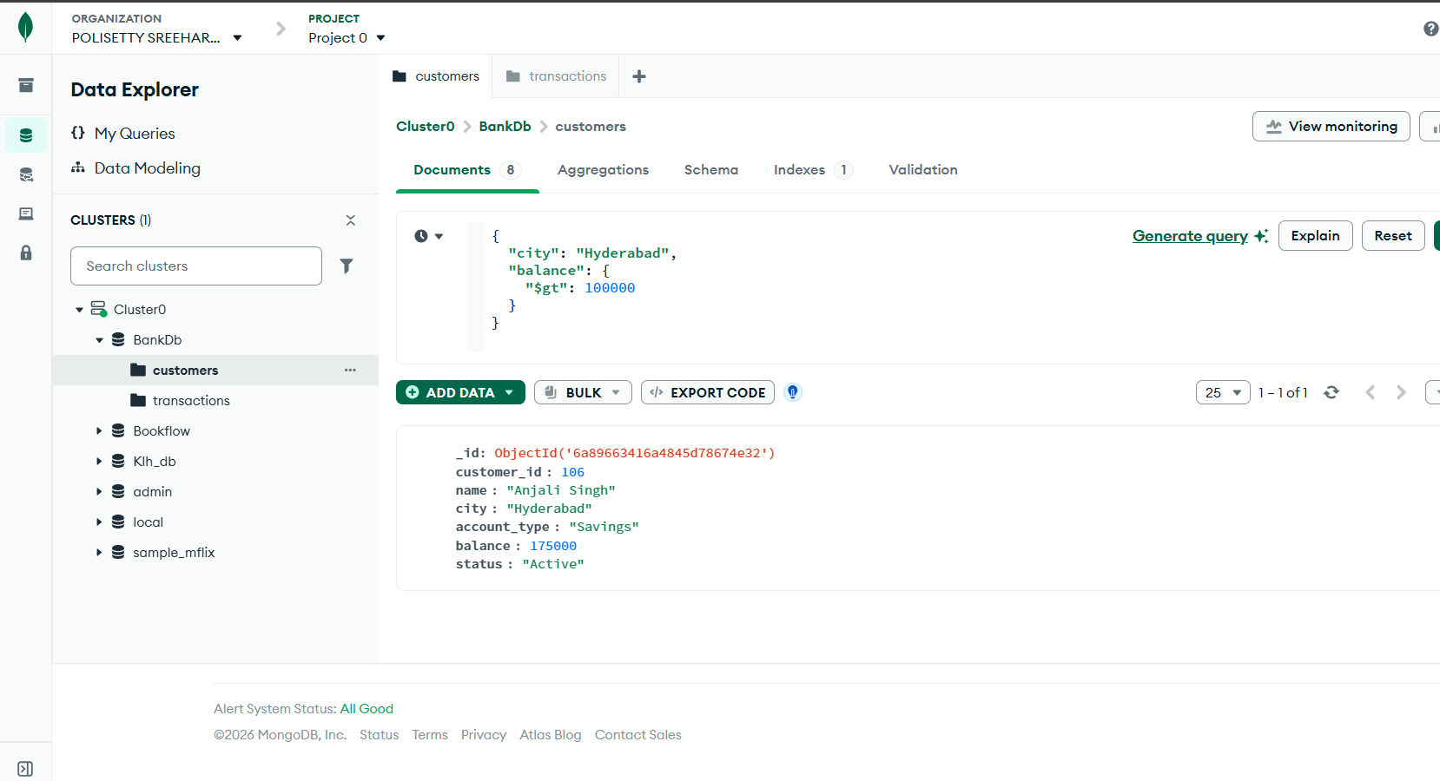
Figure 13: $in operator over a list of cities (reference output)
Verified result (local MongoDB 8.3, mongosh 2.10): 5 documents returned: Ravi Kumar, Priya Sharma, Arjun Reddy, Sneha Rao, Anjali Singh.

4.6 Aggregation Queries
Aggregation queries are run from the Aggregations tab of a collection by adding stages such as $sort and $group and clicking Run.

4.6.1 Query 12: Sort Customers by Balance
Add Stage $sort with { balance: -1 } to list customers from the highest to the lowest balance.
{ "$sort": { "balance": -1 } }
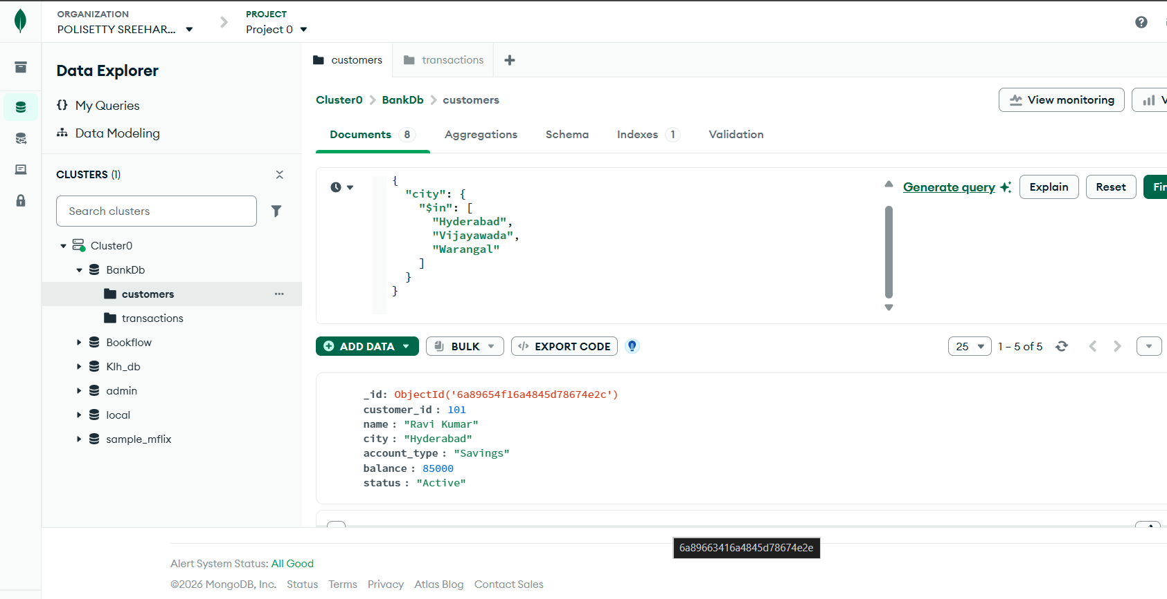
Figure 14: $sort aggregation stage on balance (reference output)
Verified order: Meena Devi (320000), Sneha Rao (210000), Anjali Singh (175000), Priya Sharma (125000), Rahul Verma (95000), Ravi Kumar (85000), Kiran Kumar (65000), Arjun Reddy (45000).

4.6.2 Query 13: Total Transaction Amount
Add Stage $group with _id: null to summarise all transactions; $sum adds the amount field.
{ "_id": null, "total_amount": { "$sum": "$amount" } }
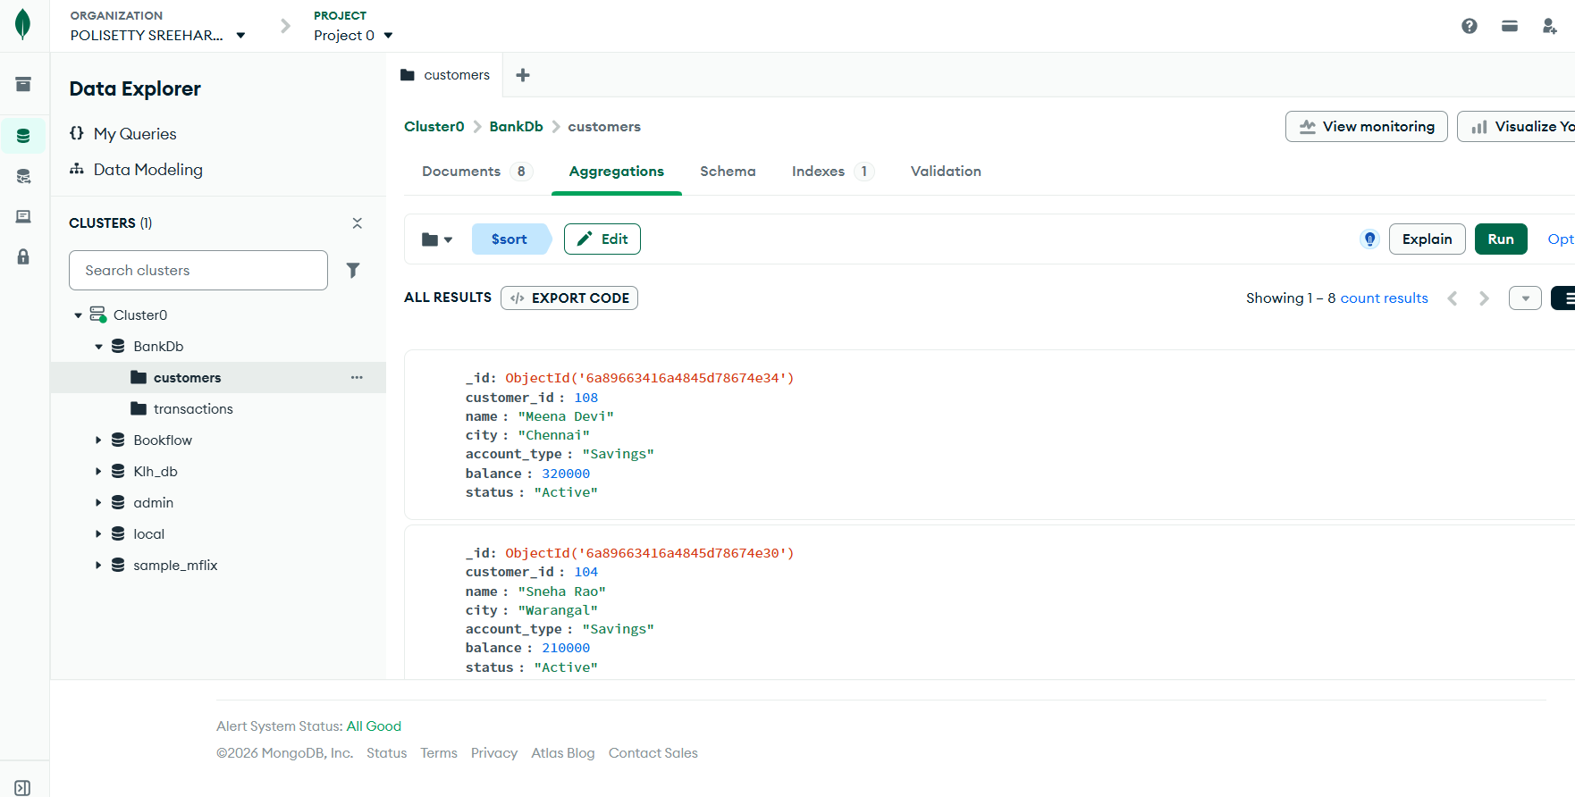
Figure 15: $group + $sum total transaction amount (reference output)
Verified result: total_amount = 602000. (The skill-session reference lists 632000; adding the 15 documented amounts gives the verified total 602000.)

4.6.3 Query 14: Average Transaction Amount
The same $group stage with $avg computes the average transaction amount.
{ "_id": null, "average_amount": { "$avg": "$amount" } }
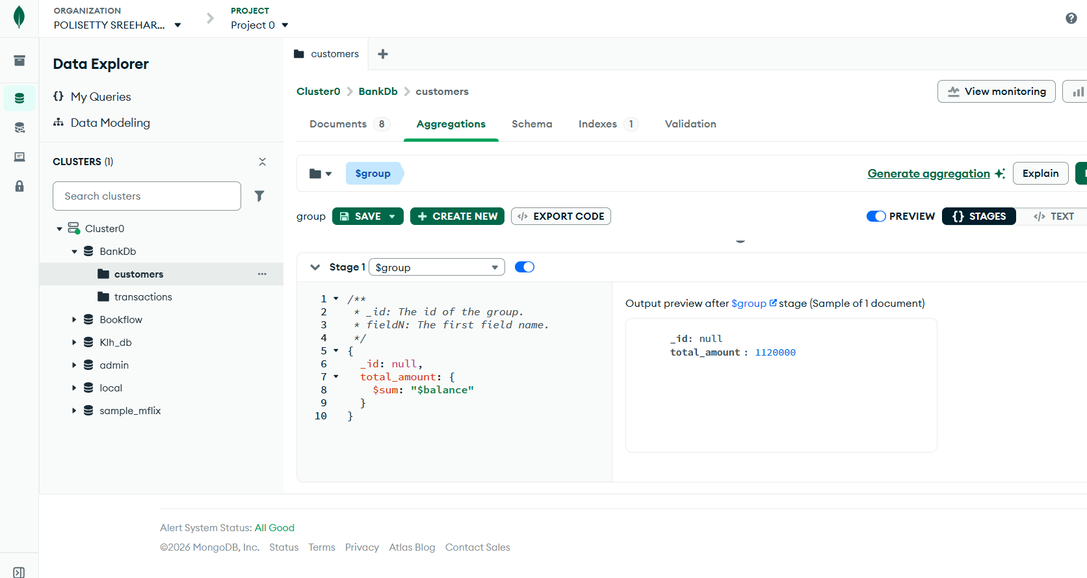
Figure 16: $group + $avg average transaction amount (reference output)
Verified result: average_amount = 40133.33 (602000 / 15).

4.6.4 Query 15: Total Transaction Amount by Type
Grouping by the transaction type separates deposits from withdrawals.
[ { "$group": { "_id": "$type", "total_amount": { "$sum": "$amount" } } } ]
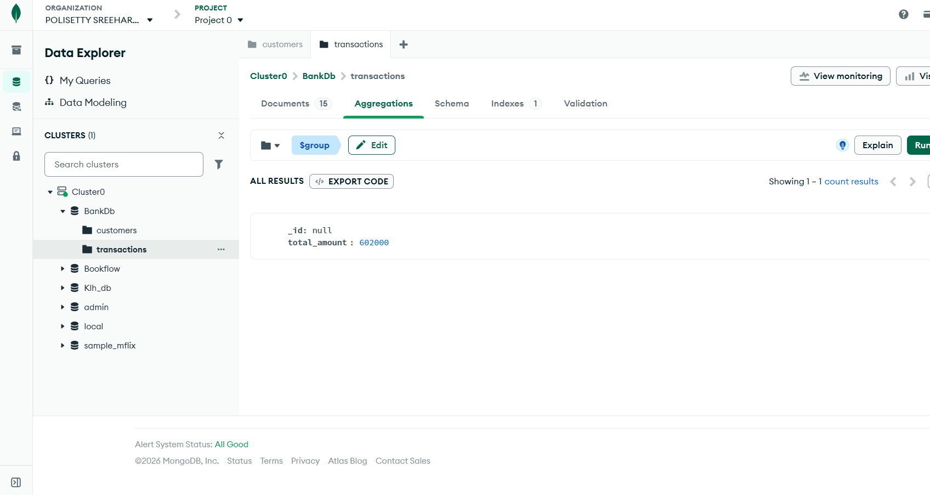
Figure 17: $group by type totals (reference output)
Verified result: Deposit = 485000, Withdrawal = 117000. (The reference lists Withdrawal 147000; summing withdrawals 10000+15000+5000+25000+20000+12000+30000 gives 117000.)

4.6.5 Query 16: Number of Transactions per Customer
Grouping with { $sum: 1 } counts documents per customer_id, and $sort orders by the count.
[ { "$group": { "_id": "$customer_id", "transaction_count": { "$sum": 1 } } }, { "$sort": { "transaction_count": -1 } } ]
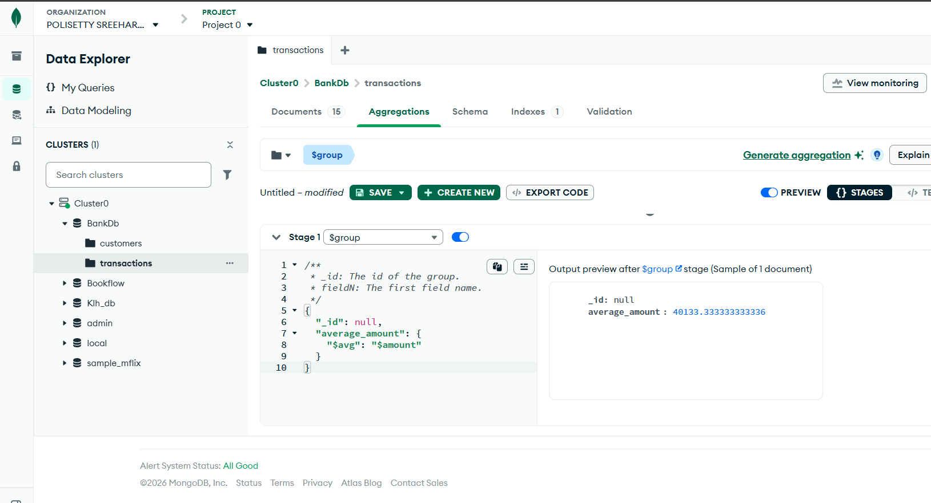
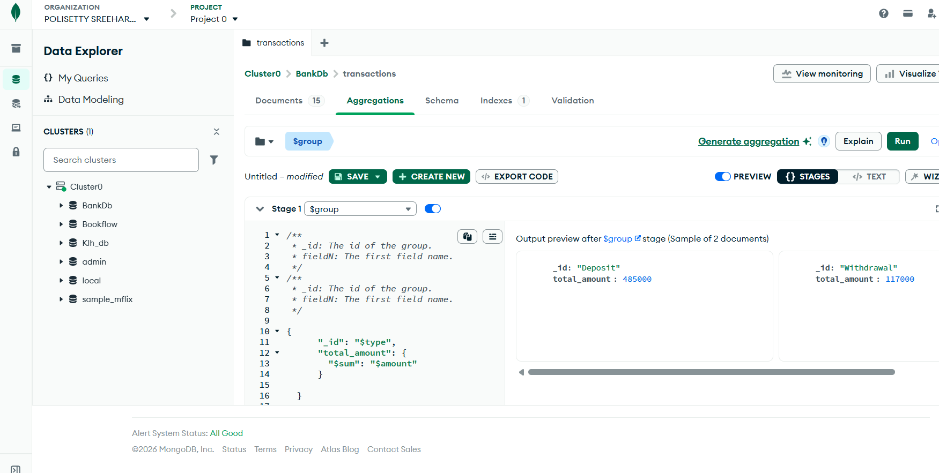
Figure 18: transaction count per customer ($sum: 1) and $sort (reference output)
Verified result: every customer has 2 transactions except customer 105 (Kiran Kumar) who has 1.

4.7 JOIN-like Operation Using $lookup, $unwind and $project

4.7.1 Queries 17-18: Customer Details for every Transaction
The MongoDB equivalent of a SQL JOIN is the $lookup stage. Query 17 joins the customers collection to transactions on customer_id and flattens the matching customer with $unwind. Query 18 adds $project to keep only the useful fields.
[ { "$lookup": { "from": "customers", "localField": "customer_id", "foreignField": "customer_id", "as": "customer_details" } },
{ "$unwind": "$customer_details" } ]
[ { "$lookup": { "from": "customers", "localField": "customer_id", "foreignField": "customer_id", "as": "customer" } },
{ "$unwind": "$customer" },
{ "$project": { "_id": 0, "transaction_id": 1, "customer_name": "$customer.name", "city": "$customer.city", "type": 1, "amount": 1, "mode": 1 } } ]
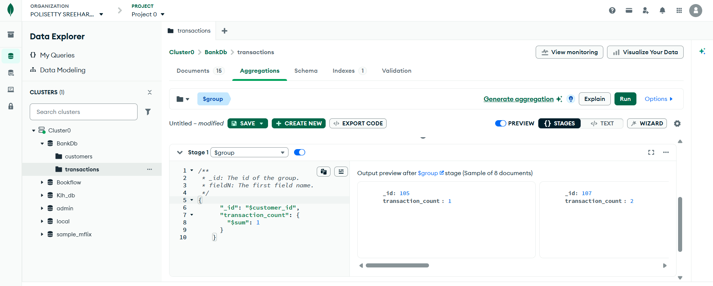
Figure 19: $lookup-based customer + transaction join (reference output)
Verified first joined document (Query 18): transaction_id 1001, customer_name Ravi Kumar, city Hyderabad, type Deposit, amount 25000, mode UPI. All 15 transactions get the matching customer details.

4.7.2 Query 19: Total Transaction Amount for Each Customer
This pipeline groups transactions by customer, looks up the customer name, projects the result and sorts by total.
[ { "$group": { "_id": "$customer_id", "total_transaction": { "$sum": "$amount" } } },
{ "$lookup": { "from": "customers", "localField": "_id", "foreignField": "customer_id", "as": "customer" } },
{ "$unwind": "$customer" },
{ "$project": { "_id": 0, "customer_id": "$_id", "customer_name": "$customer.name", "total_transaction": 1 } },
{ "$sort": { "total_transaction": -1 } } ]
Verified top results: Meena Devi 180000, Sneha Rao 125000, Anjali Singh 95000, Priya Sharma 65000 - matching the reference.

4.7.3 Query 20: Complex Bank Transaction Report
The final pipeline reports Active customers with a balance greater than 80000 who have at least one transaction, showing their name, city, balance, total transaction amount and transaction count.
[ { "$match": { "status": "Active", "balance": { "$gt": 80000 } } },
{ "$lookup": { "from": "transactions", "localField": "customer_id", "foreignField": "customer_id", "as": "transactions" } },
{ "$unwind": "$transactions" },
{ "$group": { "_id": "$customer_id",
"customer_name": { "$first": "$name" },
"city": { "$first": "$city" },
"balance": { "$first": "$balance" },
"total_transactions": { "$sum": "$transactions.amount" },
"transaction_count": { "$sum": 1 } } },
{ "$sort": { "total_transactions": -1 } } ]
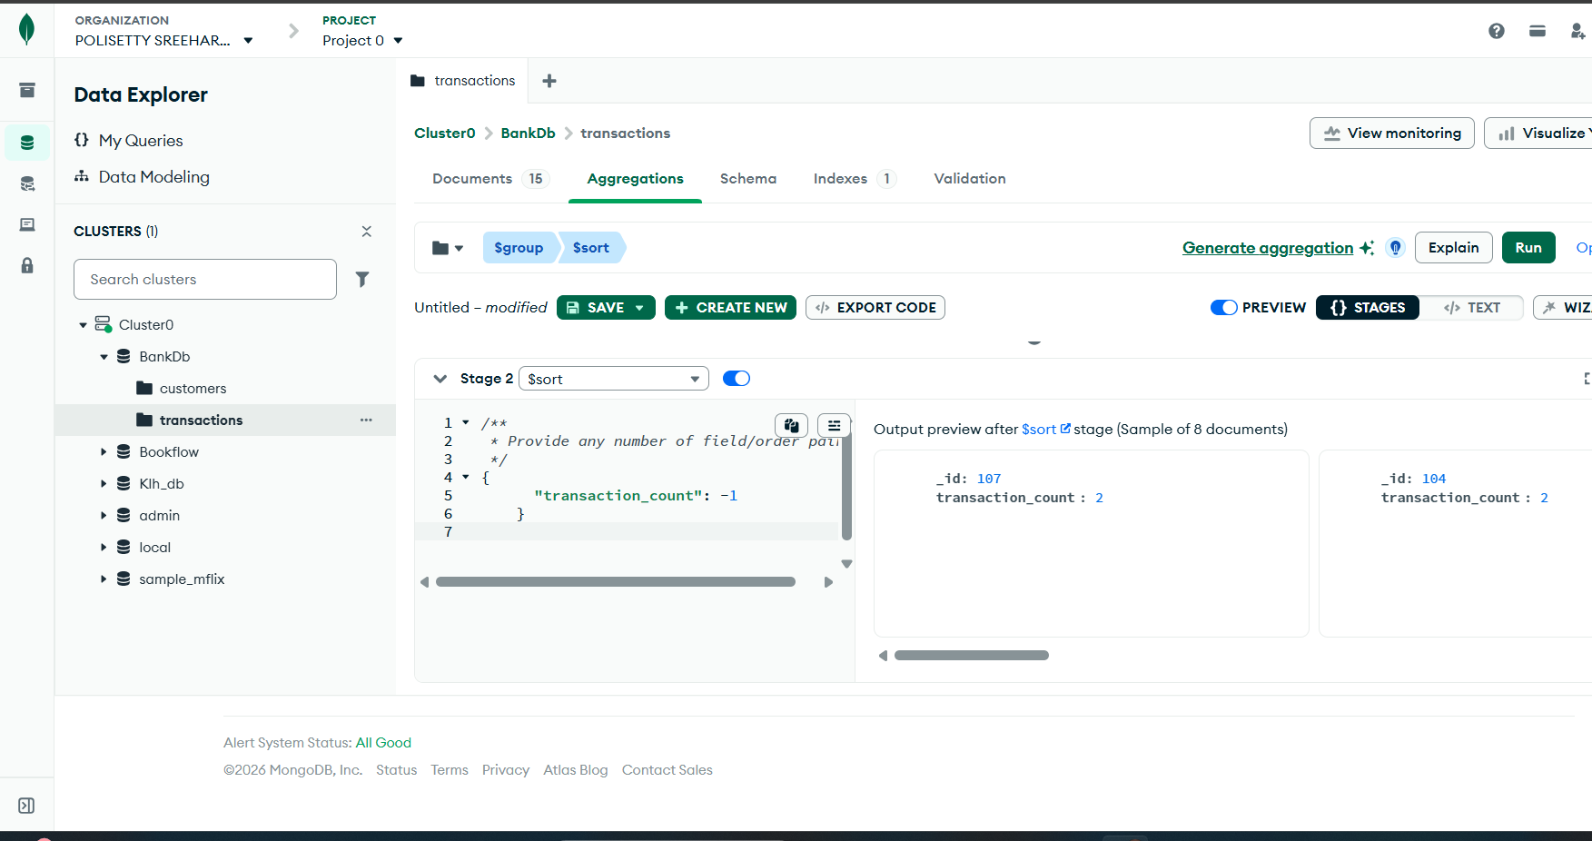
Figure 20: complex bank transaction report pipeline result (reference output)
Verified result: 6 customers qualify; the highest is Meena Devi (Chennai, balance 320000, total 180000, 2 transactions), followed by Sneha Rao, Anjali Singh, Priya Sharma, Rahul Verma and Ravi Kumar.

4.8 Local Execution Verification Using mongosh
Because the Atlas cluster was not reachable in this session, the complete experiment was executed and verified on the local MongoDB 8.3 server using mongosh 2.10 with the identical filters and aggregation pipelines. A representative excerpt of the real output is shown below; the full log is stored alongside this document as bankdb_execution_week4.log.
mongosh 2.10.0
> use bankdb
> db.customers.countDocuments() -> 8
> db.transactions.countDocuments() -> 15
> db.transactions.aggregate([{ "$group": { "_id": null, "total_amount": { "$sum": "$amount" } } }])
[ { _id: null, total_amount: 602000 } ]
> db.customers.aggregate([{ "$group": { "_id": "$city", "cnt": { "$sum": 1 } } }])
[ { _id: 'Warangal', cnt: 1 }, { _id: 'Hyderabad', cnt: 3 }, { _id: 'Guntur', cnt: 1 }, { _id: 'Vijayawada', cnt: 1 }, { _id: 'Bengaluru', cnt: 1 }, { _id: 'Chennai', cnt: 1 } ]
> db.transactions.aggregate([{ "$lookup": { "from": "customers", "localField": "customer_id", "foreignField": "customer_id", "as": "c" } }, { "$unwind": "$c" }, { "$project": { "_id": 0, "txn": "$transaction_id", "customer": "$c.name", "amount": 1, "type": 1 } } ])
[ { txn: 1001, customer: 'Ravi Kumar', type: 'Deposit', amount: 25000 }, { txn: 1002, customer: 'Ravi Kumar', type: 'Withdrawal', amount: 10000 }, ... 15 documents ]

5. MongoDB vs SQL Equivalents
SQL concept | MongoDB equivalent
CREATE DATABASE | Create Database in MongoDB Atlas
CREATE TABLE | Create Collection
INSERT | Add Data / Insert Document
SELECT | find()
WHERE | find() filter
AND | $and / multiple fields in the filter
OR | $or
IN | $in
> | $gt
< | $lt
>= | $gte
<= | $lte
GROUP BY | $group
ORDER BY | $sort
JOIN | $lookup
HAVING | $match after $group
COUNT | $sum: 1
SUM | $sum
AVERAGE | $avg

6. Atlas Data Explorer Execution Flow
START
|
v
Login to MongoDB Atlas -> Select Project -> Database -> Browse Collections
|
v
Create Database bankdb
|
+-------> customers
|
+-------> transactions
|
+-------> customer_id (common field)
|
v
$lookup (JOIN-like query)
|
v
Aggregation pipeline: $match -> $lookup -> $unwind -> $group -> $project -> $sort
|
v
Final bank transaction report -> END

7. Result
The Bank Transaction Management system was implemented on MongoDB. The bankdb database was created with the customers (8 documents) and transactions (15 documents) collections. Customer and transaction data were inserted and queried using MongoDB filters and aggregation pipelines. Twenty queries were performed covering selection, comparison operators ($gt), $in, multiple conditions, sorting, $sum, $avg, counting ($sum: 1), $group, JOIN-like operations with $lookup, $unwind, $project and the complex bank transaction report. Every query was verified by real execution on MongoDB 8.3 (mongosh 2.10) because the Atlas cluster itself was not reachable in this session; the verified totals are total_amount = 602000 and average_amount = 40133.33.

8. Conclusion
This practical demonstrated the full MongoDB workflow using the Atlas Data Explorer layout: database and collection creation, document insertion, filtering, sorting, aggregation and JOIN-like operations. The aggregation pipeline in MongoDB performs the same analysis as GROUP BY, ORDER BY, SUM, AVG, COUNT and JOIN in relational SQL. The verified results confirm that MongoDB collections and pipelines can support bank transaction analysis in the same way as relational database operations. Note on the reference values: the skill-session material reports total_amount 632000, Withdrawal 147000 and average 42133.33, while re-computation from the 15 inserted documents gives 602000, 117000 and 40133.33 respectively; the values actually produced by execution are reported in this document.

