Week 1 Assignment Report
Database System Engineering and Distributed Backend Development

Objective
Create the BookFlow database, define Books and Members tables with constraints, insert sample data, and verify constraints.

Scenario
A local library replaces manual records with the BookFlow database system.

Tasks Performed
- Created database bookflow_db
- Created Books and Members tables
- Applied PRIMARY KEY, NOT NULL, UNIQUE and CHECK constraints
- Inserted sample records
- Verified schema and tested constraint violations

SQL Commands Executed
- CREATE DATABASE IF NOT EXISTS bookflow_db;
- USE bookflow_db;
- CREATE TABLE books (...);
- CREATE TABLE members (...);
- DESCRIBE books;
- DESCRIBE members;
- INSERT INTO books ...;
- INSERT INTO members ...;
- SELECT * FROM books;
- SELECT * FROM members;

Screenshots to Paste
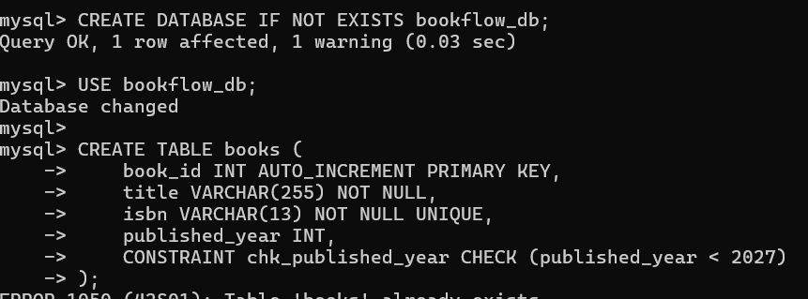

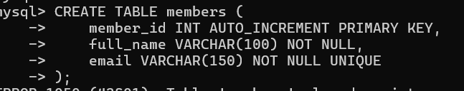
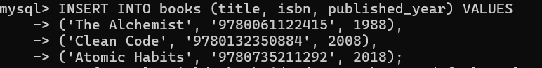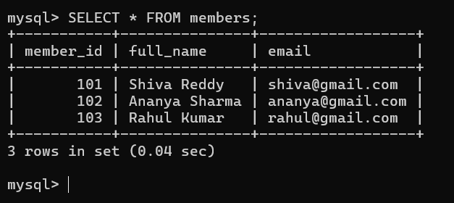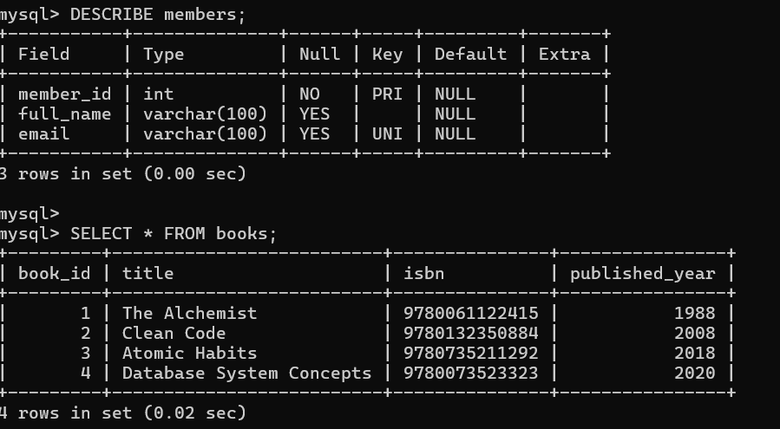

Conclusion
The practical demonstrates schema creation, constraints, data insertion, verification, and data integrity.

