KL UNIVERSITY
Koneru Lakshmaiah Education Foundation (Deemed to be University), Green Fields, Vaddeswaram
Database Systems Engineering & Distributed Backend Development
LABORATORY PRACTICAL - WEEK 9
Student Records CRUD API and Student Management Web Application
React.js + Axios + Express.js + Node.js + Mongoose + MongoDB
Submitted to the Department in partial fulfilment of the Database Systems Engineering & Distributed Backend Development coursework.
Field | Details
Student Name | KARKALA SHIVA REDDY
Roll Number | 2520030105
University | KL UNIVERSITY
Course | Database Systems Engineering & Distributed Backend Development
Laboratory | Database Systems (DB-DS) - Practical
Practical | Week-9 (Lab DB-DS)
Date of Experiment | 24 September 2026

1. Objective
The aim of this Week-9 laboratory practical is to implement and verify a Student Management Web Application and Student Records CRUD API using the MERN-style architecture described in the source material. The React frontend communicates with an Express REST API through Axios, while Mongoose persists validated student records in MongoDB. The specific objectives are:
- Define a Mongoose Student model with name, age, course and email fields.
- Enforce required fields, age limits, unique email values and timestamps.
- Implement createStudent, getAllStudents, getStudentById, updateStudent and deleteStudent controller operations.
- Map the documented REST endpoints to Express routes.
- Build a React form and table for adding, viewing, updating and deleting students.
- Connect the React application to the Express API using Axios HTTP requests.
- Execute CRUD and validation requests against the student_records database and record the observed responses.
- Capture live application, API and MongoDB evidence in this practical report.

2. System and Software Environment
The practical was executed on the student's Windows machine using VS Code, Windows PowerShell, Node.js, MongoDB Community Server, MongoDB Shell, React/Vite and a browser. The versions and services verified during execution are listed below.
Item | Details
Operating System | Microsoft Windows 11 Home Single Language (64-bit), Version 10.0.26200 (Build 26200)
Computer | HP Laptop 15-fd0xxx, 16 GB RAM
Shell | Windows PowerShell
Node.js / npm | v24.19.0 / 11.17.0
MongoDB Server | MongoDB 8.3.8 Community Server - Windows service: MongoDB (Running)
MongoDB Shell | mongosh 2.10.0
Frontend | React 18.3.1, Vite 6.4.3, Axios 1.7.9
API testing | Node.js fetch and Windows PowerShell Invoke-WebRequest
Git | git version 2.53.0.windows.1

Note: the MongoDB connection string is supplied through the MONGO_URI environment variable. The local verification used mongodb://127.0.0.1:27017/student_records; no credentials or .env file are included in the repository.

3. Practical Scenario: Student Records CRUD System
The source material describes a Student Management Web Application with a React form and table, Axios communication, an Express.js REST API and MongoDB. The detailed guide expands this into a Student Records CRUD API organized into routes, controllers, a Mongoose model and MongoDB. The Week-9 implementation follows that terminology and uses the database name student_records with the students collection.
The application supports adding a student, viewing students, updating a student and deleting a student. The REST layer is the single communication path between the browser and the database, so the table is populated from MongoDB rather than from frontend mock data.

3.1 Architecture
React Frontend (Vite)
|
| Axios HTTP requests
v
Express.js REST API (Node.js)
|
v
Routes -> Controller -> Mongoose -> MongoDB
Client / Postman / Browser -> Express Server -> Routes -> Controller -> Mongoose -> MongoDB

3.2 Project Structure
Project/Week-9-Student-Management/
├── backend/
│ ├── controllers/
│ │ └── studentController.js
│ ├── models/
│ │ └── Student.js
│ ├── routes/
│ │ └── studentRoutes.js
│ ├── .env.example
│ ├── package.json
│ ├── package-lock.json
│ └── server.js
└── frontend/
├── src/
│ ├── App.css
│ ├── App.jsx
│ └── main.jsx
├── index.html
├── package.json
├── package-lock.json
└── vite.config.js

4. Step-by-Step Practical Execution

4.1 Setting Up the Backend
The backend was created in the existing Project area under a dedicated Week-9 folder. The detailed source structure was retained: server.js loads the routes, the controller contains the CRUD functions, and the model defines the Student collection.
cd Project\Week-9-Student-Management\backend
npm install
copy .env.example .env
npm run dev
The local .env value used for execution was MONGO_URI=mongodb://127.0.0.1:27017/student_records. The server connects to MongoDB, initializes the model indexes and then listens on port 3000.

4.2 Student Model and Validation
import mongoose from 'mongoose';
const studentSchema = new mongoose.Schema({
name: { type: String, required: true, trim: true },
age: { type: Number, required: true, min: 16, max: 100 },
course: { type: String, required: true, trim: true },
email: { type: String, required: true, unique: true, trim: true, lowercase: true }
}, { timestamps: true });
const Student = mongoose.model('Student', studentSchema);
export default Student;
Field | Mongoose rule | Purpose
name | String, required, trim | A student name must be supplied.
age | Number, required, min 16, max 100 | Age is validated against the source limits.
course | String, required, trim | A course must be supplied.
email | String, required, unique, lowercase | Email is mandatory and cannot be duplicated.
timestamps | createdAt and updatedAt enabled | Record creation and update times are stored.

4.3 Controller and Routes
The controller uses Student.create, Student.find, Student.findById, Student.findByIdAndUpdate and Student.findByIdAndDelete. ValidationError and CastError are returned as 400 responses; a duplicate email key is returned as 409; a valid but unknown ObjectId is returned as 404.
router.post('/', createStudent);
router.get('/', getAllStudents);
router.get('/:id', getStudentById);
router.patch('/:id', updateStudent);
router.delete('/:id', deleteStudent);
const student = await Student.create(req.body);
res.status(201).json({
message: 'Student created successfully',
student
});
The Express entry point enables JSON parsing, CORS for the Vite frontend, the root response and the /students router. MongoDB is connected before the server starts listening.

4.4 Frontend and Axios Communication
The React frontend uses a controlled form for name, email, course and age. On startup it calls GET /students. The Add student button sends POST /students, Edit sends PATCH /students/:id, and Delete sends DELETE /students/:id. The table is refreshed from the API after each mutation.
const apiBase = import.meta.env.VITE_API_URL || 'http://localhost:3000';
const response = await axios.get(`${apiBase}/students`);
setStudents(response.data);
await axios.post(`${apiBase}/students`, payload);
await axios.patch(`${apiBase}/students/${editingId}`, payload);
await axios.delete(`${apiBase}/students/${student._id}`);
The interface visibly displays the Express API endpoint in the page header, making the React -> Axios -> Express -> MongoDB request path clear without adding unrelated product features.

4.5 CRUD API Procedure
Operation | Method | Endpoint | Purpose
Create | POST | /students | Add a student
Read all | GET | /students | Get all students
Read one | GET | /students/:id | Get one student
Update | PATCH | /students/:id | Update supplied fields
Delete | DELETE | /students/:id | Delete a student

POST /students
{"name":"Anita","age":20,"course":"CSE","email":"anita@example.com"}
PATCH /students/:id
{"age":21,"course":"AI & DS"}

4.6 Validation and Constraint Testing
The following requests were sent to the running API. The status codes are the actual observed responses from the implementation, not expected values copied from the guide.
Test case | Observed status | Observed response summary
Missing required email | 400 | Student validation failed: email is required.
Invalid age (12) | 400 | Age is less than minimum allowed value (16).
Duplicate email | 409 | E11000 duplicate key error on email_1.
Malformed ID | 400 | Invalid student ID / Cast to ObjectId failed.
Valid but unknown ID | 404 | Student not found.

4.7 CRUD Execution Results
Test | Method and endpoint | Observed status | Verification
Root | GET / | 200 | Student Records API is running
Create | POST /students | 201 | Student created successfully
Read all | GET /students | 200 | Created student appeared in the array
Read one | GET /students/:id | 200 | Returned the real MongoDB _id
Update | PATCH /students/:id | 200 | Age became 21 and course became AI & DS
Delete | DELETE /students/:id | 200 | Student deleted successfully
Verify delete | GET /students | 200 | Deleted student was absent

4.8 Live Output and Screenshots
The following figures are real captures from the running Week-9 implementation. The images are embedded in this DOCX; no external evidence directory is required.
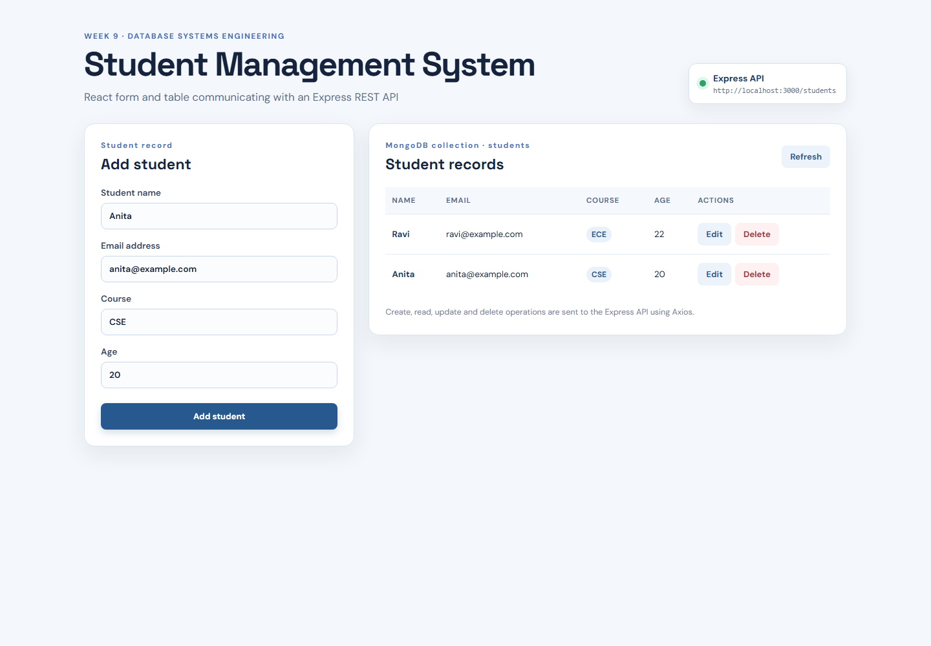
Figure 1: React Student Management form communicating with the Express API

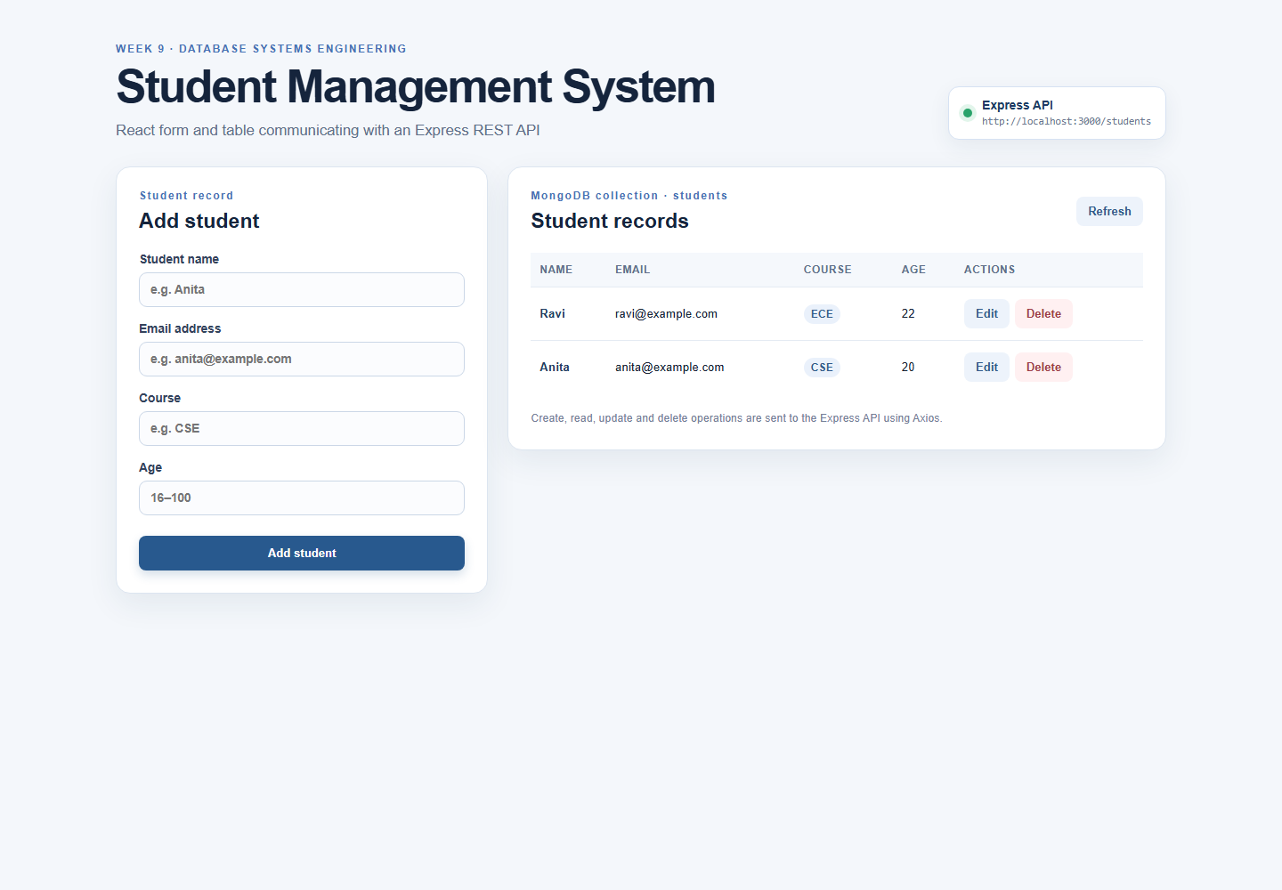
Figure 2: Student records retrieved from MongoDB through the React and Axios frontend

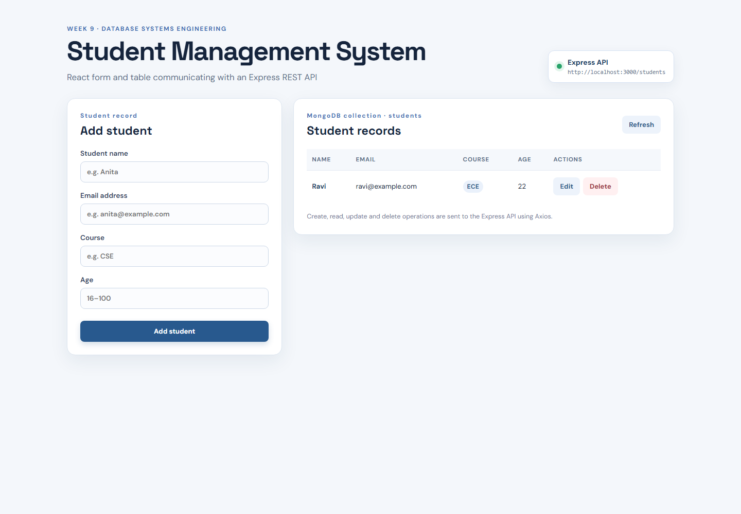
Figure 3: Student created through the React form and POST request

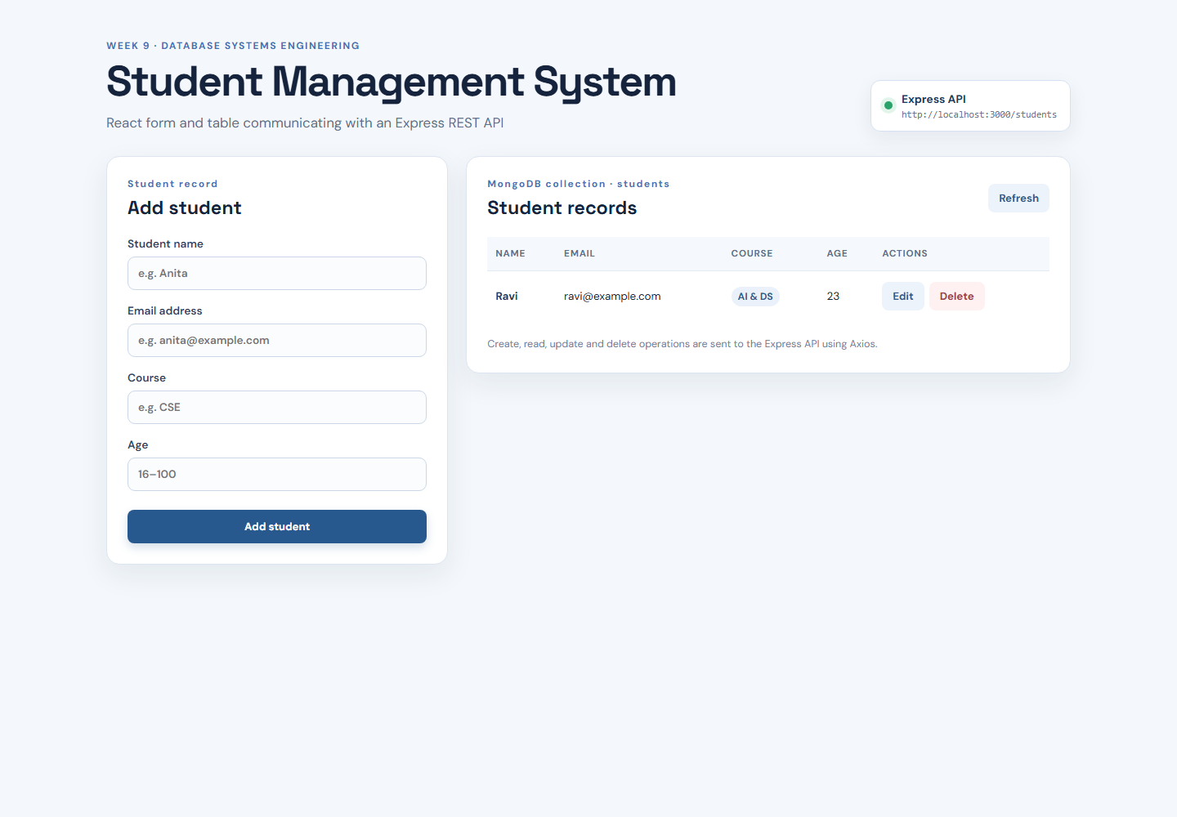
Figure 4: Student record updated through the React edit form and PATCH request

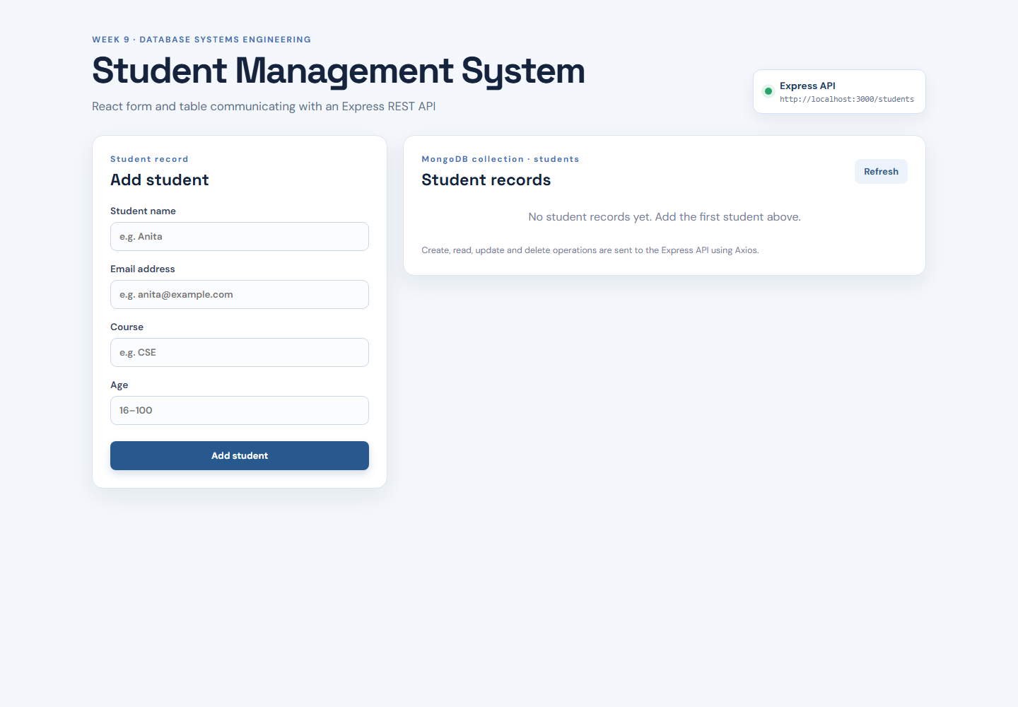
Figure 5: Student deleted and the React table refreshed from the API

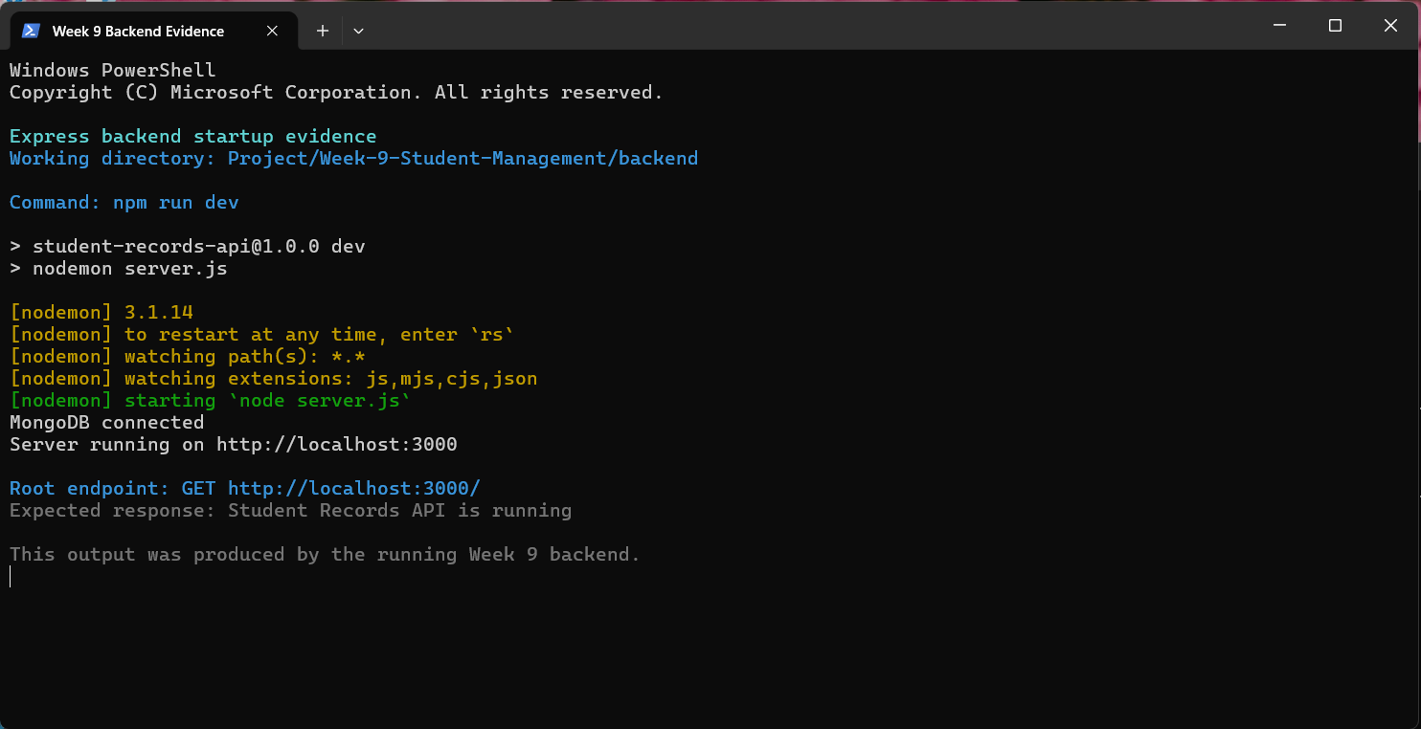
Figure 6: Express server running successfully with MongoDB connected

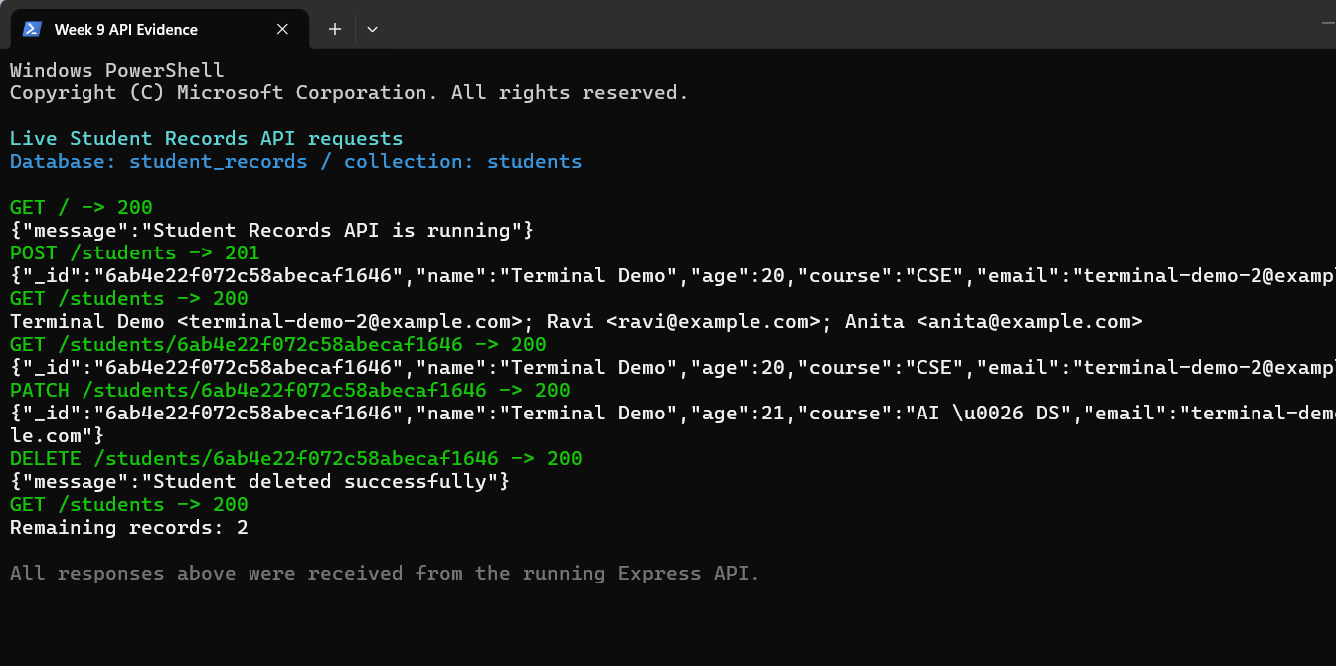
Figure 7: Live CRUD API requests and observed HTTP responses

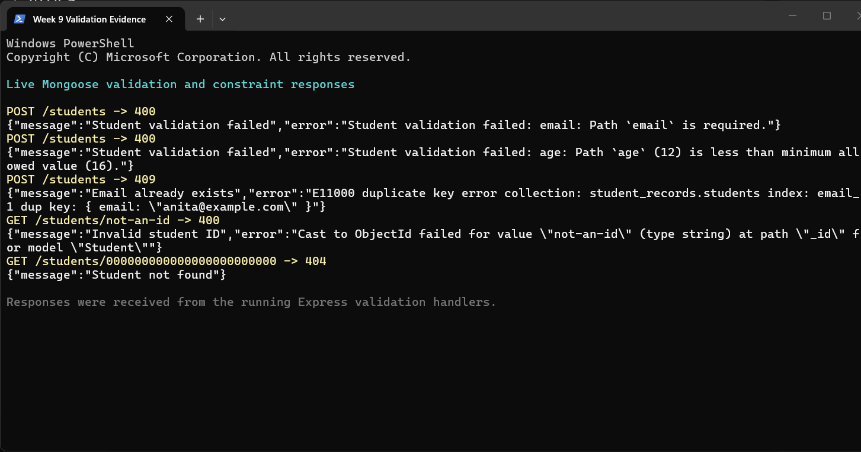
Figure 8: Mongoose validation and constraint responses

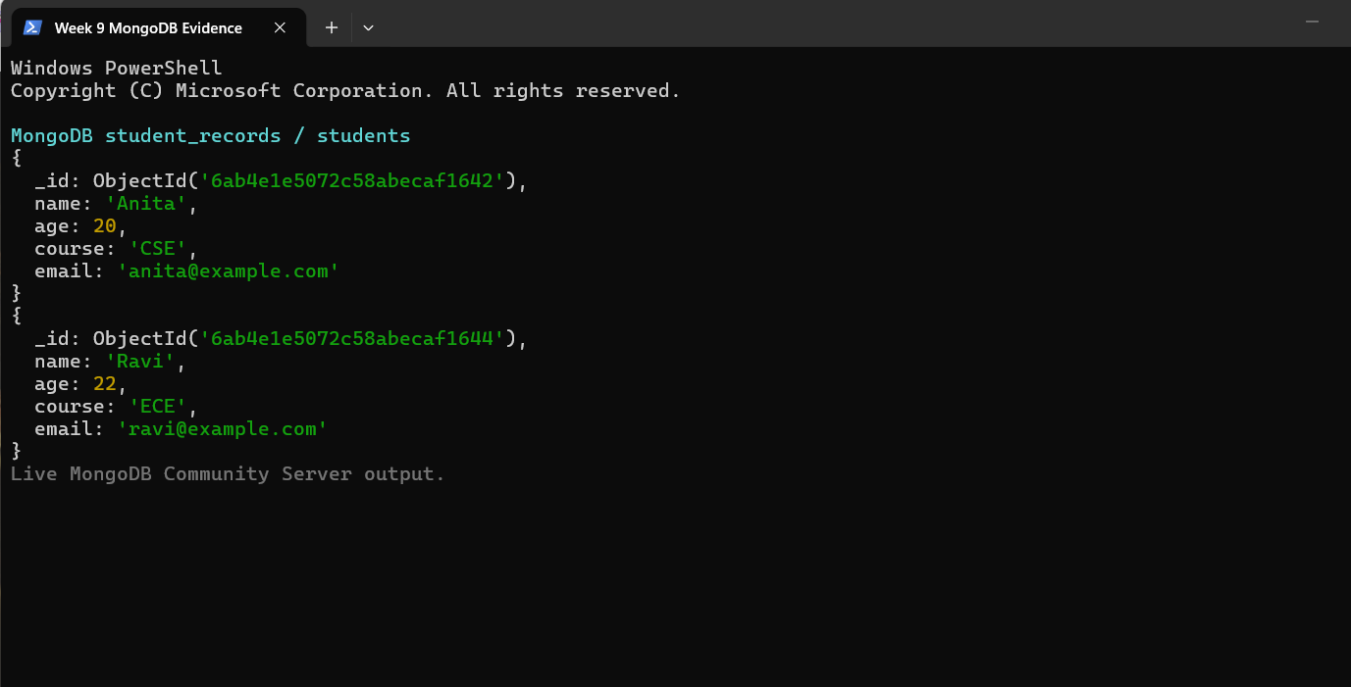
Figure 9: student_records.students documents stored in MongoDB

5. Result
The Week-9 practical was completed successfully. The React/Vite frontend loaded on the Vite development server and communicated with the Express API on port 3000. The API connected to the local MongoDB Community Server, created the students collection and enforced the model rules. Real requests verified all five CRUD endpoints, the root endpoint and the required validation cases. The final database query showed the Anita and Ravi student documents, and the final frontend table displayed the same API-backed records.

6. Conclusion
This practical established the complete Student Management / Student Records workflow described by the source material: React and Axios provide the browser client, Express and Node.js provide the REST API, routes delegate to controller functions, and Mongoose maps the Student model to the MongoDB students collection. The implementation demonstrates practical CRUD communication, server-side validation, unique email enforcement, database persistence and evidence-based verification. The Week-9 source and report therefore remain aligned while providing a functional academic application rather than a documentation-only example.

