Source Before & After Document
Project Details
Doc Name | APS Production Deployment - Source Code Before & After
Project No. | TBD - Deployment Bundle
Project Name | APS Production Deployment - 23 July 2026
Document Signed Off By
Name  First name & Surname & Title | Signature | Date
Document Control
Version  Number | Issued On  Date | Author(s)  First name & Surname & Title | Reviewer(s)  First name & Surname & Title | Change Description
1.0 | 2026/07/22 | I Nyoman Krisna Arkandea  .NET Developer |  | Source Code Before & After

TABLE OF CONTENTS
1. | REQUIREMENTS REFERENCE | 3
2. | BACKGROUND, PURPOSE & BUSINESS VALUE | 3
2.1 | Background | 3
2.2 | Purpose | 3
2.3 | Business Value | 3
3. | SOLUTION & OVERVIEW | 4
3.1 | Changed Conditions | 4
3.1.1 | API - Report Procurement WIP / Report PO | 4
3.1.2 | WEB - PRF Vendor Enhancement | 6
3.1.3 | WEB - HttpClient Timeout | 7
3.2 | Validation & Deployment Notes | 8

1. REQUIREMENTS REFERENCE
Doc Name and Version | Description | Location
APS REST API release | Report Procurement WIP / Report PO query alignment, join scope, date filtering, and deterministic ordering. | APS-REST-API/Queries/Report/ReportPurchaseOrder.cs
APS WebApp release | Display PRF Vendor Enhancement independently from DD Request while preserving Next navigation priority. | APS-WEB-APP/Views/.../QuotationStep1.cshtml
APS WebApp release | Increase GET and POST HttpClient timeout for large Report PO requests. | APS-WEB-APP/Helper/HttpClientHelper.cs
2. BACKGROUND, PURPOSE & BUSINESS VALUE
2.1 Background
The production deployment bundle contains REST API and WebApp corrections identified during Report Procurement WIP testing and PRF Vendor Enhancement validation. The final REST API query is aligned with the QA-passed develop version so UI and export return a consistent result set. The WebApp changes address a hidden PRF Vendor Enhancement tab and report requests that can exceed the default HttpClient timeout.
2.2 Purpose
To deploy a production package that preserves report records without a matched order, produces stable pagination and export ordering, displays all required procurement tabs, and supports large report processing without premature client timeout.
2.3 Business Value
- Improve accuracy and consistency between Report PO UI data and exported data.
- Prevent eligible PRF Vendor Enhancement processing from being hidden when DD Request is also required.
- Reduce operational retries and user disruption when generating large procurement reports.
- Provide a release package that has been validated on local and DEV/UAT according to the deployment flow.

3. SOLUTION & OVERVIEW
The detailed source changes are shown below. Red panels represent the previous behavior and green panels represent the release behavior.
3.1 Changed Conditions
3.1.1 API - Report Procurement WIP / Report PO
File: APS-REST-API/Queries/Report/ReportPurchaseOrder.cs
The query scope is aligned with the QA-passed develop version. Date predicates are consistently applied while the count and rendered result keep PR rows that do not yet have a matching order record.
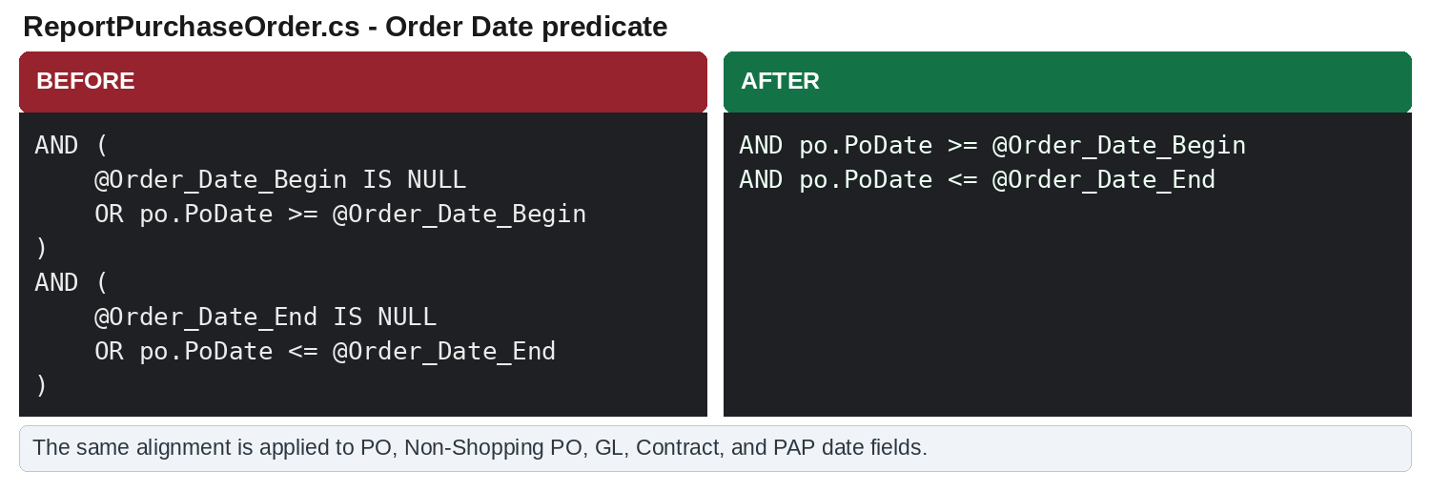
Figure 1. Order Date predicate alignment across type-process query branches.

3.1.1.1 API - Count, Result Scope, and Ordering
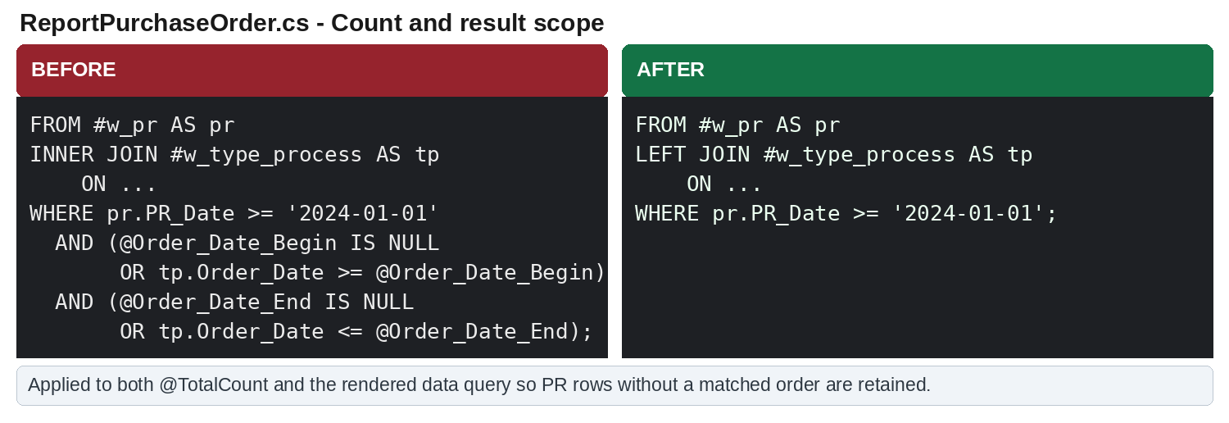
Figure 2. INNER JOIN and additional result-level Order Date filters changed to the QA-aligned scope.
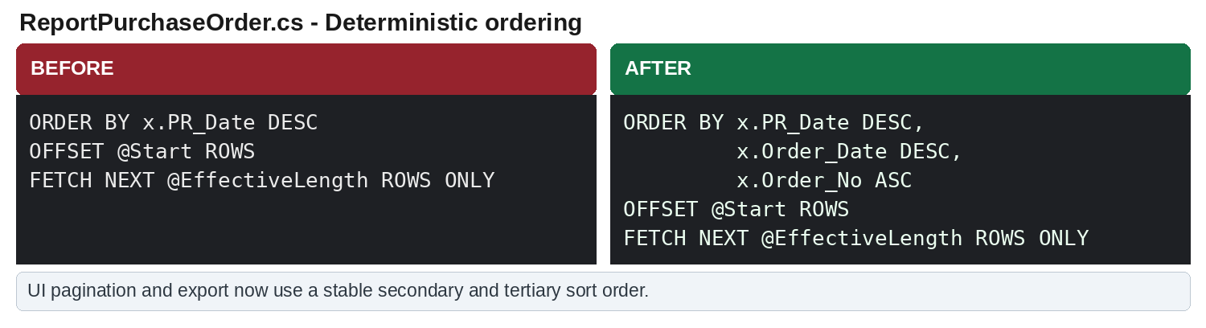
Figure 3. Stable ordering added for UI pagination and export consistency.

3.1.2 WEB - PRF Vendor Enhancement
File: APS-WEB-APP/Views/NonShoppingCart/ProcurmentBuyer/QuotationVendor/QuotationStep1.cshtml
Previously, DD Request and PRF Vendor Enhancement were evaluated through an if / else-if chain. When both conditions were true, only DD Request was displayed. The revised logic calculates both requirements independently and toggles both tabs. Navigation still prioritizes DD Request.
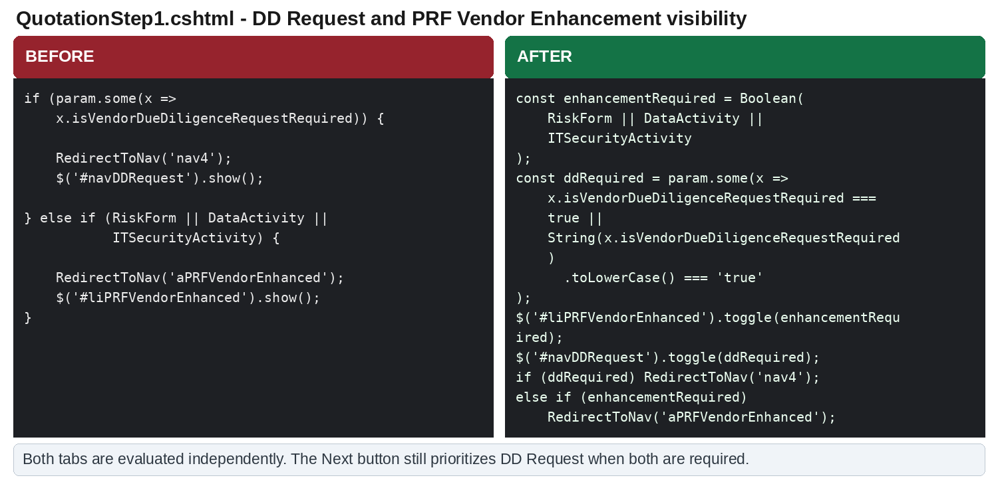
Figure 4. Independent visibility logic for DD Request and PRF Vendor Enhancement, applied in both page flows.
Condition | Tab Visibility | Next Action
DD required + Enhancement required | Both tabs visible | DD Request
DD required only | DD Request visible | DD Request
Enhancement required only | PRF Vendor Enhancement visible | PRF Vendor Enhancement

3.1.3 WEB - HttpClient Timeout
File: APS-WEB-APP/Helper/HttpClientHelper.cs
The default HttpClient timeout can expire before a large Report PO request finishes. The GET and POST helper clients now use a 10-minute timeout so long-running report and export calls can complete.
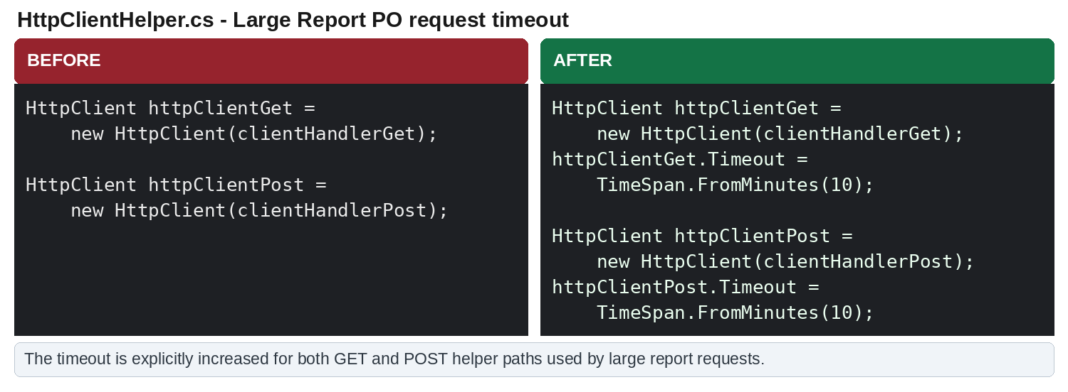
Figure 5. Explicit 10-minute timeout for GET and POST helper clients.
Scope note:
- Only timeout configuration is added; authentication headers and request handling remain unchanged.
- The change is included in the APS WebApp production release branch.

3.2 VALIDATION & DEPLOYMENT NOTES
Validation completed
- Report PO UI result count and export result count are consistent in local testing.
- Large Report PO request completed with the 10-minute HttpClient timeout.
- PRF Vendor Enhancement is displayed together with DD Request when both conditions are true.
- PRF Vendor Enhancement was verified on DEV/UAT after deploying the WebApp DLL built from develop.
Deployment source
- DEV/UAT WebApp build: origin/develop, to avoid overwriting changes from other developers.
- Production REST API build: release/aps-restapi-20260722.
- Production WebApp build: release/aps-webapp-20260722.
- Production DLLs must be rebuilt from release branches on 23 July 2026 before deployment.
- Existing production DLLs must be backed up before replacement.
Open pre-deployment item
- SonarQube currently shows only the main branch. Release-branch Quality Gate confirmation remains pending with DevOps/Cepy and must not be recorded as Passed until confirmed.
Out of scope
- ProcSum Committee Approval change is excluded from this production deployment.

