Contents
CHAPTER 1: INTRODUCTION 1
1.1 Background of the Study 1
1.2 Problem Statement 1
1.3 Objectives of the Project 2
1.4 Scope of the Project 2
1.5 Limitations of the Project 3
CHAPTER 2: LITERATURE REVIEW 4
2.1 Introduction 4
2.2 Studies on Student Information Management Systems 4
2.3 Research on Result Management Systems 4
2.4 Web-Based Academic Systems in Higher Education 4
2.5 Security and Role-Based Access Control 5
2.6 Research Gap 5
2.7 Summary of Literature Review 5
CHAPTER 3: SYSTEM ANALYSIS AND DESIGN 6
3.1 System Analysis 6
3.2 SYSTEM DESIGN 8
3.2.1 Level 0 DFD 8
3.2.2 Database Design 9
3.2.3 Flow chart 10
CHAPTER 5: IMPLEMENTATION 11
5.1 Tools and Technologies Used 11
5.2 Module-wise Implementation 11
5.2.1 Authentication Module 11
5.2.2 Admin Module 12
5.2.3 Teacher Module 12
5.2.4 Student Module 12
5.3 Logic Implementation 13
5.3.1 Attendance Calculation 13
5.3.2 GPA Calculation 13
5.4 Security Implementation 13
CHAPTER 6: CONCLUSION AND FUTURE ENHANCEMENTS 14
7.1 Conclusion 14
7.2 Future Enhancements 14
8. REFERENCES 15

CHAPTER 1: INTRODUCTION

1.1 Background of the Study
In recent years, the rapid advancement of information technology has significantly transformed the education sector. Educational institutions are increasingly required to manage large volumes of student-related data, including personal information, academic records, attendance details, and examination results. Managing such data using traditional manual methods has become inefficient, time-consuming, and prone to human error.
In many colleges affiliated with Tribhuvan University (TU), student information is still maintained through physical registers, paper-based files, or disconnected spreadsheet systems. These methods often result in data redundancy, inconsistency, and difficulty in accessing historical records. As the number of students and academic activities increases, the limitations of manual systems become more evident, highlighting the need for a centralized and automated solution.
A web-based Student Information and Result Management System provides a modern approach to handling academic data by utilizing internet-based technologies. Such systems enable real-time data access, improve accuracy, and ensure better communication among administrators, teachers, and students. By digitizing academic processes, institutions can enhance transparency, efficiency, and overall academic management.
This project, titled “Web-Based Student Information and Result Management System,” is developed to address these challenges by providing a centralized platform for managing student records, attendance, and academic results. The system leverages modern web technologies such as React.js for the user interface and Supabase (PostgreSQL) for secure data storage and authentication. The project is designed in accordance with the academic environment and evaluation standards of Tribhuvan University.

1.2 Problem Statement
In many educational institutions affiliated with Tribhuvan University, the management of student information and academic records is still carried out using traditional manual methods or partially computerized systems such as spreadsheets. Student details, attendance records, internal assessment marks, and examination results are often maintained in separate registers or files by different departments. This fragmented approach makes it difficult to maintain data consistency and accuracy across the institution.
The existing system requires significant manual effort for daily academic activities such as recording attendance, calculating total marks, and preparing result sheets. These processes are time-consuming and highly dependent on human involvement, which increases the likelihood of errors in data entry and calculation. Even a small mistake in attendance or marks can negatively affect a student’s academic evaluation and overall performance.
Furthermore, the retrieval of student records in the current system is inefficient. Searching for historical academic data or generating reports for administrative or academic purposes often requires manual aggregation of information from multiple sources. This leads to delays in decision-making and reduces the efficiency of academic administration. In addition, the lack of a centralized system restricts real-time access to academic information for students and teachers.
Data security and privacy are also major concerns in the existing system. Physical records and unsecured digital files can be easily damaged, lost, or accessed by unauthorized individuals. The absence of proper role-based access control makes it difficult to ensure that sensitive academic information is only accessible to authorized users.
Due to these limitations, there is a clear need for a secure, centralized, and automated system that can efficiently manage student information and academic results. A web-based solution can address these challenges by providing accurate data storage, automated processing, real-time access, and improved transparency within the academic environment.

1.3 Objectives of the Project
The primary objective of this project is to study, design, and develop an efficient web-based system that addresses the challenges of managing student academic information in educational institutions affiliated with Tribhuvan University.
• To analyze the limitations of the existing manual and semi-automated systems used for managing student information and academic results.
• To propose a centralized and automated solution that enhances the management of student records, attendance, and examination results.
• To develop a practical understanding of modern web application development in an academic environment.

1.4 Scope of the Project
The scope of this project defines the boundaries within which the study and system development have been carried out. The scope of the “Web-Based Student Information and Result Management System” includes the following aspects:
• The system is intended for educational and academic demonstration purposes under the BCA program.
• The project is limited to academic record management and does not include non-academic services.
• The system is intended for educational and academic demonstration purposes under the BCA program.
• The project is limited to academic record management and does not include non-academic services.
• The system is intended for educational and academic demonstration purposes under the BCA program.

1.5 Limitations of the Project
Despite fulfilling the objectives of the study, the project has certain limitations due to academic, technical, and resource constraints. These limitations are outlined below:
- The system requires a stable internet connection for proper operation.
- The project is designed based on the TU BCA academic structure and may not be directly applicable to other programs without modification.
- Financial modules such as fee management and accounting are not included.
- Real-time communication features such as live chat and discussion forums are not implemented.

CHAPTER 2: LITERATURE REVIEW

2.1 Introduction
A literature review is essential to examine existing research and studies related to student information and result management systems. It identifies research gaps, highlights best practices, and provides a foundation for developing an improved system. This chapter reviews prior works focusing on the design, implementation, and evaluation of student information systems, result management systems, web-based academic applications, and access control mechanisms.

2.2 Studies on Student Information Management Systems
Student information systems (SIS) play a critical role in managing student academic and administrative data efficiently. Al-Shehri [1] conducted a case study on SIS implementation in higher education and found that digital systems significantly reduce administrative workload and minimize errors associated with manual record keeping. Owolabi and Adebayo[2] examined academic record management systems in universities and concluded that web-based solutions enhance data accessibility, improve transparency, and facilitate centralized management of student records.

2.3 Research on Result Management Systems
Processing academic results manually often leads to delays and calculation errors. Kumar and Singh [3] proposed an online result management system that automates result calculation and reporting, demonstrating reduced processing time and increased accuracy. Adeyemi et al. [4] evaluated electronic result processing systems in Nigerian universities and observed that students had greater trust in results due to timely and accurate publication. However, the study also highlighted concerns regarding data security and unauthorized access in poorly designed systems.

2.4 Web-Based Academic Systems in Higher Education
Web-based academic systems have gained attention due to their accessibility and scalability. Sánchez and Hueros [5] analyzed web-based information systems for higher education and concluded that such platforms enable institutions to provide services without geographical constraints while supporting large-scale data management. Rahman and Islam [6] investigated the adoption of web-based academic systems in developing countries and found that infrastructure limitations and lack of technical skills often hinder implementation. They recommended cloud-based solutions to improve system reliability and reduce infrastructure costs.

2.5 Security and Role-Based Access Control
Security is a crucial aspect of academic information systems. Sandhu et al. [7] studied role-based access control (RBAC) models and demonstrated that RBAC effectively restricts access according to user roles, reducing the risk of unauthorized data access. Ferraiolo and Kuhn [8] emphasized the importance of implementing access control mechanisms at the database level to ensure sensitive student information is protected. These studies support the use of RBAC and fine-grained access control in multi-user academic management systems.

2.6 Research Gap
The reviewed literature indicates that while many student information and result management systems exist, most focus either on administrative efficiency or result processing alone. Challenges remain in ensuring data security, scalability, and real-time accessibility. Additionally, there is limited research on cloud-based, role-secured academic systems tailored for universities in developing countries, such as Tribhuvan University. This gap justifies the development of a centralized, web-based student information and result management system for BCA programs at TU.

2.7 Summary of Literature Review
The literature demonstrates that web-based academic systems improve data accuracy, accessibility, and administrative efficiency. Prior studies confirm that automated result processing enhances transparency and trust among students. However, issues such as security, role-based access, and system scalability are still prevalent. The proposed system aims to address these gaps by providing a secure, centralized, and role-based web application for managing student information and academic results, aligning with the academic framework of Tribhuvan University.

CHAPTER 3: SYSTEM ANALYSIS AND DESIGN

3.1 System Analysis
3.1.1 Functional Requirements
Functional requirements describe what the system must do:
- User Authentication: Secure login for administrators, teachers, and students.
- User Profile Management: View and update profiles for all users.
- Student Management: Add, update, and delete student records.
- Teacher Management: Add, update, and delete teacher records; assign subjects.
- Semester & Subject Management: Define semesters, courses, and assign subjects to teachers.
- Attendance Management: Teachers can record attendance; students can view their attendance history.
- Marks Management: Input internal, practical, and final marks; automatic GPA calculation.
- Result Generation: Automated result calculation and PDF report generation.
- Dashboard & Analytics: Display visual summaries of student performance, attendance, and trends.
3.1.2 Non-Functional Requirements
Non-functional requirements describe how the system should perform:
- Performance: Fast page load and optimized database queries.
- Security: Role-based access control and row-level security for sensitive data.
- Scalability: Capable of handling increasing numbers of students and subjects.
- Usability: Responsive and intuitive UI on desktop, tablet, and mobile devices.
- Availability: System should be accessible 24/7 with minimal downtime.
- Maintainability: Easy to update and extend in future.
3.1.3 Feasibility Study
1. Technical Feasibility:
The system uses React.js, Supabase/PostgreSQL, and Tailwind CSS, which are widely supported and easy to implement. Existing skills of BCA students and faculty are sufficient, and no special hardware is required. Security features like authentication and role-based access control ensure technical reliability.
2. Operational Feasibility:
The system automates attendance, marks calculation, and report generation, reducing manual work and errors. Students can access their records in real-time, improving transparency, while teachers and administrators benefit from streamlined operations.
3. Economic Feasibility:
Open-source tools and Supabase’s free tier minimize development and maintenance costs. Automation reduces administrative time, providing cost savings and efficiency benefits.
4. Schedule Feasibility:
The system can be developed within a semester. With proper planning of phases (requirement gathering, design, development, testing), the project can be completed on time using available resources.

3.2 SYSTEM DESIGN

3.2.1 Level 0 DFD
The Level 0 DFD provides a high-level overview of the system. It shows how the three primary external entities (Admin, Teacher, and Student) interact with the central process, the Student Information and Result Management System.
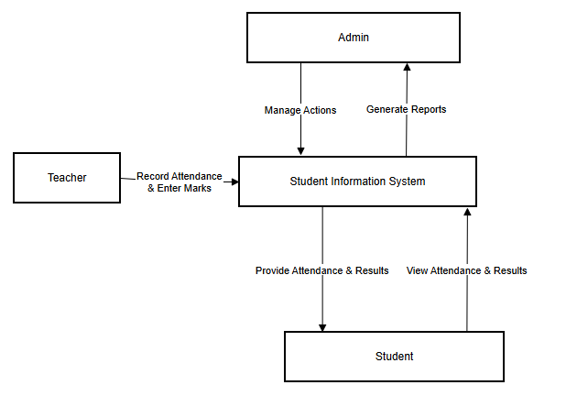
- Input:
  - Admin sends requests to manage students, teachers, and subjects.
  - Teacher sends data for attendance recording and marks entry.
  - Student sends requests to view their attendance and results.
- Output:
  - Admin receives system-generated reports and dashboard analytics.
  - Teacher receives confirmation of attendance and marks updates.
  - Student receives real-time attendance summaries, academic results, and downloadable PDF reports.
This diagram illustrates that all interactions with the system flow through a single central process, ensuring centralized data management and streamlined communication between users.

3.2.2 Database Design
The database of the Web-Based Student Information and Result Management System is designed using Supabase (PostgreSQL) to store all academic and user-related data. It ensures that student records, teacher information, subjects, attendance, and marks are organized efficiently.
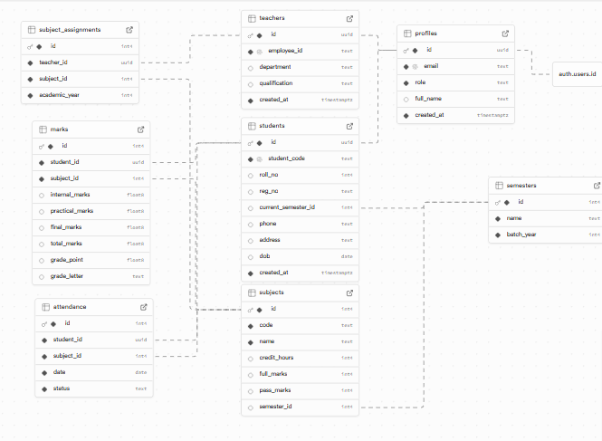
- The profiles table stores basic user information for all roles (Admin, Teacher, Student).
- The students table contains details specific to each student, including roll number, semester, and contact information.
- The teachers table stores details about faculty members, including department and qualifications.
- The semesters table defines academic semesters, while the subjects table stores information about each subject offered.
- subject_assignments links teachers with the subjects they teach.
- The attendance table records daily presence of students for each subject.
- The marks table stores internal, practical, final marks, total marks, and grade details for each student in every subject.
Relationships:
- Each student belongs to a semester.
- Subjects are linked to a semester and teachers via assignments.
- Attendance and marks tables link students and subjects to track academic performance.
- Each profile connects to either a student or a teacher.
This structure ensures centralized, consistent, and easily accessible data for all users of the system.

3.2.3 Flow chart
The flowchart shows how users interact with the Student Management Portal:
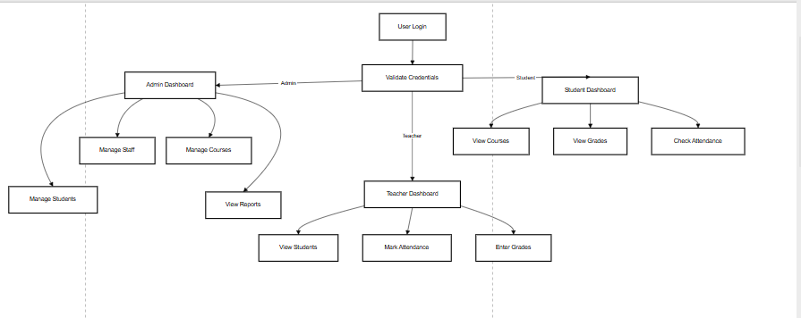
Figure 3: Flow chart
- Login: Users (Admin, Teacher, Student) log in with their credentials.
- Validation: The system checks if the login details are correct. Invalid logins show an error.
- Role-Based Access:
  - Admin: Can manage students, staff, courses, and view reports.
  - Teacher: Can view students, mark attendance, and enter grades.
  - Student: Can view courses, check grades, and monitor attendance.
- Central System: All actions are handled by the portal, ensuring proper management and data updates.

CHAPTER 5: IMPLEMENTATION

5.1 Tools and Technologies Used
The system leverages the following technologies:
- Frontend Framework: React 18 with Vite – provides a fast and reactive user interface.
- Language: TypeScript – ensures type safety and reduces runtime errors.
- Styling: Tailwind CSS – for efficient, utility-first styling of UI components.
- Backend-as-a-Service: Supabase – used for authentication, database management, and real-time data handling.
- Database: PostgreSQL – provides a robust relational database system with support for advanced queries and constraints.
- Form Handling: React Hook Form – simplifies form management and validation.
- Data Fetching & Caching: TanStack Query (React Query) – optimizes server requests and maintains a reactive state.
- PDF Generation: jsPDF / React-PDF – allows users to download marksheets and attendance reports.
- Icons: Lucide React – used to enhance the visual design of buttons and dashboards.
This combination of tools provides a modern, scalable, and maintainable full-stack solution.

5.2 Module-wise Implementation

5.2.1 Authentication Module
The authentication module is implemented using Supabase Auth, providing secure user login, registration, and session persistence. Key features include:
- User Registration: Only Admins can create new users (students or teachers).
- Login & Session Management: Users can securely log in; sessions persist across browser reloads.
- Role-Based Access Control (RBAC): Users are redirected to dashboards based on their role (Admin, Teacher, Student).
- Row-Level Security (RLS): Database policies ensure users access only data relevant to their role.
Example Policy:
create policy "Students can view own marks"
on marks for select
using (auth.uid() = student_id);

5.2.2 Admin Module
The Admin dashboard provides a central control panel to manage all academic operations. Features include:
- Student Management: Add, update, or delete student records using a custom-built StudentForm.
- Teacher Management: Manage teacher profiles through TeacherForm components.
- Course/Subject Management: Admin can define subjects and courses, assign teachers, and configure schedules.
- Report Generation: Generate academic performance reports for students, teachers, and courses.
This module is designed for ease of management and ensures all core operations can be performed by a single admin user.

5.2.3 Teacher Module
The Teacher module allows educators to perform teaching-related tasks efficiently. Features include:
- Student Viewing: Access class lists and individual student profiles.
- Attendance Management: Mark attendance using a responsive list-view interface.
- Marks Entry: Input internal, practical, and final marks with validation to prevent exceeding maximum allowed scores.
Teachers interact with the portal to ensure data integrity and accurate academic tracking.

5.2.4 Student Module
The Student module provides students with personalized academic information. Features include:
- Dashboard Overview: Displays weighted attendance and latest marks.
- Course Access: View enrolled courses and related details.
- Grades & Attendance: Check grades and attendance records.
- PDF Downloads: Students can generate and download individual marksheets and attendance reports.
This module focuses on user-friendly presentation of personal academic data.

5.3 Logic Implementation

5.3.1 Attendance Calculation
Attendance is calculated as a percentage of classes attended relative to classes conducted:
This ensures that students and teachers can monitor attendance accurately.

5.3.2 GPA Calculation
The portal follows the Tribhuvan University grading system. Marks are converted into Grade Points (GP) based on defined ranges. For example, a score of 90–100 corresponds to a 4.0 GP.
This calculation provides students and admins with accurate performance metrics.

5.4 Security Implementation
The system incorporates multiple security measures to ensure data safety, integrity, and role-based access:
- Authentication: Managed using Supabase Auth, providing secure login with JWT tokens.
- Authorization: Role-based access control ensures users only access pages and actions permitted for their role.
- Row-Level Security (RLS): Ensures data visibility is restricted to authorized users.
- Validation: Both client-side and server-side validation prevent malformed or unauthorized data entry.
Example RLS Policy for Students:
create policy "Students can view own marks"
on marks for select
using (auth.uid() = student_id);
These measures guarantee that sensitive academic data is protected and only accessible to authorized users.

CHAPTER 6: CONCLUSION AND FUTURE ENHANCEMENTS

7.1 Conclusion
The development of the Web-Based Student Information and Result Management System effectively addresses the challenges of manual record-keeping in educational institutions. By providing a centralized, role-based platform, the system improves data accuracy, enhances accessibility for students and teachers, and streamlines administrative processes for college management.
The project demonstrates the effectiveness of modern web technologies, such as React for frontend interactivity and Supabase for backend services, in creating robust and scalable academic management solutions. Overall, the system ensures efficient handling of student data and provides a foundation for future expansion.

7.2 Future Enhancements
While the current system meets the primary objectives, the following enhancements can further improve functionality and user experience:
- Online Fee Payment: Integration with local payment gateways (e.g., Khalti, eSewa) for convenient fee submission.
- Mobile Application: Native Android/iOS apps to provide students and teachers with easy access on smartphones.
- SMS/Email Notifications: Automated alerts for attendance, exam schedules, and result announcements.
- Exam Management: Features for exam scheduling, seat allocation, and result processing.
- Library Management Integration: Track library resources and manage book issuance digitally.
- Advanced Analytics with AI: Predictive analysis to identify students at risk of poor academic performance and support decision-making.
These enhancements will make the system more comprehensive, accessible, and intelligent, supporting the growing needs of modern educational institutions.

8. REFERENCES
[1] A. Al-Shehri, “Implementation of Student Information Systems in Higher Education: A Case Study,” International Journal of Computer Applications, vol. 162, no. 7, pp. 20–26, 2017.
[2] F. Owolabi and O. Adebayo, “Design and Development of Academic Record Management System for Higher Education Institutions,” Journal of Information Technology Research, vol. 11, no. 3, pp. 45–59, 2018.
[3] R. Kumar and S. Singh, “Online Academic Result Management System for Universities,” International Journal of Advanced Research in Computer Science, vol. 10, no. 2, pp. 55–61, 2019.
[4] O. Adeyemi, A. Oladipo, and J. Lawal, “Impact of Electronic Result Processing System in Nigerian Universities,” International Journal of Computer Applications, vol. 175, no. 10, pp. 12–19, 2020.
[5] M. Sánchez and R. Hueros, “Web-Based Information Systems for Higher Education Institutions: A Review,” Computers & Education, vol. 122, pp. 1–17, 2018.
[6] M. Rahman and S. Islam, “Adoption of Web-Based Academic Management Systems in Developing Countries,” Education and Information Technologies, vol. 26, no. 3, pp. 3101–3118, 2021.
[7] R. Sandhu, E. Coyne, H. Feinstein, and C. Youman, “Role-Based Access Control Models,” IEEE Computer, vol. 29, no. 2, pp. 38–47, 2016.
[8] D. Ferraiolo and R. Kuhn, “Role-Based Access Controls,” NIST National Institute of Standards and Technology, Technical Report, 2019. [Online]. Available: https://csrc.nist.gov/publications/detail/sp/800-162/final

