Release Notes

**Stock Awesome**

# V.4.0.5

Table of Contents

V.4.0.4 1

Release Features 3

Upgrading 4

Upgrade Path 4

Database Changes 4

File System Changes 4

Enhancements 5

Validation For Currency Form 5

Data Grid 5

Fixes 6

Invoice Creation 6

Department Data Creation 6

Created Products Do not show up in Invoice Module 6

Known Issues and Problems 7

Products Excel and PDF export 7

Workaround 7

# Release Features

## Barcodes and Labels

From Version 4.0.5 we provide the ability to create beautiful barcodes. As of now we have only two presets and we are willing to add more for you. If you have a certain design you want implemented please email me at [dwanyoike@codedcell.com](mailto:dwanyoike@codedcell.com)

**Small Label**

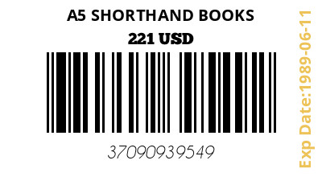

**Big Label With Additional Information**

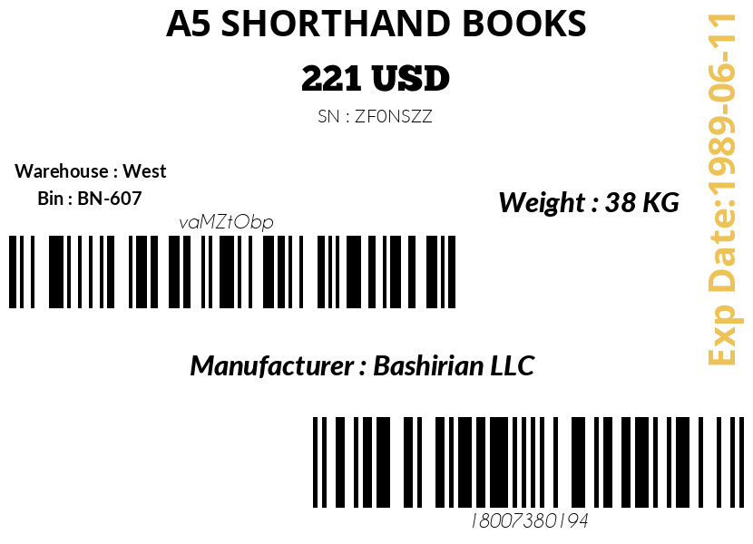

# Upgrading

## Upgrade Path

To install this update as a patch your previous Stock Awesome Version Number **must be V.4.0.3.** You can check for your current version in your application footer.

## Database Changes

* **None**

## File System Changes

Please see attached file on files and folders that have changed Please note that you do not need to re-install the whole application you can simply use the **patch file** to upgrade your system. Simply replace the changed files using the ones in the patch file.

# Enhancements

## Validation for Currency Form

The Currency Form doesn’t allow null values for the exchange rate field now.

## Data Grid

Filter Records divider doesn’t show up if there is no module specific filter.

The default filter that was named Latest Products is now renamed to Latest.

User Module Now has Filters

# Fixes

## Invoice Creation

This Update Fixes an issue with creating invoices where you would get the error

Class 'CodedCell\Repository\Invoice\SalesOrderItem' not found

## Department Data Creation

Fixed an issue with the creation of Departments Due to missing Date Picker Input add-on and Wrong arguments in DepartmentController Store Function

## Picture Uploads

Fixed existing error where when picture is uploaded it is saved on filesystem but is not visible in UI to the end user.

# Known Issues and Problems

## Products Excel and PDF export

When extracting excel or PDF document in the Products module an error occurs. This happens when you have a long list of items that causes the server to hang due to memory limits

### Workaround

1. Use Excel
2. Filter records to the absolute minimum you need using Grid Filters

***[Example:]***

None