# Setting up eDRS Land Registry

We have added a new Solution named as “eDRS Land Registry”.(.Net 4.7). It’s including all the LR service calls and models to capture LR responses

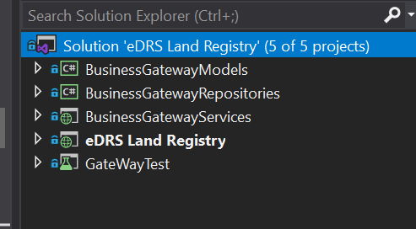

**Step 01.**

Get latest code from GitHub

**Step 02.**

Add eDRS Land Registry project into IIS

**Step 03**

Install pfx certificate in your browser. we have attached pfx certificate in this email

**Step 04**

Run UI project on your browser

# Setting up Backend

* Go to Backend Folder from github link and open the Solution.
* Change the database connection string in appsettings.json file as shown in the below screenshot. 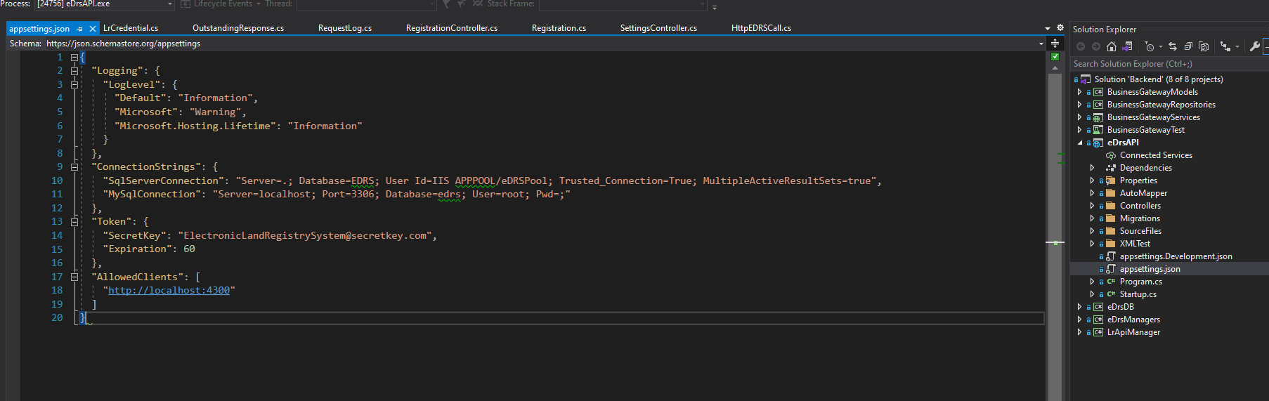
* Open the HttpEDRSCall.cs file and change the baseUrl to the eDRS Land Registry project.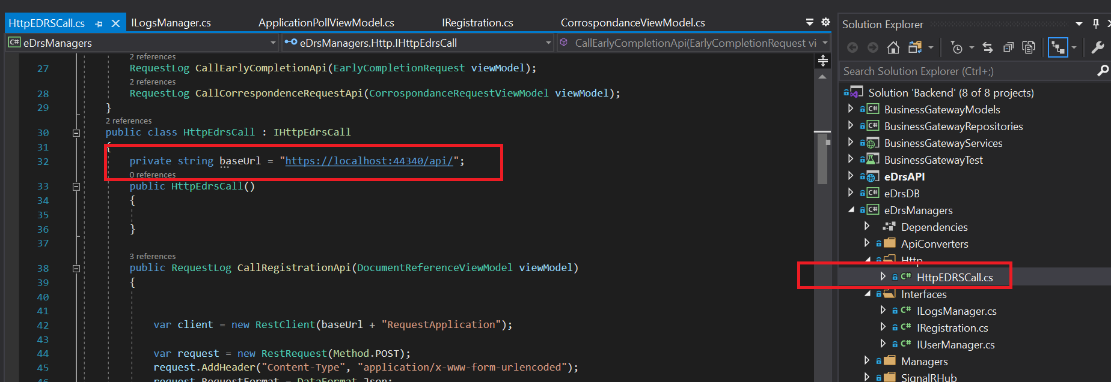
* Now you can publish the eDrsAPI application to IIS.

# Setting up UI Project

## Install the Angular CLI

To install the Angular CLI, open a terminal window and run the following command

* npm install -g @angular/cli

## Create a workspace

* Copy the FrontEnd folder from github and place it in the root directory where you installed angular cli previously.

## Install Angular dependencies

* npm install

## Change ApiUrl

* open environment.ts file point towards the Backend app.

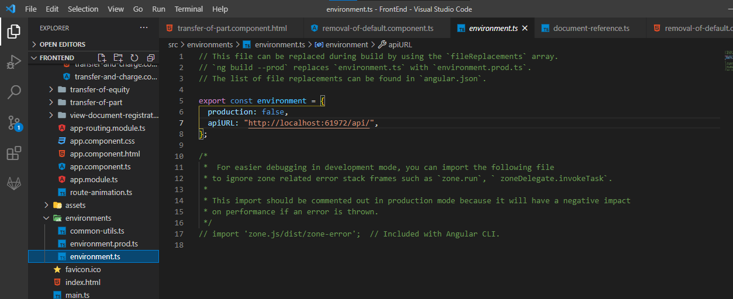

## Build Angular application

* ng build --base-href=./
* Navigate to dist folder and point your IIS path to it.