**CEBU INSTITUTE OF TECHNOLOGY**

**UNIVERSITY**

COLLEGE OF COMPUTER STUDIES

Software Requirements Specifications

for

Barangay360

Prepared by:

Omen, Jared Karl A.

Castañeda, Achilles Niño V.

Navarro, Mikhail James P.

Change History

Table of Contents

Change History 2

Table of Contents 3

1. Introduction 4

1.1. Purpose 4

1.2. Scope 4

1.3. Definitions, Acronyms and Abbreviations 4

1.4. References 4

2. Overall Description 5

2.1. Product perspective 5

2.2. User characteristics 5

2.4. Constraints 5

2.5. Assumptions and dependencies 6

3. Specific Requirements 7

3.1. External interface requirements 7

3.1.1. Hardware interfaces 7

3.1.2. Software interfaces 7

3.1.3. Communications interfaces 7

3.2. Functional requirements 7

Module 1 7

Module 2 8

3.4 Non-functional requirements 8

Performance 8

Security 8

Reliability 8

# Introduction

## Purpose

The purpose of **Barangay360** is to empower barangays by creating a connected, informed, and engaged community through a digital platform that bridges the gap between residents and officials. By addressing challenges such as fragmented communication, inefficient service delivery, and low civic participation, Barangay360 aims to streamline processes like event management, document requests, and emergency alerts while promoting transparency and accountability. Ultimately, the platform seeks to strengthen community bonds, enhance the quality of life for residents, and foster a collaborative environment where barangays can thrive as modern, resilient, and inclusive local governance units.

## Scope

* *Identify the software product(s) to be produced by name (e.g., Host DBMS, Report Generator, etc.);*
* *Explain what the software product(s) will, and, if necessary, will not do;*
* *Describe the application of the software being specified, including relevant benefits, objectives, and goals;*
* *Be consistent with similar statements in higher-level specifications (e.g., the system requirements specification), if they exist.*

## Definitions, Acronyms and Abbreviations

* *provide the definitions of all terms, acronyms, and abbreviations required to properly interpret the SRS*

## References

* *Provide a complete list of all documents referenced elsewhere in the SRS;*
* *Identify each document by title, report number (if applicable), date, and publishing organization;*
* *Specify the sources from which the references can be obtained.*

# Overall Description

## Product perspective

**Barangay360** is a comprehensive digital platform designed to address the challenges of fragmented communication, low community engagement, and inefficient service delivery in barangays by providing a centralized hub for essential services and activities. It solves these issues by offering features such as event management for organizing vaccination drives and local seminars, real-time announcements for important updates, streamlined document requests for certificates and permits, and instant emergency alerts for natural disasters or health crises. Additionally, Barangay360 promotes transparency and accountability through resource management tools, a directory for barangay officials, and a feedback system that allows residents to report issues and participate in surveys. By bridging the gap between officials and residents, Barangay360 fosters a stronger sense of community, enhances civic engagement, and improves overall quality of life, ensuring barangays operate as modern, efficient, and transparent communities.

**Why Barangay360 Matters**

Barangay360 is more than just a platform—it’s a movement toward smarter, more inclusive communities. By leveraging technology to solve long-standing challenges, it ensures that every resident, regardless of location or background, has access to the information and services they need. Whether it’s staying informed about local events, accessing critical documents, or responding to emergencies, Barangay360 equips barangays with the tools to operate effectively and residents with the means to participate actively.

In a world where connectivity and efficiency are paramount, Barangay360 stands as a beacon of progress, redefining how barangays function and empowering communities to build a brighter future together.

## User characteristics

* *Describe all user types and their roles and privileges in the system*

## 2.4. Constraints

* *Provide a general description of any other items that will limit the developer’s options.*
* *Regulatory policies;*
* *Hardware limitations (e.g., signal timing requirements);*
* *Interfaces to other applications;*
* *Parallel operation;*
* *Audit functions;*
* *Control functions;*
* *Reliability requirements;*
* *Criticality of the application;*
* *Safety and security considerations.*

## 2.5. Assumptions and dependencies

*This subsection of the SRS should list each of the factors that affect the requirements stated in the SRS. These factors are not design constraints on the software but are, rather, any changes to them that can affect the requirements in the SRS. For example, an assumption may be that a specific operating system will be available on the hardware designated for the software product. If, in fact, the operating system is not avail- able, the SRS would then have to change accordingly.*

# Specific Requirements

## External interface requirements

### 3.1.1. Hardware interfaces

*This should specify the logical characteristics of each interface between the software product and the hard- ware components of the system. This includes configuration characteristics (number of ports, instruction sets, etc.). It also covers such matters as what devices are to be supported, how they are to be supported, and protocols. For example, terminal support may specify full-screen support as opposed to line-by-line support.*

### 3.1.2. Software interfaces

*This should specify the use of other required software products (e.g., a data management system, an operating system, or a mathematical package), and interfaces with other application systems (e.g., the linkage between an accounts receivable system and a general ledger system).*

### 3.1.3. Communications interfaces

*This should specify the various interfaces to communications such as local network protocols, etc.*

## Functional requirements

### Module 1: Web Functionalities

#### 1.1 Dashboard for Admins or Officials Overview of announcements, requests, and statistics. Use Case Diagram

#### 1.2 Community Announcements with Search Filter

Create, edit, and filter announcements.

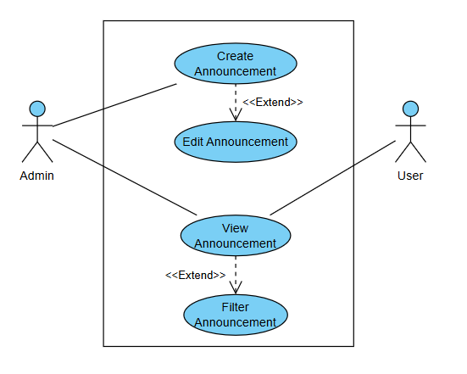

#### 1.3 Request Approval System

Approve/reject requests for documents and permits.

##### 

##### Use Case Description

##### Activity Diagram

* Wireframe

#### 1.4 Data Analytics

Monitor residents, services, and event participation.

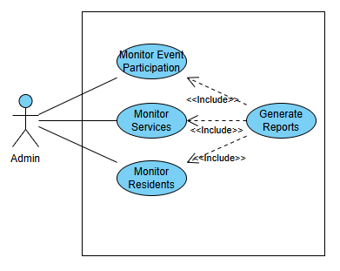

##### Use Case Diagram

##### Use Case Description

##### Activity Diagram

* Wireframe

#### 1.5 Resident Management

Register, edit, and search resident profiles.

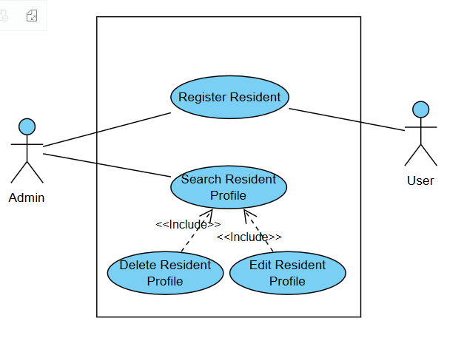

#### 1.6 Event Management

Create events, track attendees, and upload materials.

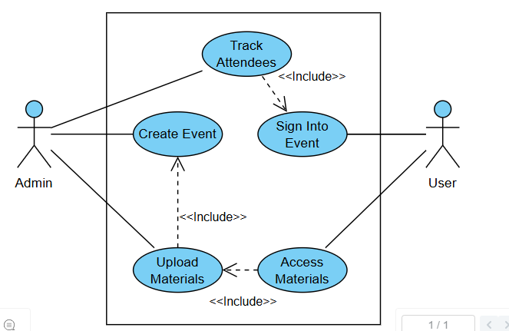

### Module 2: Mobile Functionalities

#### 1.1 Push Notifications

Real-time alerts for emergencies, events, and requests.

##### Use Case Diagram

##### Use Case Description

##### Activity Diagram

##### Wireframe

#### 1.2 QR Code Scanning

Scan codes for event check-ins and service access.

##### Use Case Diagram

##### Use Case Description

##### Activity Diagram

##### Wireframe

#### 1.3 Request Downloadable Documents

Request, download, and track barangay documents.

##### Use Case Diagram

##### Use Case Description

##### Activity Diagram

## Non-functional requirements

### Performance

##### Details

### Security

##### Details

### Reliability

##### Details